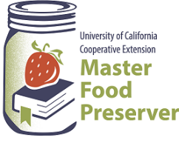

$5.00

“Preserve today, Relish tomorrow”

**Some Like it Hot! (or Not)**

*Preserving Peppers*

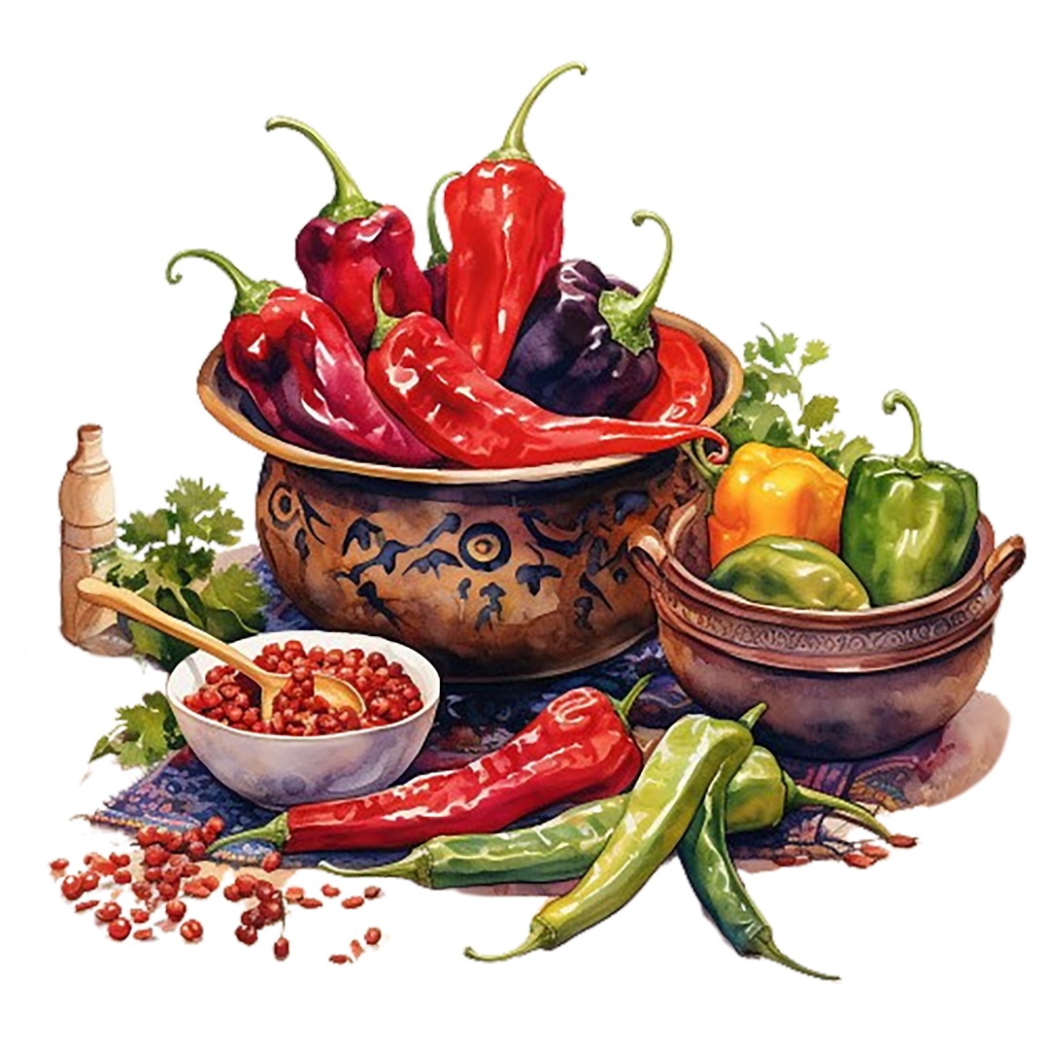

**UCCE Master Food Preservers of El Dorado County**

**311 Fair Lane, Placerville CA 95667**

**Helpline (530) 621-5506 • Email:** [**edmfp@ucanr.edu**](mailto:edmfp@ucanr.edu) **• Visit us on Facebook and Instagram!**

**About Peppers**

Originating in the Americas, peppers are members of the nightshade family (Solanaceae), which includes tomatoes, eggplants, and potatoes. And just like tomatoes and eggplants, peppers are botanically fruits, although from a culinary perspective, they are treated like vegetables. All peppers are in the genus *Capsicum* (pronounced KAP sih kum), with 26 currently known wild species and 5 cultivated species. Most cultivated varieties belong to the *Capsicum annuum* species, which includes sweet bell peppers and most of the chile peppers (such as Anaheim, jalapeño, cherry, poblano, and serrano). Other chile cultivars are *C. chinense* (habanero, Scotch bonnet), *C. frutescens* (tabasco), *C. baccatum*, and *C. pubescens*.

The peak harvest season for peppers is July to September. Here in California, the pepper season runs from April through November, with mini sweet bell peppers running from August to November.

Almost all peppers start out green, then change color as they ripen. Color alone is typically not a good indicator of how hot a pepper is; in fact in many cases, sweet peppers and hot peppers can look identical in color and in size. Most species of peppers contain capsaicin (pronounced kap SAY ih sin), a chemical compound that is responsible for a pepper’s heat. The amount of capsaicin varies by species and is dependent on genetics. The amount can also vary from plant to plant, or even pepper to pepper on the same plant. In the case of sweet bell peppers, the gene is recessive, thus these peppers are not hot.

All types of peppers will accumulate more sugars as they ripen and change color, and chile peppers will amass more capsaicin. Smaller chile pepper varieties tend to be hotter than larger varieties. The growing environment can also impact a chile pepper’s heat and flavor: Smaller peppers can be hotter if the plants are stressed and ripen too fast, and greenhouse peppers have fewer volatile compounds than field-grown peppers.

The majority of the capsaicin in a pepper is concentrated in the placenta, the white pith (also referred to as ribs or veins) that is attached to the seeds. It can also be found to a lesser extent in other fleshy parts of the pepper – but not in the seeds themselves. Both the membranes and the seeds can be bitter, so to improve a dish’s flavor (and texture), it’s generally recommended to remove them before cooking (which will also reduce the heat).

When skin or mucous membranes come in contact with the capsaicin in a hot pepper, it can feel like you’ve been burned. The capsaicin does not actually create a physical burn, however; rather, it activates a protein in humans’ cells that is part of the pain response system, which “tricks” the brain into thinking the burning sensation is real. The brain then sends pain signals to the affected areas (much like when a fingertip touches a hot stove), which causes physical reactions such as sweating, inflammation, and reddening of the skin.

**How Hot is Hot?**

A pepper’s heat is measured with laboratory equipment using a rating system known as Scoville heat units (SHU). Bell peppers, which contain no capsaicin, are rated as zero. As the Scoville rating goes up, so does the heat. A jalapeño measures between 2,500 to 8,000 SHU; a habanero measures from 100,000 to 350,000 SHU; and Pepper X, the hottest pepper as of this writing, measures about 2,693,000 SHU (that’s HOT!). New pepper varieties are being developed all the time. For a list of SHU’s for over 160 peppers, from mild to super hot, visit

<https://pepperscale.com/hot-pepper-list/>.

**Selecting, Handling, and Preparing Peppers for Preserving**

Choose fresh, firm peppers that are free from blemishes and decay, disease, and insect damage. Peppers, like all produce items, should be washed just before preparing them. Gently rub the peppers under cool running water to remove dirt, then shake off excess water.

Because contact with capsaicin may “burn” skin or eyes (see pg. 2), it’s important to handle hot peppers carefully. We recommend wearing gloves when handling and cutting hot peppers; dispose of the gloves immediately after handling them, being sure not to touch your face before disposing of the gloves, then wash your hands thoroughly. If you do not wear gloves, wash your hands thoroughly with *dish soap* immediately after handling the peppers.

Follow a tested recipe from a safe preserving resource for preparation instructions. Some peppers require blanching prior to canning. To blanch peppers, place them in a large pot of boiling water for 3 minutes (if they are large, first put 2-4 slits in each pepper). Remove from the water, and when cool enough to handle, prepare as directed in the recipe.

Chile and other peppers with tough skins generally must have their skins removed prior to processing by blistering them. When the peppers are finely chopped in a salsa, they do not need to be peeled.

The skin can be removed by first blistering the peppers, and then peeling. *Note:* If the peppers are not processed within 2 hours after blistering and/or peeling, refrigerate them in shallow containers until ready to process. Cut a small slit in the side of the peppers to allow steam to escape, then blister the skins using one of the following methods.

*Oven/Broiler:* Place peppers in a pan in a single layer in hot oven (400°F to 450°F) or under a broiler for 6-8 minutes until the skins blister and the skins can be easily peeled away from the flesh. Turn the peppers over occasionally to blister evenly.

*Range Top:* Cover a hot burner (either gas or electric) with heavy wire mesh. Place peppers on burner for several minutes until the skins blister, turning the peppers frequently to prevent scorching and ensure even blistering.

*Outdoor Grill:* Place the hot peppers on a charcoal grill about 5-6 inches above glowing coals, or in a gas grill heated to (400°F to 450°F). Turn the peppers frequently to prevent scorching and ensure even blistering.

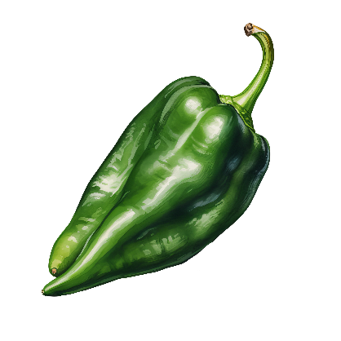After the peppers are blistered, spread them in a single layer until cool enough to handle, then peel. For a crisper hot pepper, dip the peppers into ice water as soon as they are removed from the heat. For peppers that are more thoroughly cooked, place the peppers in paper bag or in pan and cover with damp cloth. Cool for several minutes and then peel off the skins.

**POBLANO**

**Storing Peppers**

Peppers are ideally stored at 45°F, but at home refrigerator temperatures (which should be no more than 40°F), they will last about a week if they are in good condition. Keeping fresh, whole peppers dry will help them last longer. Cut peppers not consumed within 2 hours should be refrigerated.

Peppers are one of the few vegetables which do not require blanching prior to freezing. While frozen raw peppers will retain crispier texture (and are thus best used in uncooked foods), blanching can extend the shelf life and take up less space. Blanched frozen peppers are best suited for use in cooking.

To blanch peppers for freezing, water blanch strips or rings for 2 minutes, or halves for 3 minutes. Cool promptly and drain.

When packaging food for freezing, for the best quality remove as much air as possible. Choose freezer-safe, moisture- and vapor-proof containers or heavy zip-lock bags designed for freezing. Food may also be vacuum sealed. After packaging, label and date the packages and freeze at or below 0°F.

***To freeze bell or other sweet peppers:*** Select crisp, tender peppers. Wash, cut in half, and remove stems and seeds. If desired, cut into ½-inch strips or rings. For raw peppers, package using no headspace, seal and freeze. For blanched peppers, package leaving ½-inch headspace, seal, and freeze.

***To freeze pimientos:*** Select firm, crisp pimientos of deep red color. Peel by roasting in an oven at 400°F to 450°F for 6-8 minutes, or until the skins can be rubbed off. Wash off the charred skins, cut out stems, and remove seeds. Package leaving ½-inch headspace, seal, and freeze.

***To freeze hot peppers:*** Wash and stem peppers. Package leaving no headspace, seal, and freeze.

***To freeze roasted bell or Anaheim peppers:*** Peel peppers (see pg. 3) and remove stems and seeds. Flatten whole peppers to remove air, or cut them into strips, rings, or pieces. Package, seal, and freeze. If desired, a sheet of waxed or freezer paper or plastic wrap can be placed between the layers, which will make them easier to handle when thawing.

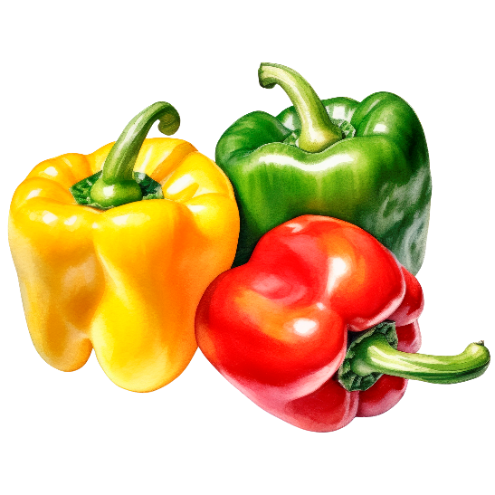

**BELL**

**Swapping Peppers in Canned Pickle and Salsa Recipes**

The heat level of canned pepper products can be adjusted simply by swapping the types of peppers. Use bell peppers in place of some or all of the hot peppers for a milder pickle or salsa, or increase the intensity by choosing all hot peppers. The key is to *swap* the peppers: The total amount of peppers must not be increased.

If the recipe calls for a certain amount of peppers by weight or volume (such as pounds or cups), the swap is easy: Simply weigh or measure that amount, regardless of the type of pepper you have chosen.

If a specific number of peppers are called for by size, you will need to do some calculations, as you cannot simply swap the same number of large peppers for small ones. For example, if the recipe calls for 6 jalapeños, do not use 6 bell peppers. Making this type of physical size adjustment will require that you determine the equivalent weight or volume of the small peppers in order to know how many large peppers can be used.

Note that while pepper types may be exchanged for each other, peppers should not be swapped for other ingredients in canning recipes. For example, do not use peppers in place of onions (or vice versa). The amount of peppers and other low-acid vegetables such as onions or celery (but not tomatoes) may be reduced or eliminated, but they may not be increased. Lowering the quantity of peppers and/or other vegetables may affect the overall texture of the recipe, but it will not impact its safety (again, do not reduce the amount of tomatoes called for in a tested canning recipe, as their acidity is required for safety).

**Food Safety / Preserving Basics**

Food preservation starts with food safety. Cleaning and sanitizing your work area, washing hands frequently, properly handling produce and meat, and avoiding cross-contamination are all part of the process in avoiding food-borne illness.

Following recipes from trusted resources is the next step in ensuring safety when preserving food. This is especially important when canning: It’s critical to follow a current, research-based recipe and to use the correct canning method for the food being processed.

For further details on food safety in general, as well as information on a variety of food preservation topics, visit our Food Safety website, where you’ll find free, downloadable publications and educational posters: <https://ucanr.edu/sites/mfp_of_cs/Food_Safety/>.

You can also access the site by scanning this QR code with your smartphone or tablet.



**RECIPES**

**Candied Jalapeños**

*Also known as Cowboy Candy, these sweet-hot pickles are delicious served on sandwiches, salads, nachos, tacos, chili, cornbread, and more. Try garnishing cocktails with them!*

*Yield: about 4 pint jars*

**BW/STEAM CANNING**

3 cups apple cider or white vinegar (5% acidity)

2 tsp salt

4 cups sugar

6 garlic cloves, sliced

2 tsp turmeric

½ tsp cayenne powder

2 tsp mustard seeds

4 lbs jalapeños, sliced into ¼” rings

1. Combine all ingredients except jalapeños in a large saucepan. Bring to a boil over high heat, stirring to dissolve sugar.
2. Add sliced jalapeños, lower heat to medium, and simmer for 15 minutes, until the jalapeños are dark green and have begun to absorb some of the brine.
3. Ladle hot mixture into a hot jar, leaving ½-inch headspace. Remove air bubbles and adjust headspace if needed, by adding more hot mixture. Wipe jar rim with a dampened clean paper towel or cloth. Place lid and ring on jar, tightening ring only finger-tip tight (unless otherwise directed by the manufacturer). Place jar in canner. Repeat with remaining jar(s).
4. Process **pint** jars in a boiling water or atmospheric steam canner as follows:

15 minutes at 0-1,000 feet elevation

20 minutes at 1,001-3,000 feet elevation

20 minutes at 3,001-6,000 feet elevation

25 minutes at 6,001-8,000 feet elevation

1. For boiling water canning, turn off heat, remove canner lid and wait 5 minutes. For atmospheric steam canning, turn off heat, leave canner lid on and wait 2-3 minutes. Remove jars to a rack or towel and let cool, undisturbed, for 12-24 hours and then check seals. Store unsealed jars in the refrigerator or reprocess. Clean and label sealed jars and store in a cool, dry dark location.

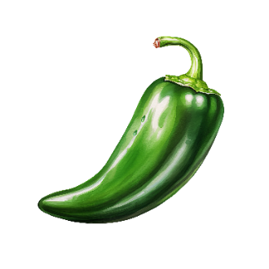*Source: ballmasonjars.com*

**JALAPEÑO**

**Pickled Roasted Red Peppers**

*Yield: about 4 pint jars*

**BW/STEAM CANNING**

4 large garlic cloves, roasted (see below), skin removed, and mashed

1½ cups white vinegar (5% acidity)

1½ cups apple cider vinegar (5% acidity)

1½ cups dry white wine

½ cup water

1 cup coarsely chopped onion

½ cup granulated sugar

2 Tbsp dried oregano

4 tsp canning salt

20 medium sweet red peppers (such as bell or Shepherd)

1. *Roast Peppers and Garlic:* Place peppers and garlic cloves over hot coals, on a grill at 425°F, or under the broiler until charred, turning to roast all sides. Once the skin of the peppers wrinkles and chars and the garlic has charred spots, remove from the heat. Place peppers in a paper bag until cool enough to handle, about 15 minutes, then lift off skins. Slice lengthwise into serving-size pieces. Cool garlic, then squeeze the cloves to remove them from the peel.
2. In a large non-reactive saucepan, combine the roasted garlic, both vinegars, white wine, water, onion, sugar, oregano and salt. Bring to a boil over medium-high heat, stirring to dissolve the sugar. Reduce the heat and boil gently for 5 minutes, until the garlic and oregano flavors have infused the liquid.
3. Pack the room temperature peppers into a hot jar, leaving a generous ½-inch headspace. Ladle hot pickling liquid over the peppers, leaving ½-inch headspace. Remove air bubbles and adjust headspace if needed, by adding more hot liquid. Wipe jar rim with a dampened clean paper towel or cloth. Place lid and ring on jar, tightening ring only finger-tip tight (unless otherwise directed by the manufacturer). Place jar in canner. Repeat with remaining jar(s).
4. Process **pint** jars in a boiling water or atmospheric steam canner as follows:

15 minutes at 0-1,000 feet elevation

20 minutes at 1,001-3,000 feet elevation

25 minutes at 3,001-6,000 feet elevation

30 minutes at 6,001-8,000 feet elevation

1. For boiling water canning, turn off heat, remove canner lid and wait 5 minutes. For atmospheric steam canning, turn off heat, leave canner lid on and wait 2-3 minutes. Remove jars to a rack or towel and let cool, undisturbed, for 12-24 hours and then check seals. Store unsealed jars in the refrigerator or reprocess. Clean and label sealed jars and store in a cool, dry dark location.

*Source: Ball Complete Book of Home Preserving (2024)*

**Marinated Peppers**

*Adjust the heat by mixing the peppers. For mild heat, use 1 lb of jalapeños and 3 lbs of sweet or mild peppers; for medium heat use 2 lbs jalapeños and 2 lbs of sweet or mild peppers, and for hot use all jalapeño peppers.*

*Yield: about 9 half-pint jars*

**BW/STEAM CANNING**

4 lbs firm peppers (such as bell, Hungarian, banana, or jalapeño)

1 cup bottled lemon juice

2 cups white vinegar (5% acidity)

1 Tbsp oregano leaves

1 cup olive or salad oil

½ cup chopped onion

2 Tbsp prepared horseradish *(optional)*

2 to 3 garlic cloves, quartered *(optional)*

salt *(optional)*

1. *PREPARE PEPPERS:* Peppers may be left whole; large peppers may be quartered. Slash 2-4 slits in each pepper. Blanch peppers in boiling water, or blister skins on tough-skinned hot peppers and remove skins (see pg. 3 for directions). Flatten whole peppers.
2. In a nonreactive saucepan, mix lemon juice, vinegar, oregano, oil, onions, and optional horseradish. Heat to boiling.
3. *Optional:* Place ¼ garlic clove in each jar. Add ¼ tsp salt to each half-pint jar (or ½ tsp to each pint jar).
4. Fill hot jars with peppers, leaving ½-inch headspace. Ladle hot, well-mixed pickling solution over peppers, leaving ½-inch headspace. Remove air bubbles and adjust headspace if needed, by adding more hot liquid. Wipe jar rim with a dampened clean paper towel or cloth. Place lid and ring on jar, tightening ring only finger-tip tight (unless otherwise directed by the manufacturer). Place jar in canner. Repeat with remaining jar(s).
5. Process **half-pint or pint** jars in a boiling water or atmospheric steam canner as follows:

15 minutes at 0-1,000 feet elevation

20 minutes at 1,001-6,000 feet elevation

25 minutes above 6,000 feet elevation

1. For boiling water canning, turn off heat, remove canner lid and wait 5 minutes. For atmospheric steam canning, turn off heat, leave canner lid on and wait 2-3 minutes. Remove jars to a rack or towel and let cool, undisturbed, for 12-24 hours and then check seals. Store unsealed jars in the refrigerator or reprocess. Clean and label sealed jars and store in a cool, dry dark location.

*Source: USDA Complete Guide to Home Canning*

**Cayenne Pepper Sauce**

*Yield: about 5 pint jars*

**BW/STEAM CANNING**

3 lbs hot peppers (such as Anaheim, Hungarian, jalapeño, etc.)

⅓ cup minced garlic

4 cups sliced onion

⅓ cup stemmed, chopped cilantro

3 cans (28 oz each) diced tomatoes

3 cups apple cider vinegar (5% acidity)

2½ cups water

1. Trim and slice peppers into rings. In a 10-quart nonreactive Dutch oven or pot, mix together all ingredients. Bring to a boil, and boil 1 hour. Reduce heat slightly and simmer for 1 additional hour. Turn the heat off, and cool mixture slightly.
2. Carefully purée mixture in a blender (about 2 minutes per blender batch). Return the puréed mixture to the pot, and bring carefully just to a boil. *Note! The mixture will start to spatter as it gets close to boiling; heat slowly while stirring constantly, being careful not to get burned by splashing sauce.* Turn off the heat.
3. Ladle hot sauce into a hot jar, leaving ½-inch headspace. Remove air bubbles and adjust headspace if needed, by adding more hot sauce. Wipe jar rim with a dampened clean paper towel or cloth. Place lid and ring on jar, tightening ring only finger-tip tight (unless otherwise directed by the manufacturer). Place jar in canner. Repeat with remaining jar(s).
4. Process **pint** jars in a boiling water or atmospheric steam canner as follows:

10 minutes at 0-1,000 feet elevation

15 minutes at 1,001-6,000 feet elevation

20 minutes above 6,000 feet elevation

1. For boiling water canning, turn off heat, remove canner lid and wait 5 minutes. For atmospheric steam canning, turn off heat, leave canner lid on and wait 2-3 minutes. Remove jars to a rack or towel and let cool, undisturbed, for 12-24 hours and then check seals. Store unsealed jars in the refrigerator or reprocess. Clean and label sealed jars and store in a cool, dry dark location.

*Source: So Easy to Preserve*

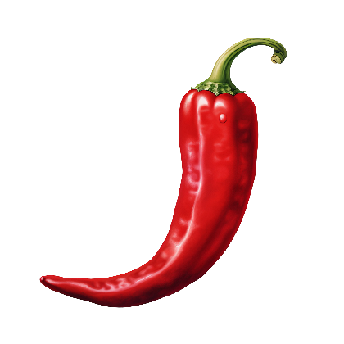

**CAYENNE**

**Inferno Pepper Wine Jelly**

*Yield: about 7 quarter-pint (4 oz) jars*

**BW/STEAM CANNING**

½ cup minced, seeded red bell peppers

2 Tbsp minced, seeded jalapeño peppers

3 dried hot chile peppers, halved lengthwise

1½ cups sweet white wine (such as Sauternes)

3 Tbsp bottled lemon juice

3½ cups granulated sugar

1 pouch liquid pectin

1. In a large, deep nonreactive saucepan, combine the peppers, white wine and lemon juice. Stir in the sugar. Over high heat, stirring constantly, bring to a full rolling boil that cannot be stirred down. Stir in the pectin. Boil hard, stirring constantly, for 2 minutes. Remove from the heat and quickly skim off foam.
2. Quickly pour the hot jelly into a hot jar, leaving ¼-inch headspace. Wipe jar rim with a dampened clean paper towel or cloth. Place lid and ring on jar, tightening ring only finger-tip tight (unless otherwise directed by the manufacturer). Place jar in canner. Repeat with remaining jar(s).
3. Process **quarter-pint** jars in a boiling water or atmospheric steam canner as follows:

10 minutes at 0-1,000 feet elevation

15 minutes at 1,001-3,000 feet elevation

20 minutes at 3,001-6,000 feet elevation

25 minutes at 6,001-8,000 feet elevation

1. For boiling water canning, turn off heat, remove canner lid and wait 5 minutes. For atmospheric steam canning, turn off heat, leave canner lid on and wait 2-3 minutes. Remove jars to a rack or towel and let cool, undisturbed, for 12-24 hours and then check seals. Store unsealed jars in the refrigerator or reprocess. Clean and label sealed jars and store in a cool, dry dark location.

*Source: Ball Complete Book of Home Preserving (2024)*

**HOW TO SUSPEND PEPPERS (OR OTHER PARTICLES) THROUGHOUT JELLY**

*NOTE: This process is only for jellies prepared in 4-oz or 8-oz jars that have been processed for 10 minutes in a boiling water or atmospheric steam canner.*

Cool the processed jars upright for 15 to 30 minutes, or just until the lids pop down but the jelly is not fully set. As soon as the lids are concave, carefully and gently twist and/or tilt – do not shake and do not invert – each jar to distribute solids throughout the jelly.

Inverting the sealed jars might prevent formation of a vacuum seal, so it’s important to not do this until the jars are fully sealed. Also not recommended is stirring the jelly for several minutes before pouring it into jars. This interferes with the natural gelling process and result in gel failure of the completed jelly.

**Dried Peppers**

*Peppers are one of the few vegetables that do not require blanching prior to dehydrating. However, tough-skinned peppers, such as chiles, should usually be removed of their skins prior to drying (see pg. 3 for instructions).*

**DEHYDRATING**

*For further details on dehydrating, see our publication* **Dehydrating Basics: Produce***, available for free at our website:* [*https://ucanr.edu/sites/mfp_of_cs/files/398681.pdf*](https://ucanr.edu/sites/mfp_of_cs/files/398681.pdf)*.*

***SWEET PEPPERS (BELL-TYPE AND PIMIENTOS) IN A DEHYDRATOR:***

Remove stems, seeds, and membranes. Cut into ¼-inch disks or slices. Spread on dehydrator trays and dry at no more than 140°F until peppers are tough and brittle (about 8 to 10 hours). Peppers can also be started at 140°F for 2 hours and then reduced to 130°F until done.

Note that the skins of peppers dried in large pieces can be tough when rehydrated. Grinding such dried peppers can reduce the problem.

***HOT PEPPERS IN A DEHYDRATOR:***

To dry green chile peppers, first remove the skin. Remove the stems and seeds. Dry at 140°F until crisp or brittle and a medium green. To dry red chile peppers, spread whole pods in a thin layer on dehydrators trays and dry at 140°F until they are shriveled, dark, red, and crisp. Remove stems and seeds before using. Hot peppers can also be dried in ¼” to ½” pieces.

***PEPPERS IN AN OVEN:***

Prepare peppers as for drying in a dehydrator (see above) and place on a baking tray. Hot chile peppers may also be sliced in half and the stems removed. Place in a single layer on a baking sheet. Put tray in a preheated 200°F oven until tough and brittle (about 8 to 10 hours). Check the peppers frequently to make sure that they do not burn.

***SUN-DRIED PEPPERS:***

Peppers may be dried in the sun if daytime temperatures are higher than 85°F and the humidity is below 60%. If the nighttime temperatures drop enough to cause dew to form on grass, bring the peppers indoors.

Large peppers dry better if they are cut in half. Remove stems, seeds, and membranes. Slice or cut into cubes. Small peppers may be left whole but should be slit with a knife to speed drying. Peppers are dried when brittle.

Produce dried in the sun may be subject to insect infestation. “Pasteurize” the peppers to kill insects and/or insect eggs by either freezing at 0°F or lower for at least 48 hours, or by heating in an oven at 160°F for 30 minutes, or for at 175°F for 15 minutes. Use care to avoid scorching the food.

***AIR-DRIED CHILE PODS:***

String whole red chile pods together through the stems with a needle and cord or heavy thread, or suspend the pods in bunches, stem-side up, in an area with good air circulation and low humidity. Dry until the pods are shrunken, dark red, and flexible. Air-drying chiles may take as long as 3 to 4 weeks.

**Dried Peppers (cont.)**

***SMOKED PEPPERS:***

Many varieties of peppers can be smoked. A pepper commonly smoked is the jalapeño (a ripe smoked-dried jalapeño is known as a *chipotle*). Smoke peppers in a clean smoker (grease and fat drippings can negatively impact the flavor of the peppers) according to the instructions for your particular smoker for 2-3 hours at a temperature no hotter than 140°F. If your grill can maintain a constant temperature, you may be able to use it as a smoker box.

After 2-3 hours, transfer the peppers to a dehydrator and dry at 140°F until the peppers are brittle. *Note:* The smokiness from the peppers can permeate the surfaces of the dehydrator, leaving it with a smokey smell that can last for days or months. The smokey aroma can also permeate your house, so consider where you place your dehydrator and/or when you run it.

***PEPPER POWDERS AND FLAKES:***

Pepper powders can be made by grinding dried peppers using a spice mill, food processor, or blender. Pepper flakes, such as chile pepper flakes, are not as fine as powders and can be made by crushing dried peppers with a mallet or rolling pin, or by encasing the peppers in a plastic bag or clean towel and hand crushing.

For powders and flakes, dry peppers until all moisture is gone and the peppers are crisp.

*TIP*: When grinding hot peppers, wearing a mask can provide some protection against floating capsaicin-laced particles.

**DIY CHIPOTLE CHILI POWDER**

4 dried ancho chiles

4 dried chipotle chiles

¼ cup smoked paprika (pimenton)

3 Tbsp onion powder

3 Tbsp garlic powder

1 Tbsp cumin seeds

Remove the stems from the chiles and cut into 1” pieces. Lay flat on a baking sheet and toast in a 200°F oven until slightly crisp. Combine the chiles with the rest of the ingredients and grind together in a spice mill. Transfer to an airtight container and store in a cool, dark place.

*Source: The Spice Lover’s Guide to Herbs & Spices*

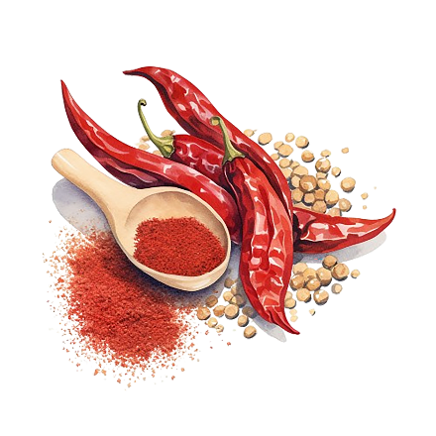

**Chile Lime Salt**

*Yield: about ½ cup*

**DRY STORAGE**

½ cup flaked sea salt

2 tsp dried chile flakes (or dried Aleppo pepper)

2 tsp dried lime zest

½ tsp smoked paprika (pimenton)

1. Whirl all ingredients in a spice grinder or small food processor.
2. Store in an airtight container in a cool, dark place.

*Source: delicious.com.au*

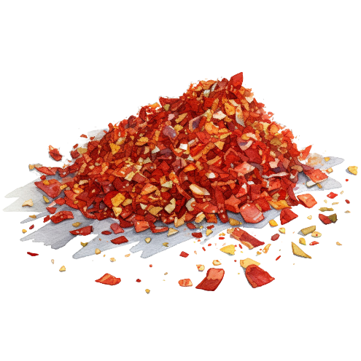

**Spicy Refrigerator Pickled Peppers**

*Yield: 1 pint jar*

**REFRIGERATION**

1 cup white or apple cider vinegar

1 tsp kosher salt

2 Tbsp dark brown sugar

½ tsp dried oregano

3 garlic cloves, peeled and crushed

¼ cup extra-virgin olive oil

½ lb red jalapeños or Italian roasting peppers, thinly sliced into ¼” rounds

1. In a saucepan combine the vinegar, salt, brown sugar, oregano, garlic, and olive oil. Bring to a simmer over medium heat. Add the sliced peppers and simmer for 10 to 15 minutes, until the peppers are tender.
2. Transfer the peppers to a mason jar or container with an airtight lid, then pour the liquid over the top. Refrigerate overnight to allow the flavors to infuse. Store in a tightly capped jar in the refrigerator for up to 1 month.

*Source: loveandoliveoil.com*

**WASTE NOT WANT NOT!**

Leftover brine from your pickled peppers can be used to make a delicious vinaigrette, or added to marinades, and much more!

**CHILI POWDER OR CHILE POWDER?**

Yes, there is a difference in these spices, besides the spelling.

*Chili powder* is ground, dried chile peppers mixed with other spices. *Chile powder* is pure ground dried chile peppers.

**Selected References:**

Univ. of California Division of Agriculture and Natural Resources, Peppers: Safe Methods to Store, Preserve, and Enjoy <https://anrcatalog.ucanr.edu/pdf/8004.pdf>

Michigan State University, Michigan Fresh: Using, Storing, and Preserving Hot Peppers <https://www.canr.msu.edu/resources/michigan-fresh-hot-peppers>

North Carolina Extension, Gardener Extension Plant Toolbox, Capsicum annuum (Grossum Group) <https://plants.ces.ncsu.edu/plants/capsicum-annuum-grossum-group/>

New Mexico State University, Processing Fresh Chile Peppers <https://pubs.nmsu.edu/_e/E324/>

New Mexico State University, The Story of Chile Peppers <https://cpi.nmsu.edu/chile-info/for-kids-pages/the-story-of-chile-peppers.html>

Penn State Extension, Let’s Preserve: Peppers <https://extension.psu.edu/lets-preserve-peppers>

Penn State Extension, What Can You Change in a Canning Recipe? <https://extension.psu.edu/what-can-you-change-in-a-canning-recipe>

Texas A&M, Is That Chile Pepper Hot or Not? <https://agrilifetoday.tamu.edu/2022/01/28/is-that-chile-pepper-hot-or-not/>

U.S. Dairy, Does Milk Help with Spicy Food? <https://www.usdairy.com/news-articles/does-milk-help-with-spicy-food>

The Well by Northwell, How to Avoid Pepper Burn on Your Eyes and Hands <https://thewell.northwell.edu/healthy-living-fitness/pepper-burn>

Washington State Univ. Extension, Salsa Recipes for Canning <https://extension.usu.edu/tooele/files/SalsaRecipesforCanning.pdf>

**Additional Resources:**

UC Master Food Preservers of Central Sierra <https://ucanr.edu/sites/mfp_of_cs/>

UC Master Food Preserver Program <https://mfp.ucanr.edu/>

National Center for Home Food Processing <https://nchfp.uga.edu/>

USDA Complete Guide to Home Canning <https://nchfp.uga.edu/publications/publications_usda.html#gsc.tab=0>

So Easy to Preserve <https://setp.uga.edu/>

Ball Blue Book Guide to Preserving. ©2024. Newell Brands Inc.

Ball Complete Book of Home Preserving. ©2024. Newell Brands Inc.

All New Ball Book of Canning and Preserving. ©2023. Newell Brands Inc.

The information in this handout is provided as a courtesy to the reader. No endorsements of commercial products or services are made or implied, nor is criticism implied of similar products or information not listed.

It is the policy of the University of California (UC) and the UC Division of Agriculture & Natural Resources not to engage in discrimination against or harassment of any person in any of its programs or activities (complete nondiscrimination policy statement can be found at https://policy.ucop.edu/doc/1001004/Anti-Discrimination).