**Crazy For Cranberries**

**Basic Food Safety & Sanitation**

When preparing food for preservation, cleanliness is essential in preventing food-borne illness, especially when handling raw fish, meat and other foods that won’t be cooked (including fruits and vegetables).

**Step 1: Clean Your Work Area**

Wash your sink and countertops with soap and warm water, rinse well, and dry with clean paper towels. Then apply a sanitizing solution such as bleach (1 scant teaspoon of liquid unscented bleach to 1 quart of water). Spray well and allow to air dry, or let sit for 30 seconds and wipe dry with clean paper towels. If using commercial sanitizers, follow the manufacturer’s instructions. Wash and sanitize both before and after preparing food.

**Step 2: Wash Your Hands**

Wet your hands, apply soap, lather and then scrub for at least 20 seconds. Rinse well and dry with paper towels or a clean cloth. If using gloves, first wash your hands and then wash the gloves following these same procedures. Wash your hands again when switching tasks.

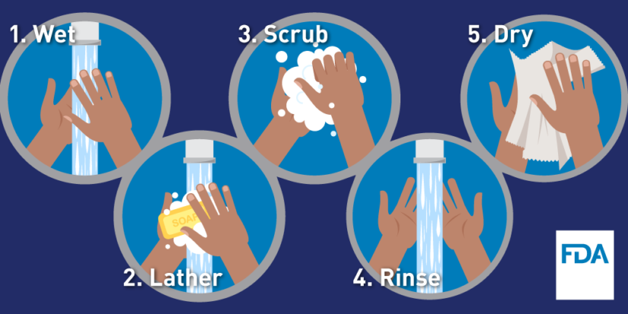

*Image Source: FDA*

**Step 3: Avoid Cross-Contamination**

Be sure to use clean cutting boards and kitchen utensils, and wash them thoroughly before switching from one food type to another, or use separate boards and utensils for different types of foods (e.g., use one board for raw fish or meat and another board for vegetables, herbs, etc.). Wipe up spills promptly, and re-clean your work area as often as necessary.

*Image Source: Partnership for Food Safety Information*

**Basic Food Safety & Sanitation – cont.**

**QUICK TIPS**

* use paper towels or a fresh clean dish towel to clean surfaces
* wipe up spills immediately with paper towels or a clean dish towel (and then put that towel straight into the laundry basket)
* change dish cloths and towels **every day**
* sanitize sponges between uses by using one of these 3 methods:
  + moisten the sponge and heat in a microwave for one minute
  + wash in a dishwasher with a drying cycle
  + soak in a bleach solution for one minute
* replace sponges frequently

**Step 4: Prepare Your Food**

Do not wash raw seafood, meat and poultry – doing so can spread pathogens and potentially cross-contaminate other foods. Wash **all** fresh produce, even if the skin or rinds won’t be eaten. To wash produce, rinse under cool running water in a clean sink – do not soak.

**QUICK TIPS**

* clean produce right before using
* gently rub soft fruits and vegetables (such as tomatoes) with your hands under running water to remove dirt
* scrub firm fruits and vegetables (such as potatoes, carrots, and melons) with a vegetable brush (don’t forget to clean the brush!)
* remove outer leaves of lettuce and cabbage before washing
* rinse herbs and sprouts, then shake to remove excess water
* use a kitchen sink sprayer to rinse berries in a colander, gently turning and shaking the colander to remove dirt and excess water

For more information on cleaning and sanitizing the kitchen using inexpensive and food-safe household products, check out this publication: <https://extension.colostate.edu/docs/pubs/foodnut/kitchen-sanitize.pdf>

**When In Doubt, Throw It Out**

Never taste food that looks or smells strange to see if it can still be eaten. Most bacteria that cause foodborne illness are odorless, colorless, and tasteless.

For general information on food safety, here are some good websites to visit:

<http://nchfp.uga.edu>

[www.foodsafety.gov](http://www.foodsafety.gov)

[www.fightbac.org](http://www.fightbac.org)

<https://www.cdc.gov/foodsafety/cdc-and-food-safety.html>

**Boiling Water Canner Essentials**

Boiling water canners are generally made from enamel-coated steel, stainless steel, or aluminum and come with removable perforated racks and fitted lids. There are also electric canners available, which are generally more expensive. The canner must be deep enough so that at least 1” of water (2” if the processing time is longer than 30 minutes) covers the tops of the jars. There also must be enough airspace to allow for 1” to 2” of vigorously boiling water. If you don’t have a dedicated canner, a large deep pot with a lid can be used. Canning racks can be purchased separately, or a perforated pizza pan, cake rack, silicone trivet, etc. can be substituted. Pressure canners can also function as boiling water canners, however, the lid should not be applied tightly.

Filled canners can be heavy and they generate a lot of heat. Before canning on a smooth top range, check with the manufacturer as to whether it is suitable for canning and for any canner size limits. On smooth top and electric burners, use only pots with flat bottoms (canners with flat, ridged, or concave bottoms can all be used on gas burners). In general, to ensure uniform processing when canning on an electric range, the canner should be no more that 4” wider in diameter (2” on each side) than the burner element used to heat the canner. Just as with smooth top ranges, some types of portable burners are okay for canning and others are not, so first check the manual. Lastly, keep in mind the height of your range hood; if there’s insufficient clearance between it and the top of the canner, it will be difficult to add or remove jars if you’re using a vessel that is fairly tall.

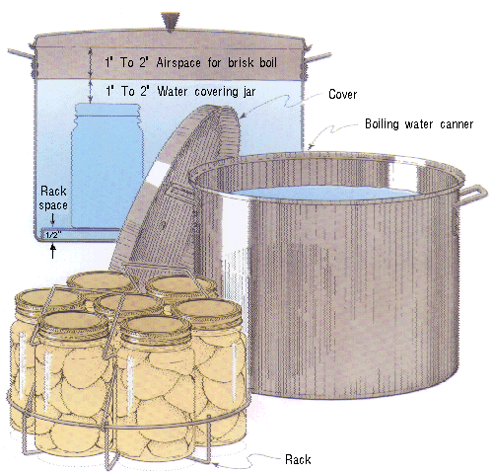

*Image Source: U.S. Department of Agriculture*

**Steam Canner Essentials**

Steam canners consist of a shallow pan, a perforated rack, and a tall vented dome cover. These canners are lightweight and use much less water than boiling water canners, so they heat up quickly and use less energy.

Some models have a temperature sensor/gauge on the dome. The sensors on steam canners cannot be tested, so they should be used only as a guide.

Steam canners have been approved for use with reputable recipes that have been developed for boiling water or atmospheric steam canning (meaning high-acid foods such as most fruits, pickles, and other acidified foods) in half-pint, pint, and quart jars. Follow these guidelines when using steam canners:

* use only standard glass canning jars with 2-piece metal lids
* jars must be no larger than quart size
* **the processing time must be 45 minutes or less, including any adjustments for altitude**
* during processing, do not lift the dome cover to add more water (doing so immediately lowers the heat and thus processing will need to start over from the beginning)
* regulate the heat so that the canner maintains a temperature of 212°F (**a canner that boils too vigorously can boil dry within 20 minutes**)
* *helpful hint:* put a quarter or some marbles in the bottom of the canner; they will begin to rattle if the water gets too low

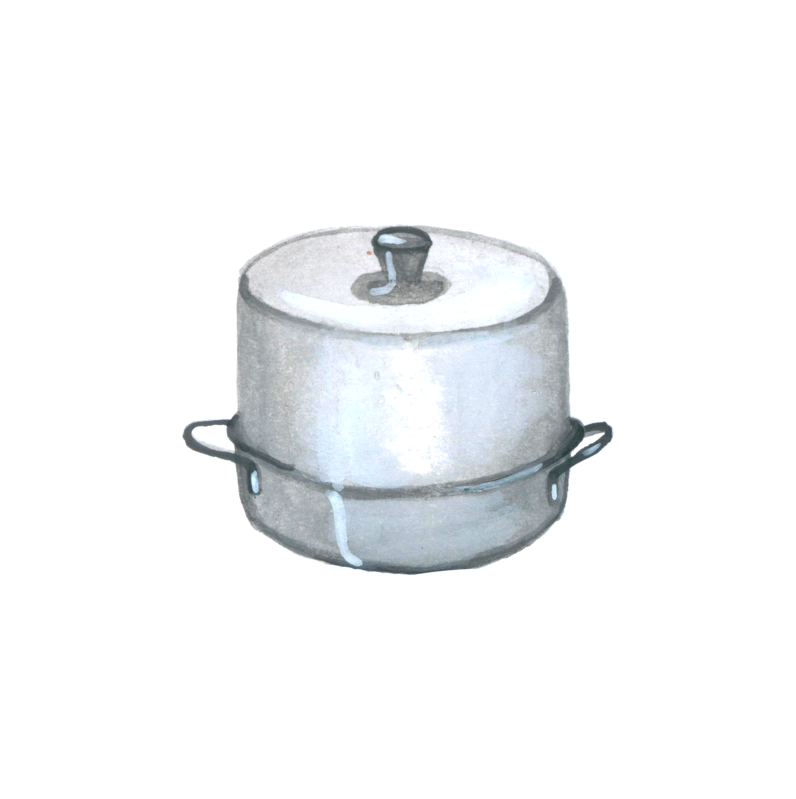

dome cover

base with rack inside

**Cranberry Conserve** Yield: About 4 half-pint jars

* 1 unpeeled, finely chopped orange
* 2 cups water
* 3 cups sugar
* 1 quart cranberries, washed
* ½ cup seedless raisins
* ½ cup chopped nuts

Combine orange and water; cook rapidly until peel is tender (about 20 minutes). Add cranberries, sugar and raisins. Bring slowly to boiling, stirring occasionally until sugar dissolves. Cook rapidly, almost to the gel point (**see note**). As mixture thickens, stir frequently to prevent sticking. Add nuts during the last 5 minutes of cooking.

Fill hot jars with hot conserve, leaving ¼ inch headspace. Remove air bubbles and adjust headspace by adding more conserve, if needed. Wipe jar rim, center lid on jar, and screw band on until resistance is met, then tighten to fingertip-tight.

Process half-pint jars in a boiling water bath or atmospheric steam canner for:

0-1000ft. = 10 minutes, 1001-6000 ft. = 15 minutes, above 6000 ft. = 20 minutes.

Before removing canner lid, wait 5 minutes for both boiling water and steam canner, then remove jars, cool, and store. Cool jars for 12-24 hours, wash, label, and store in a cool dark place.

***Note:*** *The gel point is reached at a temperature 8 degrees above boiling. At seal level water boils at 212° F. Therefore, the gel point will be 212 + 8 = 220° F. If you live at a higher elevation your water may boil at a lower temperature. If your water boils at 206° F then the gel point will be 206 + 8 = 214° F.*

*Source: National Center For Home Food Preservation https://nchfp.uga.edu/how/can_07/cranberry_conserve.html*

**Cranberry Sauce** Yield: About 4 half-pint jars

* 1 cups fresh cranberries, washed (about 2 lbs)
* 4 cups water
* 4 cups sugar
* Zest of 1 large orange (optional)

Combine sugar and water. Bring to a boil to dissolve sugar, about 5 minutes. Add cranberries, bring back to a boil. Reduce heat and boil gently, stirring occasionally, until berries burst, and liquid begins to sheet on a metal spoon, about 15 minutes. Stir in orange zest, if using, during the last few minutes of cooking.

Fill hot jars with hot sauce, leaving ¼ inch headspace. Remove air bubbles and adjust headspace by adding more conserve, if needed. Wipe jar rim, center lid on jar, and screw band on until resistance is met, then tighten to fingertip-tight.

Process half-pint jars in a boiling water bath or atmospheric steam canner for:

0-1000ft. = 15 minutes, 1001-6000 ft. = 20 minutes, above 6000 ft. = 25 minutes.

Before removing canner lid, wait 5 minutes for both boiling water and steam canner, then remove jars, cool, and store. Cool jars for 12-24 hours, wash, label, and store in a cool dark place.

*Source: Ball Complete Book of Home Preserving*

**Dried Cranberries**

Wash cranberries well.

Pretreat the cranberries by "checking" them: Boil a pan of water. Place cranberries in boiling water for approximately 60 seconds, until the cranberries develop cracks or split. Remove cranberries from water immediately as they split with a slotted spoon and place on cookie sheet lined with paper towels to dry and cool.

Place cranberries in a single layer on dehydrator tray lined with parchment paper to prevent staining. Dry cranberries at 135°F for 20-24 hours or until dry.

*Source: https://www.excaliburdehydrator-recipes.com/recipe/dried-cranberries/*

**Spicy Cranberry Salsa** Yield: About 6 pint jars.

* 6 cups chopped red onion
* 4 finely chopped large Serrano peppers*
* 1½ cups water
* 1½ cups cider vinegar (5%)
* 1 tablespoon canning salt
* 1 ⅓ cups sugar
* 6 tablespoons clover honey
* 12 cups (2 ¾ pounds) rinsed, fresh whole cranberries

*Caution: Wear plastic or rubber gloves and do not touch your face while handling or cutting hot peppers. If you do not wear gloves, wash hands thoroughly with soap and water before touching your face or eyes.

Combine all ingredients except cranberries in a large Dutch oven. Bring to a boil over high heat; reduce heat slightly and boil gently for 5 minutes.

Add cranberries, reduce heat slightly and simmer mixture for 20 minutes, stirring occasionally to prevent scorching.

Fill the hot mixture into clean, hot pint jars, leaving ¼-inch headspace. Remove air bubbles and adjust headspace if needed. Wipe rims of jars with a dampened clean paper towel; apply two-piece metal canning lids.

Process half-pint jars in a boiling water bath or atmospheric steam canner for:

0-1000ft. = 10 minutes, 1001-6000 ft. = 15 minutes, above 6000 ft. = 20 minutes.

Before removing canner lid, wait 5 minutes for both boiling water and steam canner, then remove jars, cool, and store. Cool jars for 12-24 hours, wash, label, and store in a cool dark place.

*Source: National Center For Home Food Preservation* [*https://nchfp.uga.edu/how/can_salsa/spicy_cranberry_salsa.html*](https://nchfp.uga.edu/how/can_salsa/spicy_cranberry_salsa.html)

**Cranberry Mustard** Makes about 7 (4 oz) jars

*This fruity mustard is particularly delicious with ham and turkey, start your next sandwich off with a vibrant spicy kick.*

* 1 cup red wine vinegar
* ⅔ cup yellow mustard seeds
* 1 cup water
* 1 Tbsp Worcestershire sauce
* 2 ¾ cups fresh or frozen cranberries (about 1 12-oz bag)
* ¾ cup sugar
* ¼ cup dry mustard
* 2 ½ tsp ground allspice

Bring vinegar to a boil in a medium saucepan. Remove from heat and add mustard seeds. Cover and let stand at room temperature until seeds have absorbed most of the moisture, about 1 ½ hours.

Combine mustard seeds and liquid, water and Worcestershire sauce in a food processor or blender. Process until slightly grainy. Add cranberries and blend until chopped.

Bring cranberry mixture to a boil in a medium saucepan, stirring constantly. Reduce heat and simmer for 5 minutes, stirring frequently. Whisk in sugar, dry mustard and allspice. Continue to simmer, stirring frequently, until volume is reduced by a third, about 15 minutes.

Fill hot jars with hot mustard, leaving ¼ inch headspace. Remove air bubbles and adjust headspace by adding more mustard, if needed. Wipe jar rim, center lid on jar, and screw band on until resistance is met, then tighten to fingertip-tight.

Process 4 ounce jars in a boiling water bath or atmospheric steam canner for:

0-1000ft. = 10 minutes, 1001-6000 ft. = 15 minutes, above 6000 ft. = 20 minutes.

Before removing canner lid, wait 5 minutes for both boiling water and steam canner, then remove jars, cool, and store. Cool jars for 12-24 hours, wash, label, and store in a cool dark place.

*Source: Ball website* [*https://www.freshpreserving.com/blog?cid=cranberry-mustard-recipe*](https://www.freshpreserving.com/blog?cid=cranberry-mustard-recipe)

**Cranberry Marmalade** Yield: about 5 pint or 10 half-pint jars

* 2 oranges
* 1 lemon
* 3 cups water
* 1 pound cranberries (about 4 cups)
* 1 box powdered pectin
* 7 cups sugar

To prepare fruit. Peel oranges and lemon; remove half of white part of rinds. Finely chop or grind the remaining rinds. Put in large saucepan. Add water, bring to a boil. Cover and simmer 20 minutes, stirring occasionally. Chop peel fruit. Sort and wash fully ripe cranberries. Add fruit to rind; cover and cook slowly 10 minutes longer.

To make marmalade. Measure 6 cups of fruit into a large kettle. Add water to make 6 cups if necessary. Add pectin and stir well. Place on high heat and, stirring constantly, bring quickly to a

full boil with bubbles over the entire surface. Add sugar, continue stirring, and heat again to full rolling boil. Boil hard for 1 minute, stirring constantly. Remove from heat; skim.

Fill the hot mixture into clean, hot jars, leaving ¼-inch headspace. Remove air bubbles and adjust headspace if needed. Wipe rims of jars with a dampened clean paper towel; apply two-piece metal canning lids.

Process half-pint jars in a boiling water bath or atmospheric steam canner for:

0-1000ft. = 10 minutes, 1001-6000 ft. = 15 minutes, above 6000 ft. = 20 minutes.

Before removing canner lid, wait 5 minutes for both boiling water and steam canner, then remove jars, cool, and store. Cool jars for 12-24 hours, wash, label, and store in a cool dark place.

*Source: National Center For Home Food Preservation https://nchfp.uga.edu/how/can_salsa/spicy_cranberry_salsa.html*

**Cran-apple Butter** Yield: about 9 half-pint jars

* 6 lbs. apples, peeled cored and chopped
* 8 cups cranberry juice cocktail
* 4 cups granulated sugar
* 1 Tbsp. ground cinnamon
* 1 tsp. ground nutmeg

In a large stainless-steel saucepan, combine apples and cranberry juice cocktail. Bring to a boil over medium-high heat. Reduce heat and boil gently, stirring occasionally, until apples are soft, about 15 minutes.

Working in batches, transfer apple mixture to a food mill or a food processor fitted with a metal blade and purée just until a uniform texture is achieved. Do not liquefy.

In a clean large stainless steel saucepan, combine apple purée, sugar, cinnamon and nutmeg. Stir until sugar dissolves. Bring to a boil over medium-high heat. Reduce heat, cover and boil gently, stirring frequently, until mixture thickens and holds its shape on a spoon. (To test for doneness, spoon a small quantity of cooked mixture onto a chilled plate. When liquid does not separate,

creating a rim around the edge, and the mixture holds a buttery, spreadable shape, the butter is ready to ladle into jars and process.)

Fill the hot mixture into clean, hot jars, leaving ¼-inch headspace. Remove air bubbles and adjust headspace if needed. Wipe rims of jars with a dampened clean paper towel; apply two-piece metal canning lids.

Process half-pint jars in a boiling water bath or atmospheric steam canner for:

0-1000ft. = 10 minutes, 1001-6000 ft. = 15 minutes, above 6000 ft. = 20 minutes.

Before removing canner lid, wait 5 minutes for both boiling water and steam canner, then remove jars, cool, and store. Cool jars for 12-24 hours, wash, label, and store in a cool dark place.

*Source: https://www.bernardin.ca/recipes/en/crabapple-cranberry-butter.htm*

**Crackers With Cranberries and Seeds** Yield: about 46 crackers

* 1 cup milk
* 1 Tbsp. brown sugar
* ¼ cup yoghurt
* ½ cup flour
* ½ cup whole wheat flour
* ½ cup dried cranberries
* 1 tsp. baking soda
* ½ cup rolled oats
* ¼ cup sunflower seeds
* ½ tsp. cinnamon
* ¼ tsp. nutmeg
* ½ tsp. dried thyme
* ¼ tsp. salt
* ⅛ tsp. black pepper

Preheat oven to 180C. Grease and line a loaf tin with baking paper (12x30x7 cm). Whisk the milk, sugar and yogurt in a bowl.

In a separate bowl, add plain flour, wholemeal flour and cranberries. Stir. Add remaining ingredients and you will get a thick batter, like muffin batter. Pour into tin and bake for 25 minutes. Cool on rack, then wrap in foil and freeze for at least 2 hours, up to 3 months.

Unwrap loaf and allow to unfreeze partially so the outside is not rock hard frozen (around 20 minutes). This will help you to cut in thin slices.

Preheat oven to 120 °C. Place one shelf in the middle, and another shelf beneath it. Use a bread knife to slice thinly – around 1.5 mm. Place crackers on 2 large baking trays. Bake for 50 minutes . Leave crackers on tray to cool – they will harden so they snap when you break them.

Store in an airtight container for 4 weeks. Brilliant served with creamy cheeses like brie, Camembert.

*Source;: Lunchbox https://www.lunchbox.eu/en/recipe-items/gourmet-crackers-with-cranberries-and-seeds/*

**Fruit and Nut Rye Bread** Yield: 1 9x5 inch loaf

1 ¼ cups raw unsalted nuts (such as walnuts, pecans and/or almonds)

1 cup boiling water, cooled slightly

1 ¼ cups dried fruit (such as cranberries, cherries, raisins and/or chopped figs)

2 cups bread flour

1 cup rye flour

1 tsp. instant yeast

2 Tbsp. molasses

2 Tbsp. vegetable oil, plus more as needed

1 ½ tsp. kosher salt

Rolled oats, for topping

Preheat the oven to 350˚ F. Spread the nuts on a baking sheet and bake until lightly toasted, about 10 minutes. Let cool, then roughly chop.

Pour the hot water over the dried fruit in a bowl; let soak until softened, about 15 minutes. Drain the fruit, reserving the soaking liquid. Add more water to the liquid to equal 1 cup. Let the liquid cool to room temperature.

Stir the bread flour, rye flour and yeast in the bowl of a stand mixer with a wooden spoon. Make a well in the center and add the 1 cup soaking liquid, molasses and vegetable oil. Stir with the spoon until the mixture forms a stiff shaggy ball (there might be some patches of dry flour). Cover the dough with a lightly damp kitchen towel and let sit until the liquid is absorbed, about 20 minutes.

Sprinkle the salt evenly on the dough. Knead with the dough hook on medium speed until the dough pulls away from the bowl and is very smooth and elastic, about 7 minutes. With lightly oiled hands, mix the nuts and dried fruit into the dough. Press down on the dough to remove any air pockets. Lightly oil the top. Cover with a lightly damp kitchen towel and let rise at room temperature until doubled in size, about 2 hours.

Lightly oil a 9-by-5-inch loaf pan. With oiled hands, gently deflate the dough in the bowl and transfer to the pan, pressing down until smooth and even. Push down and submerge any visible fruit or nuts on the top of the dough to keep them from burning during baking. Cover with a lightly oiled piece of plastic wrap and set aside until the dough rises 1 to 1 1/2 inches above the top of the pan, about 1 1/2 hours.

Position a rack in the middle of the oven; preheat to 375˚ F. Brush the top of the loaf with water. Sprinkle some oats on top. Bake until the crust is dark brown and a thermometer inserted into the middle of the bread registers 200˚ F, 35 to 40 minutes (tent the bread with foil if it starts getting too dark). Remove the loaf from the pan and transfer to a rack to cool completely.

*Source: https://www.foodnetwork.com/recipes/food-network-kitchen/fruit-and-nut-rye-bread-9428463*

**Resources for tested recipes:**

National Center for Home Food Preservation: <http://nchfp.uga.edu/>

Complete Guide to Home Canning. 2015. <http://nchfp.uga.edu//publications/publications_usda.html>

Also available in paper copy from Purdue Extension (online store is located at <https://mdc.itap.purdue.edu/item.asp?item_number=AIG-539>)

Canning Vegetables, 2012. Publication 8072. University of California Ag & Natural Resources, <http://anrcatalog.ucanr.edu>.

So Easy to Preserve, Sixth Edition. 2016. Bulletin 989. Cooperative Extension/University of Georgia, Athens

Ball Blue Book Guide to Preserving. 2020. Newell Corporation.

Ball Complete Book of Home Preserving, 2020. Bernardin, Newell Corporation.

Bernardin: <https://www.bernardin.ca/>

Ball: <https://www.ballmasonjars.com/>

UC ANR is an equal opportunity provider and employer

Should you need assistance or require special accommodations for any of our educational programs, please contact us at 530-621-5502.