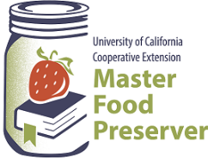

“Preserve today, Relish tomorrow”

$2.00

**Preserving**

**Pumpkins & Winter Squash**

*Canning, Dehydrating, Freezing and more!*

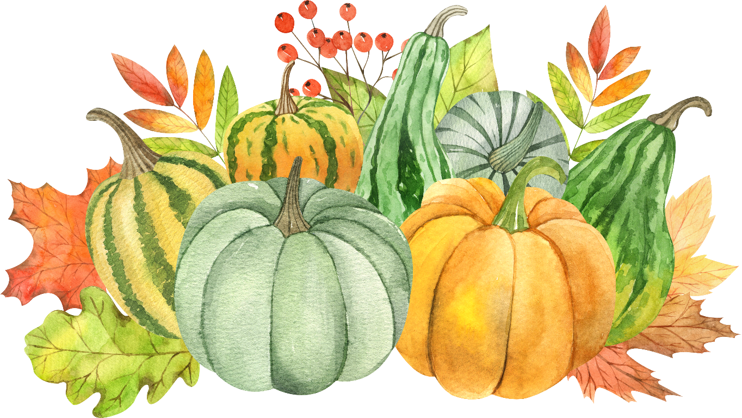

**UCCE Master Food Preservers of El Dorado County**

**311 Fair Lane, Placerville CA 95667**

**Helpline (530) 621-5506 • Email:** [**edmfp@ucanr.edu**](mailto:edmfp@ucanr.edu) **• Visit us on Facebook and Instagram!**

It is the policy of the University of California (UC) and the UC Division of Agriculture & Natural Resources not to engage in discrimination against or harassment of any person in any of its programs or activities (Complete nondiscrimination policy statement can be found at <http://ucanr.edu/sites/anrstaff/files/215244.pdf>.

**Food Safety / Canning Basics**

When it comes to food preservation (and cooking, too), avoiding food-borne illness is of the utmost importance. Cleaning and sanitizing, the proper handling of produce and meat, and avoiding cross-contamination are all part of the process. Key things to remember include:

**Clean Work Area ⬩ Wash Hands ⬩ No Cross-Contamination ⬩ Prepare Food Properly**

To ensure safety when canning any type of food, always follow a current, research-based recipe and use the correct canning method and processing steps for the food being processed.

For **further details on basic food safety and the essentials of home canning**, including the types of canners and which types of foods they are appropriate for; preparing jars and lids; step-by-step processing instructions; and helpful tips for canning success, please see our publication, ***Core Canning Techniques***. It’s free to download from our website here: <https://ucanr.edu/sites/mfp_of_cs/files/380380.pdf>.

**Pumpkins and Winter Squash**

Pumpkins are members of the cucurbit family, which includes pumpkins and winter squash (as well as summer squash, melons, cucumbers and gourds). The difference between pumpkins and winter squash? Well, there it can get confusing. All pumpkins are squash, but not all squash are pumpkins. They are grouped together into species based on their similarities.

Pumpkins include two species: *Cucurbita* pepo (which includes the familiar jack-o’-lanterns and some pie pumpkins) and *C.* maxima (those ginormous pumpkins grown for decoration and competition). Winter squash include four species: *C.* maxima, *C.* mixta, *C.* moshata and *C.* pepo.

While all pumpkins are edible, not all make good eating, nor are they good for preserving. Jack-o’-lanterns have bland, stringy, watery flesh making them best for decorating. However, as long as they have not been carved, they can certainly be eaten. And when carving, save those seeds and “guts”! The seeds can be dried and/or roasted, and the innards can be frozen for later turning into a tasty pumpkin stock. Pumpkins best suited for cooking and preserving include the small sugar and pie varieties.

Winter squashes that are well suited to preserving include acorn, banana, buttercup, butternut, golden delicious, Hubbard, and sweet meat.

While most pumpkins and squashes may be canned, there are some limitations. Pumpkins and squashes are low-acid fruit (yes, pumpkins are fruit!) **so they must either be properly acidified or pressured canned *in cubed form***. Because of the very dense flesh of pumpkins and winter squash, *neither pumpkin butter or mashed or puréed pumpkin or squash is safe for canning*. Note that while spaghetti squash is a winter squash, its flesh does not stay in cubed form when canned, so *spaghetti squash may not successfully be canned*.

**IMPORTANT!** **Do not can pumpkin butter, mashed or puréed pumpkin or squash, or spaghetti squash**. These products may instead be frozen.

**Washing Pumpkins and Winter Squash**

Other safety precautions when preparing pumpkins and squashes for cooking and preserving include carefully washing them before cutting and peeling. Even though the outer skins are usually not eaten, they can harbor harmful bacteria. Wash all pumpkins and squashes under cool running water, use a vegetable brush to scrub them, and then give them a final rinse.

**Cutting Hard Pumpkins and Squashes**

Cutting through the hard rinds of some pumpkins and squashes can be a challenge. Use a sharp knife with a long blade, and work on a flat surface. Bear down while cutting, and cut next to the stem, rather than through it. If the fruit is still too hard to cut, microwave it until it’s soft enough to cut (if it can fit in the microwave, that is!). If all else fails, one source suggests placing the squash in a plastic bag and dropping it on the floor to break open.

**Waste Not Want Not!**

Save your pumpkin and squash “guts”! You can roast and/or dry the seeds, and the innards (and even the skin) can be used to make a flavorful broth or stock.

Leftover canned pumpkin can be frozen in small portions (a cookie scoop works great). Freeze on a tray, then wrap individually – very handy for when a recipe calls for a small amount of pumpkin. Freezing in ice cube trays also works well. Try popping one or two pumpkin balls or cubes into a soup or stew for extra flavor!

**Pumpkin Math**

One 15-ounce can of pumpkin purée equals about 1¾ - 1⅞ cups.

One cup of canned pumpkin purée equals 8 oz (227 gr).

A 2½ lb. pumpkin will yield about 1¾ cups of strained pumpkin purée.

A 3½ lb. pumpkin will yield about 2½ cups of strained pumpkin purée.

A 5 - 6 lb. pumpkin will yield about 2¾ cups of strained pumpkin purée.

10 lbs. of pumpkin or squash will yield about 9 pint jars of canned cubed pumpkin/squash.

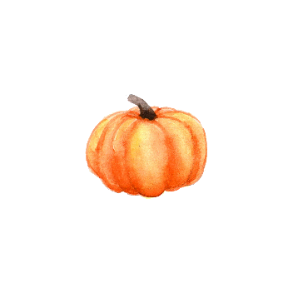16 lbs. of pumpkin or squash will yield about 7 quart jars of canned cubed pumpkin/squash.

Other Resources:

UC Master Food Preservers of Central Sierra <https://ucanr.edu/sites/mfp_of_cs/>

National Center for Home Food Processing <https://nchfp.uga.edu/>

USDA Complete Guide to Home Canning <https://nchfp.uga.edu/publications/publications_usda.html#gsc.tab=0>

The information in this handout is provided as a courtesy to the reader. No endorsements of commercial products or services are made or implied, nor is criticism implied of similar products or information not listed.

**RECIPES**

**DIY Pumpkin Purée**

Cook the pumpkin or squash using your preferred method (baked, whole roasted, boiled, etc.) until tender. When cool enough to handle, spoon the flesh into a fine-mesh sieve. Allow to drain for about an hour, then lightly press to remove any excess liquid. *Optional:* Run the drained puree through a food strainer for a smoother purée.

Note that some varieties of pumpkins or squashes may be more watery or stringy than others, and some are sweeter than others, so choose your pumpkins and squashes according to your cooking/baking needs (see Page 2 for further information).

**Dried Pumpkin / Winter Squash**

Peel the pumpkin or squash, cut in half lengthwise, scrape out seeds and loose flesh, and remove the rinds. Cut the squash into slices no more than ¼” thick. Steam blanch the slices for 2 to 3 minutes, or until almost tender. Dry on mesh trays at 140°F for 2-3 hours, then reduce the temperature to 130F° and continue drying until brittle.

**DEHYDRATING**

Store in an airtight container in a cool, dry place. Pumpkin stored at room temperature longer than 1-2 months can develop an undesirable flavor.

*Source: Adapted from Washington State University Extension*

**Pumpkin Pie Leather**

2 cups puréed pumpkin

**DEHYDRATING**

2 cups unsweetened applesauce

2 cups canned coconut milk

4 Medjool dates

¼ cup honey

1 tsp ground cinnamon

½ tsp ground nutmeg

½ tsp ground allspice

1. Blend all ingredients in a high-speed blender until smooth.
2. Spread the mixture on a silicone sheet-lined dehydrator tray, smoothing it evenly to about ¼” thick.
3. Dry at 125°F for 6-8 hours or until leathery (it should be evenly dry, with no visible moist spots, and still be flexible).
4. Let the fruit leather cool, then cut into strips.

*Source: excaliberdehydrator.com*

**Frozen Pumpkin or Winter Squash**

***To freeze mashed or puréed pumpkin or winter squash:*** Wash, remove pulp and seeds, and cut the squash into pieces. Cook (boil, steam, bake, or roast whole) until soft, then remove rind when cool enough to handle. Drain, and then mash or purée and transfer it to a bowl or container. Cool the squash quickly by placing the bowl in a larger bowl of ice water, stirring occasionally. When cool, package in rigid freezer containers leaving ½” headspace. Mashed squash may also be frozen in plastic freezer bags. Remove as much air as possible, lay the sealed bags on a tray and freeze until solid. The bags may be stacked in the freezer once frozen.

**FREEZING**

***To freeze cubed pumpkin or winter squash:*** Water blanch cubes for 3 minutes (just until heated through), drain, and place the cubes in a colander. Place colander in cold water to chill. Drain, pat dry with paper towels, and spread the cubes on a baking sheet in a single layer. Freeze the squash for at least 4 hours, then transfer to a plastic freezer bag. Remove as much air as possible, then return the sealed bag to the freezer.

***To freeze spaghetti squash:*** Cut the spaghetti squash and remove seeds. Place in a baking dish, cut side down. Add ½” of water to the dish and bake at 350°F until tender. Using a fork, rake pulp away from the peel, separating pulp into strands. Cool the strands, then pack into rigid freezer containers leaving ½” headspace and freeze.

**Savory Pumpkin Vinaigrette**

*Yield: about ⅓ cup*

**REFRIGERATION**

¼ cup extra virgin olive oil

2 tbsp apple cider vinegar

2 tbsp pumpkin purée (canned or homemade)

½ tsp Dijon mustard (or mustard of your choice)

scant ¼ tsp dried thyme

¼ tsp fine sea salt

pepper to taste

Whisk all ingredients together until well blended. Strain through a fine-mesh sieve if desired. Store unused vinaigrette tightly capped in the refrigerator for up to 5 days.

*Recipe from the kitchen of MFP Laura Crowley*

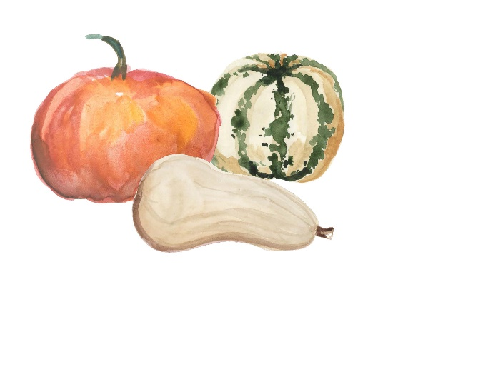

**Pumpkin Spice Syrup**

*Use this versatile syrup for more than just Pumpkin Spice Lattes! Mix it in cocktails, brush it on carrot cake before frosting the cake, use it in place of water when making a powdered sugar glaze, and more!*

*Yield: about 1¼ cups*

**REFRIGERATION**

1 cup water

1 cup brown sugar (preferably dark brown)

⅓cup pumpkin purée

1 tbsp pumpkin pie spice

½ tsp vanilla extract

1. Add water, brown sugar, pumpkin purée, and spice to a medium pan and whisk to blend.
2. Bring to a boil, reduce heat, and simmer for 4 minutes, or until the sugar is completely dissolved. Add the vanilla and simmer 1 more minute.
3. Strain the syrup through a fine-mesh sieve and discard the solids. Poor the syrup into a container and allow to cool *(for a thicker syrup, return to a clean pan and reduce on low heat until it reaches the desired thickness)*. Cap tightly and refrigerate for up to 2 months.

*Source: artoffoodandwine.com*

**Pumpkin Jam**

*A savory jam to serve on toast, in a jam tart, or with a cheese platter. Makes about “one large jar or two smaller ones.”*

**REFRIGERATION**

2 lbs pumpkin, seeds removed and cut into 5” pieces

1⅓ cups sugar

2 tbsp orange juice

1 tbsp lemon juice

pinch of salt

½ vanilla bean, split lengthwise

1. Steam the pumpkin until completely cooked through (about 30 minutes). When cool enough to handle, scrape the flesh from the rind and purée in a food processor, immersion blender, food mill, or a ricer. You should have about 2 cups of purée.
2. Add the purée to a heavy saucepan along with the sugar, orange and lemon juices, and salt. Scrape the vanilla bean seeds into the pan and add the bean. Cook over medium heat, stirring frequently, until the sugar dissolves. Continue cooking, stirring constantly to prevent burning (use caution, as this mixture tends to splatter). The jam is done when it visibly thickens and holds its shape in a jelly-like mound (about 10 minutes).
3. Transfer to a jar, cap tightly and refrigerate for up to a month. This jam is best served at room temperature.

*Source: Adapted from davidlebovitz.com*

**Pumpkin Chutney**

*Yield: about 4 pint jars*

**REFRIGERATION**

2.2 lbs pumpkin or squash, seeds and rind removed and diced

15 oz apples (about 3 medium)

1.1 lbs onions, diced (about 3 medium)

1 tsp chili flakes

2 tsp crushed coriander seeds

2 tsp mustard seeds

2 tsp turmeric

1 small cinnamon stick

1 oz fresh ginger, grated

1 tsp sea salt

2 cups apple cider vinegar

2½ cups superfine (caster) sugar

1½ cups dried cranberries

**STOVETOP METHOD:**

1. Add the diced pumpkin, apples and onion along with the spices, ginger, salt, and vinegar to a large saucepan. Stir well and slowly bring to a boil. Cover with a lid, reduce the heat and simmer for 30 minutes.
2. Remove the pan from the heat and add the sugar and cranberries. Return the pan to the heat and simmer on low for 1½ to 2 hours, stirring occasionally to prevent the mixture from sticking to the bottom of the pan.
3. The chutney is ready when the liquid has reduced and the pumpkin and cranberries look plump and glossy.
4. Transfer the chutney to jars, cap tightly and store in the refrigerator for up to a month.

**SLOW COOKER METHOD:**

1. Add the diced pumpkin, apples and onion along with the spices, ginger, salt, and vinegar to a large saucepan. Stir well and slowly bring to a boil.
2. Carefully transfer the mixture to the slow cooker and cover with its lid. Cook on High for 1 hour.
3. Stir in the sugar and cranberries. Replace the lid, but prop it open a little with a spoon or spatula, then continue to cook on High for 5 hours.
4. Check to see if the chutney is done (the liquid will have reduced and the pumpkin and cranberries will look plump and glossy). If not, continue to cook with the lid propped open for another hour or so.
5. Transfer the chutney to jars, cap tightly and store in the refrigerator for up to a month.

*Source: Adapted from talesfromthelitchenshed.com*

**Pumpkin Salsa**

**REFRIGERATION**

2-3 tsp olive oil

2 small sugar pumpkins

2 tomatoes, seeded and cut into small dice

½ red onion, cut into small dice

1 jalapeno, seeded and finely chopped

¼ cup fresh cilantro, chopped

1 clove garlic, finely diced

zest and juice of 1-2 limes

¼ tsp ground cumin

1. Carefully cut open pumpkins with a serrated knife. Remove pulp and seeds. Lay pumpkins flesh-side up on a lined baking sheet and drizzle with 1-2 tsp olive oil. Season with salt and pepper. Roast at 400°F, uncovered, for 15-20 minutes, until very slightly undercooked. Cool quickly to prevent overcooking.
2. In a small bowl, combine remaining ingredients (tomatoes through cumin) with 1-2 tsp olive oil. Add cooled, diced pumpkin and toss to coat. Adjust seasoning with salt and pepper and additional cumin and lime juice, if needed.
3. Store salsa in the refrigerator for up to 3 days.

*Source: 30seconds.com*

**Pumpkin & Peanut Butter Dog Treats**

*Use your homemade pumpkin puree (or leftover canned puree) to make these tasty treats for your favorite furry friend. Be sure to use peanut butter without xylitol, as it is toxic to dogs.*

½ cup pumpkin purée

**USE YOUR PRESERVES!**

1 cup peanut butter (xylitol free)

2 eggs

¼ cup vegetable oil

2½ cups flour

1 tsp baking soda

1. Preheat oven to 350°F. Mix together the wet ingredients (pumpkin through oil). Blend the flour and baking soda together, then mix into the wet ingredients slowly until a dough has formed.
2. Roll out the dough, cut into shapes, place on a greased baking sheet and bake for 14 minutes.

*Recipe from MFP Eileen Hidahl’s friend Evie*



**Autumn Glory Compote**

*Yield: about 6 pint jars*

**BW/STEAM CANNING**

2 cinnamon sticks (each about 4”), broken into pieces

5 cups cubed, seeded, peeled pie pumpkin (¾” cubes)

5 cups cubed, cored, peeled fresh pineapple

12 whole allspice

10 whole cloves(¾” cubes)

grated zest and juice of 2 lemons

1 cup coarsely chopped dried apricots

1 cup golden raisins

2½ cups granulated sugar

½ cup water

1. Tie the cinnamon stick pieces in a piece of cheesecloth to form a spice bag. Set aside.
2. In a large non-reactive saucepan, combine the pumpkin and pineapple. Add the lemon zest and juice, apricots, raisins, sugar, water and spice bag.
3. Bring to a boil over medium-high heat, stirring occasionally. Reduce heat and boil gently, stirring constantly, until heated through (about 5 minutes). Discard spice bag.
4. With a slotted spoon, pack hot mixture into a hot jar, leaving a generous ½-inch headspace. Cover mixture with hot syrup, leaving ½-inch headspace. Remove air bubbles and adjust headspace if needed, by adding more hot syrup. Wipe jar rims with a dampened clean paper towel or cloth. Place lid and ring on jar, tightening ring only finger-tip tight (unless otherwise directed by the manufacturer). Place jar in canner. Repeat with remaining jar(s).
5. Process **pint jars** in a boiling water or atmospheric steam canner as follows:

25 minutes at 0-1,000 feet elevation

30 minutes at 1,001-3,000 feet elevation

35 minutes at 3,001-6,000 feet elevation

40 minutes at 6,001-8,000 feet elevation

45 minutes at 8,000-10,000 feet elevation

1. For boiling water canning, turn off heat, remove canner lid and wait 5 minutes. For atmospheric steam canning, turn off heat, leave canner lid on and wait 2-3 minutes. Remove jars to a rack or towel and let cool, undisturbed, for 12-24 hours and then check seals. Store unsealed jars in the refrigerator or reprocess. Clean and label sealed jars and store in a cool, dry dark location.

*Source: Adapted from Ball Complete Book of Home Preserving (2012)*

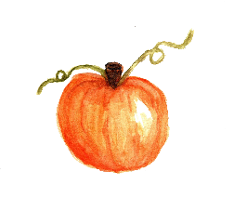

**Sweet Pumpkin Pickles**

*Yield: about 6 pint jars*

**BW/STEAM CANNING**

2 cinnamon sticks (each about 4”), halved

12 whole allspice

10 whole cloves

1 lemon

6 cups granulated sugar

4 cups white vinegar

24 cups cubed, seeded, peeled pie pumpkin or butternut squash (about ¾” cubes)

1. Tie the cinnamon stick halves, allspice, and cloves in a piece of cheesecloth to form a spice bag. Set aside.
2. Zest the lemon using a fine-tooth grater, and set zest aside. Remove and discard the white pith from the lemon. Separate the segments from the membrane and coarsely chop. Squeeze any juice from the membrane and add to the segments. Set flesh aside and discard the membrane.
3. In a large non-reactive saucepan, combine the zest, lemon flesh and juice, sugar, vinegar, and spice bag. Bring to a boil over medium-high heat, stirring occasionally. Cover, reduce heat, and boil gently for 10 minutes.
4. Add pumpkin and return to a boil. Cook for 3 minutes, until heated through. Discard spice bag.
5. Pack hot pumpkin into a hot jar, leaving a generous ½-inch headspace. Cover pumpkin with hot syrup, leaving ½-inch headspace. Remove air bubbles and adjust headspace if needed, by adding more hot syrup. Wipe jar rims with a dampened clean paper towel or cloth. Place lid and ring on jar, tightening ring only finger-tip tight (unless otherwise directed by the manufacturer). Place jar in canner. Repeat with remaining jar(s).
6. Process **pint jars** in a boiling water or atmospheric steam canner as follows:

20 minutes at 0-1,000 feet elevation

25 minutes at 1,001-3,000 feet elevation

30 minutes at 3,001-6,000 feet elevation

35 minutes at 6,001-8,000 feet elevation

40 minutes at 8,000-10,000 feet elevation

1. For boiling water canning, turn off heat, remove canner lid and wait 5 minutes. For atmospheric steam canning, turn off heat, leave canner lid on and wait 2-3 minutes. Remove jars to a rack or towel and let cool, undisturbed, for 12-24 hours and then check seals. Store unsealed jars in the refrigerator or reprocess. Clean and label sealed jars and store in a cool, dry dark location.

*Source: Adapted from Ball Complete Book of Home Preserving (2012)*