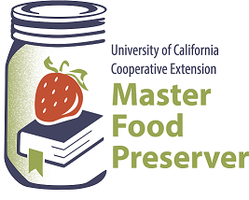

$2.00

**UCCE Master Food Preservers of El Dorado County**

**311 Fair Lane, Placerville CA 95667**

**Helpline (530) 621-5506 • Email:** [**edmfp@ucanr.edu**](mailto:edmfp@ucanr.edu) **• Visit us on Facebook!**

“Preserve today, Relish tomorrow”

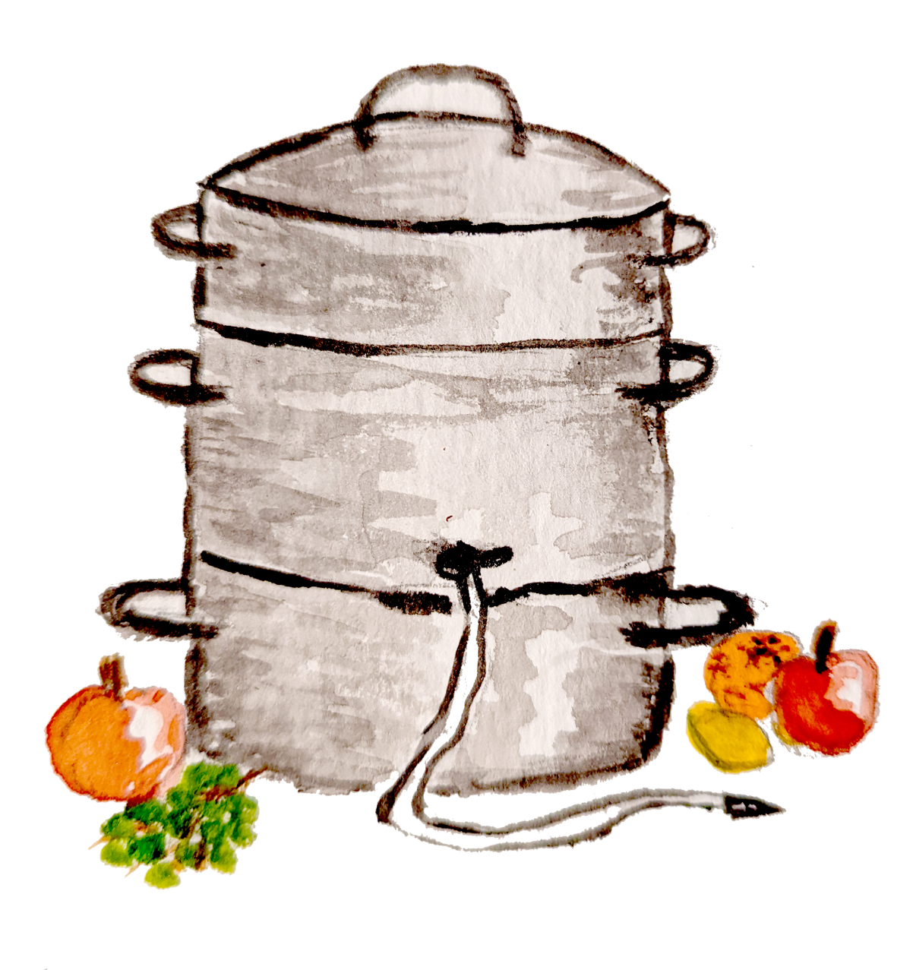**Steam Juicing Basics**

*Illustration by Barbara Simpson*

It is the policy of the University of California (UC) and the UC Division of Agriculture & Natural Resources not to engage in discrimination against or harassment of any person in any of its programs or activities (Complete nondiscrimination policy statement can be found at <http://ucanr.edu/sites/anrstaff/files/215244.pdf>).

**Steam Juicer Basics**

Steam juicers (not to be confused with atmospheric steam canners) are a device that easily extracts juice from fruits and vegetables through the use of hot steam. The steam juicer is essentially a three-level pot with a lid. Produce is put into the top level (“strainer” or “colander”), which has a perforated bottom. Juice flows down from the strainer into the middle level (called a “collection pan” or “juice kettle”) which has a special hose that can be used to syphon off the juice. The bottom level is a pot that is filled with water, which when boiled creates steam that rises to the top of the juicer, heating the produce so that it can release its juice. The bottom pan can also be used as a cooking pan or stock pot.

The benefits of a steam juicer, besides its ease of use, is that it creates beautifully clear juice with no sediment. Unlike crushed and cooked fruit, the juice does not need to be strained through a jelly bag or multiple layers of cheesecloth to obtain clear juice. There may be some exceptions, such as with cranberries, which have tiny seeds that may need to be filtered out.

The amount of time it takes to process a batch of juice depends on many factors: the type of produce being steam juiced; the amount in the strainer; your burner temperature; and your altitude. Steaming times generally run 60-90 minutes, but can be as little as 30 minutes or run for a couple of hours. If you are planning on juicing several batches in a row, for optimal performance be sure to juice one full colander at a time and remove waste before adding another batch. Do not press on the steamed fruit to extract more juice, as this can force sediment into the juice collecting pan and cloud your juice.

Juice obtained from a steam juicer can be consumed immediately, or refrigerated or frozen for longer-term storage. Some juices can also be heat processed in a boiling water or steam canner for shelf-stable storage.

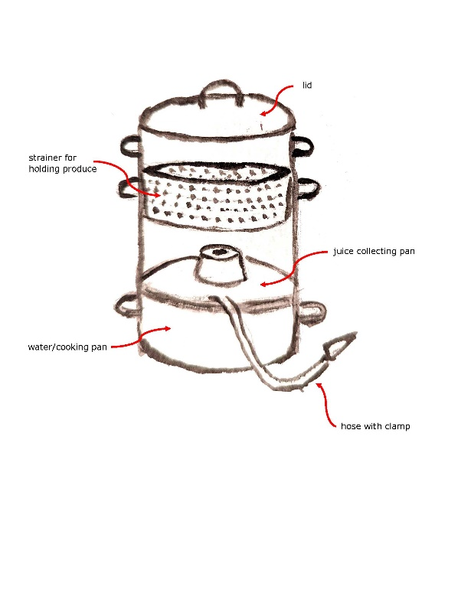

*Illustration by Barbara Simpson*

*Illustration by Barbara Simpson*

**Basic Food Safety & Sanitation**

When preparing food for preservation, cleanliness is essential in preventing food-borne illness.

Please review our handout, ***Core Canning Techniques***, for basic food safety information, including details on cleaning and sanitizing; avoiding cross-contamination, how to wash (or not wash!) fruits, vegetables and meats; and other food safety tips. Remember:

**Clean Work Area ⬩ Wash Hands ⬩ No Cross-Contamination ⬩ Prepare Food Properly**

**Selecting and Preparing Produce for Steam Juicing**

Choose good quality fruit and vegetables. Fruit should be ripe (but not overripe); vegetables and herbs should be very fresh. Discard any damaged or moldy produce and cut away blemishes. It is not generally necessary to peel or to remove stems or seeds, although your juicer manual may instruct you to remove hard seeds, pits, stones, or heavy cores or stalks. Large fruits, such as apples, will release juice quicker if they are first chopped into pieces.

**All** fresh produce should be washed right before using, even if the skin or rinds won’t be eaten. To wash produce, rinse under cool running water in a clean sink – do not soak. Gently rub soft fruits and vegetables (such as tomatoes) with your hands under running water to remove dirt. Scrub firm fruits and vegetables with a vegetable brush. Use a kitchen sink sprayer to rinse berries in a colander, gently turning and shaking the colander to remove dirt and excess water. Rinse herbs, then shake to remove excess water.

**Windfall Fruit**

Windfalls (aka ground falls, grounders, or drops) are fruits that have fallen from a tree onto the ground. This occurs for several reasons, including natural processes such as trees discarding excess baby fruit, disease, insect damage, and wind storms. Fruit that comes in contact with the ground is more likely to harbor dangerous bacteria, including *E. coli*, because of domestic and wild animal waste on the ground. Washing may not remove all of the pathogens on windfall fruit. Raw juice and cider have been associated with outbreaks of *E. coli*. In addition, injured fallen fruits are susceptible to molds which produce patulin, a mycotoxin that can produce serious illness in humans and animals. This toxin is heat-stable, even at pasteurization temperatures. Also, fruit contaminated with molds is more likely to spoil when canned. **Because of the food safety issues involved, it is recommended that windfall fruit not be eaten fresh, used for making juice or cider, baked, or canned**. For further information on windfalls, see

<https://www.canr.msu.edu/news/apple_cider_safety>

<https://blog-fruit-vegetable-ipm.extension.umn.edu/2020/08/food-safety-considerations-when-using.html>

**Pasteurizing Juice**

Most juice (particularly fresh apple juice or cider) should be pasteurized to a temperature of 160°F before consuming. The steam juicing process heats juice to this temp (or well above), so no further heat treatment is necessary; however, a calibrated thermometer can be used to check. Note that juice that sits in the hose will cool down quickly, so when checking the temperature be sure to test the juice while it’s still in the collection pan or immediately after it comes from the pan out through the hose. Keeping the hose clamp positioned right up where the hose attaches to the collection pan will keep the juice in the pan – and thus hot – until you are ready to release the hose clamp and syphon the juice off.

**Storing Fresh Juice**

Store juice in the refrigerator for up to one week; for longer storage, freeze it. Some high-acid fruit juices may be successfully canned (see Canning Steamed Juice below).

When freezing, choose freezer-safe containers, such as metal or rigid plastic or glass jars. Juice will expand when frozen so use the appropriate amount of head space: about ½” in rigid containers; ½” in pint or 1” in wide-mouth containers; and 1 ½” in narrow-top containers. *Note:* When using glass jars, the use of straight-sides jars is recommended to help prevent breakage.

**Canning Steamed Juice**

Not all juices are appropriate for home canning. If you plan on canning your steamed juice – whether as plain juice, jelly, or as part of some other type of preserve – it’s critical to follow a current, research-based recipe and to use the correct canning method. Use a boiling water or atmospheric steam canner and follow the instructions from a reputable resource that follows the recommendations of the National Center for Home Food Preservation.

Please review our handout, ***Core Canning Techniques***, which covers the essentials of home canning, including the types of canners and which types of foods they are appropriate for; preparing jars and lids; step-by-step processing instructions; and helpful tips for canning success. A pdf of *Core Canning Techniques* may be downloaded for free at our website here:

<https://ucanr.edu/sites/mfp_of_cs/files/380380.pdf>).

**SAFETY NOTE:** Some steam juicer manuals (as well as some misguided internet sites) indicate that the juice can be syphoned directly into sterilized jars, capped, and then stored at room temperature without any further processing, a process known as “bottling”. ***This is not safe!*** To create a shelf-stable juice, follow the canning recommendations from a reputable resource that follows the guidelines of the National Center for Home Food Preservation.

Other Canning and Preserving Resources:

UC Master Food Preservers of Central Sierra <https://ucanr.edu/sites/mfp_of_cs/>

National Center for Home Food Processing <https://nchfp.uga.edu/>

USDA Complete Guide to Home Canning <https://nchfp.uga.edu/publications/publications_usda.html#gsc.tab=0>

**Steam Juicing Processing Steps**

*The following are generic steps; be sure to follow the instructions for your specific juicer.*

1. Fill the bottom pan with water to the level recommended in your juicer’s manual.
2. Place the juice collecting pan on top of the water pan. Make sure that the hose clamp is securely fastened on the hose, and that the hose falls lower than the juice pan.
3. Add produce to the top strainer, filling to the level specified in your manual.
4. Apply the lid, making sure that it fits securely on top. Do not overfill the top strainer.
5. Bring the water to a boil. (Check your manual; many manufacturers instruct starting with the heat set to High; others say to bring the juicer to a boil slowly.) Once boiling, adjust the heat source so that the juicer maintains a boiling temperature.
   * **NOTE:** Do not let the water pan boil dry! This can damage the juicer. Check the water level regularly and add more water as necessary. Do not leave the steam juicer unattended while it is in use.
   * **CAUTION!** Steam is hot! Always use heat protective gloves or mitts when working with your juicer.
6. Heat from the steam will begin to cook the produce. As the produce breaks down, it will release its juice which will drip down into the collecting pan. Do not press down on nor stir the produce while it is heating, as this will result in cloudy juice. For best results, leave the produce untouched during the juicing process.
7. Direct the hose into a saucepot or other receptacle placed near the juicer. The receptacle should be a bit lower than the collecting pan so that the juice can drain properly, and the hose should hang into the receptacle by about 3-4”.
8. Check that the juice is ready to begin draining in one of two ways:
   * Carefully squeeze open the hose clamp. If there is enough juice in the collecting pan, it will automatically begin draining out the hose.
   * Lift the hose straight up by holding onto the clamp. *Do not touch the hose itself as it will be very hot.* If you do not see any juice in the hose, there is not enough juice in the collecting pan.
9. To release the juice from the juicer into the saucepot/receptacle, squeeze the spring clamp on the hose. ***Careful, the hose and the juice are hot!***  Note that draining juice into a separate receptable prevents overflowing of the collecting pan, so do drain as required.
10. Juicing is complete when the fruit in the strainer has completely collapsed and no more juice drips into the collecting pan.
11. Always clean your steam juicer after use and dry thoroughly before storing.

**Canned Apple or Grape Juice from Steamed Juice**

1. Prepare fruit. Extract juice according to your steam juicer’s instructions. If necessary, strain juice through a strainer or cheesecloth to remove any seeds.
2. Add juice to a clean, non-reactive saucepan along with sugar to taste, if desired. Heat juice just to a boil, stirring to dissolve sugar (if applicable).
3. *Optional:* To help prevent darkening of apple juice during storage, add ¼ to ½ tsp of ascorbic acid (vitamin C) powder to each quart jar.
4. Ladle the juice into a hot jar, leaving **¼**-inch headspace. Wipe jar rims with a dampened clean paper towel or cloth. Place lid and ring on jar, tightening ring only finger-tip tight (unless otherwise directed by the manufacturer). Place jar in canner. Repeat with remaining jar(s).
5. Process **half-pint or pint** jars in a boiling water or atmospheric steam canner as follows:

5 minutes* at 0-1,000 feet elevation *\*(jars must first be sterilized)*

10 minutes at 1,001-6,000 feet elevation

15 minutes above 6,000 feet elevation

Process **quart** jars in a boiling water canner or atmospheric steam canner as follows:

10 minutes at 0-1,000 feet elevation

15 minutes at 1,001-6,000 feet elevation

25 minutes above 6,000 feet elevation

Process **half-gallon** jars in a boiling water canner as follows *(NOTE: half-gallon jars may* ***NOT*** *be processed in atmospheric steam canners)*:

10 minutes at 0-1,000 feet elevation

15 minutes at 1,001-6,000 feet elevation

25 minutes above 6,000 feet elevation

1. For boiling water canning, turn off heat, remove canner lid and wait 5 minutes. For atmospheric steam canning, turn off heat, leave canner lid on and wait 2-3 minutes. Remove jars to a rack or towel and let cool, undisturbed, for 12-24 hours and then check seals. Store unsealed jars in the refrigerator or reprocess. Clean and label sealed jars and store in a cool, dry dark location.

*Source: Adapted from Utah State Extension, “How to Preserve Apples”*

**IMPORTANT!!**

Half-gallon canning jars may be used ONLY for apple or grape juices. For canning other juices, see the recipes that follow.





**Canned High-Acid Fruit Juices from Steamed Juice**

**Juice from the following fruits may be canned with this recipe:**

Apricots; berries (except elderberries), cherries; citrus; currents; kiwi;

yellow peaches and nectarines; pears; pineapple; pomegranates; plums; rhubarb; and quince.

Do **NOT** use these instructions for canning low-acid or borderline high-acid fruit juices, either individually or added to the above high-acid fruit juices. **The list of excluded fruit includes, but is not limited to:**

Asian pears; bananas; coconut; dates, elderberries; figs; ripe mangoes; melons; papaya; white peaches and nectarines; persimmons; prickly pear; and tomatoes (for canning tomato juice, see the next page).

1. Prepare fruit. Extract juice according to your steam juicer’s instructions. If necessary, strain juice through a strainer or cheesecloth to remove any seeds.
2. Add juice to a clean, non-reactive saucepan along with sugar to taste, if desired. Heat juice just to a boil, stirring to dissolve sugar (if applicable).
3. *Optional:* To help prevent light-colored fruits from darkening during storage, add ¼ to ½ tsp of ascorbic acid (vitamin C) powder to each quart jar.
4. Ladle hot juice into a hot jar, leaving **¼**-inch headspace. Wipe jar rims with a dampened clean paper towel or cloth. Place lid and ring on jar, tightening ring only finger-tip tight (unless otherwise directed by the manufacturer). Place jar in canner. Repeat with remaining jar(s).
5. Process **pint or quart jars** in a boiling water or atmospheric steam canner as follows:

15 minutes at 0-1,000 feet elevation

20 minutes at 1,001-3,000 feet elevation

25 minutes at 3,001-6,000 feet elevation

30 minutes at 6,001-8,000 feet elevation

1. For boiling water canning, turn off heat, remove canner lid and wait 5 minutes. For atmospheric steam canning, turn off heat, leave canner lid on and wait 2-3 minutes. Remove jars to a rack or towel and let cool, undisturbed, for 12-24 hours and then check seals. Store unsealed jars in the refrigerator or reprocess. Clean and label sealed jars and store in a cool, dry dark location.

*Source: Adapted from Ball Blue Book (2020)*

**Canned Tomato Juice from Steamed Juice**

1. Prepare tomatoes. Extract juice according to your steam juicer’s instructions. If necessary, strain juice through a strainer or cheesecloth to remove any seeds.
2. In a clean large non-reactive saucepan, heat juice just to a boil.
3. To each jar, add an acidifier as follows (note that while 5% acidity vinegar may be used, it may cause unacceptable flavor changes):

|  |  |  |  |
| --- | --- | --- | --- |
| **JAR SIZE** | **CITRIC ACID** | **BOTTLED LEMON JUICE** | **VINEGAR** |
| Pint | ¼ tsp | 1 tbsp | 2 tbsp |
| Quart | ½ tsp | 2 tbsp | 4 tbsp |

**IMPORTANT!!**

Tomatoes are a borderline high-acid fruit. To be safely canned, they **MUST** be acidified by adding bottled lemon juice, citric acid or vinegar to each jar.

1. *Optional:* Add 1 tsp salt to each quart jar.
2. Ladle hot juice into a hot jar, leaving **½**-inch headspace. Wipe jar rims with a dampened clean paper towel or cloth. Place lid and ring on jar, tightening ring only finger-tip tight (unless otherwise directed by the manufacturer). Place jar in canner. Repeat with remaining jar(s).
3. Process **pint** jars in a boiling water or atmospheric steam canner as follows:

35 minutes at 0-1,000 feet elevation

40 minutes at 1,001-3,000 feet elevation

45 minutes at 3,001-6,000 feet elevation

50 minutes* above 6,000 feet elevation

Process **quart** jars in a boiling water canner or atmospheric steam canner as follows

40 minutes at 0-1,000 feet elevation

45 minutes at 1,001-3,000 feet elevation

50 minutes* at 3,001-6,000 feet elevation

55 minutes* above 6,000 feet elevation

*\*Note that processing times in steam canners are limited to 45 minutes or less.*

1. For boiling water canning, turn off heat, remove canner lid and wait 5 minutes. For atmospheric steam canning, turn off heat, leave canner lid on and wait 2-3 minutes. Remove jars to a rack or towel and let cool, undisturbed, for 12-24 hours and then check seals. Store unsealed jars in the refrigerator or reprocess. Clean and label sealed jars and store in a cool, dry dark location.

*Source: Adapted from NCFHP*