**Preserve Today, Relish Tomorrow**

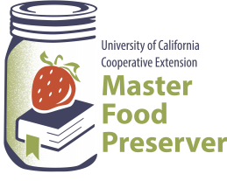

**UCCE Master Food Preservers of El Dorado County**

**311 Fair Lane, Placerville Ca 95667**

**Helpline (530) 621-5506 •** [**edmfp@ucanr.edu**](mailto:edmfp@ucanr.edu) **• Visit us on Facebook and Instagram!**

**Basic Cheese Making**

Cheese making is a long process, taking hours and sometimes days. Aged cheese may take weeks or months to age. The recipes included in this handout are recommended for beginners. These are soft cheeses and require little equipment to produce. They are eaten fresh, requiring no long aging times. These cheeses must be kept in the refrigerator and will keep for about one week.

**FOOD SAFETY CONCERNS**

There are four major pathogens associated with fresh cheese. These can cause foodborne illness. They are: *Salmonella*, *E. coli*, *Listeria monocytogenes*, and *Staphylococcus aureus*. These pathogenic bacteria are controlled by good sanitation of equipment and food contact surfaces, proper cooking, cooling and handling of cheese curds during processing, and proper hand washing.

**ESSENTIAL TOOLS/EQUIPMENT**

1. Large stock pot, generally 6 to 8 quarts. The pot should be stainless steel or unchipped enamel. Avoid pots made of aluminum or other reactive metals.
2. Thermometer, digital or a candy thermometer. Make sure the thermometer goes low enough for your recipe as some candy thermometers start at 200°F.
3. Measuring spoons and cups, stainless steel, glass or plastic.
4. Long–handled spoon and slotted spoon. You need a spoon for stirring as well as a spoon to remove the curds from the whey. They can be stainless steel, plastic or nylon. However, stainless steel is the easiest to clean.
5. Large bowl for heating milk indirectly or catching whey.
6. Cheese cloth, butter muslin or flour sack towel to drain the curds.
7. Colander or strainer made from any non-reactive material (plastic, metal, enamel). As with other utensils, avoid aluminum or other reactive material, even when lined with cheesecloth.

**All equipment must be cleaned and sterilized before and after cheese making. Most home cheese making failures are caused by unclean or unsterile equipment. When you are finished with a utensil, rinse it thoroughly with cold water. Then wash it in hot water with a good dishwashing detergent. Rinse thoroughly in hot water.**

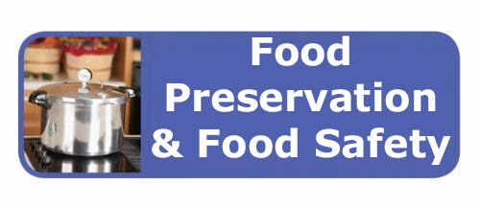

**SANITIZATION**

**You must sterilize your equipment before use.**

1. Boil all cheese-making equipment for 5 minutes or soak all cheese-making equipment in a bleach water solution for 2 minutes.
2. Reuse cheese cloth, butter muslin or flour sack towel **only** if they have been sanitized.



**Bleach Water Solution:**

* 1 gallon of water
* 1 tablespoons household unscented bleach

**CLEANING AND REUSING CHEESECLOTH OR BUTTER MUSLIN**

If the cloth is only used to drain curds, it will not be as difficult to clean as if it is used to press or age cheese for a long period of time.

**How to Reuse Cheesecloth or Butter Muslin**:

1. Rinse immediately after use.
2. Wash in the washing machine or by hand in the sink.
3. Avoid detergents and fabric softeners. Use only mild detergent if necessary, and rinse thoroughly to remove any soap residue.
4. If there are bits of curd sticking to the cloth, rinse with whey or white vinegar to help remove it.
5. For sterilization, boil the cheesecloth or butter muslin for about 5 minutes or soak it in the Bleach Water Solution. If soaking in bleach solution, rinse thoroughly before hanging it out to dry.
6. As soon as the cheesecloth or butter muslin is dry, fold and store in a zipper-style plastic bag until ready to use again.

**MILK**

Milk is a complicated substance. Seven-eighths of it is water. The rest is proteins, minerals, milk sugar (lactose), milk fat, vitamins and trace elements. As a result, variation in the quality of cheese does occur, depending on the type of milk used. When we make cheese, we cause the protein part of the milk to curdle. Cheese can be made from whole milk, 2%, 1%, skim milk or reconstituted milk powder. Whatever type of milk used, it should always be pasteurized. The fresher the milk, the better the cheese.

* Raw milk is that which is collected from a dairy animal and not processed further. **It may contain harmful bacteria**. **Raw milk should be pasteurized before it is used in the production of soft cheese.**
* Pasteurized milk is milk that has been heated to destroy all pathogens. All milk purchased in the store has been pasteurized.
* UT (Ultra-Pasteurized) or UHT (Ultra High Temperature) pasteurized milk is milk that has been heated to 191° to 212°F and 280°F respectively to kill bacteria and extend shelf life. Avoid using this milk as this process changes the protein structure of the milk, preventing it from separating into curds and whey.
* Homogenized milk is milk that has been subjected to a process that breaks up the fat globules so that they will no longer separate from the milk. Most milk purchased at the store has been homogenized. You can use homogenized milk to make cheese.
* Whole milk is pasteurized milk with 3.25% fat (by weight)
* Skim milk is milk that has had some or all of its fat removed.
* Milk Powder can be reconstituted and used in cheese making.

**WHAT IS PASTEURIZATION?**

Pasteurization destroys most disease producing organisms and limits fermentation in milk, beer and other liquids by partial or complete sterilization. The pasteurization process heats milk to 161°F for 15 seconds, inactivating or killing organisms that grow rapidly in milk. Pasteurization does not destroy organisms that grow slowly or produce spores. While pasteurization destroys many microorganisms in milk, improper handling after pasteurization can re-contaminate milk. Raw milk can also be pasteurized on the stovetop. *Microwaving raw milk is not an effective means of pasteurization because of uneven heat distribution.*

**How do I pasteurize milk?**

Milk must be heated, with agitation, in such a way that every particle of the milk, including the foam, receives a minimum heat treatment of 145°F continuously for 30 minutes or 161°F for 15 seconds. The temperature should be monitored with an accurate metal or protected glass thermometer. Commercial operations commonly use a high temperature, short-time process in which the milk is heated to 170°F for 15 seconds and then cooled immediately to below 40°F to increase storage life without any noticeable flavor change in the milk. Pasteurization of fluid milk has very specific requirements for time and temperature as listed in the chart.

**Temperature-Time Pasteurization**

Requirements for Fluid Milk

|  |  |
| --- | --- |
| ***Temperature*** | ***Time*** |
| 145°F (63°C) | 30 minutes (vat pasteurization) |
| 161°F (72°C) | 15 seconds (high temperature, short time pasteurization) |
| 191°F (89°C) | 1 second (Higher-Heat, Shorter Time) |
| 212°F (100°C) | 0.01 second |



**CHEESE SALT**

Cheese salt is merely a salt that is non-iodized. Iodized salt harms and inhibits bacterial growth and well-being that is essential to any good cheese-making. **You can use any non-iodized salt in cheese-making.** Salt is important in a number of cheese-making steps: it adds to the flavor of the cheese, it helps to dry the curds during draining and it will help to kill bacteria and other harmful growth when used as a brine.

**WHEY**

Whey is the yellowish liquid left over when you make various cultured milk products. There are actually two kinds of whey, and they have different uses.

**ACID WHEY**

Acid whey is the liquid produced from making more acidic cultured dairy products such as paneer, feta, chevrè, or **whole milk ricotta**.

**USES FOR ACID WHEY**

* Soak grain in acid whey for making breads.
* Feed acid whey to animals. They may like sweet whey better than acid whey. Whichever kind you feed them, be careful, because it can upset their digestion if they consume too much. Cats should not be feed whey.

**SWEET WHEY**

Sweet whey is the liquid that is produced when making hard cheese like cheddar or **most soft** **cheeses.**

**USES FOR SWEET WHEY**

You can use sweet whey the same way you use acid whey, in addition to the ways below:

* Add it to smoothies and shakes to provide more vitamins, minerals, and proteins.
* Use as cooking liquid for potatoes, rice, grits, pasta, and grains.
* Drink it straight!
* Make whey cheeses.
* Put it in your compost pile. It adds nutrients and makes thick, black compost.

**Whey may be frozen up to 3 months until used.**



**HOW TO MAKE MOZZARELLA CHEESE**

*Makes approximately ¾ pound*

**Ingredients**

* 1 gallon milk (not ultra-pasteurized)
* 1-1/4 cup cool water (chlorine-free)
* 1-1/2 teaspoon citric acid
* 1/4 rennet tablet or 1/8 teaspoon double-strength liquid rennet
* 1 teaspoon cheese salt (optional) (Salt substitutes and/or herbs can be used as an alternative.)

**Equipment**

* 1 gallon stainless steel pot or any non-aluminum or non-cast iron pot
* Instant-read thermometer or candy thermometer
* Measuring cups and spoons
* Colander or strainer
* Butter muslin, flour sack towel or cheese cloth
* 4-quart mixing bowl to collect whey
* Slotted spoon
* Extra spoon
* Long knife
* 2-quart microwaveable bowl (Pyrex)
* Rubber gloves
* Microwave
* Timer

**Mozzarella Cheese Instructions**

***Before you start, put on your gloves.***

1. Mix 1/8 teaspoon double-strength liquid rennet with ¼ cup of cool, chlorine-free water. Stir; set aside. * Diluted rennet must be used within 30 minutes.
2. Mix 1 ½ teaspoons citric acid into 1 cup cool, chlorine-free water. Ensure the citric acid is fully dissolved.
3. Pour the citric acid solution into your pot.
4. Pour 1 gallon of milk quickly into the pot and stir vigorously.
5. Heat milk slowly to 90°F while stirring. Use thermometer to check temperature.
6. Take pot off burner, add rennet solution while stirring slowly top to bottom (folding) for approximately 30 seconds.
7. Cover pot with lid and leave undisturbed for 5 minutes or longer.
8. Check the curd. It should look like custard, with a clear separation between the curd and the whey. If the curd is too soft or the whey is milky, let sit for a few more minutes.
9. Cut the curds in a 1-inch checkerboard pattern with a long knife.
10. Place pot back on stove and heat to 105°F while stirring slowly and gently. Use thermometer to check temperature.
11. Take the pot off the burner and continue stirring slowly for 2 – 5 minutes. (More time will make a firmer cheese.)
12. Place the colander over a 4-quart bowl or pot that will catch the whey. Scoop the curds from your pot with a slotted spoon and place them in the colander. Drain off as much of the whey as you can without pressing the curds too much.
13. Put the curds into a microwave safe bowl (Pyrex glass). If you still have small curds floating in the whey, place a piece of cheese cloth over the colander and pour the whey into the cheese cloth-lined colander. Add the small curds to the microwave safe bowl.
14. Microwave the curds on HIGH for 15 seconds. Drain the free whey into your bowl or pot. **Add salt.** Gently knead or fold the curds into one piece with a spoon or your hands.
15. Repeat #14 until the curds reach a temperature of 135°F. The cheese should be soft and pliable enough to stretch like taffy. Stop heating at this point.
16. Stretch the cheese by pulling like taffy until it is smooth and shiny. The more you work the cheese, the firmer it will be. Form into one or 3 balls to share.
17. Drop cheese balls into ice water to cool.
18. When cold the cheese will last several days refrigerated. Eat or refrigerate your cheese within 2 hours.
19. Clean up following the Sanitary Standard Operating Procedures.

* Grind 1/4 rennet tablet and dissolve in1/4 cup of cool, chlorine-free water or mix 1/4 teaspoon single-strength liquid rennet with ¼ cup chlorine free water

*Source: Clemson Cooperative Extension* [*http://www.clemson.edu/extension/hgic/hot_topics/2017/12%20home_cheese_making_mozzarella.html*](http://www.clemson.edu/extension/hgic/hot_topics/2017/12%20home_cheese_making_mozzarella.html)

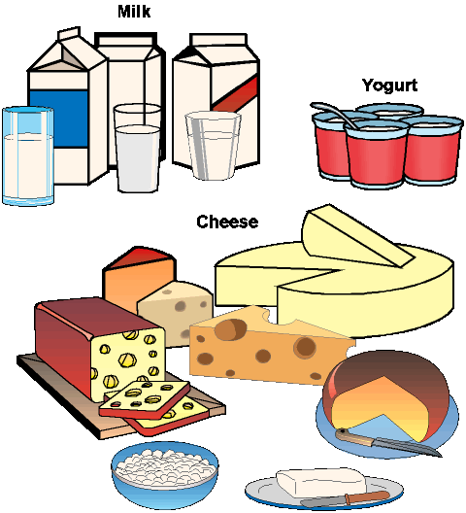

**HOW TO MAKE HOMEMADE RICOTTA**

*Makes 4 cups or approximately 1 ¾ pounds*

**What You Need**

**Ingredients**

* 1 gallon whole milk (*not ultra-pasteurized)*
* 2/3 cup lemon juice (fresh or bottled) or 2/3 cup distilled white vinegar or 1 teaspoon citric acid (available in canning supplies or from cheese-making suppliers)
* 2 teaspoon salt, optional

**NOTE:** This recipe may be cut in half.

**Equipment**

* 8-quart pot
* Instant-read thermometer or candy thermometer
* Measuring cup and spoons
* Cheese cloth, butter muslin or flour sack towel
* Strainer or colander
* 4-quart mixing bowl to catch whey
* Extra bowl
* Spoon for stirring
* Slotted spoon
* Timer

**Instructions**

* **Warm the milk to 200°F:**Pour the milk into a 8-quart pot and set it over medium heat. Let it warm gradually to 200°F, monitoring the temperature with an instant read thermometer. This could take as long as an hour. The milk will get foamy and start to steam; remove it from heat if it starts to boil.
* **Add the vinegar and salt:**Remove the milk from heat. Pour in the vinegar or lemon juice (or citric acid) and the salt. Stir gently to combine.
* **Let the milk sit for 10 minutes:**Let the pot of milk sit undisturbed for 10 minutes. After this time, the milk should have separated into clumps of milky white curds and thin, watery, yellow-colored whey — dip your slotted spoon into the mix to check. If you still see a lot of un-separated milk, add another 1 to 2 tablespoons of lemon juice or vinegar or 1/8 teaspoon of citric acid and wait a few more minutes.
* **Strain the curds:**Set a strainer over a bowl and line the strainer with cheese cloth. Scoop the big curds out of the pot with a slotted spoon and transfer them to the strainer. Pour the remaining curds and the whey through the strainer. (Removing the big curds first helps keep them from splashing and making a mess as you pour.)
* **Drain the curds for 10 to 60 minutes:**Let the ricotta drain for 10 to 60 minutes, depending on how wet or dry you prefer your ricotta. If the ricotta becomes too dry, you can also stir some of the whey back in before using or storing it.
* **Use or store the ricotta:**Fresh ricotta can be used right away or refrigerated in an airtight container for up to a week. For longer storage, it may be frozen for up to 6 months.
* **Making Fresh Ricotta Salata:**If you'd like to make a fresh farmer's cheese (Ricotta Salata) from this ricotta, wrap it in cheese cloth and press it beneath a weighted plate in the refrigerator overnight.

*Source: adapted from New Mexico State University,* [http://aces.nmsu.edu/pubs/_e/E216/](http://aces.nmsu.edu/pubs/_e/E216/%20)

**Whey Caramel**

* 2 quarts whey (strain whey in a colander lined with cheese cloth to remove any bits of curd).
* 2 cups sugar
* 4 ounces butter
* 1 Tbsp.vanilla extract
* 1 hefty pinch of salt - I used kosher salt

Simmer the whey in a heavy bottom pot on medium until it reduces by about half. Skim the foam off the top if needed. You could probably do this part at a higher temperature while keeping a close eye on it and stirring frequently so it doesn’t scorch. I like the hands off factor of this recipe, so once I got it to a slow simmer I walked away from it for an hour.

After about 1- to1 ½ hours your whey should be reduced by half and you can add the cane sugar. Stir it until the sugar is melted and it comes back to a simmer.

Leave it again to simmer and caramelize. Check on it periodically to stir and assess the progress. Once you add the sugar, the caramelization process will take just over an hour.

As it cooks down and caramelizes, it will start to bubble and foam, keep it going on low and keep an eye on the color. Once the color is a medium-dark amber (your preference) and the viscosity looks like syrup add the cold butter and stir as it melts, continue to stir until the butter is completely mixed in.

Add salt and vanilla extract.

NOTE: After the sugar is added, you can transfer the whey mixture to a crockpot so you don’t have to tend to it. It will take about 8 hours to cook down in the crockpot.

**Jeri’s Hot Whey Toddy (Whey may be frozen until used.)**

*Now you know we’ve gone over the edge! But, whey not? It’s cold outside here in western Massachusetts and if ever there was a time for a stiff drink – this is it! What is a hot toddy? According to Wikipedia: A hot toddy, also known as hot whisky in Scotland, is typically a mixed drink made of liquor and water with honey, herbs and spices, and served hot.*

* 1/2 cup maple syrup
* 1/2 cup water
* 2 or 3 lemon slices
* 3 or 4 cloves
* A dash of cinnamon
* 3 cups whey (You can use any kind of whey for this – sweet, acid, goat, sheep, etc.)
* 1/4 cup bourbon (optional)

Directions:

1. Make cheese and save the whey.
2. Heat up maple syrup and water with cloves, cinnamon, and lemon slices.
3. Strain your whey through butter muslin. (Even though the whey had already been strained, I strained it again to get the remaining milk solids out.)
4. Strain the lemons and cloves through the same muslin.
5. Heat again and when very hot, add bourbon (or not).
6. Drink and be merry.

*Source: Jeri Case, 2018*

**Italian 7 Layer Dip**

Crostini:

* 1 baguette, thinly sliced
* ¼ cup extra-virgin olive oil
* 1 tsp. salt
* 1 tsp. garlic powder
* Freshly ground black pepper

Dip:

* 2 cups ricotta
* Kosher salt and freshly ground black pepper (If cheese is already salted, omit)
* 2 Tblsp. olive oil
* 1 medium onion, chopped
* 2 cups grape tomatoes, halved
* ½ cup chicken stock
* 5 cloves garlic, chopped
* 12 ounces spicy Italian sausage, casings removed
* ½ cup sliced pepperoncini, drained
* One 12-ounce jar marinated artichoke hearts, drained and chopped
* One 12-ounce jar roasted red peppers, drained and chopped
* One 8-oz container fresh Ciliegini Mozzarella, drained and cut in half (You can substitute your homemade mozzarella.)
* 8 leaves basil, cut into chiffonade

NOTE: Ciliegini is an Italian fresh mozzarella cheese that is formed into small cherry tomato shaped portions and packed in water or brine.

Directions:

1. Preheat the oven to 350°F.
2. For the crostini: Lay baguette slices on a baking sheet. Brush with oil and sprinkle with salt, garlic powder and fresh pepper. Bake for 15 minutes, rotating pan halfway through. Remove the crostini from oven and set aside. Turn oven to broil.
3. For the dip: In medium bowl, combine ricotta with salt and pepper to taste. Mix, then transfer to an 8-by-8 pan, spreading mixture evenly across bottom. Set aside.
4. In a large pan with a lid, heat oil over medium heat. Add onions and sweat for 3 to 5 minutes. Add the halved grape tomatoes, chicken stock and garlic and bring to a boil; cover and reduce the heat to low. Cook until the tomatoes have softened and the mixture has thickened, about 15 minutes.
5. While the tomatoes are cooking, add the sausage to a saute pan over high heat. Break up sausage and cook it through. When the sausage is finished, spoon it directly over the ricotta, spreading evenly.
6. When tomato mixture is done, spoon over the sausage layer. Top the tomato layer with the sliced pepperoncini, marinated artichokes and roasted peppers. Place the mozzarella on top.
7. Place the dip under the broiler and broil on high heat until the cheese has browned slightly, 2 to 3 minutes.
8. Remove the dip from the broiler and top with basil. Serve immediately with crostini.

**ON-LINE SOURCES AND REFERENCES**

* Center for Dairy Research, Madison, WI , www.cdr.wisc.edu
* Clemson Cooperative Extension

http://www.clemson.edu/extension/hgic/hot_topics/2017/12%20home_cheese_making_mozzarella.html

* Making Homemade Cheese, New Mexico State University, [http://aces.nmsu.edu/pubs/_e/E-216.pdf](http://aces.nmsu.edu/pubs/_e/E-216.pdf%20)
* Oregon State University (2002). Fresh cheese made safely. Pacific Northwest Extension publication.

Available at: <http://extension.oregonstate.edu/lane/sites/default/files/documents/pnw0539.pdf>

* New England Cheese Making Co., <https://www.cheesemaking.com/learn/faq/milk.html>
* International Dairy Foods Association, <http://idfa/org/news-views/media-kits/milk/pasteurization>
* Michigan State University Extension, <http://msue.anr.msu.edu/news/they_did_what_to_your_milk>

It is the policy of the University of California (UC) and the UC Division of Agriculture & Natural Resources not to engage in discrimination against or harassment of any person in any of its programs or activities (Complete nondiscrimination policy statement can be found at <http://ucanr.edu/sites/anrstaff/files/215244.pdf> ) Inquiries regarding ANR’s nondiscrimination policies may be directed to John I. Sims, Affirmative Action Compliance Officer/Title IX Officer, University of California, Agriculture and Natural Resources, 2801 Second Street, Davis, CA 95618, (530) 750- 1397.

Should you need assistance or require special accommodations for any of our educational programs, please contact us at 530-621-5502.

MCj02933200000[1]MCj02933200000[1]MCj02933200000[1]

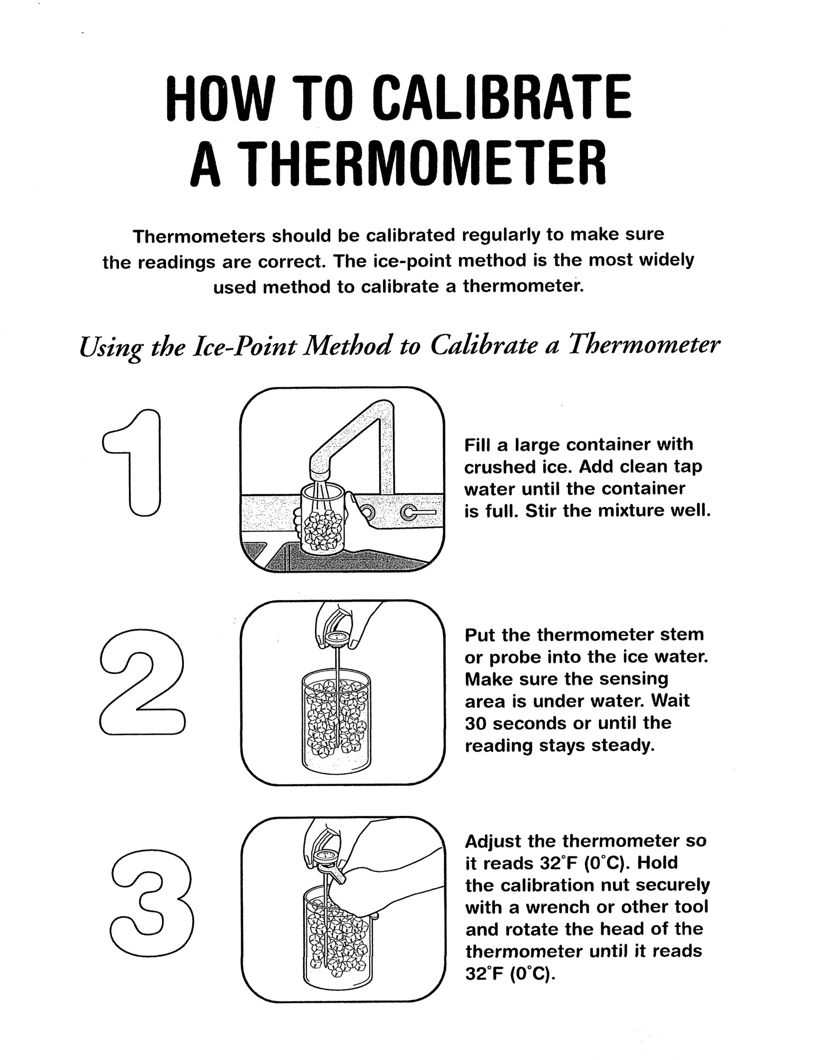

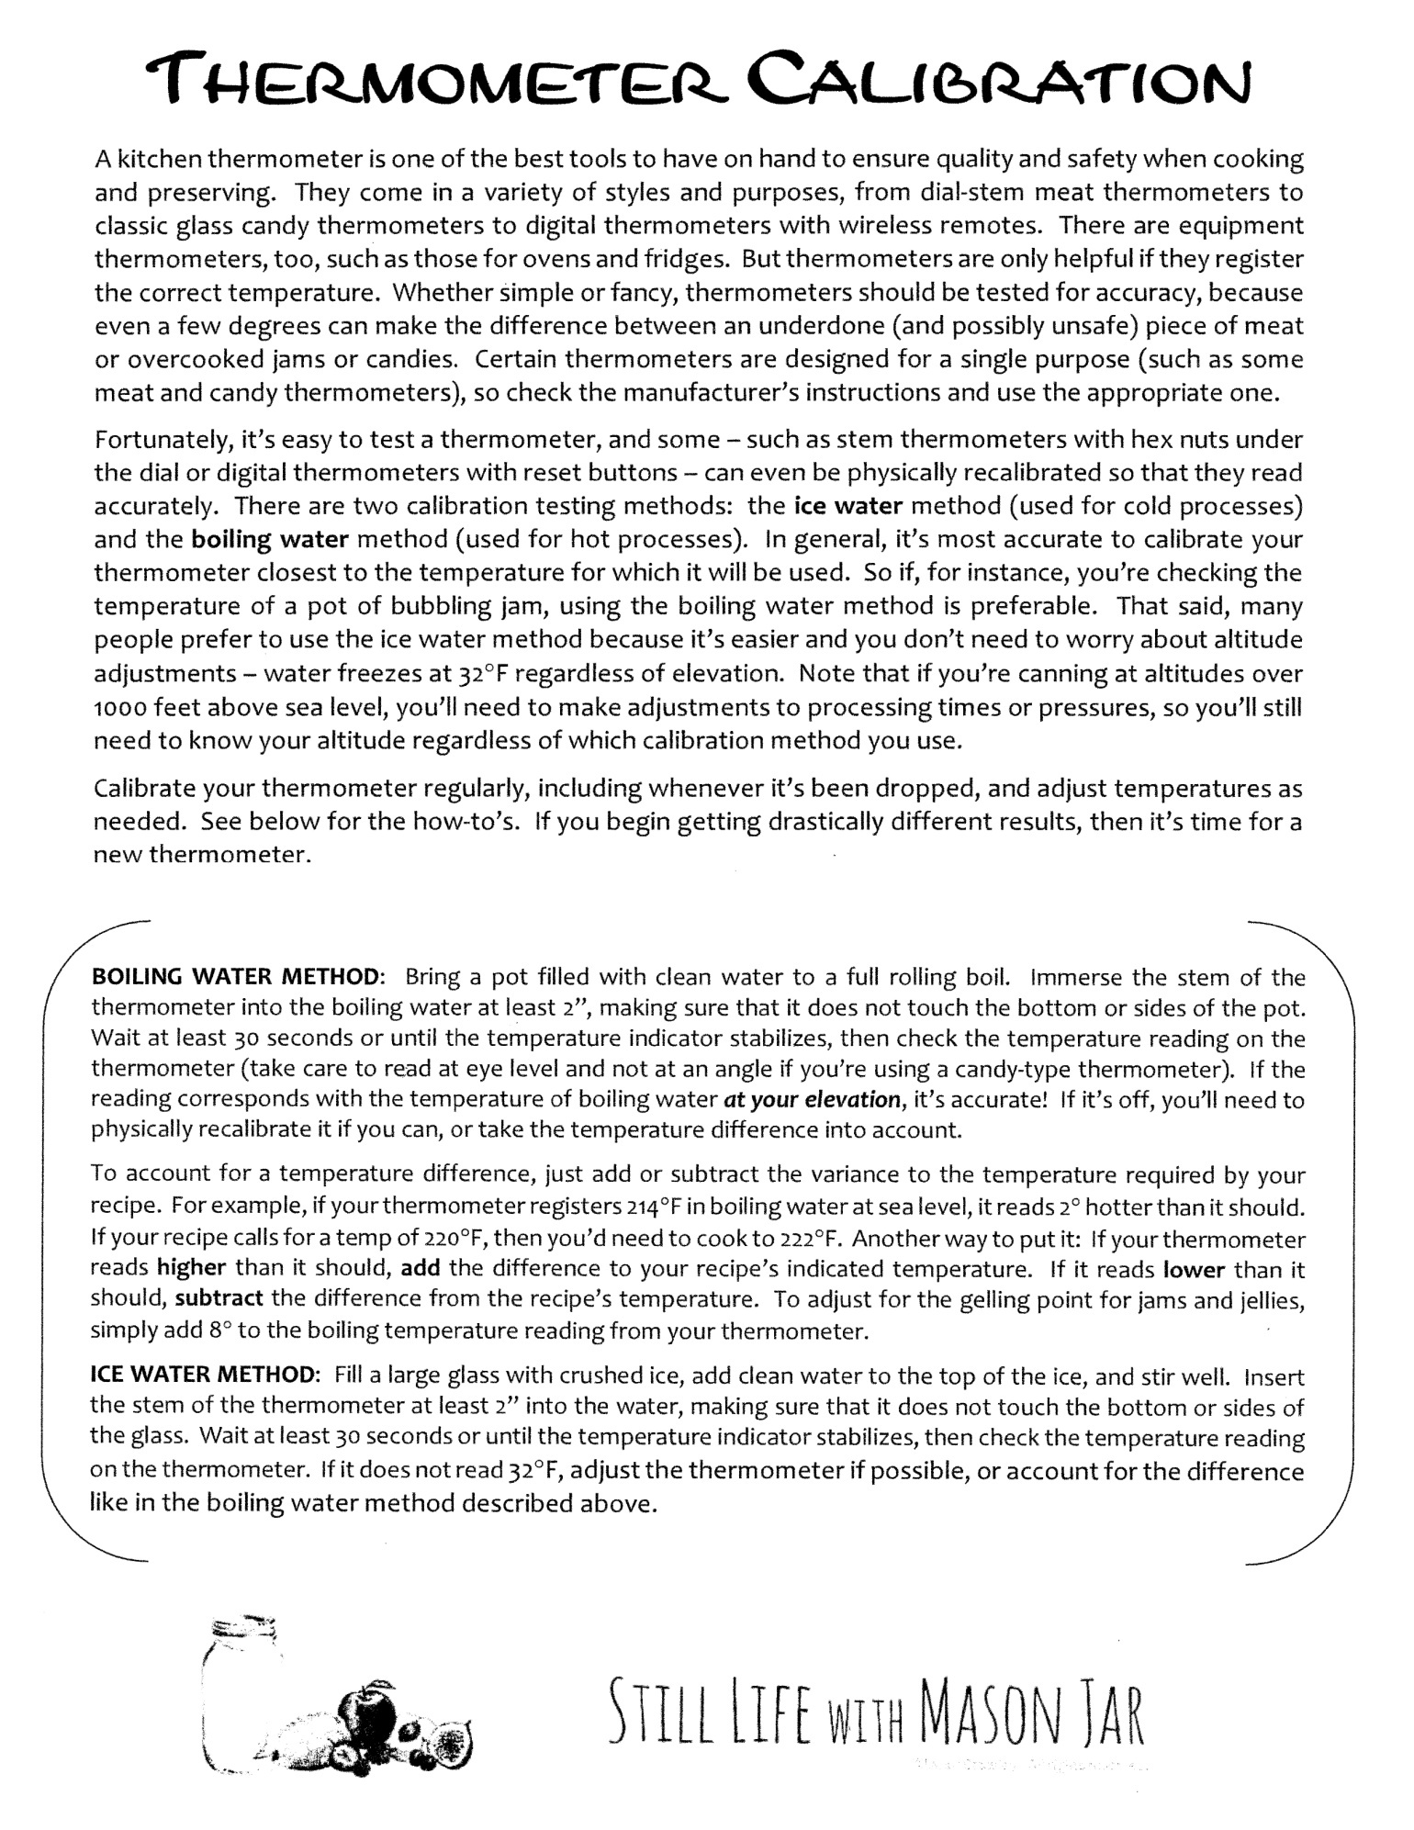

**ON-LINE SOURCES AND REFERENCES**

* Center for Dairy Research, Madison, WI , www.cdr.wisc.edu
* Clemson Cooperative Extension

http://www.clemson.edu/extension/hgic/hot_topics/2017/12%20home_cheese_making_mozzarella.html

* Making Homemade Cheese, New Mexico State University, [http://aces.nmsu.edu/pubs/_e/E-216.pdf](http://aces.nmsu.edu/pubs/_e/E-216.pdf%20)
* Oregon State University (2002). Fresh cheese made safely. Pacific Northwest Extension publication.

Available at: <http://extension.oregonstate.edu/lane/sites/default/files/documents/pnw0539.pdf>

* New England Cheese Making Co., <https://www.cheesemaking.com/learn/faq/milk.html>
* International Dairy Foods Association, <http://idfa/org/news-views/media-kits/milk/pasteurization>
* Michigan State University Extension, <http://msue.anr.msu.edu/news/they_did_what_to_your_milk>

It is the policy of the University of California (UC) and the UC Division of Agriculture & Natural Resources not to engage in discrimination against or harassment of any person in any of its programs or activities (Complete nondiscrimination policy statement can be found at <http://ucanr.edu/sites/anrstaff/files/215244.pdf> ) Inquiries regarding ANR’s nondiscrimination policies may be directed to John I. Sims, Affirmative Action Compliance Officer/Title IX Officer, University of California, Agriculture and Natural Resources, 2801 Second Street, Davis, CA 95618, (530) 750- 1397.

Should you need assistance or require special accommodations for any of our educational programs, please contact us at 530-621-5502. MCj02933200000[1]MCj02933200000[1]MCj02933200000[1]