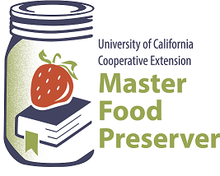

**UCCE Master Food Preservers of El Dorado County**

**311 Fair Lane, Placerville CA 95667**

**Helpline (530) 621-5506 • Email:** [**edmfp@ucanr.edu**](mailto:edmfp@ucanr.edu) **• Visit us on Facebook!**

“Preserve today, Relish tomorrow”

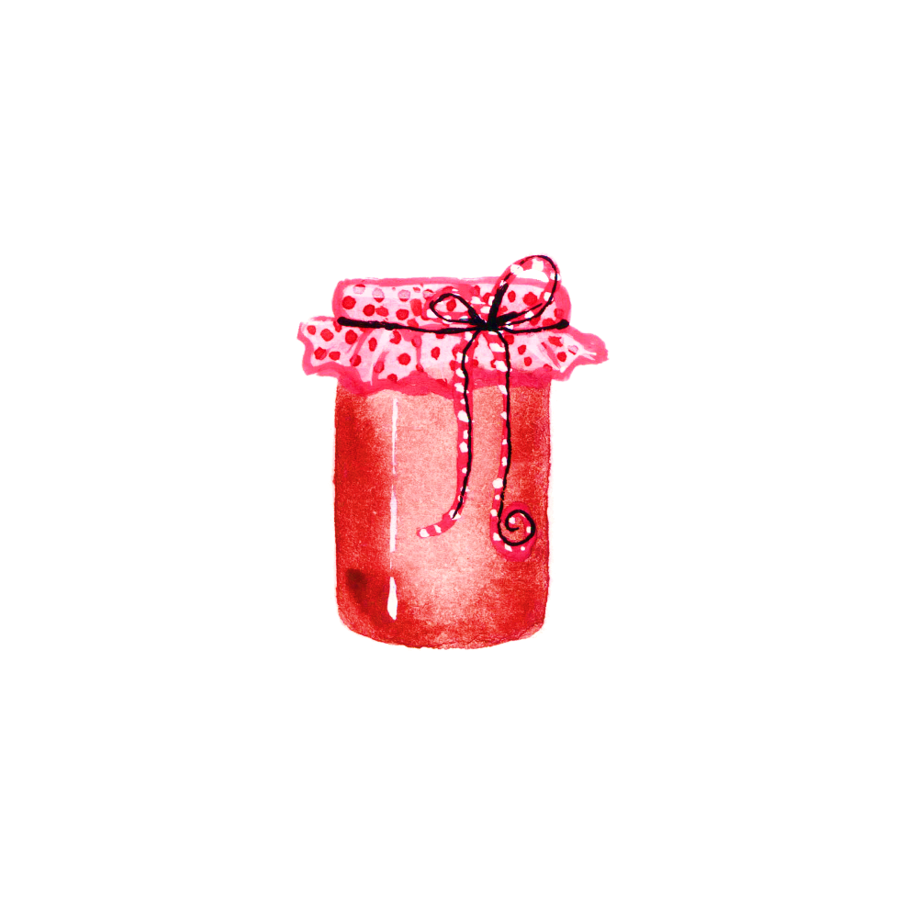**Pie Fillings and Canning Summer Fruit**

Thursday, July 27, 2023

6:00 p.m. – 7:30 p.m.

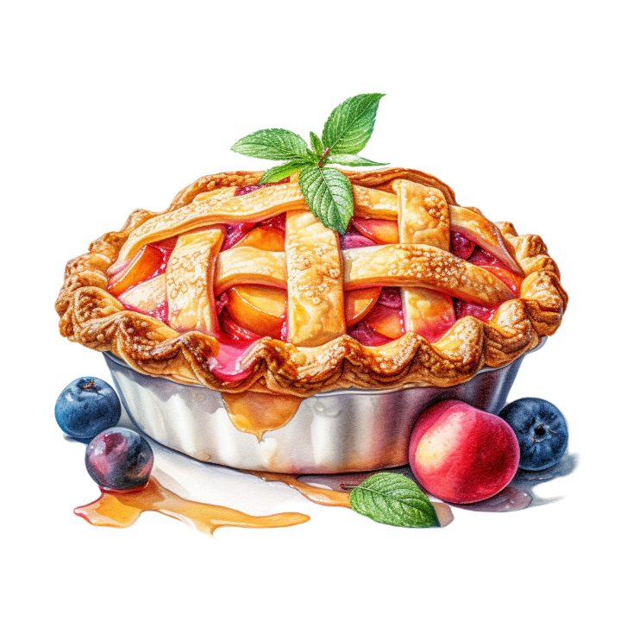

What better way is there to preserve our summer fruit than as a pie filling? In this class we will show and discuss how to can pie fillings as well as canning summer fruit that can be used later for pie fillings or other uses. We will demonstrate how to use a boiling water bath canner and an atmospheric steam canner. The use of CLEARJEL® as a thickener will be explained. We will share lots of ideas and safe, science-based recipes!

**Food Safety / Canning Basics**

The first step when preparing food for preservation is food safety. Cleanliness is essential in preventing food-borne illness. Proper cleaning and sanitizing, avoiding cross-contamination, and washing produce are all part of the canning process. Remember:

**Clean Work Area ⬩ Wash Hands ⬩ No Cross-Contamination ⬩ Prepare Food Properly**

To ensure safety when canning, it’s critical to follow a current, research-based recipe and to use the correct canning method and processing steps.

For further details, please review our publication, ***Core Canning Techniques*** (free to download from our website here: <https://ucanr.edu/sites/mfp_of_cs/files/380380.pdf>), which covers basic food safety information and the essentials of home canning, including the types of canners and which types of foods they are appropriate for; preparing jars and lids; step-by-step processing instructions; and helpful tips for canning success.

**Canned Pie Fillings**

Canning your own pie fillings is a great way to preserve seasonal fruit for making easy pies and other desserts throughout the year. Pie fillings can be used for more than desserts too: Spoon them over pancakes or waffles or oatmeal, or use them in yogurt parfaits.

Each quart of pie filling makes one 8”- to 9”-inch pie. To bake pies with canned pie fillings:

Single crust: Prepare and bake a single pie crust. Let the crust cool completely, then fill

with pie filling.

Double crust: Assemble the pie with prepared pie crusts. Bake at 425°F for 20-25

minutes or until crust is brown and the filling is hot.

**CHOOSING FRUIT.** Select fresh, ripe (but not overripe), and firm fruit of good quality. Fresh fruit is preferred for making pie fillings, but frozen blueberries or cherries work well.

If using frozen fruit, be sure to thaw it completely before making pie filling. Collect and measure the juice from the thawed fruit and use it to partially replace the water specified in the recipe. If the frozen fruit is not unsweetened, rinse off the sugar while the fruit is frozen. When using frozen fruit, reduce the amount of CLEARJEL® to ¼ cup per quart or 1 ¾ cups for 7 quarts.

The variety of the fruit may affect the flavor of the filling. For this reason, it’s often advised that a trial quart be made before making a larger batch.

**BLANCHING.** Fresh fruit for canned pie fillings should first be blanched. This process helps to removes excess air, which may help to reduce siphoning. When blanching, do so in small batches, and change the blanching water frequently. For pie fillings, the maximum amount of fruit to blanch per batch is 6 cups of fruit to 1 gallon of water. Blanch for the amount of time specified in the recipe, starting when the water returns to a full boil after adding the fruit.

*NOTE:* Frozen fruit does not require blanching.

**Safe Recipe Adjustments to Canned Pie Fillings**

There are a few adjustments to canned pie fillings that you can make to suit your preferences.

* **CHANGE THE AMOUNT OF SUGAR.** Sugar can be decreased if you prefer a low-sugar option, or increased to offset the tartness of the fruit.
* **ADJUST THE SPICES.** Change the types and amounts of dried spices according to your liking.
* **ELIMINATE THE CLEARJEL®.** Not everyone prefers, or has ready access to, CLEARJEL®. It can be eliminated when canning, and the thickener of your choice added when it’s time to open a jar and use the pie filling. THERMFLO® thickener may be used in place of CLEARJEL®.

**WHAT NOT TO CHANGE:** The amount of **bottled lemon juice should NOT be reduced** in any recipe that calls for it. It is added to ensure that the proper acidity level of the pie filling is reached and is thus safe for canning. Lemon juice may be *increased* if additional tartness is desired (e.g., when the fruit is exceptionally sweet).

Only CLEARJEL® or THERMFLO® may be used when canning pie filling. **Do NOT substitute other types of starches or thickeners**.

**Starches & Thickeners for Pie Fillings**

Starches and thickeners are ingredients that are generally not appropriate for use in home-canned foods, as they can impact heat penetration and render the product unsafe. There are some limited exceptions, however, one of which is the use of CLEARJEL® (or THERMFLO®) in canned pie fillings.

CLEARJEL® is a modified corn starch made from waxy maize. There are two types: regular (aka “traditional” or “cook-type”) and instant. For canned pie fillings, only regular CLEARJEL® should be used (the instant type thickens without heat and as soon as liquid is added, making it unsuitable for canning – but it does work well for frozen pie fillings).

CLEARJEL® is flavorless and makes a nice sauce consistency, even after canning and baking. Because it thickens only a small amount with heat, the density and heat penetration issues associated with other starches and thickeners are not a problem when canning. It stands up well to the three heat treatments of pie fillings (preparation, canning, and baking), and it is shelf stable (the canned pie fillings don’t weep, separate or curdle during storage).

There is a new type of modified corn starch called THERMFLO® which may be used in place of CLEARJEL®. **Do not substitute any other starch or thickener during canning**. If prefered, you may can pie fillings without CLEARJEL® OR THERMFLO® and add the thickener of your choice (such as corn starch, flour, tapioca starch/tapioca flour, arrowroot, etc.) when the jar is opened prior to baking.

Note that CLEARJEL® is not the same product as SURE JEL®, which is a pectin used for making jams and jellies. Pectins are not suitable for making canned pie fillings.

**Preventing Siphoning (Oozing)**

Siphoning (*aka* “oozing”) in canning refers to the phenomenon in which the contents of a jar ooze out from under the lid when it is removed from the canner at the end of the processing time. It is caused by a rapid change in temperature and air pressure and is a fairly common occurrence when canning pie fillings (and some other products as well). There are a few things that can be done to minimize siphoning in canned pie fillings.

* **BLANCH FRESH FRUIT.** Correctly blanching fresh fruit helps to reduce siphoning (see pg. 2 for details).
* **THAW FROZEN FRUIT COMPLETELY.** Incompletely thawed fruit may interfere with gel formation. Canning cold fruit could also result in underprocessing, a potential safety issue.
* **REMOVE AIR BUBBLES BEFORE APPLYING THE LID.** Take extra care to remove air bubbles. It may help to fill the jar a bit at a time (quickly, so the filling remains hot), and de-bubble after each fill.
* **USE LESS CLEARJEL®.** If using CLEARJEL®, use **¾** of the amount called for in the recipe. This results in a pie filling that is a little less thick, and thus less likely to ooze. ClearJel can also be eliminated altogether when the pie filling is being canned, and added when the jar is opened.
* **ELIMINATE CLEARJEL® ALTOGETHER.** Add the thickener of your choice after canning, when the jar is opened prior to serving.
* **DON’T DOUBLE BATCHES.** Large batches of pie filling made with CLEARJEL® may become difficult to stir because of the thickness. Make multiple single batches instead.
* **KEEP THE PIE FILLING HOT.** Can the pie filling without delay, and make sure it stays hot while you’re filling jars. Be sure that the water in the canner is hot (180°F), too.
* **MIND THE HEADSPACE.** The headspace for pie fillings is 1” – be sure your filled jars have no less than this amount. Experiments at the University of Wisconsin indicate that increasing the headspace to 1 ¼” can help prevent oozing.
* **USE QUART JARS.** Where allowed by the recipe, choose quart jars instead of pint jars.
* **USE A 10 MINUTE WAIT TIME FOR BWC.** If canning pie fillings in a boiling water canner, increase the wait time before removing jars at the end of processing from 5 minutes to 10 minutes (this is not necessary if using a steam canner).

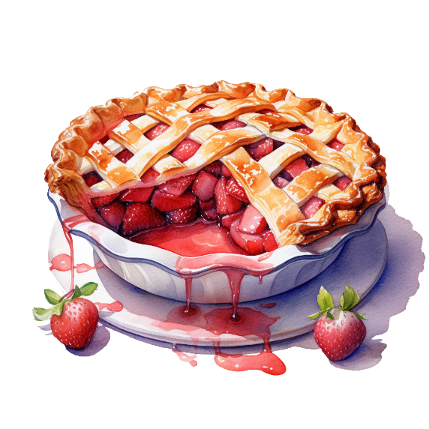**SAFETY NOTE:** If you do have a situation where your pie filling has oozed out of a jar, it’s likely that the lid is more stuck-on from the sticky pie filling than truly vacuum sealed. In such a case, store the jar(s) in the refrigerator and use within 2 weeks, or freeze it.

**Canned Fruit Now, Pie Fillings Later**

Canning fruit is a wonderful way to preserve summer’s bounty (and fall/winter’s bounty too!). It’s a good option, as it provides plenty of flexibility for using the fruit at a later time, for whatever purpose you need – pie fillings, simple fruit desserts, breakfast toppers, and more. Follow a canning recipe from a reputable source that follows the guidelines of the NCHFP.

Choose quality fruit that is ripe, firm, and of good quality. Fruit may be canned in water, fruit juice, or syrup. Syrup helps canned fruit retain its flavor, color and shape. It does not prevent spoilage. While heavy and very heavy syrups are typically used for tart and very sour fruit, it is possible to can these fruits in lighter syrups. Light corn syrup or mild-flavored honey may be used to replace up to half of the sugar amount called for in the following sugar syrup table.

|  |  |  |  |  |  |
| --- | --- | --- | --- | --- | --- |
|  | | For 9-Pint Load* | | For 7-Quart Load | |
| Syrup  Type | Approx.  % Sugar | Cups Water | Cups Sugar | Cups Water | Cups Sugar |
| Very Light | 10 | 6 ½ | ¾ | 10 ½ | 1 ¼ |
| Light | 20 | 5 ¾ | 1 ½ | 9 | 2 ¼ |
| Medium | 30 | 5 ¼ | 2 ¼ | 8 ¼ | 3 ¾ |
| Heavy | 40 | 5 | 3 ¼ | 7 ¾ | 5 ¼ |
| Very Heavy | 50 | 4 ¼ | 4 ¼ | 6 ½ | 6 ¾ |

*\*This amount is also adequate for a 4-quart load.*

Commercial, unsweetened apple, pineapple, or white grape juices are good options when canning fruit, and can be used full strength or diluted with water. Fruit may also be canned in its own juice or from fresh apples, pineapples or white grapes. To extract juice from fresh fruit, select ripe, unbruised fruit and crush it. Heat to simmering over low heat, then strain through fine cheesecloth or a jelly bag.

There’s no need to be stuck with cases and cases of plain canned fruit. Have some fun with herbs, spices, cordials, liqueurs, or other interesting alcoholic beverages that can be used to flavor some of your canned fruit.

Brandy, bourbon, and rum are good places to start. Add more interesting flavors with orange-flavored Cointreau, Crème de Menthe, cherry-flavored Kirsch, a raspberry Chambord, or the cinnamon flavor of Fireball whiskey. **Make sure there are no dairy products in any of your choices!**

Other flavoring options include dried herbs and spices. Cinnamon, ginger, nutmeg, allspice, and clove complement many fruits. Rosemary, thyme, summer savory, lemon verbena, and other herbs add a savory twist. Try some curry powder!

For another flavor, substitute 50% of the sugar in your canning syrup with honey.

**Pre-Treatment for Fruit to Prevent Browning**

Many light-colored fruits, as well as the stem-ends of cherries and grapes, can discolor and darken when exposed to oxygen. To retain good color and flavor when canning fruit, use high-quality fruit at the proper maturity, and place prepared (peeled, halved, sliced, etc.) fruit in an ascorbic acid (Vitamin C) solution. Ascorbic acid is available in three forms: pure powdered form; Vitamin C tablets (which must be first crushed or ground to a fine powder); and in commercial mixtures. To use ascorbic acid as a pre-treatment for canning fruit:

Pure ascorbic acid powder: 1 tsp per gallon of water

Vitamin C tablets: 6 crushed 500-milligram tablets dissolved in 1 gallon of water

Commercial products: follow the manufacturer’s instructions

Lemon juice may also be used as a pre-treatment, however it’s not as effective as ascorbic acid (1 tsp ascorbic acid crystals = 6 tsp lemon juice).

Other Resources:

UC Master Food Preservers of Central Sierra <https://ucanr.edu/sites/mfp_of_cs/>

National Center for Home Food Processing <https://nchfp.uga.edu/>

USDA Complete Guide to Home Canning <https://nchfp.uga.edu/publications/publications_usda.html#gsc.tab=0>

So Easy to Preserve, Sixth Edition. 2016. Bulletin 989. Cooperative Extension/University of Georgia, Athens

<https://www.fcs.uga.edu/extension/so-easy-to-preserve>

Ball Blue Book Guide to Preserving. 2016. Newell Corporation.

Ball Complete Book of Home Preserving, 2020. Bernardin, Newell Corporation.

Bernardin: <https://www.bernardin.ca/>

Ball: <https://www.ballmasonjar.com>

The information in this handout is provided as a courtesy to the reader. No endorsements of commercial products or services are made or implied, nor is criticism implied of similar products or information from organizations not listed.

It is the policy of the University of California (UC) and the UC Division of Agriculture & Natural Resources not to engage in discrimination against or harassment of any person in any of its programs or activities (Complete nondiscrimination policy statement can be found at <http://ucanr.edu/sites/anrstaff/files/215244.pdf>

**RECIPES**

**Mincemeat**

If you’re a fan of traditional, real-meat mincemeat, there’s a recipe for canned Festive Mincemeat Pie Filling here <https://nchfp.uga.edu/how/can_05/mincemeat_filling.html>. Note that because this product contains meat, which is a low-acid food, it must be processed in a pressure canner.

For an all-fruit mincemeat, which contains apples cranberries, raisins, figs, citrus, and more, try Ball’s Brandied Fruit Mincemeat recipe, available in the *Ball Complete Book of Home Canning*. This recipe can be water bath or steam canned.

**Apple Pie Filling**

*Yield: 1 quart jar ~or~ 7 quart jars (for 7 quart jars, use the measurements in parentheses)*

3 ½ cups *(6 quarts)* blanched, sliced fresh apples

¾ cup + 2 tbsp *(5 ½ cups)* sugar

¼ cup *(1 ½ cups)* CLEARJEL®

½ tsp *(1 tbsp)* ground cinnamon

½ cup *(2 ½ cups)* cold water

¾ cup *(5 cups)* apple juice

2 tbsp *(3/4 cup)* bottled lemon juice

⅛ tsp *(1 tsp)* nutmeg (optional)

1 drop *(7 drops)* yellow food coloring (optional)

1. Wash, peel and core apples. Slice ½” thick and place in water with ascorbic acid to prevent browning (see pg. 5).
2. Blanch fruit in batches for 1 minute after the water returns to a boil (see pg. 2 for further blanching information). Drain but keep the blanched fruit in a covered bowl or pot.
3. Combine sugar, CLEARJEL®, cinnamon, water, apple juice, and optional nutmeg and food coloring in a large pot. Stir and cook over medium-high heat until the mixture thickens and begins to bubble. Add the lemon juice and boil for 1 minute, stirring constantly. Fold in drained apple slices immediately.
4. Ladle hot mixture into a hot jar, leaving 1-inch headspace. Remove air bubbles and adjust headspace, if necessary, by adding more mixture. Wipe jar rims with a dampened clean paper towel or cloth. Place lid and ring on jar, tightening ring only finger-tip tight (unless otherwise directed by manufacturer). Place jar in canner. Repeat with remaining jar(s).
5. Process pint or quart jars in a boiling water or atmospheric steam canner as follows:

25 minutes at 0-1,000 feet elevation

30 minutes at 1,001-3,000 feet elevation

35 minutes at 3,001-6,000 feet elevation

40 minutes above 6,000 feet elevation

1. For boiling water canning, turn off heat, remove canner lid and wait 5 minutes. For atmospheric steam canning, turn off heat, leave canner lid on and wait 2-3 minutes. Remove jars to a rack or towel and let cool, undisturbed, for 12-24 hours and then check seals. Store unsealed jars in the refrigerator or reprocess. Clean and label sealed jars and store in a cool, dry dark location.

*Source: Adapted from USDA Complete Guide to Home Canning*

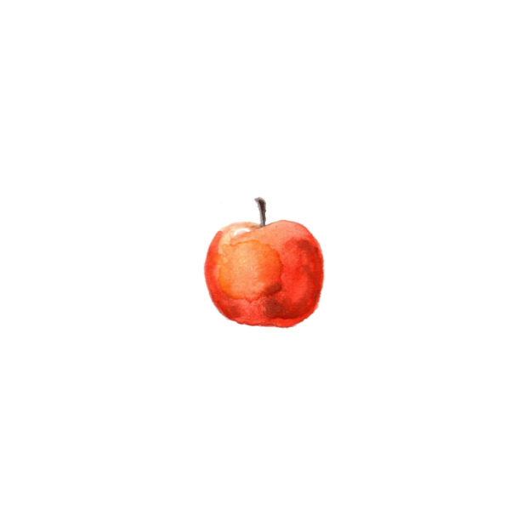

**Apple-Cranberry Pie Filling**

*Yield: 3 quart jars*

10 cups (2.4L) peeled, cored and ½” thick sliced apples (from about 5 lbs)

2 cups (500 ml) fresh or thawed frozen cranberries

1 cup (250 ml) water

2 ½ cups (625 ml) apple cider or juice

2 ½ cups (625 ml) sugar

⅔ cup CLEARJEL®

zest of 1 orange

⅛ tsp ground cloves

½ tsp ground nutmeg

½ tsp ground ginger

1 tsp cinnamon

pinch of salt

¼ cup (60 ml) bottled lemon juice

1. Place apple slices in water with ascorbic acid to prevent browning (see pg. 5). Drain, then combine the apple slices, cranberries, and water in a large pan. Bring to a low simmer over medium heat, stirring constantly. Cook 10 minutes, until apple slices become tender. Remove mixture to a bowl.
2. Combine the sugar, CLEARJEL®, orange zest, and spices in the pan, stir in the apple cider or juice, and any juices collected in the bowl of the apple-cranberry mixture. Bring to a boil over medium-high heat, stirring constantly. Cook until mixture thickens and begins to bubble.
3. Add lemon juice and a pinch of salt, and boil for 1 minute, stirring constantly. Remove from heat and immediately fold in the apple-cranberry mixture. Heat, stirring, until the apples are heated through.
4. Ladle hot mixture into a hot jar, leaving 1-inch headspace. Remove air bubbles and adjust headspace, if needed, by adding more mixture. Wipe jar rims with a dampened clean paper towel or cloth. Place lid and ring on jar, tightening ring only finger-tip tight (unless otherwise directed by manufacturer). Place jar in canner. Repeat with remaining jar(s).
5. Process pint or quart jars in a boiling water or atmospheric steam canner as follows:

25 minutes at 0-1,000 feet elevation

30 minutes at 1,001-3,000 feet elevation

35 minutes at 3,001-6,000 feet elevation

40 minutes at 6,001-8,000 feet elevation

1. For boiling water canning, turn off heat, remove canner lid and wait 5 minutes. For atmospheric steam canning, turn off heat, leave canner lid on and wait 2-3 minutes. Remove jars to a rack or towel and let cool, undisturbed, for 12-24 hours and then check seals. Store unsealed jars in the refrigerator or reprocess. Clean and label sealed jars and store in a cool, dry dark location.

*Source: Adapted from Ballmasonjars.com*

**Blueberry Pie Filling**

*Yield: 1 quart jar ~or~ 7 quart jars (for 7 quart jars, use the measurements in parentheses)*

3 ½ cups *(6 quarts)* blanched, fresh blueberries*

**THIS RECIPE CAN ALSO BE USED FOR THESE FRUITS:**

Blackberry, currant, gooseberry, huckleberry, loganberry, raspberry, and strawberry.

¾ cup + 2 tbsp *(6 cups)* sugar

¼ cup + 1 tbsp *(2 ¼ cups)* CLEARJEL®*

1 cup *(7 cups)* cold water

3 tbsp *(½* *cup)* bottled lemon juice

3 drops *(20 drops)* blue food coloring (optional)

1 drop *(7 drops)* red food coloring (optional)

*\*If using frozen berries, thaw them completely (if the*

*frozen fruit is sweetened, rinse off the sugar prior to*

*thawing). Collect, measure, and use the juice from the thawed fruit*

*to partially replace the water. Reduce the amount of CLEARJEL® to*

*¼ cup per quart or 1 ¾ cups for 7 quarts.*

1. Blanch fresh fruit in batches for 1 minute after the water returns to a boil (see pg.2 for further blanching information). Drain but keep the blanched fruit in a covered bowl or pot.
2. Combine sugar and CLEARJEL® in a large pot. Add water and optional food coloring. Cook over medium-high heat until the mixture thickens and begins to bubble. Add the lemon juice and boil for 1 minute, stirring constantly. Fold in drained blueberries.
3. Ladle hot mixture into a hot jar, leaving 1-inch headspace. Remove air bubbles and adjust headspace, if necessary, by adding more mixture. Wipe jar rims with a dampened clean paper towel or cloth. Place lid and ring on jar, tightening ring only finger-tip tight (unless otherwise directed by manufacturer). Place jar in canner. Repeat with remaining jar(s).
4. Process pint or quart jars in a boiling water or atmospheric steam canner as follows:

30 minutes at 0-1,000 feet elevation

35 minutes at 1,001-3,000 feet elevation

40 minutes at 3,001-6,000 feet elevation

45 minutes above 6,000 feet elevation

1. For boiling water canning, turn off heat, remove canner lid and wait 5 minutes. For atmospheric steam canning, turn off heat, leave canner lid on and wait 2-3 minutes. Remove jars to a rack or towel and let cool, undisturbed, for 12-24 hours and then check seals. Store unsealed jars in the refrigerator or reprocess. Clean and label sealed jars and store in a cool, dry dark location.

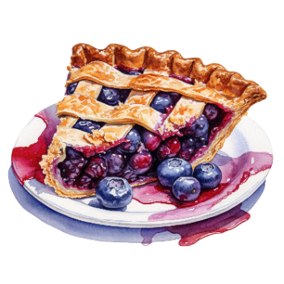*Source: Adapted from USDA Complete Guide to Home Canning*

**Cherry Pie Filling**

*Yield: 1 quart jar ~or~ 7 quart jars (for 7 quart jars, use the measurements in parentheses)*

**THIS RECIPE CAN ALSO BE USED FOR THESE FRUITS:**

Blackberry and Marionberry.

MAKE THE FOLLOWING RECIPE ADJUSTMENTS:

Do not blanch the berries, and omit the cinnamon, extract, and food coloring.

3 ⅓ cups *(6 quarts)* sour cherries*

1 cup *(7 cups)* sugar

¼ cup + 1 tbsp *(1 ¾ cups)* CLEARJEL®*

1 ⅓ cup *(9 ⅓ cups)* cold water

1 tbsp + 1 tsp *(½* *cup)* bottled lemon juice

1/8 tsp *(1 tsp)* cinnamon (optional)

¼ tsp *(2 tsp)* almond extract (optional)

6 drops *(¼ tsp)* red food coloring (optional)

*\*If using frozen cherries, thaw them completely (if the*

*frozen fruit is sweetened, rinse off the sugar prior to*

*thawing). Collect, measure, and use the juice from the*

*thawed fruit to partially replace the water. Reduce the amount*

*of CLEARJEL® to ¼ cup per quart or 1 ¾ cups for 7 quarts.*

1. Rinse and pit cherries and hold in cold water. To prevent stem-end browning, treat the water with ascorbic acid (see pg. 5).
2. Blanch fresh fruit in batches for 1 minute after the water returns to a boil (see pg. 2 for further blanching information). Drain but keep the blanched fruit in a covered bowl or pot.
3. Combine sugar and CLEARJEL® in a large pot. Add water and optional cinnamon, almond extract, and/or food coloring. Cook over medium-high heat until the mixture thickens and begins to bubble. Add the lemon juice and boil for 1 minute, stirring constantly. Fold in drained cherries.
4. Ladle hot mixture into a hot jar, leaving 1-inch headspace. Remove air bubbles and adjust headspace, if necessary, by adding more mixture. Wipe jar rims with a dampened clean paper towel or cloth. Place lid and ring on jar, tightening ring only finger-tip tight (unless otherwise directed by manufacturer). Place jar in canner. Repeat with remaining jar(s).
5. Process pint or quart jars in a boiling water or atmospheric steam canner as follows:

30 minutes at 0-1,000 feet elevation

35 minutes at 1,001-3,000 feet elevation

40 minutes at 3,001-6,000 feet elevation

45 minutes above 6,000 feet elevation

1. For boiling water canning, turn off heat, remove canner lid and wait 5 minutes. For atmospheric steam canning, turn off heat, leave canner lid on and wait 2-3 minutes. Remove jars to a rack or towel and let cool, undisturbed, for 12-24 hours and then check seals. Store unsealed jars in the refrigerator or reprocess. Clean and label sealed jars and store in a cool, dry dark location.

*Source: Adapted from USDA Complete Guide to Home Canning*

**Peach Pie Filling**

*Yield: 1 quart jar ~or~ 7 quart jars (for 7 quart jars, use the measurements in parentheses)*

3 ½ cups *(6 quarts)* peeled, sliced fresh peaches*

**THIS RECIPE CAN ALSO BE USED FOR THESE FRUITS:**

Apricots, nectarines*, pears, plums, prunes, and rhubarb.

1 cups *(7 cups)* sugar

¼ cup + 1 tbsp *(2 cups + 3 tbsp)* CLEARJEL®

¾ cup *(5 ¼ cups)* cold water

cinnamon (optional)

almond extract (optional)

¼ cup *(1 ¾ cups)* bottled lemon juice

*\*NOTE:* ***Do not can white peaches or nectarines****. Choose only yellow-fleshed varieties.*

1. Peel peaches. To loosen skins, submerge peaches in boiling water for about 30-60 seconds, then place them in cold water for 20 seconds. Slip skins off, slice ½” thick, and place in water with ascorbic acid to prevent browning (see pg. 5).
2. Blanch fresh fruit in batches for 1 minute after the water returns to a boil (see pg. 2 for further blanching information.) Drain but keep the blanched fruit in a covered bowl or pot.
3. Combine water, sugar, CLEARJEL®, and optional cinnamon and/or almond extract in a large pot. Stir and cook over medium-high heat until the mixture thickens and begins to bubble. Add the lemon juice and boil for 1 minute, stirring constantly. Fold in drained apple slices and continue to heat mixture for 3 minutes.
4. Ladle hot mixture into a hot jar, leaving 1-inch headspace. Remove air bubbles and adjust headspace, if necessary, by adding more mixture. Wipe jar rims with a dampened clean paper towel or cloth. Place lid and ring on jar, tightening ring only finger-tip tight (unless otherwise directed by manufacturer). Place jar in canner. Repeat with remaining jar(s).
5. Process pint or quart jars in a boiling water or atmospheric steam canner as follows:

30 minutes at 0-1,000 feet elevation

35 minutes at 1,001-3,000 feet elevation

40 minutes at 3,001-6,000 feet elevation

45 minutes above 6,000 feet elevation

1. For boiling water canning, turn off heat, remove canner lid and wait 5 minutes. For atmospheric steam canning, turn off heat, leave canner lid on and wait 2-3 minutes. Remove jars to a rack or towel and let cool, undisturbed, for 12-24 hours and then check seals. Store unsealed jars in the refrigerator or reprocess. Clean and label sealed jars and store in a cool, dry dark location.

*Source: Adapted from USDA Complete Guide to Home Canning*

**Pear Mincemeat**

*Yield: about 9 pint jars*

7 lbs Bartlett pears (about 21 medium)

1 lemon

2 lbs golden or dark raisins

6 ¾ cups sugar

1 tbsp ground cloves

1 tbsp ground cinnamon

1 tbsp nutmeg

1 tbsp allspice

1 tsp ground dried ginger

1 cup vinegar (5% acidity)

1. Wash pears and lemon; drain. Cut pears in half lengthwise and core. Coarsely chop pears. Cut lemon into quarters, remove seeds, and finely chop (including the peel), using a food processor or food grinder.
2. Combine all ingredients in a large saucepan. Bring mixture to a boil over medium heat, stirring to prevent sticking. Reduce heat and simmer 30 minutes.
3. Ladle hot mixture into a hot jar, leaving ½-inch headspace. Remove air bubbles and adjust headspace, if necessary, by adding more mixture. Wipe jar rims with a dampened clean paper towel or cloth. Place lid and ring on jar, tightening ring only finger-tip tight (unless otherwise directed by manufacturer). Place jar in canner. Repeat with remaining jar(s).
4. Process pint jars in a boiling water or atmospheric steam canner as follows:

25 minutes at 0-1,000 feet elevation

30 minutes at 1,001-3,000 feet elevation

35 minutes at 3,001-6,000 feet elevation

40 minutes at 6,000-8,000 feet elevation

1. For boiling water canning, turn off heat, remove canner lid and wait 5 minutes. For atmospheric steam canning, turn off heat, leave canner lid on and wait 2-3 minutes. Remove jars to a rack or towel and let cool, undisturbed, for 12-24 hours and then check seals. Store unsealed jars in the refrigerator or reprocess. Clean and label sealed jars and store in a cool, dry dark location.

*Source: Adapted from Ball Blue Book (2020)*

**TIP**

Pear mincemeat can be used for more than pie. See our website for a great recipe for Pear Mincemeat Bread. Stuff it into the cavity of acorn squash during the last 15 minutes of baking and then drizzle with honey, or simply serve alongside roast pork or beef.

**Rhubarb-Strawberry Pie Filling**

*Yield: about 5 pint jars*

3 large apples, peeled and finely chopped

1 tbsp grated orange zest

¼ cup freshly squeezed orange juice

7 cups sliced rhubarb (1” slices)

2 cups sugar

4 cups halved hulled strawberries*

*\*If using frozen strawberries, thaw them completely (if the frozen fruit is sweetened, rinse off the sugar prior to thawing). Collect, measure, and use the juice from the thawed fruit to partially replace the water.*

1. Combine the apple, orange zest, and orange juice in a large pan. Stir to coat apples thoroughly. Stir in rhubarb and sugar. Bring to a boil over medium-high heat, stirring constantly.
2. Reduce heat and boil gently, stirring frequently, until rhubarb is tender (about 12 minutes). Add strawberries and return to a boil.
3. Ladle hot mixture into a hot jar, leaving 1-inch headspace. Remove air bubbles and adjust headspace, if needed, by adding more mixture. Wipe jar rims with a dampened clean paper towel or cloth. Place lid and ring on jar, tightening ring only finger-tip tight (unless otherwise directed by manufacturer). Place jar in canner. Repeat with remaining jar(s).
4. Process pint jars in a boiling water or atmospheric steam canner as follows:

15 minutes at 0-1,000 feet elevation

20 minutes at 1,001-3,000 feet elevation

25 minutes at 3,001-6,000 feet elevation

30 minutes at 6,001-8,000 feet elevation

1. For boiling water canning, turn off heat, remove canner lid and wait 5 minutes. For atmospheric steam canning, turn off heat, leave canner lid on and wait 2-3 minutes. Remove jars to a rack or towel and let cool, undisturbed, for 12-24 hours and then check seals. Store unsealed jars in the refrigerator or reprocess. Clean and label sealed jars and store in a cool, dry dark location.

*Source: Adapted from Ball Complete Book of Home Canning (2012)*

**Green Tomato Pie Filling**

*Yield: about 7 quarts*

4 qts chopped green tomatoes

3 qts peeled and chopped tart apples

1 lb dark seedless raisins

1 lb golden raisins

¼ cups minced citron, lemon or orange peel

2 cups water

2 ½ cups brown sugar

2 ½ cups white sugar

½ cup vinegar (5% acidity )

1 cup bottled lemon juice

2 tbsp ground cinnamon

1 tsp ground nutmeg

1 tsp ground cloves

1. Combine all ingredients in a large saucepan. Cook slowly, stirring often, until tender and slightly thickened (about 35-40 minutes).
2. Ladle hot mixture into a hot jar, leaving ½-inch headspace. Remove air bubbles and adjust headspace, if necessary, by adding more mixture. Wipe jar rims with a dampened clean paper towel or cloth. Place lid and ring on jar, tightening ring only finger-tip tight (unless otherwise directed by manufacturer). Place jar in canner. Repeat with remaining jar(s).
3. Process pint or quart jars in a boiling water or atmospheric steam canner as follows:

15 minutes at 0-1,000 feet elevation

20 minutes at 1,001-6,000 feet elevation

25 minutes above 6,000 feet elevation

1. For boiling water canning, turn off heat, remove canner lid and wait 5 minutes. For atmospheric steam canning, turn off heat, leave canner lid on and wait 2-3 minutes. Remove jars to a rack or towel and let cool, undisturbed, for 12-24 hours and then check seals. Store unsealed jars in the refrigerator or reprocess. Clean and label sealed jars and store in a cool, dry dark location.

*Source: Adapted from USDA Complete Guide to Home Canning*

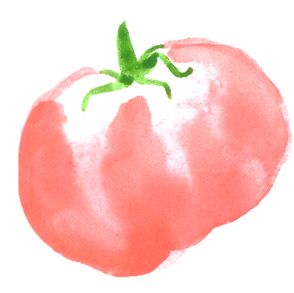

**Ginger Bourbon Peaches**

*Yield: about 5 pint jars*

4 quarts peaches (about 17 to 20 medium)

8 inches cinnamon stick  
2 tbsp finely chopped gingerroot  
1 tsp whole cloves

1 cup granulated sugar

2 cups water

½ cup bourbon

1. Blanch, peel, halve and pit peaches. Place in water with ascorbic acid to prevent browning (see pg. 5). Set aside.
2. Break cinnamon stick into pieces and tie with gingerroot and cloves in a square of cheesecloth, creating a spice bag. Place spice bag in a large stainless steel saucepan with sugar and water. Bring to a boil; boil 5 minutes to make syrup.
3. Drain peaches and add to syrup. Return to a boil; boil 3 to 5 minutes. Remove from heat, stir in bourbon, discard spice bag.
4. Pack hot peaches snugly, pit side down, in overlapping layers into a hot jar to within ¾-inch of top rim. Add hot syrup to cover peaches, leaving ½-inch headspace. Remove air bubbles and adjust headspace, if necessary, by adding more hot syrup. Wipe jar rims with a dampened clean paper towel or cloth. Place lid and ring on jar, tightening ring only finger-tip tight (unless otherwise directed by the manufacturer). Place jar in canner. Repeat with remaining jar(s).
5. Process pint jars in a boiling water or atmospheric steam canner as follows:

20 minutes at 0-1,000 feet elevation

25 minutes at 1,001-3,000 feet elevation

30 minutes at 3,001-6,000 feet elevation

35 minutes above 6,000 feet elevation

1. For boiling water canning, turn off heat, remove canner lid and wait 5 minutes. For atmospheric steam canning, turn off heat, leave canner lid on and wait 2-3 minutes. Remove jars to a rack or towel and let cool, undisturbed, for 12-24 hours and then check seals. Store unsealed jars in the refrigerator or reprocess. Clean and label sealed jars and store in a cool, dry dark location.

*Source: Adapted from Bernardin.ca*

**Spiced Plums**

*Spiced plums bring back childhood memories. My mother served them in winter, often warmed. A simple but delicious dessert. Of course, they can be jazzed up with pound cake and ice cream! They also make a great pie, cobbler or plum cake. Spiced plums are wonderful as a condiment with turkey or pork. Another idea is to make crostini and top it with goat cheese and chopped spiced plums.*

*Yield: 4 quart jars*

4 quarts plums

6 cups sugar

1 cup distilled white vinegar (5% acidity)

1 tsp ground cinnamon

1 tsp ground allspice

1 tsp ground cloves

1. Wash and drain plums. Prick each plum with a fork to prevent the skins from bursting. Place plums in a large non-reactive container.
2. Combine sugar, vinegar, and spices; boil for 5 minutes. Pour syrup over plums and let stand for 24 hours in refrigerator.
3. Drain syrup, heat and pour over plums again. Let stand for 24 hours in refrigerator. *TIP:* When cold, the syrup is thick and sticky. Heat syrup and plums together until plums can be removed separately. Continue heating the syrup as directed in the recipe.
4. The third day, pack the plums into a hot jar, leaving ½-inch headspace. Fill jar to ½-inch of top with boiling hot syrup. Remove air bubbles and adjust headspace, if necessary, by adding more hot syrup. Wipe jar rims with a dampened clean paper towel or cloth. Place lid and ring on jar, tightening ring only finger-tip tight (unless otherwise directed by the manufacturer). Place jar in canner. Repeat with remaining jar(s).
5. Process quart jars in a boiling water or atmospheric steam canner as follows:

10 minutes at 0-1,000 feet elevation

15 minutes at 1,001-6,000 feet elevation

20 minutes above 6,000 feet elevation

1. For boiling water canning, turn off heat, remove canner lid and wait 5 minutes. For atmospheric steam canning, turn off heat, leave canner lid on and wait 2-3 minutes. Remove jars to a rack or towel and let cool, undisturbed, for 12-24 hours and then check seals. Store unsealed jars in the refrigerator or reprocess. Clean and label sealed jars and store in a cool, dry dark location.

*Source: Adapted from So Easy to Preserve*