**Pucker Up - It’s Citrus Time!**

**Basic Food Safety & Sanitation**

When preparing food for preservation, cleanliness is essential in preventing food-borne illness, especially when handling raw fish, meat and other foods that won’t be cooked (including fruits and vegetables).

**Step 1: Clean Your Work Area**

Wash your sink and countertops with soap and warm water, rinse well, and dry with clean paper towels. Then apply a sanitizing solution such as bleach (1 scant teaspoon of liquid unscented bleach to 1 quart of water). Spray well and allow to air dry, or let sit for 30 seconds and wipe dry with clean paper towels. If using commercial sanitizers, follow the manufacturer’s instructions. Wash and sanitize both before and after preparing food.

**Step 2: Wash Your Hands**

Wet your hands, apply soap, lather and then scrub for at least 20 seconds. Rinse well and dry with paper towels or a clean cloth. If using gloves, first wash your hands and then wash the gloves following these same procedures. Wash your hands again when switching tasks.

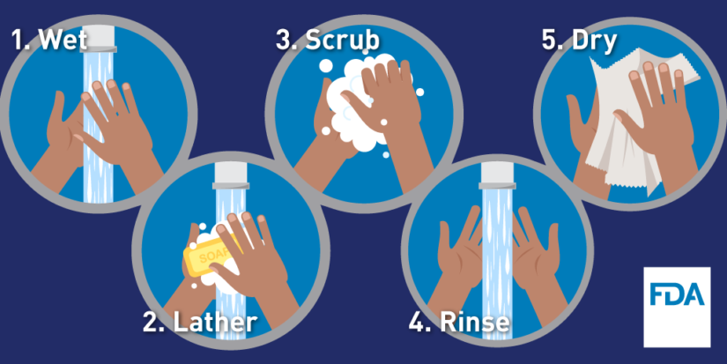

*Image Source: FDA*

**Step 3: Avoid Cross-Contamination**

Be sure to use clean cutting boards and kitchen utensils, and wash them thoroughly before switching from one food type to another, or use separate boards and utensils for different types of foods (e.g., use one board for raw fish or meat and another board for vegetables, herbs, etc.). Wipe up spills promptly, and re-clean your work area as often as necessary.

*Image Source: Partnership for Food Safety Information*

**Basic Food Safety & Sanitation – cont.**

**QUICK TIPS**

* use paper towels or a fresh clean dish towel to clean surfaces
* wipe up spills immediately with paper towels or a clean dish towel (and then put that towel straight into the laundry basket)
* change dish cloths and towels **every day**
* sanitize sponges between uses by using one of these 3 methods:
  + moisten the sponge and heat in a microwave for one minute
  + wash in a dishwasher with a drying cycle
  + soak in a bleach solution for one minute
* replace sponges frequently

**Step 4: Prepare Your Food**

Do not wash raw seafood, meat and poultry – doing so can spread pathogens and potentially cross-contaminate other foods. Wash **all** fresh produce, even if the skin or rinds won’t be eaten. To wash produce, rinse under cool running water in a clean sink – do not soak.

**QUICK TIPS**

* clean produce right before using
* gently rub soft fruits and vegetables (such as tomatoes) with your hands under running water to remove dirt
* scrub firm fruits and vegetables (such as potatoes, carrots, and melons) with a vegetable brush (don’t forget to clean the brush!)
* remove outer leaves of lettuce and cabbage before washing
* rinse herbs and sprouts, then shake to remove excess water
* use a kitchen sink sprayer to rinse berries in a colander, gently turning and shaking the colander to remove dirt and excess water

For more information on cleaning and sanitizing the kitchen using inexpensive and food-safe household products, check out this publication: <https://extension.colostate.edu/docs/pubs/foodnut/kitchen-sanitize.pdf>

**When In Doubt, Throw It Out**

Never taste food that looks or smells strange to see if it can still be eaten. Most bacteria that cause foodborne illness are odorless, colorless, and tasteless.

For general information on food safety, here are some good websites to visit:

<http://nchfp.uga.edu>

[www.foodsafety.gov](http://www.foodsafety.gov)

[www.fightbac.org](http://www.fightbac.org)

<https://www.cdc.gov/foodsafety/cdc-and-food-safety.html>

**Boiling Water Canner Essentials**

Boiling water canners are generally made from enamel-coated steel, stainless steel, or aluminum and come with removable perforated racks and fitted lids. There are also electric canners available, which are generally more expensive. The canner must be deep enough so that at least 1” of water (2” if the processing time is longer than 30 minutes) covers the tops of the jars. There also must be enough airspace to allow for 1” to 2” of vigorously boiling water. If you don’t have a dedicated canner, a large deep pot with a lid can be used. Canning racks can be purchased separately, or a perforated pizza pan, cake rack, silicone trivet, etc. can be substituted. Pressure canners can also function as boiling water canners, however, the lid should not be applied tightly.

Filled canners can be heavy and they generate a lot of heat. Before canning on a smooth top range, check with the manufacturer as to whether it is suitable for canning and for any canner size limits. On smooth top and electric burners, use only pots with flat bottoms (canners with flat, ridged, or concave bottoms can all be used on gas burners). In general, to ensure uniform processing when canning on an electric range, the canner should be no more that 4” wider in diameter (2” on each side) than the burner element used to heat the canner. Just as with smooth top ranges, some types of portable burners are okay for canning and others are not, so first check the manual. Lastly, keep in mind the height of your range hood; if there’s insufficient clearance between it and the top of the canner, it will be difficult to add or remove jars if you’re using a vessel that is fairly tall.

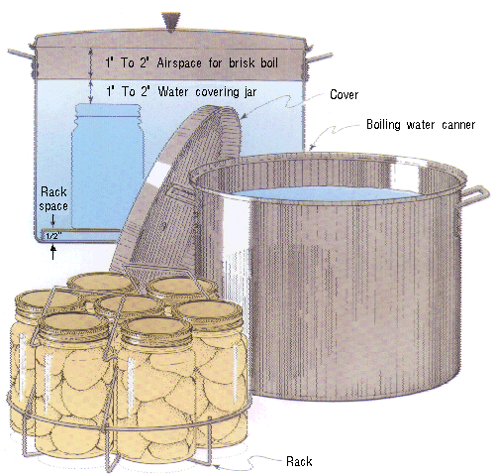

*Image Source: U.S. Department of Agriculture*

**Steam Canner Essentials**

Steam canners consist of a shallow pan, a perforated rack, and a tall vented dome cover. These canners are lightweight and use much less water than boiling water canners, so they heat up quickly and use less energy.

Some models have a temperature sensor/gauge on the dome. The sensors on steam canners cannot be tested, so they should be used only as a guide.

Steam canners have been approved for use with reputable recipes that have been developed for boiling water or atmospheric steam canning (meaning high-acid foods such as most fruits, pickles, and other acidified foods) in half-pint, pint, and quart jars. Follow these guidelines when using steam canners:

* use only standard glass canning jars with 2-piece metal lids
* jars must be no larger than quart size
* **the processing time must be 45 minutes or less, including any adjustments for altitude**
* during processing, do not lift the dome cover to add more water (doing so immediately lowers the heat and thus processing will need to start over from the beginning)
* regulate the heat so that the canner maintains a temperature of 212°F (**a canner that boils too vigorously can boil dry within 20 minutes**)
* *helpful hint:* put a quarter or some marbles in the bottom of the canner; they will begin to rattle if the water gets too low

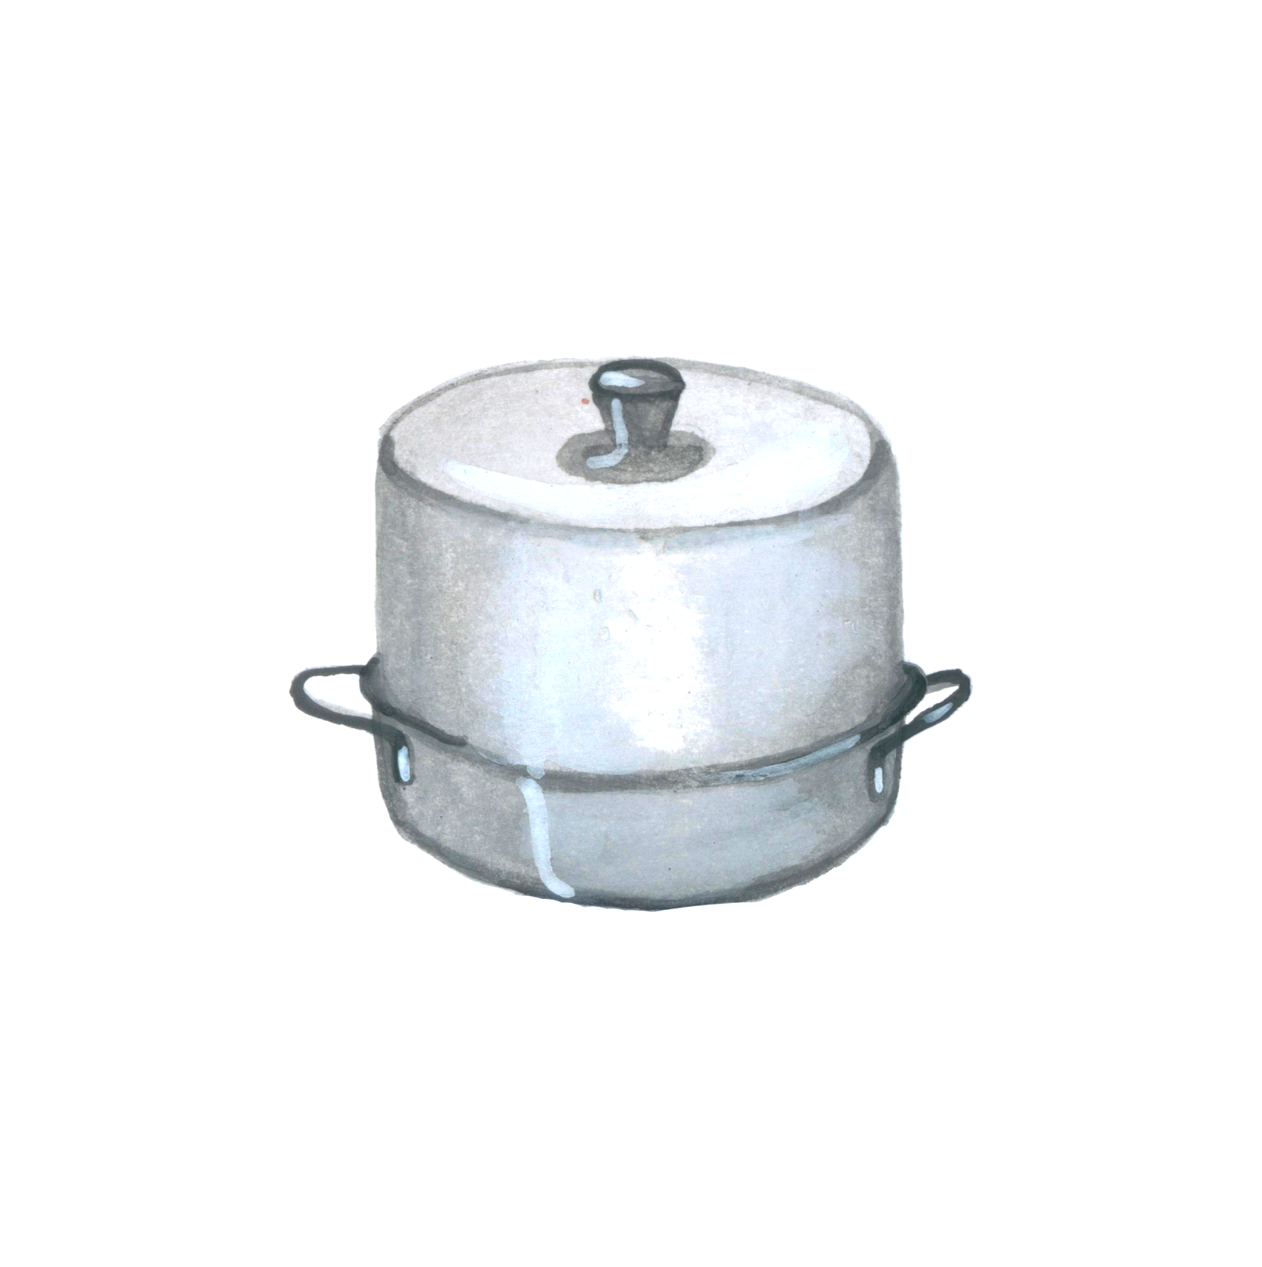

dome cover

base with rack inside

**Freezing Citrus**

Preparation – Select firm, tree-ripened fruit heavy for its size and free from soft spots. Wash and peel. Divide fruit into sections, removing all membranes and seeds. Slice oranges if desired. For grapefruit with many seeds, cut fruit in half and remove seeds; cut or scoop out sections.

Syrup Pack – Pack fruit into containers. Cover with cold 40 percent syrup made with excess fruit juice or water. Leave headspace. Seal and freeze.

Juice – Select fruit as directed for sections. Squeeze juice from fruit, using squeezer that does not press oil from rind.

Sweeten with 2 tablespoons sugar for each quart of juice or pack without sugar. Pour juice into containers immediately. To avoid development of off-flavors, pack juice in glass jars. Leave headspace. Seal and freeze.

PRO TIP: Our experience shows we can freeze whole lemons and limes. Always wash and dry the whole citrus fruit before freezing. We have no experience with oranges or mandarins.

Once thawed lemons and limes hold their shape quite well and can be sliced. The texture is softer than a fresh fruit. Fruit with thicker skins may be zested. Thinner skins do not zest as well.

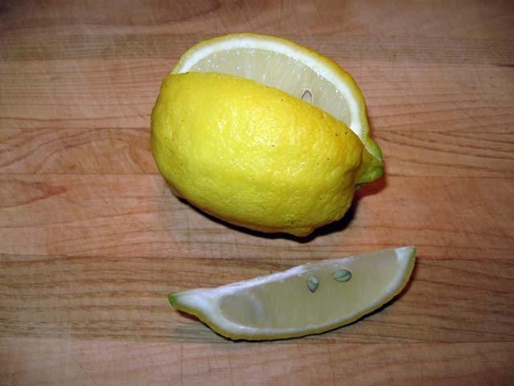

*Previously frozen and thawed lemon with wedge.*

***Citrus Marmalade*  Yield:** about 3-4 half-pint jars

*Marmalade is a suspension of fruit peel and pulp in a tart, yet sweet, jelly. Toast with marmalade is a traditional breakfast favorite, but marmalade also makes a fantastic glaze for sweet and savory foods and is a marvelous addition to many marinades.*

(Note: When peeling citrus fruits for marmalades, be sure to include some of the white membrane found just under the skin. This is where most of the pectin is located.)

* ¾ cup grapefruit peel (from grapefruit)
* ¾ cup orange peel (1 orange)
* 1/3 cup lemon peel (1 lemon)
* 1 quart cold water
* pulp of 1 grapefruit
* pulp of 4 medium-sized oranges
* 2 cups boiling water
* 3 cups sugar

Procedure: Clean canning jars and prepare two-piece canning lids according to manufacturer's directions.

To Prepare Fruit — Wash and peel fruit. Cut peel in thin strips into a saucepan. Add cold water and simmer, covered, until tender (about 30 minutes). Drain. Remove seeds and membrane from peeled fruit. Cut fruit into small pieces.

To Make Marmalade —Combine peel and fruit in saucepan, add boiling water and sugar. Boil rapidly over high heat, stirring frequently, until the temperature measures 8°F above the boiling point of water (220°F at sea level), about 20 minutes.

Ladle into hot jars leaving ¼-inch headspace. Remove air bubbles add adjust headspace, if necessary, by adding more hot marmalade. Wipe jar rims. Center lid on jar. Screw band down until resistance is met, then increase to finger-tip tight.

Process in a boiling water or atmospheric steam canner for 10 minutes at 0-6000 ft., 15 minutes at 6001 ft. and above.

Before removing canner lid, wait 5 minutes for both boiling water and steam canner, then remove jars, cool, and store. Cool jars for 12-24 hours, wash, label, and store in a cool dark place.

Note: Marmalade may take up to 2 weeks to set.

*Source: National Center For Home Food Preservation* [*https://nchfp.uga.edu/how/can_07/orange_marmalade.html*](https://nchfp.uga.edu/how/can_07/orange_marmalade.html)

***Orange Marmalade with added pectin* Yield:** about 7 half-pints

* 6 medium oranges
* 2 medium lemons
* 2 ½ cups water
* 1/8 tsp. baking soda
* 6 ½ cups granulated sugar
* 1 pkg. 1.75 oz. pectin (regular powdered fruit pectin)
* ¼ tsp. butter

Under running water, rinse/wash oranges and lemons. Thinly pare using a sharp paring knife or vegetable peeler, rind from fruits, and cut into thin slivers.

In a non-reactive pot, such as stainless steel or enamel, add water, baking soda, and slivers of orange and lemon rind. Bring to a boil; cover. Simmer on medium-low heat for 20 minutes, stirring occasionally.

Remove and discard white membrane and seeds from fruits; chop fruit, reserving the juice. Add fruits and juices to pot with rinds. Simmer for 10 minutes longer, stirring occasionally.

Into a non-reactive pot, measure exactly 4 cups of cooked fruit and rind mixture, the package of pectin, and ½ tsp. butter if desired (to prevent foaming). Bring to a full rolling boil a boil, stirring constantly.

Add sugar to fruit mixture all at once; stir; bring back to a full rolling boil for exactly 1 minute or the time specified in the pectin package instructions, stirring constantly. Remove from heat and let stand for 5 to 10 minutes, stirring often. Skim off foam with metal spoon.

Ladle into hot jars leaving ¼-inch headspace. Remove air bubbles add adjust headspace, if necessary, by adding more hot marmalade. Wipe jar rims. Center lid on jar. Screw band down until resistance is met, then increase to finger-tip tight. Process in a boiling water or atmospheric steam canner for 10 minutes at 0-6000 ft., 15 minutes at 6001 ft. and above.

Before removing canner lid, wait 5 minutes for both boiling water and steam canner, then remove jars, cool, and store. Cool jars for 12-24 hours, wash, label, and store in a cool dark place.

Note: Marmalade may take up to 2 weeks to set.

*Source: Ball Pectin box*

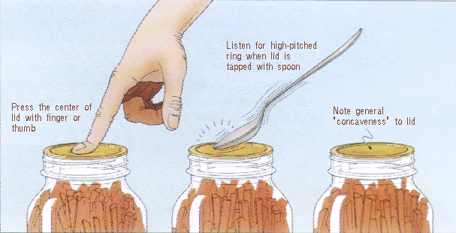

***Meyer lemon-Thyme Jelly*  Yield:** about 4 half-pint jars

Meyer lemons are a jewel of winter fruits, offering natural sweet and tart flavor.Here they are combined with fragrant fresh thyme to create this versatile jelly. A terrific addition to a cheese plate, also makes a wonderful lacquer for roast chicken.

* 2 pounds Meyer lemons (about 12-14 small) to equal 2 cups juice
* 1 cup water
* 1 Tablespoon Meyer lemon zest
* 2 teaspoons fresh thyme leaves, plus four small sprigs
* Pinch of salt (1/16 tsp)
* 6 tablespoons Ball Real Fruit Classic Pectin or one pkg. powdered pectin
* 3 cups sugar

Grate zest from 2 lemons, to equal 1 tablespoon, set zest aside. Juice enough of the lemons to equal 2 cups juice. Strain juice through a fine mesh strainer to collect any remaining solids.

Combine juice, water, zest, thyme leaves and pinch of salt in a 4 quart stainless saucepan, whisk in pectin. Stirring constantly, bring mixture to a full rolling boil over high heat.

Add sugar, stirring to dissolve. Return jelly to a full rolling boil that cannot be stirred down, boil hard for 1 minute. Remove from heat. Skim foam if necessary.

Place one sprig of thyme into a hot jar, ladle hot jelly into jar leaving a 1/4 inch headspace. Remove air bubbles. Wipe jar rim. Center lid on jar. Apply band until fit is fingertip tight

Process in a boiling water or atmospheric steam canner for: 0-6000 ft. = 10 minutes, above 6000 ft. = 15 minutes.

For boiling water canning, turn off the heat, remove canner lid and wait 5 minutes. For atmospheric steam canning, turn off the heat, leave canner lid on and wait 2-3 minutes.

Source: Ballmasonjars.com

***Lime/Lemon Curd*** Yield: about 3 cups

* 4 tsp. grated lime or lemon peel
* ⅔ cup fresh lime or lemon juice
* 5 eggs
* 1 cup sugar (add 1 additional Tbsp. if using Meyer Lemons)
* ½ cup melted butter

In a blender, blend the first four ingredients until smooth. With blender motor running at lowest setting, gradually add the melted butter, pouring in a steady stream until just blended. Transfer the mixture to a small, heavy saucepan and cook over medium heat, stirring continuously until mixture bubbles and thickens. Remove from heat. Ladle into hot jars leaving ½ inch headspace. Cover with lid and ring, cool in refrigerator, then freeze.

Want a canned version? Go to <http://nchfp.uga.edu/how/can_02/lemon_curd.html>

*Source: Sunset “Gifts From Your Kitchen”, 1988*

***Candied Citrus Peel* Yield:** about 2 cups

*Refreshing, addictive, and absolutely satisfying at the end of a meal. Candied citrus peel keeps so well that it's a good idea to double the recipe.*

* 2 grapefruit or 3 oranges or 6 lemons
* 2 cups sugar
* 3 tablespoons light corn syrup
* water

Peel the fruit in ~3/8" thick strips, using only the zest and white peel. If the white is very thick, trim it down a little.

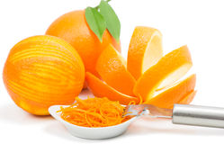Put the peel in a pan, cover with cold water and simmer for 30 minutes. Drain, cover with cold water again, and simmer until tender. Drain.

Mix one cup of the sugar with the corn syrup and ¾ cup water in a heavy saucepan**;** add fruit peel and stir over low heat until most of the syrup has been absorbed. Cover and let stand overnight. Reheat until syrup melts and citrus peel can be separated, then cool a little and drain. Pour remaining sugar (or more, if needed) into a baking dish and roll the peel in it, turning so that all the pieces are coated. Let them stand until they are dry; overnight or longer. Stored airtight, they will stay fresh for several months. If they become too dry put a lemon in the container for a day or two and the peel will soften.

The citrus peel may also be dried in an electric dehydrator. To dry on dehydrator trays, set temperature to 135°F, and dehydrate for 8-24 hrs. Check your candy every few hours. Rotate trays for even drying. Candy is done when dry but pliable, not brittle.

To test for dryness, condition your candy by filling a jar 2/3 full and close with a lid. If after 24 hours there is some condensation on the sides of the jar, return the candy to the dehydrator.

*Source: Sunset Magazine*

***Dried Citrus***

Prep Time: 20 Minutes Bake Time: 6 Hours

1. Preheat oven to 150°F.

2. Wash the citrus fruit and cut into uniform slices, about 1/8”- 1/4” thick.

3. Arrange on a baking tray over two paper towels to absorb the juices and continue layering the paper towels and fruit in a stack.

4. To bake, arrange the slices in a single layer on a baking sheet lined with parchment paper.

5. After 3 hours, place a sheet of parchment paper over the citrus slices and cover with another baking sheet. Hold both baking sheets together and flip so that the citrus slices bake evenly on both sides.

6. Return to the oven for another 3 hours or until dried; they should be bendable and no juice should come out.

Alternate technique: dry the slices in a dehydrator at 130°F for 16-18 hours, flipping several times for an even dry.

Source: Sunkist.com, 2018

***Citrus Flavored Salts* Yield:** 1 cup

* Zest from 1 lemon
* Zest from 1 lime
* 1 cup course sea salt

If using Fresh lemon and Lime zest:

* Use a zester to zest the lemon and lime. Save the fruit for a later use.
* Mix the lemon, lime, and salt in a mixing bowl before dehydrating.
* Spread the lemon-lime salt over a dehydrator sheet and dehydrate 125 degrees F for about 6-8 hours, or until the zest is completely dried through. Alternatively, spread the lemon lime salt over a baking sheet and dry in the oven at 125 degrees F about 6-8 hours, or until the zest is completely dried through. if your oven doesn't go to that low of a temperature, crack the oven a bit to let in some air flow.
* Next, grind down the larger zest into the salt with a spice grinder or mortar and pestle.

If using DRIED lemon and lime zest. simply grind down the zest into the salt with a mortar and pestle.

A spice grinder works well, try not to over process.

Source: <https://www.chilipeppermadness.com/recipes/citrus-lemon-lime-salt/>

**Resources for tested recipes:**

National Center for Home Food Preservation: <http://nchfp.uga.edu/>

Complete Guide to Home Canning. 2015. <http://nchfp.uga.edu//publications/publications_usda.html>

Also available in paper copy from Purdue Extension (online store is located at <https://mdc.itap.purdue.edu/item.asp?item_number=AIG-539>)

Canning Vegetables, 2012. Publication 8072. University of California Ag & Natural Resources, <http://anrcatalog.ucanr.edu>.

So Easy to Preserve, Sixth Edition. 2016. Bulletin 989. Cooperative Extension/University of Georgia, Athens

Ball Blue Book Guide to Preserving. 2020. Newell Corporation.

Ball Complete Book of Home Preserving, 2020. Bernardin, Newell Corporation.

Bernardin: <https://www.bernardin.ca/>

Ball: <https://www.ballmasonjars.com/>

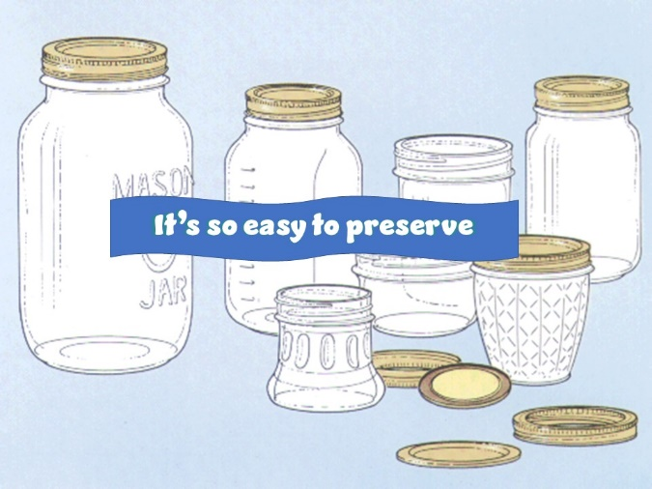

UC ANR is an equal opportunity provider and employer

Should you need assistance or require special accommodations for any of our educational programs, please contact us at 530-621-5502.