**Preserving Cole Crops**

**Basic Food Safety & Sanitation**

When preparing food for preservation, cleanliness is essential in preventing food-borne illness, especially when handling raw fish, meat and other foods that won’t be cooked (including fruits and vegetables).

**Step 1: Clean Your Work Area**

Wash your sink and countertops with soap and warm water, rinse well, and dry with clean paper towels. Then apply a sanitizing solution such as bleach (1 scant teaspoon of liquid unscented bleach to 1 quart of water). Spray well and allow to air dry, or let sit for 30 seconds and wipe dry with clean paper towels. If using commercial sanitizers, follow the manufacturer’s instructions. Wash and sanitize both before and after preparing food.

**Step 2: Wash Your Hands**

Wet your hands, apply soap, lather and then scrub for at least 20 seconds. Rinse well and dry with paper towels or a clean cloth. If using gloves, first wash your hands and then wash the gloves following these same procedures. Wash your hands again when switching tasks.

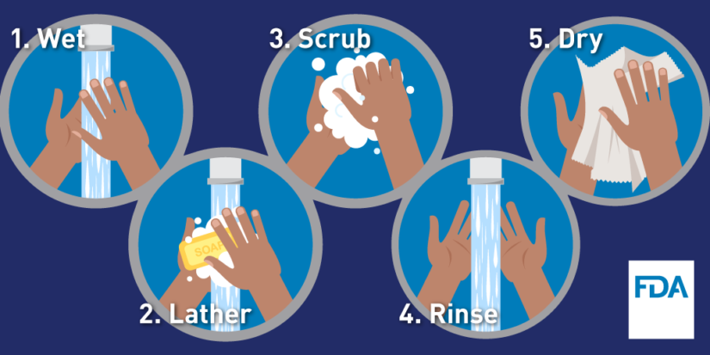

*Image Source: FDA*

**Step 3: Avoid Cross-Contamination**

Be sure to use clean cutting boards and kitchen utensils, and wash them thoroughly before switching from one food type to another, or use separate boards and utensils for different types of foods (e.g., use one board for raw fish or meat and another board for vegetables, herbs, etc.). Wipe up spills promptly, and re-clean your work area as often as necessary.

*Image Source: Partnership for Food Safety Information*

**Basic Food Safety & Sanitation – cont.**

**QUICK TIPS**

* use paper towels or a fresh clean dish towel to clean surfaces
* wipe up spills immediately with paper towels or a clean dish towel (and then put that towel straight into the laundry basket)
* change dish cloths and towels **every day**
* sanitize sponges between uses by using one of these 3 methods:
  + moisten the sponge and heat in a microwave for one minute
  + wash in a dishwasher with a drying cycle
  + soak in a bleach solution for one minute
* replace sponges frequently

**Step 4: Prepare Your Food**

Do not wash raw seafood, meat and poultry – doing so can spread pathogens and potentially cross-contaminate other foods. Wash **all** fresh produce, even if the skin or rinds won’t be eaten. To wash produce, rinse under cool running water in a clean sink – do not soak.

**QUICK TIPS**

* clean produce right before using
* gently rub soft fruits and vegetables (such as tomatoes) with your hands under running water to remove dirt
* scrub firm fruits and vegetables (such as potatoes, carrots, and melons) with a vegetable brush (don’t forget to clean the brush!)
* remove outer leaves of lettuce and cabbage before washing
* rinse herbs and sprouts, then shake to remove excess water
* use a kitchen sink sprayer to rinse berries in a colander, gently turning and shaking the colander to remove dirt and excess water

For more information on cleaning and sanitizing the kitchen using inexpensive and food-safe household products, check out this publication: <https://extension.colostate.edu/docs/pubs/foodnut/kitchen-sanitize.pdf>

**When In Doubt, Throw It Out**

Never taste food that looks or smells strange to see if it can still be eaten. Most bacteria that cause foodborne illness are odorless, colorless, and tasteless.

For general information on food safety, here are some good websites to visit:

<http://nchfp.uga.edu>

[www.foodsafety.gov](http://www.foodsafety.gov)

[www.fightbac.org](http://www.fightbac.org)

<https://www.cdc.gov/foodsafety/cdc-and-food-safety.html>

**Boiling Water Canner Essentials**

Boiling water canners are generally made from enamel-coated steel, stainless steel, or aluminum and come with removable perforated racks and fitted lids. There are also electric canners available, which are generally more expensive. The canner must be deep enough so that at least 1” of water (2” if the processing time is longer than 30 minutes) covers the tops of the jars. There also must be enough airspace to allow for 1” to 2” of vigorously boiling water. If you don’t have a dedicated canner, a large deep pot with a lid can be used. Canning racks can be purchased separately, or a perforated pizza pan, cake rack, silicone trivet, etc. can be substituted. Pressure canners can also function as boiling water canners, however, the lid should not be applied tightly.

Filled canners can be heavy and they generate a lot of heat. Before canning on a smooth top range, check with the manufacturer as to whether it is suitable for canning and for any canner size limits. On smooth top and electric burners, use only pots with flat bottoms (canners with flat, ridged, or concave bottoms can all be used on gas burners). In general, to ensure uniform processing when canning on an electric range, the canner should be no more that 4” wider in diameter (2” on each side) than the burner element used to heat the canner. Just as with smooth top ranges, some types of portable burners are okay for canning and others are not, so first check the manual. Lastly, keep in mind the height of your range hood; if there’s insufficient clearance between it and the top of the canner, it will be difficult to add or remove jars if you’re using a vessel that is fairly tall.

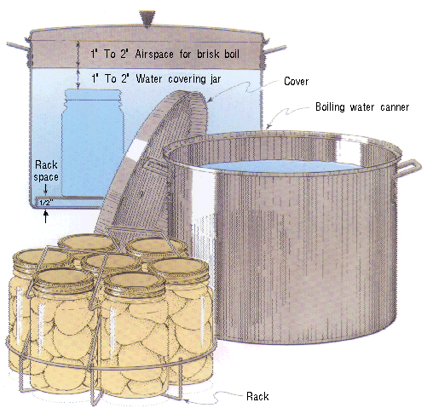

*Image Source: U.S. Department of Agriculture*

**Steam Canner Essentials**

Steam canners consist of a shallow pan, a perforated rack, and a tall vented dome cover. These canners are lightweight and use much less water than boiling water canners, so they heat up quickly and use less energy.

Some models have a temperature sensor/gauge on the dome. The sensors on steam canners cannot be tested, so they should be used only as a guide.

Steam canners have been approved for use with reputable recipes that have been developed for boiling water or atmospheric steam canning (meaning high-acid foods such as most fruits, pickles, and other acidified foods) in half-pint, pint, and quart jars. Follow these guidelines when using steam canners:

* 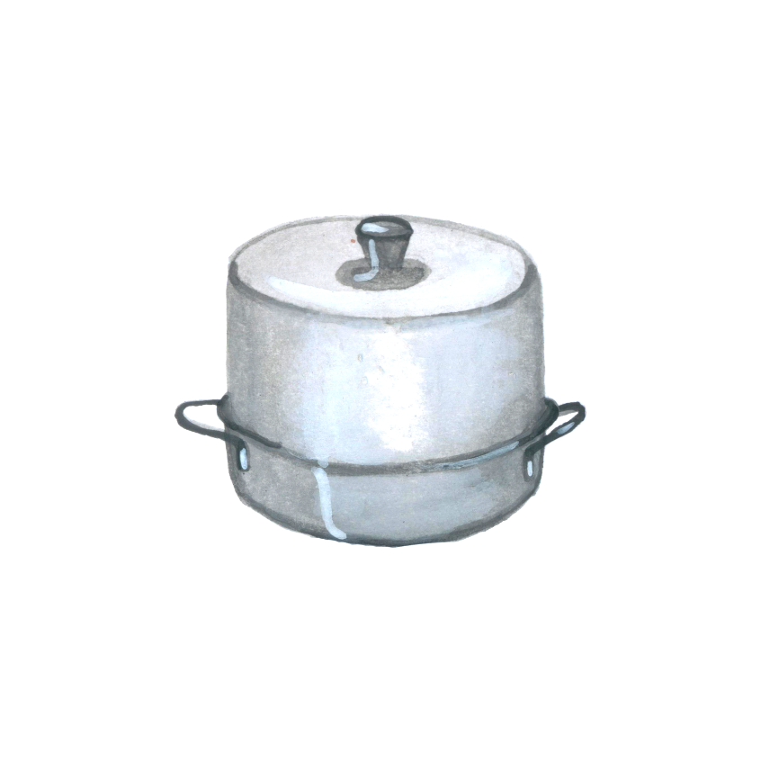use only standard glass canning jars with 2-piece metal lids
* jars must be no larger than quart size
* **the processing time must be 45 minutes or less, including any adjustments for altitude**
* during processing, do not lift the dome cover to add more water (doing so immediately lowers the heat and thus processing will need to start over from the beginning)
* regulate the heat so that the canner maintains a temperature of 212°F (**a canner that boils too vigorously can boil dry within 20 minutes**)
* *helpful hint:* put a quarter or some marbles in the bottom of the canner; they will begin to rattle if the water gets

***Let’s Preserve Cole Crops***

*There are various ways to preserve cole crops. Some may be canned, others do not fair well during the canning process, but may be preserved by fermenting, freezing and/or dehydrating or in the refrigerator in the form of refrigerator pickles.*

*Cabbage is one that does not do well when canned on its own. The flavor and odor become overwhelming once processed. However, cabbage can be pickled, either by fermenting it (sauerkraut and kimchee), or as a quick process pickle using vinegar. It also freezes well.*

*Broccoli is another vegetable that cannot be canned, but may be pickled, frozen, or dehydrated.*

*Leafy greens may be canned, but do not make good pickles. They may also be dehydrated and frozen.*

***Pressure Canning Leafy Greens***

Quantity: An average of 28 pounds is needed per canner load of 7 quarts; an average of 18 pounds is needed per canner load of 9 pints. A bushel weighs 18 pounds and yields 3 to 9 quarts – an average of 4 pounds per quart.

Quality: Can only freshly harvested greens. Discard any wilted, discolored, diseased, or insect- damaged leaves. Leaves should be tender and attractive in color.

Procedure: Wash only small amounts of greens at one time. Drain water and continue rinsing until water is clear and free of grit. Cut out tough stems and midribs. Place 1 pound of greens at a time in cheesecloth bag or blancher basket and steam 3 to 5 minutes or until well wilted. Add 1/2 teaspoon of salt to each quart jar, if desired. Fill jars loosely with greens and add fresh boiling water, leaving 1-inch headspace.

|  |  |  |  |  |  |  |
| --- | --- | --- | --- | --- | --- | --- |
| Table 1. Recommended process time for Spinach and Other Greens  in a **dial-gauge pressure canner**. | | | | | | |
|  | | | Canner Pressure (PSI) at Altitudes of | | | |
| Style  of Pack | Jar  Size | Process  Time | 0 –  2,000 ft | 2,001 –  4,000 ft | 4,001 –  6,000 ft | 6,001 –  8,000 ft |
| Hot | Pints | 70 min | 11 lb | 12 lb | 13 lb | 14 lb |
| Quarts | 90 | 11 | 12 | 13 | 14 |

|  |  |  |  |  |
| --- | --- | --- | --- | --- |
| Table 2.Recommended process time for Spinach and Other Greens  in a weighted-gauge pressure canner. | | | | |
|  | | | Canner Pressure (PSI) at Altitudes of | |
| Style  of Pack | Jar  Size | Process  Time | 0 –  1,000 ft | Above  1,000 ft |
| Hot | Pints | 70 min | 10 lb | 15 lb |
| Quarts | 90 | 10 | 15 |

***Freezer Coleslaw Yield: about 5 widemouth pint jars***

* 2 lbs. cabbage
* 1 large green bell pepper
* 3 large carrots
* ¾ cup chopped onion
* 1 tsp. salt
* 1 tsp. dry mustard
* 1 tsp. celery seed
* 1 cup apple cider vinegar
* 2 cups sugar
* ½ cup water

Shred cabbage, green pepper, and carrots. Add onion. Sprinkle with salt. Let stand 1 hour. Drain.

Combine remaining ingredients in a saucepan. Bring to a boil; boil for 3 minutes. Stir to make sure the sugar is dissolved. Cool.

Ladle cooled liquid over the cabbage mixture. Let stand 5 minutes. Stir well.

Pack slaw into plastic or glass freezer jars or other freezer containers, leaving ½ inch headspace.

Seal, label, and freeze.

**Cooks note:** if you are concerned about salt, you may rinse the salt off before adding the liquid.

Once thawed, add whatever other ingredients you may like such as mayonnaise for a creamier dressing, a shredded apple to add sweetness, maybe a squirt of Tabasco sauce.

Source: Ball Blue Book Guide to Preserving

***Sweet Pickled Radish (Refrigerator Pickle) Yield: about 1 pint jar***

* 1 bunch radishes (about a 1/2 pound), stem and root ends removed and cut into 1/8 inch slices
* 1/2 cup white or apple cider vinegar (5% acidity)
* 1/2 cup sugar
* 1/4 cup water
* 1 tsp. pickling salt
* 1 tsp. mustard seeds
* 1/2 tsp. ground black pepper
* 1 bay leaf
* 1/2 tsp. dried crushed red pepper (optional)

Place radishes in a hot 1-pint jar. Bring vinegar, next 6 ingredients, and, if desired, crushed red pepper to a boil in a small stainless steel or enameled saucepan.

Ladle hot pickling liquid over radishes. Wipe jar rim. Center lid on jar. Apply band, and adjust to fingertip-tight. Let cool on a wire rack ( about 1 hour). Chill 6 hours before serving. Store in refrigerator up to 4 months.

Source: Ball website <https://www.ballmasonjars.com/blog?cid=sweet-pickled-radish>

***Pickled Kohlrabi (Refrigerator Pickle)* Yield:** about 3-4 half-pint jars

* 1 ½ lbs of kohlrabi, peeled and cut (we sliced into shoestring fries 20% shorter than your jars)
* 1 ½ tsp kosher salt
* 1 cup rice vinegar
* 1 cup water
* 3 large garlic cloves, coarsely chopped
* zest of 1 lemon in strips
* 2 Tbsp sugar
* ½ tsp crushed black peppercorns
* 4 thin slices of fresh ginger
* ¼ tsp hot pepper flakes

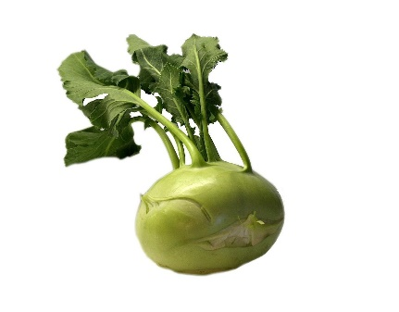Toss kohlrabi and salt in large bowl and let it stand at room temp for 1 hour.

Drain the kohlrabi of any water that came out, then pack into cleaned jars.

Bring remaining ingredients to a boil and immediately poor them over the kohlrabi, covering the kohlrabi in the jars. Screw on jar tops and let cool to room temperature.

Store in the refrigerator. They should be ready to eat in a day or two and should keep for 3-4 weeks.

*Source: Linda Ziedrich Photo by Pixabay*

***Sriracha Brussels Sprout Chips***

* 1 lb brussel sprouts
* 2-3 Tbsp sriracha
* 1 ½ Tbsp agave
* 1 tsp soy sauce or liquid aminos
* 1 pinch sea salt

Remove the leaves from the Brussels sprouts by cutting the stem as you go to make it easier to peel the layers. Mix 2 Tbsp sriracha, agave, soy sauce and sea salt in a small bowl. In a mixing bowls, toss Brussels sprout leaves and sriracha mixture until coated fairly evenly. Add more sriracha if a spicier chip is desired or you need more sauce to coat leaves. Place Brussels sprouts in an even layer on a dehydrator tray. Make sure they are not touching or overlapping. Dry at 115° F for 10 hours or until crisp.

Source: Excalibur https://www.excaliburdehydrator-recipes.com/recipe/sriracha-brussel-sprout-chips/

***Pickled Cauliflower or Brussels Sprouts* Yield**: **about 9 half-pint jars**

* 12 cups of 1- to 2-inch cauliflower flowerets or small Brussels sprouts
* 4 cups white vinegar (5 percent)
* 2 cups sugar
* 2 cups thinly sliced onions
* 1 cup diced sweet red peppers
* 2 Tbsp mustard seed
* 1 Tbsp celery seed
* 1 tsp turmeric
* 1 tsp hot red pepper flakes

Wash cauliflower flowerets or Brussels sprouts (remove stems and blemished outer leaves) and boil in salt water (4 tsp canning salt per gallon of water) for 3 minutes for cauliflower and 4 minutes for Brussels sprouts. Drain and cool.

Combine vinegar, sugar, onion, diced red pepper, and spices in large saucepan. Bring to a boil and simmer 5 minutes. Distribute onion and diced pepper among jars.

Fill jars with cauliflower pieces or Brussels Sprouts leaving ½ headspace. Pour brine into jars. Remove air bubbles and adjust headspace, if necessary, by adding more hot brine. Wipe rim, center lid on jar and screw band down until resistance is met, then increase to fingertip tight.

Process in a boiling water or atmospheric steam canner for 10 minutes at 0-1000 ft., 15 minutes at 1001-6000 ft., and 20 minutes above 6001 ft. above.

Before removing canner lid, wait 5 minutes for both boiling water and steam canner, then remove jars, cool, and store. Cool jars for 12-24 hours, wash, label, and store in a cool dark place.

Source: National Center for Home Food Preservation <https://nchfp.uga.edu/how/can_06/pickled_cauliflower_brussel.html>

***Spicy Red Cabbage*  Yield: about 5 quarts or 10 pint jars**

*This eastern European pickle has many uses. It is great as a side dish, warmed, and served with sausages, maybe some German potato salad, too. Can you say Rueben sandwich? Picture this with pastrami or corned beef on good rye bread. Don’t forget your homemade mustard!*

* 12 lbs. red cabbage (about 3 large heads), cored and shredded
* ½ cup pickling or canning salt
* ¼ cup whole cloves
* ¼ cup whole allspice
* ¼ cup whole black peppercorns
* ¼ cup celery seeds
* 2 cinnamon sticks (each about 4 “) broken into pieces
* 8 cups red wine vinegar
* 1 cup lightly packed brown sugar
* ½ cup mustard seeds
* ¼ cup ground mace or nutmeg

Day 1: In a large clean crock, jar or stainless-steel bowl, layer cabbage and salt. Cover and let stand in a cool place for 24 hours.

Day 2: Transfer cabbage to a colander placed over a sink and drain. Rinse with cool running water. Drain thoroughly on trays lined with paper towels, about 6 hours.

Tie cloves, allspice, peppercorns, celery seeds and cinnamon stick pieces in a square of cheesecloth, creating a spice bag.

In a large stainless-steel saucepan, combine vinegar, brown sugar, mustard seeds, mace and spice bag. Bring to a boil over medium-high heat, stirring to dissolve sugar. Reduce heat and boil gently for 5 minutes, until spices have infused the liquid. Discard spice bag.

Pack cabbage into hot jars to within a generous ½-inch of top of jar. Ladle hot pickling liquid into jar to cover cabbage, leaving ½-inch headspace. Remove air bubbles and adjust headspace, if necessary, by adding hot liquid. Wipe rim, center lid on jar and screw band down until resistance is met, then increase to fingertip tight.

Process in a boiling water canner or atmospheric steam canner for 20 minutes 0-1000 ft., 25 minutes 1001-6000 ft., 30 minutes above 6000 ft. Remove canner lid, wait 5 minutes, then remove jars, cool, label and store.

Source: Ball Complete Book of Home Preservation

***Vegetable Stock Powder***

Ingredients:

* 2 Carrots, thinly sliced
* 2 Parsnips, thinly sliced
* 2 Celery ribs, cut into fine strips
* 1 Sweet white potato, thinly sliced
* 1 Onion, thinly sliced
* 2 Tomatoes, thinly sliced
* 4 Mushrooms, thinly sliced
* 2 Red Cabbage leaves, cut into smaller pieces
* handful or parsley (with stalks)
* 2 Garlic cloves, thinly sliced

Seasonings:

* 2 tsp. sea salt
* 2 tsp. dry turmeric powder
* 1 tsp. dry dill
* ½ tsp. ground black pepper
* ½ tsp. chili flakes
* ½ tsp. ground nutmeg

Directions:

Wash, pat dry and slice all your vegetables. Arrange your vegetables on your dehydrator tray in a single layer. Dehydrate at 135 degrees for 1 hour, then continue to dry at 115 degrees for up to 6 hours. Some vegetables (like potato, carrot, parsnip, parsley) will dry sooner than cabbage, tomato, celery, or onion. Check then after 2-3 hours and take out those that are dry. Once all vegetables are done, allow them to cool. Add them to a blender or food processor and pulse until you get a fine crumbled mix. This may need to be done in 2 batches. In a bowl, mix your ground vegetables with the seasonings. Store in an airtight jar, in the pantry away from light or moisture.

Source: Excalibur

***Waste Not, Want Not***

Save your vegetable scraps for vegetable power for pressure canning or freezing vegetable broth.

Save coles separately as they have a strong flavor. If you want that flavor in your soup broth, then that is ok!

For vegetable broth, save onion skins, garlic skins, carrot skins and bits, celery ends, leek greens, lettuce scraps, parsley stems, cilantro stems, radish tops, and more. As long as vegetables have not begun to decay – limp carrots or celery are fine. Store in the freezer until you have a full one gallon bag, then make some broth.

For coles, broccoli stems, kohlrabi leaves, cabbage leaves, kale/chard stems, etc may be saved. If you like these flavors in your soup then feel free to add then to your stock or make a separate stock.

Broccoli stems are great in a stir fry or as a refrigerator pickle!

**Resources for tested recipes:**

National Center for Home Food Preservation: <http://nchfp.uga.edu/>

Complete Guide to Home Canning. 2015. <http://nchfp.uga.edu//publications/publications_usda.html>

Also available in paper copy from Purdue Extension (online store is located at <https://mdc.itap.purdue.edu/item.asp?item_number=AIG-539>)

Canning Vegetables, 2012. Publication 8072. University of California Ag & Natural Resources, <http://anrcatalog.ucanr.edu>.

So Easy to Preserve, Sixth Edition. 2016. Bulletin 989. Cooperative Extension/University of Georgia, Athens

Ball Blue Book Guide to Preserving. 2020. Newell Corporation.

Ball Complete Book of Home Preserving, 2020. Bernardin, Newell Corporation.

Bernardin: <https://www.bernardin.ca/>

Ball: <https://www.ballmasonjars.com/>

Excalibur dehydrating recipes: https://www.excaliburdehydrator-recipes.com/

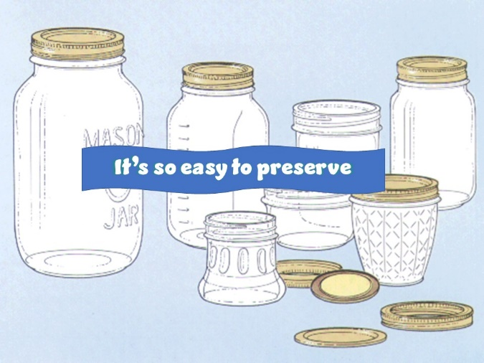

UC ANR is an equal opportunity provider and employer

Should you need assistance or require special accommodations for any of our educational programs, please contact us at 530-621-5502.