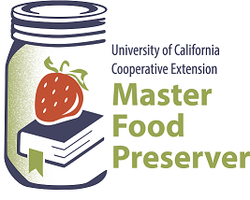

**UCCE Master Food Preservers of El Dorado County**

**311 Fair Lane, Placerville CA 95667**

**Helpline (530) 621-5506 • Email:** [**edmfp@ucanr.edu**](mailto:edmfp@ucanr.edu) **• Visit us on Facebook!**

“Preserve today, Relish tomorrow”

**Pressure Canning:**

**Meals in a Jar**

Saturday, February 18, 2023

9:00 a.m. – Noon

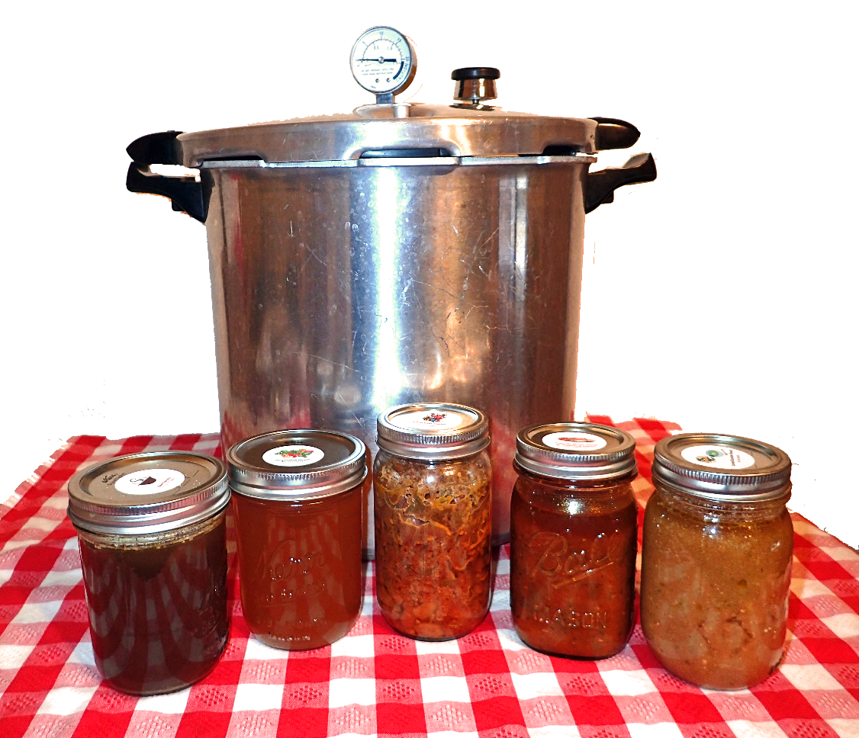

It is the policy of the University of California (UC) and the UC Division of Agriculture & Natural Resources not to engage in discrimination against or harassment of any person in any of its programs or activities (Complete nondiscrimination policy statement can be found at <http://ucanr.edu/sites/anrstaff/files/215244.pdf>

**Pressure Canner Processing Steps**

*Please be sure to read the section* ***Pressure Canner Essentials*** *in our publication,*

**Core Canning Techniques***, before following these steps.*

1. Clean lid gaskets and other parts according to the manufacturer’s directions. Make sure all vent pipes are clear.
2. Add 2-3 inches of water to the canner (follow the manufacturer’s specific recommendations).
3. Heat water in canner to 140°F for raw pack or 180°F for hot pack.
4. Placed filled jars on the canner rack.
5. Place lid on the canner and fasten securely. Leave the weight off the vent pipe or open the petcock.
6. Turn heat to high until steam flows in a steady stream from the open vent pipe or petcock.
7. Allow the canner to vent for 10 minutes. *Always vent for 10 minutes, regardless of the manufacturer’s instructions.*
8. Place the counterweight or weighted gauge on the vent pipe, or close the petcock.
9. Begin to count processing time when the pressure on the dial gauge indicates that the recommended pressure has been reached, or for canners without dial gauges, when the weighted gauge begins to jiggle or rock as the manufacturer describes.
10. Regulate the heat to maintain a steady pressure at or slightly above the correct gauge pressure or weighted gauge rocking motion.
    * If at any time during processing the pressure goes below the recommended amount, bring the canner back to pressure and re-start the timing process from the beginning.
11. When the time is up, turn off the heat, remove the canner from the heat element (electric burner) if possible, and allow the canner to cool down naturally and the pressure to drop to 0. **Do not force cool the canner**.
12. After the canner has completely depressurized, remove the weight from the vent pipe or open the petcock. **Wait 10 minutes**, then unfasten the lid and remove it, carefully lifting it away from you.
13. Carefully remove the jars to a cooling rack or heavy cloth towel.
    * Straight up – Straight Over – Straight Down
    * Do not invert jars!
14. Dry the canner, lid and gasket. Take off removable petcocks and safety valves and wash and dry them thoroughly. Follow the maintenance and storage instructions that come from your canner manufacturer.
15. Allow jars to cool in still, ambient air away from drafts for 12-24 hours.
16. Test jars for seals.
    * If a jar did not seal, refrigerate it and use within a few days, or reprocess it within 24 hours using a new lid.
17. Clean and dry jars and screw bands.
18. Label jars and store in a cool, dry, dark place.

**Resources**

National Center for Home Food Preservation <http://nchfp.uga.edu>

USDA Complete Guide to Home Canning

online (pdf) <https://nchfp.uga.edu/publications/publications_usda.html#gsc.tab=0>

print <https://mdc.itap.purdue.edu/item.asp?Item_Number=AIG-539>

So Easy to Preserve <https://setp.uga.edu/>

Ball Blue Book Guide to Preserving. 2020. Jarden Home Brands.

Ball Complete Book of Home Preserving. 2006/2012. Jarden Home Brands.

**RECIPES**

To be sure your home-canned food is safe and of high quality, follow the guidelines outlined in our publication ***Core Canning Techniques***, which is available to download for free at our website here: <https://ucanr.edu/sites/mfp_of_cs/files/372635.pdf>.

Whether you’re brand new to canning in general or could simply use a refresher, you’ll find all the current information you need to know, including the types of canners (and which to use when), preparing jars for canning, basic do’s and don’ts of canning, and safe food handling.

**Seasoned Ground Beef**

*Yield: about 5 pint or 2 quart jars*

4 lbs lean ground beef

1 ½ cups chopped onion (about 2 medium)

2 garlic cloves, minced

2 cups tomato juice

1 ½ cups beef broth

1 tsp seasoned salt

½ tsp pepper

1. Brown ground beef in a large saucepan. Drain off excess fat. Add onions and garlic, and cook mixture slowly until the onion is tender.
2. Add remaining ingredients and simmer 15 minutes (or until mixture is hot throughout), stirring to prevent sticking. Skim off excess fat.
3. Ladle hot mixture into a hot jar, leaving 1-inch headspace. Remove air bubbles and adjust headspace if needed. Wipe jar rims with a dampened clean paper towel or cloth. Apply and adjust two-piece metal canning lids. Place jar in canner. Repeat with remaining jar(s).
4. Process in a pressure canner as follows:

|  |  |  |  |  |  |
| --- | --- | --- | --- | --- | --- |
| **Dial-Gauge Pressure Canner** | | | | | |
| Jar  Size | Process  Time | 0-  2,000 ft | 2,001-  4,000 ft | 4,001-  6,000 ft | 6,001-  8,000 ft |
| Pints | 75 minutes | 11 lb | 12 lb | 13 lb | 14 lb |
| Quarts | 90 minutes | 11 lb | 12 lb | 13 lb | 14 lb |

|  |  |  |  |
| --- | --- | --- | --- |
| **Weighted-Gauge Pressure Canner** | | | |
| Jar Size | Process Time | 0-1,000 ft | + 1,000 ft |
| Pints | 75 minutes | 10 lb | 15 lb |
| Quarts | 90 minutes | 10 lb | 15 lb |

*Source: Adapted from Ball Blue Book (2020)*

**Sloppy Joe Mix**

*Yield: 8 pint jars*

4 lbs*.* lean ground beef or venison (or a combination)

3 cups onion, peeled and chopped

1 ½ cups green bell pepper, cored and chopped

1 16-oz can tomato sauce

2 cups tomato ketchup

2 cups water

1 tbsp salt

1 tbsp sugar

1 tbsp prepared mustard

¾ tsp ground black pepper

1. Sauté meat and onion. Drain off fat.
2. Add remaining ingredients, bring to a boil, then simmer 5 minutes.
3. Ladle hot mixture into a hot jar , leaving 1-inch headspace. Remove air bubbles and adjust headspace if needed. Wipe jar rims with a dampened clean paper towel or cloth. Apply and adjust two-piece metal canning lids. Place jar in canner. Repeat with remaining jar(s).
4. Process in a pressure canner as follows:

|  |  |  |  |  |  |
| --- | --- | --- | --- | --- | --- |
| **Dial-Gauge Pressure Canner** | | | | | |
| Jar  Size | Process  Time | 0-  2,000 ft | 2,001-  4,000 ft | 4,001-  6,000 ft | 6,001-  8,000 ft |
| Pints | 75 minutes | 11 lb | 12 lb | 13 lb | 14 lb |
| Quarts | 90 minutes | 11 lb | 12 lb | 13 lb | 14 lb |

|  |  |  |  |
| --- | --- | --- | --- |
| **Weighted-Gauge Pressure Canner** | | | |
| Jar Size | Process Time | 0-1,000 ft | + 1,000 ft |
| Pints | 75 minutes | 10 lb | 15 lb |
| Quarts | 90 minutes | 10 lb | 15 lb |

*Source: Adapted from University of Wisconsin Cooperative Extension, publication B3345*

**MAKE YOUR OWN EASY, NO-KNEAD BURGER/SLOPPY JOE BUNS!**

Find recipes for plain or cheese burger buns here:

<https://www.kingarthurbaking.com/recipes/beautiful-burger-buns-recipe>

<https://www.kingarthurbaking.com/recipes/no-knead-cheese-burger-buns-recipe>

**Goulash**

*Yield: about 4 pint or 2 quart jars*

4 lbs boneless beef chuck roast, cut into 1-inch cubes

6 stalks celery, top and root ends removed and cut in half

4 large carrots, stems removed and cut in half

3 medium onions, peeled and cut in half

1 tbsp salt

3 tbsp paprika

2 tsp dry mustard

1/3 cup vegetable oil

20 peppercorns

3 bay leaves

2 tsp caraway seeds

1 cup water

1/3 cup vinegar (5%acidity)

1. Combine salt, paprika, and dry mustard. Roll cubed meat in spice blend. Tie peppercorns, bay leaves, and caraway seeds in a spice bag.
2. Brown meat slowly in hot vegetable oil in a large pan. Sprinkle excess spice mixture over meat. Add the spice bag and remaining ingredients to the beef mixture. Cover the pan and simmer until beef is almost tender. Remove spice bag and vegetables and discard.
3. Ladle hot mixture into a hot jar, leaving 1-inch headspace. Remove air bubbles and adjust headspace if needed. Wipe jar rims with a dampened clean paper towel or cloth. Apply and adjust two-piece metal canning lids. Place jar in canner. Repeat with remaining jar(s).
4. Process in a pressure canner as follows:

|  |  |  |  |  |  |
| --- | --- | --- | --- | --- | --- |
| **Dial-Gauge Pressure Canner** | | | | | |
| Jar  Size | Process  Time | 0-  2,000 ft | 2,001-  4,000 ft | 4,001-  6,000 ft | 6,001-  8,000 ft |
| Pints | 75 minutes | 11 lb | 12 lb | 13 lb | 14 lb |
| Quarts | 90 minutes | 11 lb | 12 lb | 13 lb | 14 lb |

|  |  |  |  |
| --- | --- | --- | --- |
| **Weighted-Gauge Pressure Canner** | | | |
| Jar Size | Process Time | 0-1,000 ft | + 1,000 ft |
| Pints | 75 minutes | 10 lb | 15 lb |
| Quarts | 90 minutes | 10 lb | 15 lb |

*Source: Ball Blue Book (2020)*

**Beef Stew with Vegetables**

*Yield: about 14 pint or 7 quart jars*

4 – 5 lbs beef stew meat

1 tbsp vegetable oil

3 quarts potatoes, peeled and cubed into 1-inch pieces (about 18 medium)

2 quarts carrots, stem ends removed and peeled, and cut into ½-inch slices (about 15 small)

3 cups celery, leafy tops and root ends removed, and cut into ½-inch slices (about 6 stalks)

3 cups onions, peeled and chopped (about 4-5 medium)

1 ½ tsp salt

1 tsp thyme

½ tsp pepper

1. Brown meat in oil in a large saucepan. Stir in remaining ingredients. Add just enough boiling water to cover. Bring mixture to a boil.
2. Ladle hot mixture into a hot jar, leaving 1-inch headspace. Remove air bubbles and adjust headspace if needed. Wipe jar rims with a dampened clean paper towel or cloth. Apply and adjust two-piece metal canning lids. Place jar in canner. Repeat with remaining jar(s).
3. Process in a pressure canner as follows:

|  |  |  |  |  |  |
| --- | --- | --- | --- | --- | --- |
| **Dial-Gauge Pressure Canner** | | | | | |
| Jar  Size | Process  Time | 0-  2,000 ft | 2,001-  4,000 ft | 4,001-  6,000 ft | 6,001-  8,000 ft |
| Pints | 75 minutes | 11 lb | 12 lb | 13 lb | 14 lb |
| Quarts | 90 minutes | 11 lb | 12 lb | 13 lb | 14 lb |

|  |  |  |  |
| --- | --- | --- | --- |
| **Weighted-Gauge Pressure Canner** | | | |
| Jar Size | Process Time | 0-1,000 ft | + 1,000 ft |
| Pints | 75 minutes | 10 lb | 15 lb |
| Quarts | 90 minutes | 10 lb | 15 lb |

*Source: Ball Blue Book (2020)*

**CUSTOMIZE YOUR BEEF STEW!**

⬩ Combine potatoes and turnips to equal 3 quarts of root vegetables

⬩ Reduce the amount of onion to 2 cups, then add 1 cup peas, green beans or corn.

⬩ Sprinkle in additional dried herbs and spices to your liking.

⬩ To finish it off, add a splash of hot sauce, or maybe wine.

**All Purpose Chicken and Vegetable Mix**

*This mix can be used for chicken stew, hearty soups, chicken a la king, or casseroles. Add cornstarch or flour to the liquid to thicken just before serving. Do not thicken for canning.*

*Yield: 7 to 8 pint jars*

8 to 10 lbs chicken, game bird or rabbit, cut into pieces

1 tbsp salt

½ tsp pepper

1 tbsp parsley, chopped

water to cover

1 cup onion, peeled and chopped

2 cups celery, chopped

2 cups carrots, peeled and thinly sliced

1. Place chicken, salt, pepper, and parsley in a large pot. Cover with water and bring to a boil. Reduce heat and simmer until chicken can be removed from the bones.
2. Remove skin and bones. Discard fat, reserving the broth.
3. Add onion, celery and carrots to the broth and bring to a boil. Stir in chicken pieces. **NOTE**: Do not add thickeners before canning.
4. Ladle hot mixture into a hot jar, leaving 1-inch headspace. Wipe jar rims with a dampened clean paper towel or cloth. Apply and adjust two-piece metal canning lids. Place jar in canner. Repeat with remaining jar(s).
5. Process in a pressure canner as follows:

|  |  |  |  |  |  |
| --- | --- | --- | --- | --- | --- |
| **Dial-Gauge Pressure Canner** | | | | | |
| Jar  Size | Process  Time | 0-  2,000 ft | 2,001-  4,000 ft | 4,001-  6,000 ft | 6,001-  8,000 ft |
| Pints | 75 minutes | 11 lb | 12 lb | 13 lb | 14 lb |
| Quarts | 90 minutes | 11 lb | 12 lb | 13 lb | 14 lb |

|  |  |  |  |
| --- | --- | --- | --- |
| **Weighted-Gauge Pressure Canner** | | | |
| Jar Size | Process Time | 0-1,000 ft | + 1,000 ft |
| Pints | 75 minutes | 10 lb | 15 lb |
| Quarts | 90 minutes | 10 lb | 15 lb |

*Source: Adapted from University of Wisconsin Cooperative Extension, publication B3345*

**Beans with Molasses (or Tomato) Sauce**

*Yield: variable (about 5 lbs of beans is needed for a canner load of 7 quarts; about 3 ¼ lbs is needed for 9 pints – an average of ¾ lb per quart).*

dried beans

sauce (see #2 below)

pork, ham, or bacon pieces (optional)

1. Prepare beans: Sort out and discard discolored beans; rinse. Add 3 cups of water for each cup of dried beans. Boil 2 minutes, remove from heat, and soak 1 hour. Drain. Heat to boiling in fresh water. Save liquid to make sauce.
2. Prepare sauce as follows.
   1. Molasses Sauce: Mix 4 cups of cooking liquid from boiling beans, 3 tbsp dark molasses, 1 tbsp vinegar, 2 tsp salt, and ¾ tsp powdered dry mustard. Heat to boiling.
   2. Tomato Sauce Version 1: Mix 1 qt tomato juice, 3 tbsp sugar, 2 tsp salt, 1 tbsp chopped onion, and ¼ tsp each of ground cloves, allspice, mace, and cayenne pepper. Heat to boiling.
   3. Tomato Sauce Version 2: Mix 1 cup tomato ketchup with 3 cups of cooking liquid from beans. Heat to boiling.
3. Fill a hot jar ¾ full with hot beans. *Optional:* Add a ¾ piece of pork, ham, or bacon to each jar. Fill jars with heated sauce, leaving 1-inch headspace. Remove air bubbles and adjust headspace if needed. Wipe jar rims with a dampened clean paper towel or cloth. Apply and adjust two-piece metal canning lids. Place jar in canner. Repeat with remaining jar(s).
4. Process in a pressure canner as follows:

|  |  |  |  |  |  |
| --- | --- | --- | --- | --- | --- |
| **Dial-Gauge Pressure Canner** | | | | | |
| Jar  Size | Process  Time | 0-  2,000 ft | 2,001-  4,000 ft | 4,001-  6,000 ft | 6,001-  8,000 ft |
| Pints | 65 minutes | 11 lb | 12 lb | 13 lb | 14 lb |
| Quarts | 75 minutes | 11 lb | 12 lb | 13 lb | 14 lb |

|  |  |  |  |
| --- | --- | --- | --- |
| **Weighted-Gauge Pressure Canner** | | | |
| Jar Size | Process Time | 0-1,000 ft | + 1,000 ft |
| Pints | 65 minutes | 10 lb | 15 lb |
| Quarts | 75 minutes | 10 lb | 15 lb |

*Source: Adapted from USDA Complete Guide to Home Canning*

**VARIATION**

Baked Beans is another great alternative for dried beans. Find the recipe here:

<https://nchfp.uga.edu/how/can_04/beans_baked.html>

**Can Your Own Soups**

*Yield: variable*

Choose your ingredients: meat, poultry or seafood; vegetables; dried beans

***NOTE:* These directions are intended for use with ingredients that already have separate canning recommendations for those foods.**

1. Select, wash, and prepare ingredients as directed:

* *Meat:* Cover meat with water and cook until tender. Cool meat and remove bones.
* *Vegetables:* Cook as described for the hot pack method for each individual vegetable (see instructions here: <https://nchfp.uga.edu/how/can4_vegetable.html#gsc.tab=0>.
* *Dried Beans/Peas:* For each cup of dried beans or peas, add 3 cups of water. Boil for 2 minutes, remove from heat, then soak for 1 hour. Reheat to boiling and drain.

1. Combine prepared solid ingredients with meat broth, tomatoes or water to cover. Boil 5 minutes. Salt to taste if desired.

* Do NOT puree any ingredients prior to canning.
* Do NOT add any thickening agents, dairy, or cereals/grains (including flour, cream or milk, pasta or noodles, rice, etc.) prior to canning.

1. Fill a hot jar with half solids and half liquid, leaving 1-inch headspace. Remove air bubbles and adjust headspace if needed. Wipe jar rims with a dampened clean paper towel or cloth. Apply and adjust two-piece metal canning lids. Place jar in canner. Repeat with remaining jar(s).

**IMPORTANT! Do not fill jars more than half full with solids.**

1. Process in a pressure canner as follows:

|  |  |  |  |  |  |
| --- | --- | --- | --- | --- | --- |
| **Dial-Gauge Pressure Canner** | | | | | |
| Jar  Size | Process  Time | 0-  2,000 ft | 2,001-  4,000 ft | 4,001-  6,000 ft | 6,001-  8,000 ft |
| Pints | 60 minutes* | 11 lb | 12 lb | 13 lb | 14 lb |
| Quarts | 75 minutes* | 11 lb | 12 lb | 13 lb | 14 lb |

|  |  |  |  |
| --- | --- | --- | --- |
| **Weighted-Gauge Pressure Canner** | | | |
| Jar Size | Process Time | 0-1,000 ft | + 1,000 ft |
| Pints | 60 minutes* | 10 lb | 15 lb |
| Quarts | 75 minutes* | 10 lb | 15 lb |

\****NOTE:*** If your soup includes seafood, process for 100 minutes.

*Source: Adapted from National Center for Home Food Preservation*

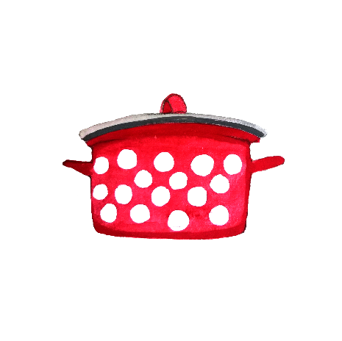

**Spice Blends**

Adding spice mixtures to meat or poultry is a great way to change the flavor profile of your canned meats. **Add spice mixtures “to taste,” but no more than 2 tablespoons per 2 pounds of meat.**  Spices tend to get stronger once canned, so “less is more” when it comes to pressure canning. You can always adjust the spices once the jar is opened.

Store all spice blends and powders in an airtight container in a cool, dry, dark place.

Suggested amount for the following 3 blends: 2 ½ tsp per pint jar, or 5 tsp per 2 lbs. meat

*Source: NDSU Extension*

**RANCH BLEND**

2 tbsp onion powder

2 tbsp onion flakes

2 tbsp dried parsley

1 tbsp garlic powder

1 tbsp dried dill weed

¼ tsp dried thyme

2 tsp ground pepper

**ITALIAN SPICE BLEND**

2 tbsp dried basil

1 tbsp dried oregano

1 tbsp dried thyme

1 tbsp dried rosemary

1 tbsp garlic powder

¼ tsp onion powder

**MEXICAN SEASONING BLEND**

1 ½ tsp dried parsley

½ tsp garlic powder

½ tsp onion powder

1 tsp dried oregano

1 tbsp ground black pepper

1 tbsp chili powder

1 tsp paprika

1 ½ tsp ground cumin

Suggested amount for the Cajun spice blend: 2 tsp per pint jar, or 4 tsp per 2 lbs. meat

*Source: Ball Complete Book of Home Canning*

**CAJUN SPICE BLEND**

3 tsp chili powder

2 tsp paprika

1 ½ tsp dried onion flakes

1 ½ tsp garlic powder

1 ½ tsp ground allspice

1 ½ tsp dried thyme

1 tsp cayenne pepper

**Spice Blends (cont.)**

**LEMON-PEPPER SEASONING WITH ROSEMARY**

Add 2 tsp finely chopped dried rosemary to the lemon-pepper blend, found on our website here: https://ucanr.edu/sites/mfp_of_cs/files/380537.pdf.

**Spice Powders**

The following spice blends will require a spice mill (a coffee grinder works great) or a mortar and pestle.

**CHIPOTLE CHILI POWDER**

4 dried Ancho chiles

4 dried Chipotle chiles

¼ cup smoked paprika (pimenton)

3 tbsp onion powder

2 tbsp garlic powder

1 tbsp cumin seeds

Remove the stems from the chiles and cut into 1-inch pieces. Lay flat on a baking sheet and toast in a 200°F oven until slightly crisp. Combine the chiles with the rest of the ingredients and grind together in a spice mill as needed.

*Source: The Spice Lover’s Guide to Herbs & Spices*

*This is a medium-hot spice blend to rub on meat before grilling. Add it to your canned meat and poultry as well!*

**BARBECUE SPICE RUB**

1 tsp black peppercorns

½ tsp cumin seeds

½ tsp dried thyme

½ tsp dried marjoram

½ tsp cayenne pepper

2 tsp paprika

1 tsp dried mustard powder

½ tsp salt

1 tbsp light brown sugar

Grind the peppercorns and cumin seeds; crumble or grind the herbs if necessary; and combine all ingredients. Spread the rub over the meat and leave for 2-3 hours before cooking.

*Use this Chinese blend sparingly to flavor slow-cooked dishes, in marinades, and to season meat or poultry.*

*Source: Herbs & Spices by Jill Norman*

**FIVE-SPICE POWDER**

6 star anise

1 tbsp Sichuan pepper

1 tbsp fennel seeds

2 tsp whole cloves

2 tsp ground cinnamon or cassia

Grind all the spices together to a powder and then sift.

*Source: Herbs & Spices by Jill Norman*