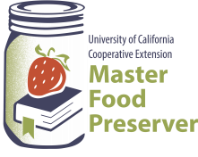Preserve Today, Relish Tomorrow

**UCCE Master Food Preservers of El Dorado County**

**311 Fair Lane, Placerville CA 95667**

**Helpline (530) 621-5506 •** [**Email: edmfp@ucanr.edu**](mailto:edmfp@ucanr.edu) **• Visit us on Facebook and Twitter!**

**Let’s Make A Dill**

**Quick-Process Pickling Fundamentals**

## Use the Right Equipment

* Standard canning jars, lids, and rings must be used.
* A deep, non-reactive kettle, stainless steel, enameled, or glass, must be used for cooking the product.
* Use a reputable recipe for the best results, as these recipes have been tested for quality, flavor, and ***safety***.

## Open Kettle Canning

* Open kettle canning involves heating the food to boiling, pouring it into the jars, applying lids, and allowing the heat of the jar to cause the lid to seal, without further processing.

## The USDA does not recommend this method of canning.

**Use the Best Ingredients**

* Select produce of good flavor and color, but not fully ripe.
* Cane or beet sugar can be used with equal success.

## Getting Ready: Be Prepared!

* Read the recipe thoroughly before you begin. Measure out all ingredients and have all needed utensils at hand. Make sure your vinegar is 5% acidity (read label).
* Do not change the quantities of produce nor vinegar in any recipe, unless specified in a tested recipe.
* Check the jar for flaws. Wash jars, lids, and rings in hot soapy water and rinse well. Place clean jars into the boiling water canner and heat the jars.
* To prepare lids, follow the manufacturer’s directions on the lid package; some say to heat and some say just wash.

## Fill and Seal Jars Properly

* 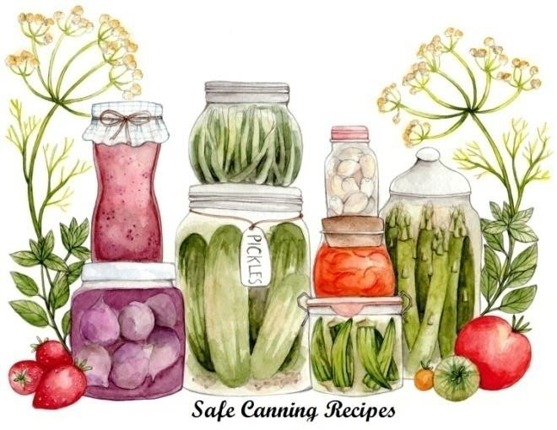Fill hot jars with hot mixture. Leave headspace specified in the recipe.
* Wipe the rim with a clean, damp, paper towel.
* Place lids and rings on jars. Tighten the rings only fingertip tight.
* Paraffin, as a sealing agent, is not recommended.

## Boiling Water Canner Processing

* Place jars in a canner with a spacer or rack in the bottom of the canner. The jars should not sit directly on the bottom of the canner. Water should be very hot but not boiling. Add enough water to cover the tops of the jars by at least 1".
* Place lid on canner. Bring the water to a rolling boil then reduce the heat to a gentle boil. Begin to count processing time when the water comes to a boil. Process for the time indicated in the recipe.

UCCE Master Food Preservers of El Dorado County, Helpline (530) 621-5506, [edmfp@ucanr.edu](mailto:edmfp@ucdavis.edu). Visit us on Facebook & Twitter! 1

## Atmospheric Steam Canners

* Use a research tested recipe and processing time developed for a **boiling water** canner when using an atmospheric steam canner. An atmospheric steam canner may be used with recipes approved for half-pint, pint, or quart jars.
* If using a canner with a temperature sensor, begin processing time when the temperature marker is in the green zone for your altitude.If using a canner without a temperature sensor, begin processing time when a steady stream of steam, 4-6 inches long, is visible from the vent hole(s).
  + **Caution!** The gauge on atmospheric steam canner cannot be calibrated. Therefore, one should not depend on them for accuracy. Just use them as a guide. Always check the steam plume
* Set the timer for the total minutes required for processing the food, adjusting for altitude. Processing time must be limited to **45 minutes or less, including any modification for elevation**. The processing time is limited by the amount of water in the canner base. When processing food, **do not** open the canner to add water.
* Monitor the temperature sensor and/or steady stream of steam throughout the entire timed process. Regulate heat so that the canner maintains a temperature of 212°F.
  + A canner that is boiling too vigorously can boil dry within 20 minutes. If a canner boils dry, the food is considered under-processed and therefore potentially unsafe.
  + Maintain a ***gentle boil***. Aside from keeping the jars from rattling around and bumping into each other and possibly breaking, there’s another reason – canner belching. If it’s boiling hard the lid may rise up just a little and belch out some steam. It will also suck cold air in!
* At the end of the processing time, turn off the heat, wait 2-3 minutes and remove the lid, lifting the lid away from you.

## Adjusting for Altitude

|  |  |
| --- | --- |
| Altitude Chart | |
| Altitude in feet | Increase processing time |
| 1000 - 3000 | 5 minutes |
| 3001 - 6000 | 10 minutes |
| Above 6001 | 15 minutes |

* Not everybody lives at the same altitude. At sea level, water boils at 212oF. All recipes are developed using sea level as the criteria for processing times. At higher altitudes water will boil at a lower degree.
* Adjustments have to be made to ensure safe canning. If you are at a higher altitude you must adjust the processing times according to the included chart.

## Food safety tips

* Wash hands and forearms frequently: after using toilet, after changing baby's soiled diaper, after touching animals, before handling food, and after touching raw meat, fish and poultry.
* 20-second rule: wash hands for 20-seconds.
* Use disposable gloves if you have a cut or sore on your hands.

***When in doubt - throw it out***

* DANGER - Never taste food that looks or smells strange to see if it can still be used. Just discard it.
* Generally foods that contain bacteria will look, smell, and taste normal.
* Generally speaking most bacteria that cause food borne illness are odorless, colorless, and tasteless.

## General cleaning tips

* Run sponges and pot scrubbers through the dishwasher frequently.
* Change dish cloths daily.
* Mop up spilled juices from meat, fish or poultry immediately using a disposable paper towel.
* Use a disinfecting solution consisting of 1 ½ teaspoon of chlorine bleach to 1 pint of water. Dispense with a spray bottle to disinfect countertops, cutting surfaces, etc. Make a new solution every week.
* AVOID CROSS CONTAMINATION. ALWAYS wash your hands, knives, cutting boards, and food preparation surfaces well with soapy water before and after any contact with raw meat, fish, or poultry.
* Rinse all fresh fruits and vegetables well under running water before preparing or eating them. Do not soak.

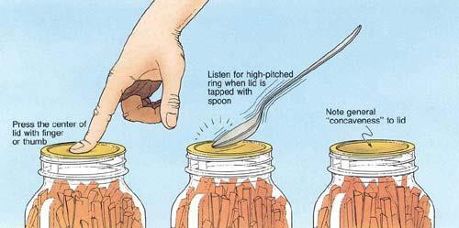

## Basic canning tips

* Remove the jars from the canner as stated in the recipe. When you remove the jars from the canner after processing, hold upright; do not disturb the seal. Do not retighten the rings.
* Place the hot jars on a rack or folded towel away from drafts. Keep the jars separated so they will cool evenly.
* Leave the ring bands on the jars until they have cooled thoroughly. Do not try to dump the water off the lids.
* Some canning books still recommend inverting jars after removing them from the boiling water canner. ***The USDA does not recommend this method.***
* After the jars have cooled (allow 24 hours), remove the ring bands. Look at the top of each jar. If the lid is slightly concave, it indicates a seal. Test the seal by pressing on the lid with your finger; the lid should not give. If you are not sure a jar is sealed, carefully lift the jar by the lid after removing the ring band. If not properly sealed, the lid will come off.
* Remove ring bands. Wash and dry ring bands and store for later use. Store jars without rings.
* Clean the jars to remove sticky residue.
* Label and date the jars, and store in a cool, dark, dry area.

## Reprocessing

* 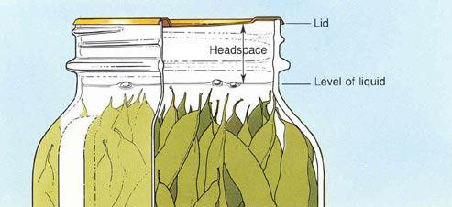If a jar does not seal, refrigerate and use within a few days, or reprocess it within 24 hours using a new metal lid. Check the jar for flaws. Process by the method originally advised and for the full length of time.

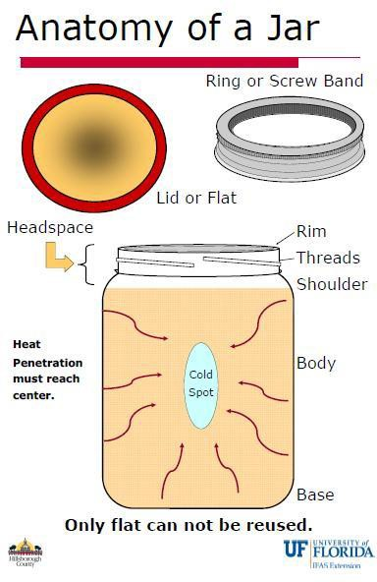

**Pickles**

A pickle is any fruit or vegetable preserved in vinegar or brine.

* **Brine pickles** are products fermented in salt brine. Regular dill pickles and sauerkraut are fermented and cured for about 3 weeks. They may be canned or stored in the refrigerator for 4-6 months.
* **Refrigerator dills** are not heat processed and must be stored in the refrigerator for 4-6 months.
* **Fresh-pack or quick-process pickles** are not fermented; some are brined several hours or overnight, then drained and covered with vinegar and seasonings.
* **Fruit pickles** are fruits that are pickled in spicy, sweet-sour syrup.
* **Relishes** are prepared using chopped products and cooked in a spicy vinegar solution.

Be sure to remove and discard a 1/16-inch slice from the blossom end of fresh cucumbers. Blossoms may contain an enzyme which causes excessive softening of pickles.

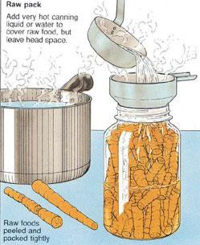

***Raw (Cold) Pack Or Hot-Pack***

# The raw, or cold-pack, method means packing the cold or raw food into a hot jar, then adding boiling liquid brine. The jars are then processed in a boiling-water canner. Fruits such as apricots, berries, cherries, grapes, plums, rhubarb and tomatoes are best if packed raw. Most vegetables can be packed raw (cold-packed) if processed in the pressure canner.

The hot-pack method requires a short pre-cooking period (boiling or heating in some manner). Then the boiling-hot product is packed into clean, hot jars and processed immediately. The hot-pack method is more satisfactory for some vegetables and fruits and it is recommended for peaches, pears and pineapple. Benefits include a tighter pack and, because food expels air when heated, less float.

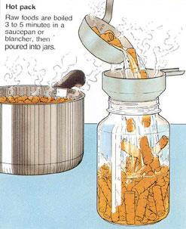

# Use the method suggested in your tested recipe for best flavor and texture.

### *Salt*

* Use canning or pickling salt. Table salt contains anti-caking ingredients which can cloud the brine.
* Since flake salt varies in density (grain size), it is not recommended for making pickled and fermented foods. (If you must substitute Kosher salt, it is lighter than canning salt so you need to use the same amount of salt by weight, not volume.

In our class experiment, **1/2 cup pickling salt = 1 cup plus 2 Tablespoons Kosher salt**.)

### *Vinegar*

The level of acidity in a pickled product is as important to its safety as it is to taste and texture. When pickling, always use high-quality commercial vinegars with 5% acidity or higher (also listed as 50-grain). The acidity should be listed on the label; if not, assume it is not 5%.

* Do not alter vinegar, food, or water proportions in a recipe or use a vinegar with unknown acidity. Doing so may alter its preservative effect and undermine the safety of the product.
* Use only recipes with tested proportions of ingredients.
* White distilled and cider vinegars of 5% acidity are recommended. White vinegar is usually preferred when light color is desirable.
* Do not use homemade vinegar as the acidity is unknown. It also produces a cloudy brine that may make your products appear spoiled.

### *Water*

* Soft water makes the best brine for pickles
* Hard water may cause cloudiness in the brine and discolor pickles. If only hard water is available, boil and let site for 24 hours. Skim off scum and use water from the top of the container without disturbing the sediment.

### *Pickles with reduced salt content*

In the making of fresh-pack pickles, cucumbers are acidified quickly with vinegar. Use only tested recipes formulated to produce the proper acidity. While these pickles may be prepared safely with reduced or no salt, their quality may be noticeably lower. Both texture and flavor may be slightly, but noticeably, different than expected. You may wish to make small quantities first to determine if you like them.

However, the salt used in making fermented sauerkraut and brined pickles not only provides characteristic flavor but is also vital to safety and texture. In fermented foods, salt favors the growth of desirable bacteria while inhibiting the growth of others. **Caution: Do not attempt to make sauerkraut or fermented pickles by cutting back on the salt required.**

### *Sugars*

White granulated and brown sugars are most often used. Corn syrup and honey, unless called for in reliable recipes, may produce undesirable flavors.

### *Spices*

Use fresh whole spices for the best quality and flavor in pickles. Powdered spices may cause the product to darken and become cloudy. Pickles will darken less if you tie whole spices loosely in a clean white cloth or cheesecloth bag and then remove the bag from the product before packing the jars.

### *Firming Agents*

If good quality ingredients are used in pickling and up-to-date methods are followed, lime and alum are not needed for crisp pickles. If you choose to use firming agents, alum may be safely used to firm fermented cucumbers. Alum does not have an effect on quick-processes pickles. However, since it is unnecessary, it is not included in these recipes.

* Soaking cucumber in ice water for 4 to 5 hours prior to pickling is a safe method for making crisp pickles.
* The calcium in pickling lime does improve pickle firmness. Food-grade lime may be used as a lime-water solution for soaking fresh cucumbers 12 to 24 hours before pickling them. However, EXCESS LIME ABSORBED BY THE CUCUMBERS MUST BE REMOVED TO MAKE SAFE PICKLES. To remove excess lime, drain the lime-water

solution, rinse and then re-soak the cucumbers in fresh water for 1 hour. Repeat the rinsing and soaking steps two more times.

* Calcium chloride for pickling is often sold where you buy canning supplies. It is usually added directly to the jars of pickles. Follow the instructions on the package.

### *Other considerations:*

* ***Yellow crystals on pickled asparagus:*** Sometimes pickled asparagus will form yellow crystals. Do not panic!!! According to San Joaquin County extension, "when asparagus is heated with acid (such as vinegar), rutin is drawn out of the asparagus plant. It then becomes insoluble in the vinegar and crystallizes on the exterior of the asparagus stems. In commercially canned asparagus, a small amount of tin salts are added to the pickling solution, which prevents the rutin from crystallizing."
* ***Blue garlic***: Garlic contains anthocyanins, water- soluble pigments that can turn blue or purple in acidic environments like vinegar or pickling brine - the garlic is still safe to eat. Garlic should be fresh and at the peak of maturity. Immature or sprouting garlic can turn blue in the jar

### *For Best Results …*

* Marinate refrigerator pickles in the refrigerator for at least two weeks before serving and use within 3 months.
* Store fresh-pack/quick pickles for 4-6 weeks in a cool, dry, dark place to allow the flavors to mellow and blend.

### *Alternative Low-Temperature Pasteurization Process*

* Low-temperature pasteurization can produce a better pickle texture, but must be done very carefully to avoid spoilage and is only acceptable for certain recipes. Fill jars with room temperature pickles. Pour 165° to 180° F liquid over the product, leaving the appropriate headspace. Remove bubbles with a rubber spatula. Wipe the jars clean and adjust lids. Process at 180˚F for 30 minutes. Be sure to use a thermometer.

## Caution: Use this process only when a recipe indicates and only for cucumbers and zucchini.

### *Preventing Spoilage*

Pickle products are subject to spoilage from microorganisms, particularly yeasts and molds, as well as enzymes that may affect flavor, color, and texture. Processing the pickles in a boiling-water or steam canner will prevent these problems.

Standard canning jars and self-sealing lids are recommended. Processing times and procedures will vary according to food acidity and the size of food pieces.

***Homemade Pickling Spice Yield: ½ cup***

* 1 cinnamon stick (about 4 inches) broken into pieces
* 5 bay leaves, crushed
* 2 Tbsp. mustard seeds
* 1 Tbsp. whole allspice
* 1 Tbsp. coriander seeds
* 1 Tbsp. whole black peppercorns
* 1 Tbsp. ground ginger
* 1 Tbsp. dill seeds
* 2 tsp. cardamom seeds
* 1 to 2 tsp. hot pepper flakes (optional)
* 1 tsp. whole cloves

In a small glass or stainless steel bowl combine all ingredients. Stir well. Store in jars or another air-tight container for up to 1 year.

***Dilled Green Beans Yield: about 8 pint jars***

* 4 lbs fresh tender green or yellow beans (5 to 6 inches long)
* 8 to 16 heads fresh dill or ½ tsp. dill seeds per jar
* 8 cloves garlic (optional)
* 1/2 cup canning or pickling salt
* 4 cups white vinegar (5 percent)
* 4 cups water
* 1 tsp hot red pepper flakes (optional)

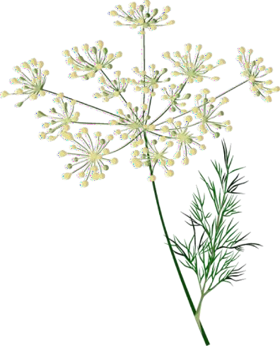Wash and trim ends from beans and cut to 4-inch lengths. In each pint jar, place 1 to 2 dill heads and, if desired, 1 clove of garlic. Place whole beans upright in jars, leaving 1/2-inch headspace. Trim beans to ensure proper fit, if necessary. Combine salt, vinegar water, and pepper flakes (if desired). Bring to a boil. Add hot solution to beans, leaving 1/2-inch headspace.

Process in a boiling water canner or atmospheric steam canner for 10 minutes 0- 6000 ft., 20 above 6000 ft.

For boiling water canning, turn off the heat, remove canner lid and wait 5 minutes. For atmospheric steam canning, turn off the heat, leave canner lid on and wait 2-3 minutes.

*Source: So easy To Preserve*

***Dilled Zucchini Slices Yield: about 4 pint jars***

* 4 ½ lb. zucchini, 12 – 14 medium
* 3 Tbsp. pickling salt
* 2 ½ cups white vinegar
* 1 ¼ cups granulated sugar
* 1 tsp. each: celery seed and dill seed
* 1 medium cooking onion, thinly sliced
* 4 garlic cloves, sliced
* 4 sprigs dill weed

Wash zucchini, retaining peel and removing ends; cut into ¼-inch slices. Layer zucchini and salt in a large glass, enamel or stainless steel bowl; let stand 1 hour.

In a stainless steel or enamel saucepan, combine vinegar, sugar, celery and dill seeds; bring to a boil.

Rinse zucchini in cold water; drain thoroughly; pat dry. Add zucchini and onions to pickling liquid; bring to a boil; boil 5 minutes.

Place 1 clove of sliced garlic and 1 large sprig of dill weed in a hot jar. Pack zucchini and onions into a hot jar to within ¾ inch of headspace. Add boiling hot liquid to cover vegetables to within ½ inch of top of jar (headspace). Using nonmetallic utensil, remove air bubbles and adjust headspace, if required, by adding more vegetables and hot liquid. Wipe jar rim removing any food residue. Center lid on clean jar rim. Screw band down until resistance is met, then increase to fingertip-tight. Return filled jar to rack in canner. Repeat for remaining vegetables and hot liquid.

Process in a boiling water canner or atmospheric steam canner for 10 minutes 0-1000 ft., 15 minutes 1001-6000 ft., 20 minutes above 6000 ft.

For boiling water canning, turn off the heat, remove canner lid and wait 5 minutes.

For atmospheric steam canning, turn off the heat, leave canner lid on and wait 2-3 minutes.

*Source:* [*https://www.bernardin.ca/recipes/en/dilled-zucchini-slices.htm*](https://www.bernardin.ca/recipes/en/dilled-zucchini-slices.htm)

***Sweet Dill Refrigerator Pickles Yield: about 4 pint jars***

* 12 large Dill Pickles prepared by the “Quick Dill “method or use pickles purchased at the store. (10 to 12 large dill pickles purchased in brine.}
* 1 cup apple cider vinegar, 5%
* 2 cups sugar
* 2 garlic cloves
* 2 Tsps. pickling spice

Purchase a large jar of dill pickles, approximately 10 to 12 pickles. Drain the brine from the jar. Cut the pickles into spears or slices

Prepare the new brine consisting of 1 cup cider vinegar and 2 cups of sugar. Bring brine to a boil

Put the cut pickles back into the jar they came from. Add 2 garlic cloves and 2 tsps. of pickling spice

Pour the freshly made brine over the pickles in the jar. Cover and refrigerate for several days before eating.

Note: If you do not want the pickles to have the spices floating on them you can wrap the spices in a piece of cheese cloth which is tied into a bag, use a tea infuser or purchase a spice bag.

I use Apple Cider Vinegar but you can use white wine vinegar or plain white vinegar. Just make sure the vinegar is 5% acidity.

*Source: Safe Methods for Preparing Pickles, Relishes & Chutneys, UC Cooperative Extension Publication 4080.*

***Pickled Roasted Red Peppers Yield: about 4 pint jars***

* + 4 large cloves garlic, roasted, removed, from skin and mashed
  + 1 ½ cups white cider vinegar, 5%
  + 1 ½ cups cider vinegar (5%)
  + 1 ½ cups dry white wine
  + ½ cups water
  + 1 cup coarsely chopped onion
  + ½ cups granulated sugar
  + 2 Tbsps. Dried oregano
  + 4 tsp. pickling salt
  + 20 medium sweet red peppers, such as red bell or Shepherd, roasted, peeled, seeded, deveined, and cut lengthwise into serving size piece

Roast peppers and garlic on a grill or under a broiler until charred, turning to roast all sides. Once the skin of the peppers wrinkles and chars and garlic has charred spots, remove from heat. Place peppers in a bag until cool enough to handle, about 15 minutes, then lift off the skins. Cool garlic, Squeeze roasted garlic cloves to remove the peel.

In a large stainless-steel saucepan, combine all ingredients accept the peppers. Bring to a boil over medium heat, stirring to dissolve sugar. Reduce heat and boil gently for 5 minutes, until garlic and oregano flavors have infused the liquid.

Pack room temperature peppers into hot jars to within a generous ½ inch of the top of the jar. Ladle hot pickling liquid into jar to cover the peppers, leaving ½ inch headspace. Remove air bubbles and adjust headspace by adding or subtracting hot pickling liquid. Wipe rim clean. Place lids and rings in jars, tightening rings finger-tip tight.

Process in a boiling water canner or atmospheric steam canner for 15 minutes 0-1000 ft., 15 minutes 1001-6000 ft., 20 minutes above 6000 ft.

For boiling water canning, turn off the heat, remove canner lid and wait 5 minutes.

For atmospheric steam canning, turn off the heat, leave canner lid on and wait 2-3 minutes.

*Source: Ball Complete Book of Home Preserving, 2006/2012*

### *Let’s Make A Dill July 16, 2022*

***Antipasto Relish Yield: about 6 half-pint jars***

* 7 whole black peppercorns
* 4 bay leaves
* 1 ¾ cups white vinegar
* 1 cup lightly packed brown sugar
* 2 Tbsp. salt
* 4 cloves garlic, finely chopped
* 1 Tbsp. dried oregano
* 6 cups coarsely chopped cored peeled tomatoes (about 6 medium)
* 3 bell peppers (1 each green, red and yellow), seeded and chopped
* 2 carrots, peeled and diced
* 1 stalk celery, diced
* 1 large onion, coarsely chopped

Tie peppercorns and bay leaves in a square of cheesecloth, creating a spice bag.

Combine vinegar, brown sugar, salt, garlic, oregano and spice bag in a large stainless steel saucepan. Bring to a boil over high heat, stirring to dissolve sugar. Stir in tomatoes, peppers, carrots, celery and onion. Reduce heat and boil gently, stirring frequently, for 1 hour, until thickened to the consistency of a thin commercial relish. Discard spice bag.

Ladle hot relish into hot jars leaving ½ inch headspace. Remove air bubbles. Wipe rim. Center lid on jar. Apply band until fit is fingertip tight. Place jar in boiling water canner. Repeat until all jars are filled.

Process in a boiling water canner or atmospheric steam canner for 10 minutes 0-1000 ft., 15 minutes 1001-6000 ft., 20 minutes above 6000 ft.

For boiling water canning, turn off the heat, remove canner lid and wait 5 minutes.

For atmospheric steam canning, turn off the heat, leave canner lid on and wait 2-3 minutes. .

*Source:Ball Complete Book of Home Preserving, 2006/2012*

***Pickled Cherries Yield: about 3 pint jars***

* 1 ½ cups white vinegar
* 2 cups granulated sugar 2 Tbsp. pickling salt
* 1 vanilla bean, split
* 7 whole cloves
* 7 star anise
* 7 cinnamon sticks, 3 inches long
* 2 ¾ lbs. dark, sweet cherries, washed, stemmed, and pitted

Combine first 3 ingredients in a medium stainless steel or other non-reactive saucepan. Scrape seeds from vanilla bean; add seeds and bean to vinegar mixture. Bring to a boil, stirring until sugar and salt dissolve.

Place 1 clove, 1 star anise, and 1 cinnamon stick into a hot jar. Pack cherries firmly into the jar, leaving ½ inch headspace. Remove vanilla bean from the brine.

Remove hot jars from the canner and pack cherries into jars. Pour hot syrup over cherries to within ½ inch of jar rim. Remove air bubbles and adjust headspace, if necessary, by adding more hot pickling liquid. Wipe rim and center lid on jar. Screw band down until resistance is met, then increase to fingertip-tight.

Process in a boiling water canner or atmospheric steam canner for 10 minutes 0-1000 ft., 15 minutes 1001-6000 ft., 20 minutes above 6000 ft.

For boiling water canning, turn off the heat, remove canner lid and wait 5 minutes.

For atmospheric steam canning, turn off the heat, leave canner lid on and wait 2-3 minutes.

*Source: ballmasonjars.com*

UCCE Master Food Preservers of El Dorado County, Helpline (530) 621-5506, [edmfp@ucanr.edu](mailto:edmfp@ucdavis.edu). Visit us on Facebook & Twitter! 9

### *Let’s Make A Dill July 16, 2022*

* 3 cinnamon sticks (each about 4 inches) broken into pieces

***Pickled Pineapple Yield: about 4 pint jars***

* ½ tsp. whole allspice
* ¼ tsp. whole cloves
* 2 cups lightly packed brown sugar
* 1 cup red wine vinegar
* 1 cup unsweetened pineapple juice
* 2 fresh pineapples, peeled, cored and cut into 1- inch spears

Tie cinnamon stick pieces, allspice and cloves in a square of cheesecloth, creating a spice bag.

In a large stainless steel saucepan, combine sugar, vinegar, pineapple juice and spice bag. Bring to a boil over medium- high heat, stirring occasionally. Reduce heat, cover and boil gently for 20 minutes. Add pineapple and boil gently until pineapple is heated through. Using a slotted spoon, remove the pineapple from syrup. Place in a large glass or stainless steel bowl and cover with foil to keep hot. Return syrup to a boil over medium-high heat. Discard spice bag.

Pack pineapple into hot jars to within a generous ½-inch of top of jar. Ladle hot syrup into jar to cover pineapple, leaving

½-inch headspace. Remove air bubbles and adjust headspace, if necessary, by adding or removing hot syrup. Wipe rim clean. Place lids and rings on jars, tightening rings finger-tip tight. Process in a boiling water canner or atmospheric steam canner for 10 minutes 0-1000 ft., 15 minutes 1001-6000 ft., 20 minutes above 6000 ft. For boiling water canning, turn off the heat, remove canner lid and wait 5 minutes.

For atmospheric steam canning, turn off the heat, leave canner lid on and wait 2-3 minutes.

*Source:Ball Complete Book of Home Preserving, 2006/2012*

***Resources:***

**National Center for Home Food Preservation**: <http://nchfp.uga.edu/>

**Complete Guide to Home Canning**. 2015. [http://nchfp.uga.edu//publications/publications_usda.html](http://nchfp.uga.edu/publications/publications_usda.html) Also available in paper copy from Purdue Extension (online store is located at <https://mdc.itap.purdue.edu/item.asp?item_number=AIG-539>)

**Canning Vegetables**, 2012. Publication 8072. University of California Ag & Natural Resources, [http://anrcatalog.ucanr.edu.](http://anrcatalog.ucanr.edu/)

**So Easy to Preserve,** Sixth Edition. 2016. Bulletin 989. Cooperative Extension/University of Georgia, Athens

**Ball Blue Book Guide to Preserving**. 2020. Newell Corporation.

**Ball Complete Book of Home Preserving**, 2020. Bernardin, Newell Corporation.

It is the policy of the University of California (UC) and the UC Division of Agriculture & Natural Resources not to engage in discrimination against or harassment of any person in any of its programs or activities (Complete nondiscrimination policy statement can be found at <http://ucanr.edu/sites/anrstaff/files/215244.pdf> )

17-16-2022

UCCE Master Food Preservers of El Dorado County, Helpline (530) 621-5506, [edmfp@ucanr.edu](mailto:edmfp@ucdavis.edu). Visit us on Facebook & Twitter! 10