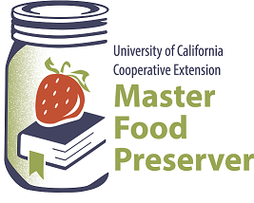

**UCCE Master Food Preservers of El Dorado County**

**311 Fair Lane, Placerville CA 95667**

**Helpline (530) 621-5506 • Email:** [**edmfp@ucanr.edu**](mailto:edmfp@ucanr.edu) **• Visit us on Facebook!**

“Preserve today, Relish tomorrow”

**THE THANKSGIVING TABLE**

*A Feast of Preserves for Your Holiday Meal – and Beyond*

Saturday, October 22, 2022

9:30 a.m. – 12:00 noon

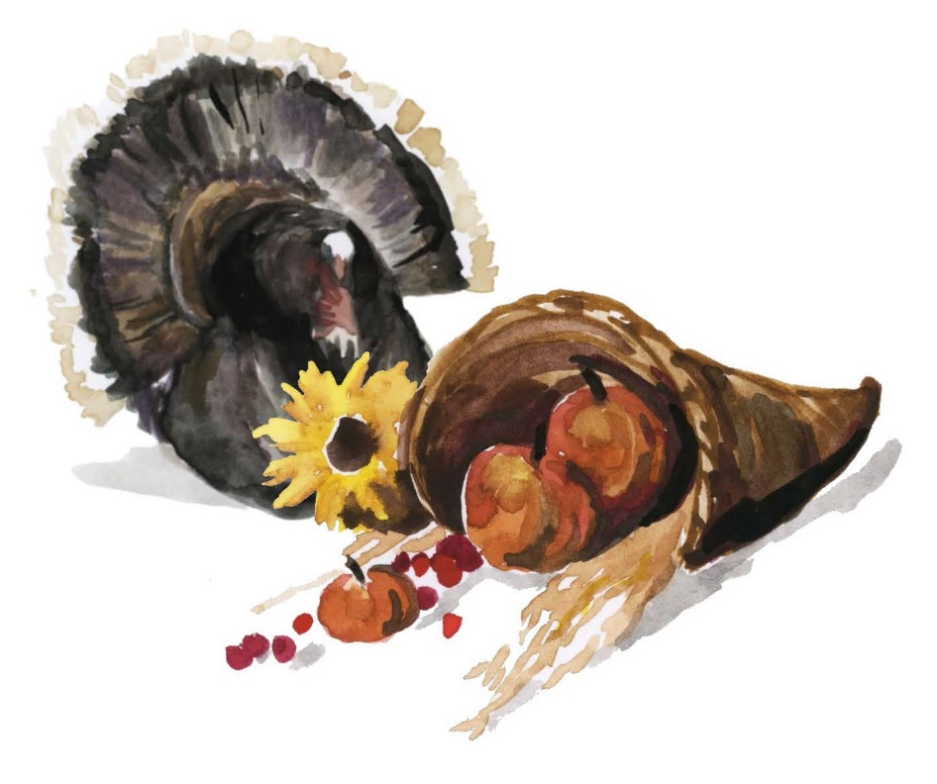

Join us for this fun and informative class where we’ll present a cornucopia of tips, tricks, and techniques to help you safely preserve, serve, and store a bounty of wonderful foods for your holiday.

We’ll cover holiday food safety, and then offer loads of recipes and creative ideas for the big holiday feast (and beyond). From appetizers to desserts to leftovers, to gifts for the host/hostess, and much more, you’ll come away with plenty of inspiration.

**Basic Food Safety & Sanitation**

When preparing food for preservation, cleanliness is essential in preventing food-borne illness.

Please review the accompanying handout, ***Core Canning Techniques***, for basic food safety information, including details on cleaning and sanitizing; avoiding cross-contamination, how to wash (or not wash!) fruits, vegetables and meats; and other food safety tips. Remember:

**Clean Work Area ⬩ Wash Hands ⬩ No Cross-Contamination ⬩ Prepare Food Properly**

**Canning Basics**

To ensure safety when canning, it’s critical to follow a current, research-based recipe and to use the correct canning method. Please review the accompanying handout, ***Core Canning Techniques***, which covers the essentials of home canning, including the types of canners and which types of foods they are appropriate for; preparing jars and lids; step-by-step processing instructions; and helpful tips for canning success.

**Let’s Talk Turkey**

It’s that time of year again…the time when the turkey anxiety level begins to rise. Memories of under-done meat, over-done birds imploding, and other sad moments will be a thing of the past – all it takes is some advance thought and preparation.

**PLANNING IS KEY:** When possible, plan as much of your menu several weeks before the holiday. If turkey is on the menu, whether it’s fresh or frozen (and its size as well) can have a big impact on your timeline, and you will need to plan accordingly.

**FRESH OR FROZEN?** There is no appreciable difference between fresh and frozen turkeys; it’s just a personal preference as to which you choose. Frozen turkeys can be purchased at any time, provided that you have adequate storage space in your freezer. Keep frozen turkeys frozen until ready to thaw. Purchase fresh turkeys 1-2 days before cooking.

**PRE-STUFFED TURKEYS:** If you prefer a pre-stuffed turkey, choose one that has been commercially frozen and has a USDA or state mark of inspection. **Fresh pre-stuffed turkeys can be unsafe and are not recommended.**

**HOW MUCH?** The next decision is the size of the turkey to purchase. Plan on the following amounts, based on whether you purchase a whole or partial turkey.

*Whole Turkey:* 1 pound per person (1½ lbs if you want leftovers)

*Breast of Turkey:* ¾ pound per person

*Boneless Breast of Turkey:* ½ pound per person

*Pre-stuffed Frozen Turkey:* 1¼ pounds per person (keep frozen until ready to cook)

**NO WASHING!** Poultry (as well as meat and fish) should not be washed, as that can spread pathogenic bacteria. See ***Core Canning Techniques*** for safe handling and sanitizing info.

**Let’s Talk Turkey (cont.)**

**THAWING:** Because of the long defrosting time, planning in advance is key, as noted above.

To thaw a frozen turkey in the refrigerator, place it in its original wrapper on a tray or in a pan to catch any juices that may leak. Allow approximately 24 hours of thawing time per 4-5 lbs. of whole turkey. Once thawed, keep the turkey refrigerated for only 1-2 days. If necessary, a turkey properly defrosted in the refrigerator may be refrozen.

If you forgot to thaw the turkey in time or don’t have room in your refrigerator for thawing, the bird may be thawed in cold water. Wrap the turkey well, making sure water is not able to leak through the wrapping. Submerge the turkey in cold water, and change the water every 30 minutes to maintain the cold temperature. Allow about 30 minutes of defrosting time per pound of whole turkey. *A turkey defrosted in water cannot be safely refrozen.* **Cook the turkey immediately after it is thawed.**

|  |  |  |
| --- | --- | --- |
| **TURKEY THAWING CHART** | | |
| **Weight** | **Refrigerator** | **Cold Water** |
| 4 – 12 lbs | 1 – 3 days | 2 – 6 hours |
| 12 – 16 lbs | 3 – 4 days | 6 – 8 hours |
| 16 – 20 lbs | 4 – 5 days | 8 – 10 hours |
| 20 – 24 lbs | 5 – 6 days | 10 – 12 hours |

**NOTE: DO NOT THAW POULTRY (OR ANY MEAT) AT ROOM TEMPERATURE!**

**THE DAY BEFORE:** Avoid stress levels – and an emergency run to the market – by checking to make sure you have all of the ingredients and equipment necessary. You’ll need a roasting pan large enough to hold the turkey as well as a meat or food thermometer. Wet and dry stuffing ingredients can be prepared in advance and stored *separately* in the refrigerator until they are ready to be cooked in a casserole dish or the turkey. **Do not stuff the turkey until it’s ready to be cooked.** Refer to the *Stuffing – In or Out?* section below for further details.

**COOKING:** A turkey may be cooked frozen, or after thawing. A frozen turkey will take at least 50% longer to cook than a fully thawed bird. Be sure to remove the giblets from the turkey cavity before stuffing and cooking. If cooking a frozen turkey, remove the bag of neck and giblets from the cavity after cooking for 3 hours, then continue cooking. Cook the neck and giblets separately.

Whether cooking a fresh, thawed, or still-frozen turkey, **always cook it until the correct minimum internal temperature is reached (165°F)**. Doneness should be checked with a food thermometer – don’t rely on time or the pop-up thermometer in the bird. Insert the tip of the thermometer into the thickest part of the thigh, away from the bone. If the temp there has reached 180°F, there is usually no other part of the bird lower than the safe temperature of 165°F. To be sure, check the temperature at several locations, including the breast and the wing joint. **And do clean the thermometer’s probe after each use!**

**Let’s Talk Turkey (cont.)**

The following cooking times are for fresh or thawed turkey in an oven at 325°F. The USDA does not recommend cooking a turkey at an oven temperature lower than 325°F. It is safe to roast a still-frozen turkey, however cooking times will be approximately 50% longer than that for a fresh or thawed bird. Note that all turkey meat – including any that remains pink – is safe to eat as long as all parts have reached at least 165°F. Stuffing, whether cooked in the bird or in a separate dish, should also reach a minimum temperature of 165°F.

|  |  |  |
| --- | --- | --- |
| **TURKEY COOKING TIMES** | | |
| **Weight** | **Unstuffed** | **Stuffed** |
| 4 – 8 lb breast | 1 ½ - 3 ¼ hrs | not applicable |
| 8 – 12 lbs | 2 ¾ – 3 hours | 3 – 3 ½ hours |
| 12 – 14 lbs | 3 – 3 ¾ hours | 3 ½ – 4 hours |
| 14 – 18 lbs | 3 ¾ – 4 ¼ hours | 4 – 4 ¼ hours |
| 18 – 20 lbs | 4 ¼ - 4 ½ hours | 4 ¼ - 4 ¾ hours |
| 20 – 24 lbs | 4 ½ – 5 hours | 4 ¾ – 5 ¼ hours |

After checking with a thermometer that both the turkey and the stuffing are done, remove the turkey from the oven and let it stand for 20 minutes to allow the juices to settle. Remove the stuffing from the cavity (if applicable) and carve the turkey.

**LEFTOVER TURKEY:** Discard any turkey or side dishes left out at room temperature longer than 2 hours (1 hour in temperatures above 90°F). See *The 2-Hour Rule* section below for further details. Cut the turkey into small pieces. Refrigerate turkey, stuffing, and gravy separately in shallow containers. Use leftover turkey and stuffing within 3 to 4 days; use leftover gravy within 1 to 2 days. These foods can be frozen for longer-term storage. Always reheat turkey, stuffing and gravy to a temperature of 165°F or until hot and steaming.

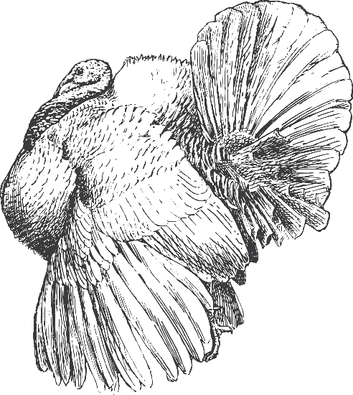

**Stuffing – In or Out?**

The USDA recommends *against* cooking stuffing inside the cavity of whole turkeys, for one main reason: bacteria. Warm, moist stuffing is an ideal environment in which bacteria can proliferate, potentially causing foodborne illness. Stuffing that’s cooked inside the bird may not reach the correct temperature for killing off bacteria, even if the turkey itself reaches the correct temp. **For safety, it’s best to cook stuffing separately.** (And a side benefit is that the turkey will cook more quickly without the stuffing.)

However you decide to cook the stuffing, follow these preparation and cooking safety tips.

* do not make *fully prepared uncooked* stuffing ahead of time
* wet and dry ingredients for stuffing can be prepared separately, then refrigerated
* *fully prepared cooked stuffing* can be made ahead, then refrigerated for serving later
* once stuffing ingredients are mixed together, make sure the stuffing is evenly moist (heat destroys bacteria more rapidly in a moist environment), then place in the vessel of your choice (casserole dish, slow cooker, or the turkey cavity) and cook immediately
* if stuffing the turkey, stuff *loosely* – about ¾ cup of stuffing per pound of turkey
* do not stuff the turkey until it is ready to be cooked
* cook stuffing in an oven at a temperature setting no lower than 325°F
* use a food thermometer to make sure that the stuffing reaches at least 165°F
* refrigerate stuffing within 2 hours after cooking

Stuffing may be safely made in a slow cooker, following these guidelines. Refer to the *Slow Cooker Safety* section below for additional safety information on using slow cookers.

* make sure that the stuffing is very moist
* loosely fill the slow cooker, no more than ⅔ full
* ensure that the lid fits tightly on the slow cooker
* start cooking on the high setting for at least 1 hour before reducing to low

For further information on safely cooking stuffing (and the turkey, too), visit these websites:

<https://www.fsis.usda.gov/food-safety/safe-food-handling-and-preparation/poultry/stuffing-and-food-safety>

<https://www.fsis.usda.gov/food-safety/safe-food-handling-and-preparation/poultry>.

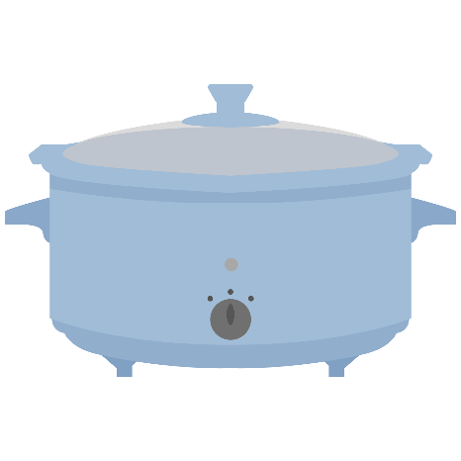

**THANKSGIVING TURKEY HOTLINES**

If you have questions about preparing your turkey – whether during the days leading up to Thanksgiving or even on the day itself, there are several resources available.

**The USDA Meat and Poultry Hotline**

**1-888-MPHOTLINE (1-888-674-6854)**

Thanksgiving Day: 8am – 2pm ET

Year-round: Monday-Friday 10am – 6pm ET

**Butterball Turkey Talk-Line**

**1-800-BUTTERBALL (1-800-288-8372)**

Thanksgiving Day: 5am – 6pm CST

Weekdays, November & December: 8am – 8pm CST

**Online, Chat, & Other Resources**

**Ask USDA:** <https://ask.usda.gov/s/> (24/7; live chat during hotline hours)

**USDA Online Info:** <https://www.fsis.usda.gov/food-safety>

**U. Wyoming Extension:** https://wyoextension.org/publications/html/MP135/

**Butterball Skill on Amazon Alexa** (“*Alexa, ask Butterball…*”)

**Butterball Email / Live Chat:** <https://www.butterball.com/contact-us>

**Butterball Online Info:** <https://www.butterball.com/online-turkey-talk-line>

**Cook to the Correct Temperatures**

Whether it’s a holiday turkey, a roast, eggs, or leftovers, all foods should be cooked to the correct internal temperature to be safe. Use a calibrated food thermometer to be sure.

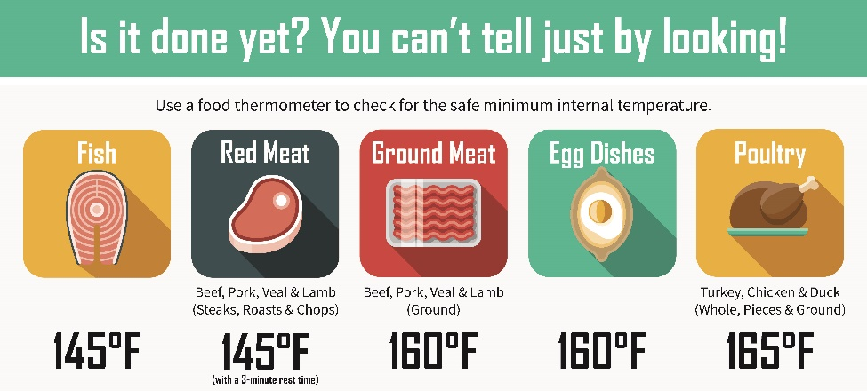

*Image Source: USDA Food Safety and Inspection Service*

**The 2-Hour Rule**

One of the basic maxims of food safety – besides cooking to proper temperatures of course – is to **keep hot foods hot and cold foods cold**. Not keeping perishable food cold enough (at or below 40°F) or hot enough (at or above 140°F) allows bacteria to multiply quickly, causing the food to become unsafe. This temperature range between 40°F to 140°F is known as the “**Danger Zone**.” Thus, when preparing or serving perishable food, it’s important that it not be left at room temperature for more than two hours. If the temperature is above 90°F (such as when you’re entertaining outdoors), don’t leave food out for more than one hour. Food left out for more than these time limits should be discarded.

Care should also be taken when defrosting frozen foods, as pathogenic bacteria can multiply as the food begins to defrost when left at room temperature. Thaw frozen foods in the fridge or under cold running water, not at room temperature.

To recap:

* **Do not leave perishable food at room temperature for more than two hours (one hour if the temperature is above 90°F).**
* This goes for food that is freshly cooked, or leftovers remaining after serving a meal or entertaining. Store foods in shallow containers and refrigerate or freeze promptly.
* Defrost frozen food safely in the refrigerator – not at room temperature.

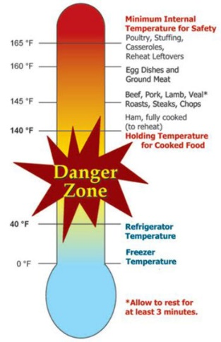

*Image Source: U.S. Department of Agriculture*

**Slow Cooker Safety**

Slow cookers (aka “crock pots”) are popular electric appliances which are an advantageous way to cook meals: They are convenient, economical, and are great for tenderizing less expensive and tougher cuts of meat (such as shoulder, round, and chuck). They are also a *safe* way to cook, as long as the devices are used correctly. Slow cookers work by cooking food at a low temperature (generally between 170-280°F) for several hours. Direct heat from the pot, steam, and long cooking times combine to destroy bacteria, making foods cooked in slow cookers safe to consume. Specific safety considerations include:

* **ADD LIQUID:**  Water or some form of liquid is necessary to create steam. When cooking meat or poultry, ingredients should be covered to ensure heat transfer throughout the pot. Follow the manufacturer’s instructions for how much liquid to add. Foods with a high moisture content (chili, soup, stew, or spaghetti sauce) are good choices for slow cookers.
* **THAW FIRST:** Meat or poultry should always be thawed before putting it in the slow cooker. Frozen meat will not quickly enough reach the minimum temperature necessary to ensure safety.
* **PREHEAT THE COOKER:** Preheat the slow cooker before adding ingredients. Liquids should preferably be hot before being added.
* **SET TO HIGH FOR THE FIRST HOUR:** Setting the temperature to high for the first hour helps ensure a rapid heat start, and it shortens the time foods are in the temperature “danger zone.” It is highly recommended to do this when cooking meat or poultry.
* **DO NOT COOK ON WARM:**  The warm setting on slow cookers is designed to keep foods hot, not to cook them.
* **SOAK & BOIL DRIED BEANS FIRST:** Dried beans contain natural toxins that are destroyed by boiling temperatures (which are not reached in slow cookers). Before adding dried beans to a slow cooker, soak them for 12 hours, rinse, and then boil them on a stove top for at least 10 minutes.
* **ADD VEGGIES FIRST:** Vegetables cook the slowest, so add them first. Or, they can be arranged on the bottom or along of the sides of the slower cooker with meat in the center.
* **KEEP THE LID ON:** It’s so tempting to lift the slow cooker’s cover, but refrain from doing so unnecessarily during the cooking cycle. Each time the cover is opened, steam is released, the internal temperature drops 10-15 degrees, and the cooking process is slowed down by 30 minutes.
* **USE A CALIBRATED THERMOMETER:** Before eating food prepared in a slow cooker, check to ensure that it has reached a safe temperature (see pg. 6).
* **COOL PROPERLY:** Cooked food should not be allowed to cool down in the slow cooker. If not eaten immediately, transfer to containers refrigerate promptly (see pg. 7).
* **NO REHEATING IN THE SLOW COOKER:** Food should not be reheated in slow cookers. Instead, reheat leftovers on the stove top or microwave to 165°F or above, after which point the food can be transferred to a slow cooker and kept warm (140°F or above).

For further information on slow cooker safety, visit:

https://www.fsis.usda.gov/food-safety/safe-food-handling-and-preparation/food-safety-basics/slow-cookers-and-food-safety

**Leftover Lifetimes**

Leftovers can be a lifesaver when you need a meal in a hurry, but unfortunately they don’t last forever. Or even a long time. And no, turning leftovers into another kind of leftover does not extend the life of the original food. Keeping food at proper temperatures and storing it for limited times is paramount for food safety. Label and date your leftovers, and check your fridge often and purge as required.

First, whether you’ve serving a family meal or you’re setting out food when entertaining, be sure to **keep perishable food at room temperature no longer than 2 hours (1 hour if you’re outdoors and the temp is over 90°F)**. Bacteria that cause foodborne illness multiply rapidly at temperatures in the “Danger Zone” (temperatures between 40°F and 140°F), rendering food potentially unsafe. Food that is not eaten during this timeframe should be promptly refrigerated or frozen.

Most leftover foods will last in the refrigerator for **3 to 4 days**. After that time, leftovers should be tossed. And it should go without saying that any food that is obviously spoiled (it smells unpleasant, or is discolored or moldy or abnormally soft) should be immediately thrown out, no matter how long it has been stored.

One of the most basic food safety practices is: **When in doubt, throw it out**.

For more information on storing food and beverages, visit **The FoodKeeper** **page** at <https://www.foodsafety.gov/keep-food-safe/foodkeeper-app>, where you can browse by category or use the search function to look up something specific. There’s also a **FoodKeeper mobile app** available for Android and Apple devices.

**Pie Storage**

Counter or refrigerator? It depends on the type of pie. Following are recommendations for storing various types of freshly baked pies. Note that some perishable commercial pies contain preservatives, so be sure to check the label for their specific storage instructions.

**FRUIT PIES MADE WITH SUGAR:** Fruit pies (apple, berry, etc.) can be kept at room temperature up to 2 days and thereafter wrapped loosely and stored in the refrigerator for up to 2 more days. Or, put them straight in the fridge for up to 7 days. Fruit-with-sugar pies can also be frozen: Place uncovered in the freezer until frozen solid, then wrap well and return to the freezer for up to 4 months.

**FRESH FRUIT, CUSTARD, CREAM, AND CHIFFON PIES:** Refrigerate promptly after cooking and cooling, and keep in the fridge until ready to serve. Store in the refrigerator for up to 4 days. These pies don’t freeze well.

**PUMPKIN, PECAN, AND OTHER PIES MADE WITH EGGS:** Store these pies in the fridge for up to 4 days. Pumpkin and pecan pies keep moderately well in the freezer for up to 2 months, but they may get a soggy crust or the filling may separate somewhat. Thaw these frozen pies in the refrigerator.

**PIES MADE WITH SUGAR SUBSTITUTE:** Lack of sugar shortens the life of these pies, which are best consumed in 1-2 days. Store in the fridge. They can be frozen in an airtight container, or well wrapped in plastic or foil, for up to 2 months.

**Handling Raw Flour and Dough**

Flour is, generally speaking, a raw agricultural product which has not undergone any type of treatment to kill pathogenic bacteria – such as E. coli and Salmonella – that can cause foodborne illness. Several disease outbreaks associated with flour and flour products (including commercially made cake mix and raw cookie dough) caused many people to become severely ill, with some requiring hospitalization. These cases, and the large product recalls that resulted because of contaminated flour, point out the importance of **never eating raw dough** and for **handling raw flour carefully**. Fortunately, properly cooking or baking flour will inactivate harmful bacteria and make the flour safe to eat.

Here are a few recommendations on handling raw flour and flour products:

* don’t eat or even taste any product that contains raw flour (alas, this means don’t lick the bowl or the beaters!)
* don’t use raw homemade raw cookie dough in ice cream
* cook or bake products to proper temperatures and for specified times
* children should not play with raw dough, including dough made for crafts
* because of the powdery nature of flour, it spreads, so avoid cross-contamination by keeping it separate from other raw foods and by washing hands, utensils and work areas after contact with raw flour

For further information on the dangers of consuming raw flour and flour products, visit the CDC website at <https://www.cdc.gov/foodsafety/communication/no-raw-dough.html>.

**Handling Raw Eggs**

Raw eggs can harbor *Salmonella* – both on the shell itself *and* inside the egg, too. Egg shells can be contaminated from *Salmonella* from poultry droppings or from the area in general in which the eggs are laid. Poultry that are infected with *Salmonella* can transfer the bacteria to the inside of eggs before the shells are even formed. *Salmonella* can cause serious foodborne illness, especially for vulnerable populations. For these reasons, it’s important to handle and prepare raw eggs carefully.

Here are a few recommendations on handling raw eggs and raw egg products:

* always wash your hands and any items that come into contact with raw eggs with soap and water (this includes utensils, dishes, cutting boards and countertops)
* don’t wash eggs (commercial eggs are cleaned at the processing plant; for home eggs, it’s better to provide a clean environment in the first place as improper washing can actually introduce contaminants into the egg)
* discard cracked or dirty eggs, and keep them refrigerated at 40°F or below
* cook eggs until both the yolk and the white reach a temperature of 160°F
* do not consume raw eggs or egg products (including sauces, salad dressings, tiramisu, etc.) unless the eggs have been pasteurized

For further information on eggs, including safety, egg basics, date codes, etc., see

<https://www.cdc.gov/features/salmonellaeggs/index.html>

<https://ucfoodsafety.ucdavis.edu/sites/g/files/dgvnsk7366/files/inline-files/26416.pdf>

<https://food.unl.edu/article/cracking-date-code-egg-cartons#:~:text=This%20three%2Ddigit%20code%20indicates,were%20packed%20on%20February%201st>.

**Baking in Canning Jars**

Baking in canning jars (aka mason jars) is an unsafe practice, despite those cute pictures of miniature pies and cakes you see on the internet, especially around the holidays. Why? Canning jars are not designed for oven use, and the manufacturers of home-use canning jars *specifically recommend against* using their jars in the oven.

Canning jar glass (made from lime, soda, and other materials) is annealed, and annealed glass is not as strong as tempered glass. Oven heat, which differs from the heat produced in boiling water and pressure canners, can create stress on a jar, causing it to break into sharp pieces. And no, putting a pan of water in the oven along with the jars does not replicate the environment of a boiling water, atmospheric steam, or pressure canner.

As for “oven canning,” putting a lid on a jar after it comes out of the oven is not a true canning process. While a vacuum seal may be formed as the contents cool, it may not be a good seal and some oxygen may remain in the jar – and that oxygen could allow certain microorganisms, including mold, to grow. As for products such as breads and cakes, these tend to be low in acid and high in moisture. Along with the low-oxygen environment created by sealing the jar, the perfect environment is created in which *C. botulinum* (the organism responsible for producing a toxin that creates botulism, a potentially fatal disease) to grow.

But what about baked goods in jars that you may find in stores? Breads or cakes in glass jars that are produced by reputable commercial entities have preservatives in them and undergo processing controls and safety testing. These types of products should not be purchased unless they contain anti-microbial additives and have been labelled in accordance with commercial food requirements.

By the way, ovens should also *not* be used to pre-sterilize jars in preparation for canning. Besides the risk of breakage as discussed above, the dry, uneven heat of an oven does not adequately sterilize jars. When sterilization is required, jars must be completely immersed in fully boiling water or steam for 10 minutes (plus any adjustments for altitude). For further details on how and when to sterilize canning jars, refer to the accompanying *Core Canning Techniques* handout, or see our Educational Posters on the subject (link on the last page).

In summary:

* **keep your canning jars out of the oven!**
* use appropriate oven-safe vessels for all of your baking needs
* refrigerate or freeze baked goods for longer-term storage
* do not eat any home-canned baked products that are given to you
* do not purchase canned baked goods unless they contain anti-microbial additives and have been labelled in accordance with commercial food requirements

For further information on canning breads and cakes, visit:

<http://www.downloads.ruralsurvival.life/Miscellaneous%20Useful%20Documents/uga_can_breads.pdf>

<https://extension.psu.edu/food-preservation-setting-the-record-straight-on-canning-breads-and-cakes>

https://extension.usu.edu/tooele/files/FN-FS_250_10.pdf

**RECIPES**

**DIY Poultry Seasoning**

*Yield: about ¼ cup*

**DRY STORAGE**

5 tsp ground thyme

4 tsp ground sage

1 ¾ tsp ground marjoram

1 ¼ tsp ground rosemary

¼ tsp ground black pepper

¼ tsp ground nutmeg

1. Combine all ingredients in a small, airtight container.
2. Store container in a cool, dry dark place.

**Porchetta Salt**

*Not everyone serves turkey on Thanksgiving. This flavorful seasoned salt works well on pork, roasted chicken, roasted potatoes and more.*

**DEHYDRATING**

*Yield: about ½ cup*

2 tbsp fennel seeds

½ cup (125 gr) coarse sea salt

2 tbsp finely grated lemon zest

2 tbsp minced fresh rosemary

2 tbsp whole black peppercorns

*optional additions:*  *crushed bay leaf; finely grated orange zest; minced fresh sage*

1. Preheat the oven to 200°F.
2. Spread the fennel seeds in a small skillet and set over medium-high heat. Toast, stirring often, until the seeds are fragrant and have turned a shade darker, about 1 to 2 minutes. Transfer to a bowl and let cool.
3. Add the salt, zest, rosemary, and peppercorns (and optional ingredients, if using) to the bowl with the fennel seeds and mix well. Spread the mixture on a rimmed baking sheet. Bake until the lemon zest and rosemary have dried out, about 30 minutes. Let cool to room temperature.
4. Pulse the mixture briefly in a food processor or spice mill, just enough to achieve a coarse grind. Put salt into a jar or container with a tight-fitting lid.
5. Store container in a cool, dry dark place. For best flavor, use within 6 months.

*Source: Adapted from* Preserving Italy *by Domenica Marchetti*

**Frozen Cranberries**

Cranberries are a wonderful fall fruit that are easy to preserve for use throughout the year. The very easiest preservation method is to simply store them in the fridge (refrigeration is preserving!), where they will keep for about 4 weeks. Next up is freezing. Yes, the bag you just purchased can be thrown directly into the freezer, but there are some considerations.

**FREEZING**

Cranberries need to be washed and sorted before being used, and sorting through still-frozen or thawed berries has its challenges. Further, the thin plastic bags that cranberries are sold in are not the best for freezer storage. A few simple steps on the front end of the process will mean that you can take cranberries straight from the freezer and into your favorite recipes. Here’s the preferred method for freezing cranberries.

* **SORT:** Berries should be brightly colored (a full, deep red or yellowish red), with firm, smooth, and glossy skins. Remove stems and leaves, and discard any berries that are soft, shriveled, wrinkled, or blemished.
* **WASH:** Rinse the cranberries in cool running water and drain, removing as much excess moisture as possible.
* **FREEZE:** Pack the berries into a freezer-safe container or freezer bag, removing as much air as possible. Label with the contents and date, and then store in the freezer. Berries may also be first frozen individually on trays and then into containers.
* **STORE:** Cranberries can be frozen for up to one year.
* **USE:**  Cranberries can be used in recipes straight from the freezer (unless otherwise directed). However, if you froze the berries in their original bag without first washing them, be sure to rinse them in cold water and drain before using.

**CANNING WITH CRANBERRIES**

Frozen cranberries can be used in place of fresh when making jams and jellies. However, be aware that their pectin content sometimes diminishes during processing. Fresh cranberries are very high in natural pectin and have consistent gelling qualities.

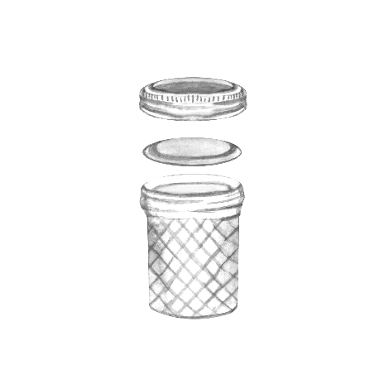

**Cranberry-Orange Vinegar**

*Yield: about 2 pint jars*

**BW/STEAM**

**CANNING**

4 whole cloves

2 sticks cinnamon

1 cup unsweetened cranberry juice

1 cup sugar

½ cup fresh cranberries (washed and drained)

3 cups white wine vinegar (5% acidity)

2 orange slices

1. Tie cloves and cinnamon in a spice bag. Put them in a large saucepan along with the cranberry juice and sugar. Cook over medium heat, stirring until sugar dissolves.
2. Add the fresh cranberries and the vinegar. Bring the mixture to a simmer (180°F) over medium heat. Simmer for 10 minutes. Remove the spice bag.
3. Put 1 orange slice into a hot jar. Ladle hot vinegar into jar, leaving ¼-inch headspace. Wipe jar rims with a dampened clean paper towel or cloth. Apply and adjust two-piece metal canning lids. Place jar in canner. Repeat with remaining jar(s).
4. Process pint jars in a boiling water or atmospheric steam canner as follows:

10 minutes at 0-1,000 feet elevation

15 minutes at 1,001-3,000 feet elevation

20 minutes at 3,001-6,000 feet elevation

25 minutes at 6,001-8,000 feet elevation

1. For boiling water canning, turn off heat, remove canner lid and wait 5 minutes. For atmospheric steam canning, turn off heat, leave canner lid on and wait 2-3 minutes. Remove jars to a rack or towel and let cool, undisturbed, for 12-24 hours and then check seals. Store unsealed jars in the refrigerator or reprocess. Clean and label sealed jars and store in a cool, dry dark location.

*Source: Adapted from Ball Blue Book (2020)*

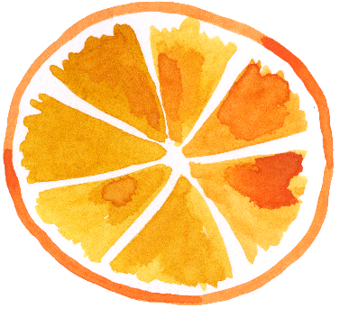

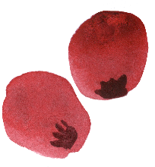

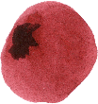

**Cranberry Mostarda**

*Yield: about 4 half-pint jars*

**BW/STEAM**

**CANNING**

¾ cup red wine

2 tbsp yellow mustard seeds

2 tbsp brown mustard seeds

2 12-oz packages fresh or frozen cranberries

1 cup sugar

¼ cup red wine vinegar (5% acidity)

2 tsp salt

6 oz (½ medium-size) red onion, diced

2 tbsp Dijon mustard

½ tsp freshly ground black pepper

1. Bring red wine and mustard seeds to a simmer in a small non-reactive saucepan over medium-high heat. Remove from heat and let stand for 10 minutes or until seeds are slightly softened.
2. Bring cranberries, sugar, vinegar, salt and red onion to a boil in a large non-reactive saucepan. Cook 10 minutes or until most of the cranberry skins begin to split and the mixture begins to thicken.
3. Stir in mustard seed mixture, Dijon mustard, and pepper. Reduce heat to medium-low and simmer 15 minutes or until mixture begins to thicken.
4. Ladle hot mixture into a hot jar, leaving ¼-inch headspace. Remove air bubbles and adjust headspace if necessary. Wipe jar rims with a dampened clean paper towel or cloth. Apply and adjust two-piece metal canning lids. Place jar in canner. Repeat with remaining jar(s).
5. Process half-pint jars in a boiling water or atmospheric steam canner as follows:

15 minutes at 0-1,000 feet elevation

20 minutes at 1,001-3,000 feet elevation

25 minutes at 3,001-6,000 feet elevation

30 minutes at 6,000-8,000 feet elevation

1. For boiling water canning, turn off heat, remove canner lid and wait 5 minutes. For atmospheric steam canning, turn off heat, leave canner lid on and wait 2-3 minutes. Remove jars to a rack or towel and let cool, undisturbed, for 12-24 hours and then check seals. Store unsealed jars in the refrigerator or reprocess. Clean and label sealed jars and store in a cool, dry dark location.

*Source: Adapted from The All New Ball Book of Canning (2016)*

**Jellied Cranberry Sauce**

*Yield: about 4 half-pint or 2 pint jars*

**BW/STEAM**

**CANNING**

4½ cups cranberries (about 1½ lbs)

1¾ cups water

2 cups sugar

1. Combine cranberries and water in a large saucepan. Boil over medium-high heat until skins burst open. Purée mixture using a food mill or electric food strainer to remove peels and seeds.
2. Return mixture to the large saucepan. Add sugar and cook over medium-high heat, stirring until sugar dissolves. Boil mixture almost to the gelling point (see below).

⮞ *Temperature Test:* The gelling point is 8°F above the boiling point of water, which is 212°F at 0-1,000 feet above sea level. Simply add 8° to the boiling point of water at your elevation to determine the gelling point. For example, at 2,000 feet above sea level, water boils at 208°F; thus the gelling point would be 216°F. Use a calibrated thermometer to determine when the mixture reaches the appropriate temperature.

⮞ *Sheet Test:* Dip a cold metal spoon into the boiling mixture. Holding the spoon over a plate, tilt the spoon and allow the jelly to drop off. The gelling point is reached when the jelly sheets or flakes off the spoon.

⮞ *Plate Test:* Remove the pot from the heat. Place a small amount of hot mixture onto a chilled plate. Set the plate in the freezer until the mixture cools to room temperature, then run a finger through it. If the mixture separates and then slowly returns to its original form, the spread is at the gelling point.

1. Ladle hot sauce into a hot jar, leaving ½-inch headspace. Remove air bubbles and adjust headspace if necessary. Wipe jar rims with a dampened clean paper towel or cloth. Apply and adjust two-piece metal canning lids. Place jar in canner. Repeat with remaining jar(s).
2. Process half-pint or pint jars in a boiling water or atmospheric steam canner as follows:

15 minutes at 0-1,000 feet elevation

20 minutes at 1,001-3,000 feet elevation

25 minutes at 3,001-6,000 feet elevation

30 minutes at 6,000-8,000 feet elevation

1. For boiling water canning, turn off heat, remove canner lid and wait 5 minutes. For atmospheric steam canning, turn off heat, leave canner lid on and wait 2-3 minutes. Remove jars to a rack or towel and let cool, undisturbed, for 12-24 hours and then check seals. Store unsealed jars in the refrigerator or reprocess. Clean and label sealed jars and store in a cool, dry dark location.

*Source: Adapted from Ball Blue Book (2020)*

***TIP:***  For easy removal of jellied cranberry sauce that will be served sliced or in a mold, can the sauce in straight-sided half-pint jelly jars or wide-mouth pint jars.

**Pickled Marinated Mushrooms**

*Yield: about 9 half-pint jars*

**BW/STEAM**

**CANNING**

7 lbs small whole mushrooms*

½ cup bottled lemon juice

2 cups olive or salad oil

2 ½ cups white vinegar (5% acidity)

1 tbsp oregano leaves

1 tbsp dried basil leaves

1 tbsp canning/pickling salt

½ cup finely chopped onions

¼ cup diced pimiento

2 cloves garlic, cut in quarters

25 black peppercorns

*\*Select very fresh unopened mushrooms with caps less than 1¼ inch in diameter.*

1. Wash mushrooms. Cut stems, leaving ¼-inch attached to cap.
2. Place mushrooms in pan and add the lemon juice and water to cover. Bring to a boil, then simmer 5 minutes. Drain mushrooms.
3. Mix olive oil, vinegar, oregano, basil, and salt in a saucepan. Stir in onions and pimiento and heat to boiling.
4. Place ¼ garlic clove and 2-3 peppercorns in a hot half-pint jar. Fill the hot jar with the mushrooms and hot, well-mixed oil/vinegar solution, leaving ½-inch headspace. Remove air bubbles and adjust headspace if necessary. Wipe jar rims with a clean paper towel or cloth dampened with vinegar. Apply and adjust two-piece metal canning lids. Place jar in canner. Repeat with remaining jar(s).
5. Process half-pint jars in a boiling water or atmospheric steam canner as follows:

20 minutes at 0-1,000 feet elevation

25 minutes at 1,001-3,000 feet elevation

30 minutes at 3,001-6,000 feet elevation

35 minutes above 6,000 feet elevation

1. For boiling water canning, turn off heat, remove canner lid and wait 5 minutes. For atmospheric steam canning, turn off heat, leave canner lid on and wait 2-3 minutes. Remove jars to a rack or towel and let cool, undisturbed, for 12-24 hours and then check seals. Store unsealed jars in the refrigerator or reprocess. Clean and label sealed jars and store in a cool, dry dark location.

*Source: Adapted from the USDA Complete Guide to Home Canning (2015)*

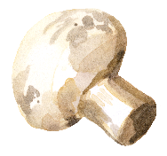



**Red Onion and Port Jam**

*Yield: 5 half-pint jars*

**BW/STEAM**

**CANNING**

2 lbs red onions, quartered and thinly sliced

½ cup red wine vinegar

1½ cups port wine

2 tsp salt

1 tsp ground black pepper

1 tsp mustard seeds

1 cup cold water

3 tbsp low- or no-sugar needed pectin

½ cup sugar

1. Combine the first 6 ingredients (the onions through the mustard seeds) in a medium saucepan. Cook over medium heat for 15 minutes, or until onions are translucent, stirring occasionally.
2. Stir in water and pectin. Bring mixture to a full rolling boil that cannot be stirred down, stirring constantly.
3. Add sugar, stirring to dissolve. Return mixture to a full rolling boil. Boil hard for 1 minute.
4. Fill a hot jar with hot jam, leaving ¼-inch headspace. Remove air bubbles and adjust headspace if necessary. Wipe jar rims with a dampened clean paper towel or cloth. Apply and adjust two-piece metal canning lids. Place jar in canner. Repeat with remaining jar(s).
5. Process **half-pint** jars in a boiling water or atmospheric steam canner as follows:

10 minutes at 0-1,000 feet elevation

15 minutes at 1,001-3,000 feet elevation

20 minutes at 3,001-6,000 feet elevation

25 minutes above 6,000 feet elevation

1. For boiling water canning, turn off heat, remove canner lid and wait 5 minutes. For atmospheric steam canning, turn off heat, leave canner lid on and wait 2-3 minutes. Remove jars to a rack or towel and let cool, undisturbed, for 12-24 hours and then check seals. Store unsealed jars in the refrigerator or reprocess. Clean and label sealed jars and store in a cool, dry dark location.

*Source: Adapted from ballmasonjars.com*

**Spiced Applesauce**

*Yield: variable*

**BW/STEAM**

**CANNING**

apples*

sugar *(optional)*

lemon juice *(optional)*

ground cinnamon, ginger, nutmeg, cardamom, and cloves, *to taste*

*\*Select apples that are sweet, juicy, and crisp. For a tart flavor, add 1-2 lbs. of tart apples to each 3 lbs. of sweeter apples. An average of 21 lbs. is needed for a canner load of 7 quarts; an average of 13 ½ lbs. is needed for a canner load of 9 pints. A bushel weighs 48 lbs. and yields 14 to 19 quarts of sauce (an average of 3 lbs. per quart).*

1. Wash, peel and core apples. Slice apples into an anti-browning treatment (1 tsp of ascorbic acid powder or 1 cup lemon juice per gallon of water), if desired.
2. Place drained slices into a large pot. Add ½ cup water. Heat quickly until apples are tender, stirring occasionally to prevent burning. This will take 5 to 20 minutes depending on the maturity and variety of the apples. Press through a sieve or food mill (skip if you prefer a chunk-style sauce).
3. Taste sauce and add sugar (about ⅛ cup per quart of sauce), lemon juice, and spices to taste. Reheat sauce to a rolling boil.
4. Fill a hot jar with hot applesauce, leaving ½-inch headspace. Remove air bubbles and adjust headspace if necessary. Wipe jar rims with a dampened clean paper towel or cloth. Apply and adjust two-piece metal canning lids. Place jar in canner. Repeat with remaining jar(s).
5. Process **pint** jars in a boiling water or atmospheric steam canner as follows:

15 minutes at 0-1,000 feet elevation

20 minutes at 1,001-3,000 feet elevation

20 minutes at 3,001-6,000 feet elevation

25 minutes above 6,000 feet elevation

1. Process **quart** jars in a boiling water or atmospheric steam canner as follows:

20 minutes at 0-1,000 feet elevation

25 minutes at 1,001-3,000 feet elevation

30 minutes at 3,001-6,000 feet elevation

35 minutes above 6,000 feet elevation

1. For boiling water canning, turn off heat, remove canner lid and wait 5 minutes. For atmospheric steam canning, turn off heat, leave canner lid on and wait 2-3 minutes. Remove jars to a rack or towel and let cool, undisturbed, for 12-24 hours and then check seals. Store unsealed jars in the refrigerator or reprocess. Clean and label sealed jars and store in a cool, dry dark location.

*Source: Adapted from the USDA Complete Guide to Home Canning (2015)*

**Brandied Pears**

*Yield: about 4 quart jars*

**BW/STEAM**

**CANNING**

1o lbs pears (about 30-35 medium)

6 cups sugar

4 cups water

3 cups brandy

1. Cut pears in half lengthwise, core, and peel. Place pears into an anti-browning treatment (1 tsp of ascorbic acid powder or 1 cup of lemon juice per gallon of water).
2. Combine sugar and water in a large saucepan. Bring mixture to a boil, stirring until sugar dissolves.
3. Drain the pears. Cook them in the sugar syrup, one layer at a time, until just tender (about 5 minutes). Transfer pears to a bowl and keep hot while cooking remaining pears.
4. Continue cooking the sugar syrup to thicken, about 15 minutes. Remove from the heat and add the brandy.
5. Pack pears into a hot jar, cavity side down and layers overlapping, leaving ½-inch headspace. Ladle hot syrup over the pears to ½-inch headspace. Remove air bubbles and adjust headspace if necessary. Wipe jar rims with a dampened clean paper towel or cloth. Apply and adjust two-piece metal canning lids. Place jar in canner. Repeat with remaining jar(s).
6. Process quart jars in a boiling water or atmospheric steam canner as follows:

15 minutes at 0-1,000 feet elevation

20 minutes at 1,001-3,000 feet elevation

25 minutes at 3,001-6,000 feet elevation

30 minutes at 6,001-8,000 feet elevation

1. For boiling water canning, turn off heat, remove canner lid and wait 5 minutes. For atmospheric steam canning, turn off heat, leave canner lid on and wait 2-3 minutes. Remove jars to a rack or towel and let cool, undisturbed, for 12-24 hours and then check seals. Store unsealed jars in the refrigerator or reprocess. Clean and label sealed jars and store in a cool, dry dark location.

*Source: Adapted from Ball Blue Book (2020)*

**Maple-Walnut Syrup**

*This versatile, tasty syrup is wonderful served warm over pancakes and waffles. Use it as a topper for oatmeal, too, or pair it with baked Brie for a savory appetizer. It’s great to have on hand for weekend guests, and it makes a lovely holiday gift!*

**BW/STEAM**

**CANNING**

*Yield: about 4 half-pint jars*

1 ½ cups corn syrup

1 cup pure maple syrup

½ cup water

½ cup granulated sugar

2 cups walnut pieces

1. In a stainless steel saucepan, combine the corn syrup, maple syrup and water. Add the sugar and heat over medium heat, stirring until the sugar is dissolved.
2. Increase heat to medium-high and bring to a boil, stirring occasionally. Reduce heat and boil gently, stirring constantly, until syrup begins to thicken, about 15 minutes.
3. Stir in walnuts and cook for 5 minutes.
4. Ladle hot syrup into a hot jar, leaving ¼-inch headspace. Wipe jar rims with a dampened clean paper towel or cloth. Apply and adjust two-piece metal canning lids. Place jar in canner. Repeat with remaining jar(s).
5. Process half-pint jars in a boiling water or atmospheric steam canner as follows:

10 minutes at 0-1,000 feet elevation

15 minutes at 1,001-3,000 feet elevation

20 minutes at 3,001-6,000 feet elevation

25 minutes at 6,001-8,000 feet elevation

1. For boiling water canning, turn off heat, remove canner lid and wait 5 minutes. For atmospheric steam canning, turn off heat, leave canner lid on and wait 2-3 minutes. Remove jars to a rack or towel and let cool, undisturbed, for 12-24 hours and then check seals. Store unsealed jars in the refrigerator or reprocess. Clean and label sealed jars and store in a cool, dry dark location.

*Source: Adapted from Ball Complete Book of Home Preserving (2012)*

**DIY Apple Pie Spice**

*Yield: about ¼ cup*

**DRY STORAGE**

3 tbsp ground cinnamon

2 tsp ground nutmeg

1 tsp ground cardamom

1 tsp ground allspice

1. Combine all ingredients in a small, airtight container.
2. Store container in a cool, dry dark place.

*Recipe from the kitchen of Pati Kenney*

**DIY Grenadine Syrup**

*Grenadine is a sweet-tart syrup made from pomegranates. The basis for many cocktails and non-alcoholic “mocktails” – including the classic Shirley Temple, it’s easy to make at home. And by doing so, you avoid the high-fructose corn syrup and other additives found in commercial syrups. Grenadine is great to have on hand for the holidays (or any time of year), whether you’re looking for a refreshing non-alcoholic beverage for adults or a fun treat for the kids.*

**REFRIGERATION**

*Yield: about 3 cups*

16 oz 100% unsweetened pomegranate juice

2 cups sugar

2 tbsp lemon juice

1. Combine all ingredients in a medium pan. Cook over medium heat until bubbles appear at the edges of the liquid and the sugar is fully dissolved. DO NOT BOIL.
2. Remove from the heat and allow to cool to room temperature.
3. Transfer to an airtight container(s) and store in the refrigerator for up to 1 month. Syrup may also be frozen for longer-term storage.

*Source: www.sugarandsoul.co*

**SHIRLEY TEMPLE MOCKTAIL**

Fill a tall glass with ice. Add 1 oz (2 tbsp) grenadine, and if desired a splash of orange or pineapple juice. Top with lemon-lime soda (such as Sprite or 7-Up) or ginger ale. Add a maraschino cherry.

For a bit more sophisticated version that adults may especially enjoy: Fill a tall glass with ice. Add ½ oz (1 tbsp) grenadine, ¼ oz freshly squeezed lime juice, and 5 oz ginger ale. Top with skewered Luxardo cherries.

**Puff Pastry Jam Braid (or Squares)**

*If you keep a box of puff pastry sheets in your freezer and a jar of jam in your cupboards, then you’ll always have a quick dessert – or even a breakfast treat or a savory appetizer – that can be put together at the last minute. Frozen puff pastry defrosts quickly, and almost any jam will do. Change the flavor profiles and ingredients to suit your tastes. And instead of a braid, the puff pastry can easily be cut into squares or triangles, from individual servings to bite size for an appetizer or charcuterie tray. See the ideas below for flavor combinations to get you started, or just have fun coming up with your own!*

**USE YOUR PRESERVES!**

1 sheet puff pastry (from a 17.3 oz box), thawed

3 tbsp cream cheese, softened (or other cheese – see Flavor Ideas below)

4 tbsp jam

1. Preheat oven to 400°F.
2. Unfold the puff pastry sheet on a piece of parchment paper, with the folds aligned vertically (top to bottom). When unfolded, you will have 3 equal sections. Using the tip of a sharp knife and starting from the top of one outside section, make 6 evenly spaced (about every 1¼”) crosswise cuts down the length of the section, cutting from just outside the fold line to the outside edge. You’ll have 7 strips. Repeat on the other outside section of the puff pastry sheet.
3. Spread the cream cheese over the center section, staying inside the fold lines and the outside edges by about ¼”. Spread the jam evenly over the cream cheese.
4. Beginning on the right side, gently lift the top pastry strip and lay it on top of the filling at a diagonal. Repeat on the other side, crossing the strop on top of the strip just laid down. Continue down the length of the puff pastry sheet, alternating strips and crisscrossing them on top of each other. Tuck the tip of the last strip underneath the center section.
5. Transfer the parchment paper to a baking sheet and place in oven. Bake for 15 minutes, or until the puff pastry is a pale golden brown. Remove the baking sheet from the oven and slide the parchment paper onto a rack to cool.

**FLAVOR IDEAS**

strawberry jam & cream cheese ⬩ chocolate-cherry jam with a drizzle of sweetened condensed milk and a sprinkling of shredded coconut ⬩ fig jam with a light brush of honey ⬩ apple-maple-bourbon jam with extra-sharp cheddar (and maybe some crumbled bacon!) ⬩ pear-ginger marmalade with gorgonzola ⬩ tomato jam (spicy or plain or herbed) with parmesan ⬩ cranberry or blueberry jam with goat cheese ⬩ plum chutney with brie ⬩ red onion-port jam & brie

*Recipe from the kitchen of Laura Crowley*

Always follow research-based recipes from reliable resources that follow the recommendations of the National Center for Home Food Processing.

For more information on food safety and preserving, see our series of Educational Posters at:

[https://ucanr.edu/sites/mfp**_**of**_**cs/Food**_**Safety/](https://ucanr.edu/sites/mfp_of_cs/Food_Safety/)

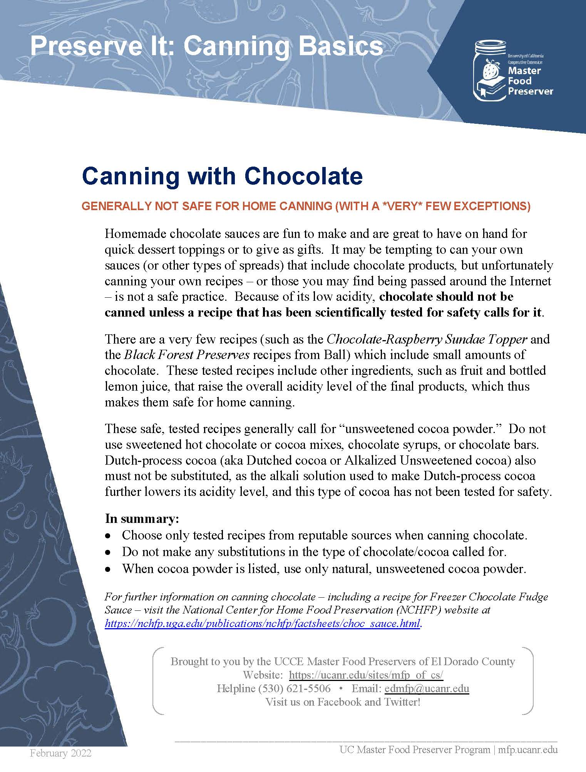

Other Resources:

UC Master Food Preservers of Central Sierra <https://ucanr.edu/sites/mfp_of_cs/>

National Center for Home Food Processing <https://nchfp.uga.edu/>

USDA Complete Guide to Home Canning <https://nchfp.uga.edu/publications/publications_usda.html#gsc.tab=0>

The information in this handout is provided as a courtesy to the reader. No endorsements of commercial products or services are made or implied, nor is criticism implied of similar products or information from companies not listed.

It is the policy of the University of California (UC) and the UC Division of Agriculture & Natural Resources not to engage in discrimination against or harassment of any person in any of its programs or activities (Complete nondiscrimination policy statement can be found at <http://ucanr.edu/sites/anrstaff/files/215244.pdf>