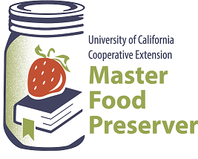
UCCE Master Food Preservers of El Dorado County
311 Fair Lane, Placerville CA 95667
Helpline (530) 621-5506 • Email: edmfp@ucanr.edu • Visit us on Facebook!

“Preserve today, Relish tomorrow”

Pumpkins & Pomes
Preserving the Favorite Fruits of Fall

Saturday, September 24, 2022
9:30 a.m. – 11:30 a.m.
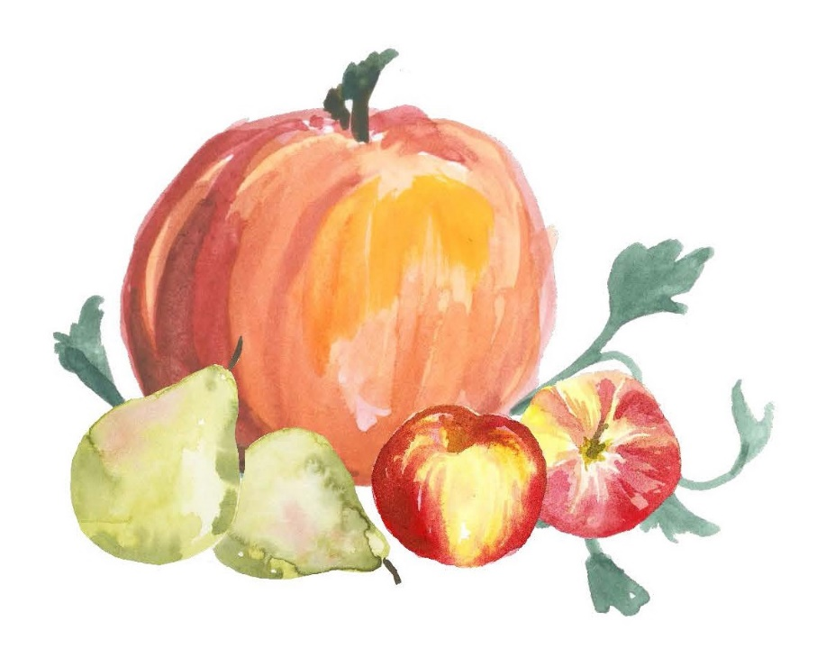

Pumpkins and apples and pears, oh my! We’ll cover different ways to preserve pumpkins and winter squash, as well as members of the pome fruit categories, including apples, pears and more. And of course, we’ll share plenty of tips and tricks and delicious recipes for using your preserves along the way.

Basic Food Safety & Sanitation
When preparing food for preservation, cleanliness is essential in preventing food-borne illness.
Please review the accompanying handout, Core Canning Techniques, for basic food safety information, including details on cleaning and sanitizing; avoiding cross-contamination, how to wash (or not wash!) fruits, vegetables and meats; and other food safety tips. Remember:

Clean Work Area Wash Hands No Cross-Contamination Prepare Food Properly

Canning Basics
To ensure safety when canning, it’s critical to follow a current, research-based recipe and to use the correct canning method. Please review the accompanying handout, Core Canning Techniques, which covers the essentials of home canning, including the types of canners and which types of foods they are appropriate for; preparing jars and lids; step-by-step processing instructions; and helpful tips for canning success.

Pre-Treatment for Canned Fruit to Prevent Browning
Many light-colored fruits, as well as the stem-ends of cherries and grapes, can discolor and darken when exposed to oxygen. To retain good color and flavor when canning fruit, use high-quality fruit at the proper maturity, and place prepared (peeled, halved, sliced, etc.) fruit in an ascorbic acid (Vitamin C) solution. Ascorbic acid is available in three forms: pure powdered form; Vitamin C tablets (which must be first crushed or ground to a fine powder); and in commercial mixtures. To use ascorbic acid as a pre-treatment for canning fruit:
Pure ascorbic acid powder: 1 tsp per gallon of water
Vitamin C tablets: 6 crushed 500-milligram tablets dissolved in 1 gallon of water
Commercial products: follow the manufacturer’s instructions

Lemon juice may also be used as a pre-treatment, however it’s not as effective as ascorbic acid (1 tsp ascorbic acid crystals = 6 tsp lemon juice).

Syrup for Canning Fruit
Syrup helps canned fruit retain its flavor, color and shape. It does not prevent spoilage. While heavy and very heavy syrups are typically used for tart and very sour fruit, it is possible to can these fruits in lighter syrups. Light corn syrup or mild-flavored honey may be used to replace up to half of the sugar amount called for in the following sugar syrup table.

 |  | For 9-Pint Load* |  | For 7-Quart Load
Syrup  Type | Approx.  % Sugar | Cups Water | Cups Sugar | Cups Water | Cups Sugar
Very Light | 10 | 6 ½ | ¾ | 10 ½ | 1 ¼
Light | 20 | 5 ¾ | 1 ½ | 9 | 2 ¼
Medium | 30 | 5 ¼ | 2 ¼ | 8 ¼ | 3 ¾
Heavy | 40 | 5 | 3 ¼ | 7 ¾ | 5 ¼
Very Heavy | 50 | 4 ¼ | 4 ¼ | 6 ½ | 6 ¾

*This amount is also adequate for a 4-quart load.

Pumpkins and Winter Squash
Pumpkins are members of the cucurbit family, which includes pumpkins and winter squash (as well as summer squash, melons, cucumbers and gourds). The difference between pumpkins and winter squash? Well, there it can get confusing. All pumpkins are squash, but not all squash are pumpkins. They are grouped together into species based on their similarities.

Pumpkins include two species: Cucurbita pepo (which includes the familiar jack-o’-lanterns and some pie pumpkins) and C. maxima (those ginormous pumpkins grown for decoration and competition). Winter squash include four species: C. maxima, C. mixta, C. moshata and C. pepo.

While all pumpkins are edible, not all make good eating, nor are they good for preserving. Jack-o’-lanterns have bland, stringy, watery flesh making them best for decorating. However, as long as they have not been carved, they can certainly be eaten. And when carving, save those seeds and “guts”! The seeds can be dried and/or roasted, and the innards can be frozen for later turning into a tasty pumpkin stock. Pumpkins best suited for cooking and preserving include the small sugar and pie varieties.

Winter squashes that are well suited to preserving include acorn, banana, buttercup, butternut, golden delicious, Hubbard, and sweet meat.

While most pumpkins and squashes may be canned, there are some limitations. Pumpkins and squashes are low-acid fruit (yes, pumpkins are fruit!) so they must either be properly acidified as a pickle or pressured canned in cubed form. Because of the very dense flesh of pumpkins and winter squash, neither pumpkin butter nor mashed or puréed pumpkin or squash is safe for canning. Note that while spaghetti squash is a winter squash, its flesh does not stay in cubed form when canned, so spaghetti squash may not successfully be canned.

IMPORTANT! Do not can pumpkin butter, mashed or puréed pumpkin or squash, or spaghetti squash. These products may instead be frozen.

Other safety precautions when preparing pumpkins and squashes for cooking and preserving include carefully washing them before cutting and peeling. Even though the outer skins are usually not eaten, they can harbor harmful bacteria. Wash all pumpkins and squashes under cool running water, use a vegetable brush to scrub them, and then give them a final rinse.

TIP: Did you know that pumpkins and squashes can be roasted whole? Peeling the hard skin and cutting through the dense flesh of these fruits can be a real chore. If you don’t need to cube the flesh in preparation for preserving or other cooking needs, simply roast them whole!

Wash the pumpkin or squash, place it on a rimmed baking sheet lined with foil or a silicone mat, and roast in a pre-heated 400°F oven until a sharp knife inserts very easily into the center.

How long it takes depends on the size of the fruit and the thickness of the flesh. A small squash may take 40 minutes or so; a large one could take 90.

Pome Fruits
Pome fruits are members of the Rosaceae (rose) plant family. The most common pomes for preserving include apples, pears, Asian pears, quince, crabapples, and loquats. The fruits are characterized by having a core of small leathery seeds surrounded by a tough membrane. Pomes grow on deciduous trees, which shed their leaves in the fall and lay dormant during the winter. The fruit is usually harvested in late summer and early fall.

Apples: There are many, many varieties of apples to choose from, all with individual textures and flavors. For canning in general, choose apples that are crisp, firm, and retain their shape and texture (for example, Jonathan, Golden Delicious, McIntosh, Braeburn, Crispin, etc.). For applesauce, choose sweet, juicy and crisp apples (or add 1-2 pounds of tart apples to every 3 lbs of sweeter fruit). Avoid buying or picking apples that are bruised, shriveled, or have skin breaks. Apples are best stored in the refrigerator, preferably in the crisper drawer or in an unsealed plastic bag. They should be stored separately from vegetables because they release small amounts of ethylene gas that can damage some produce.

Pears: There are thousands of varieties of pears and many colors to pick from. Varieties that are considered best for canning include Bartlett, Bosc, Anjou, and Comice. Small Seckel pears are often canned whole or as pickled or spiced products. Pears are generally harvested before they are ripe, and unless refrigerated they will ripen within 7 to 14 days. When canning, use the hot-pack method, as raw-packed pears make poor-quality products.

Asian Pears: These fruits (aka “apple pears”) are true pears, but of a different species than the common pears we’re familiar with. They have round shapes with green-yellow or russet skins and have – unlike pears – crunchy flesh. When purchasing Asian pears, avoid bruised, wrinkled or dry fruit, as well as fruit that is soft or mushy, or is too hard. Buy Asian pears that are fully ripe only if they are to be used immediately.

IMPORTANT! Asian pears, unlike most fruits, are low in acid. When canning Asian pears, they must be acidified in order to be safe. Always follow a research-tested recipe when canning Asian Pears.

Quince: These fruits have a golden-yellow skin and are similar in appearance to pears; however they are very astringent so must be cooked before they can be eaten. Quince may be canned as a jelly or as a preserve.

Crabapples: Wild North American apple species, or any apple with a diameter less than 2”, are known as crabapples. While some native species have very sour fruit with poor flavor, there have been many cultivars developed that are flavorful. Pick or buy crabapples that are very firm and without any signs of decay. Ripe crabapples have brown seeds and are firm and dense. Keep in a cool place for short-term storage; keep well chilled for longer term.

For a downloadable list of local El Dorado County apple and pear varieties, visit our website at
https://ucanr.edu/sites/csnce/files/310788.pdf.

For information on apple varieties and which preservation method they are best suited to, see
https://clay.ces.ncsu.edu/2020/09/a-guide-to-choosing-the-best-apple-for-preserving-2/

For information on preserving crabapples, see
https://cespubs.uaf.edu/index.php/download_file/1265/

For information on drying fruits (and vegetables) in general, see
https://nchfp.uga.edu/publications/uga/uga_dry_fruit.pdf

Windfall Fruit
Windfalls (aka ground falls, grounders, or drops) are fruits that have fallen from a tree onto the ground. This occurs for several reasons, including natural processes such as trees discarding excess baby fruit, disease, insect damage, and wind storms.

Fruit that comes in contact with the ground is more likely to harbor dangerous bacteria, including E. coli, because of domestic and wild animal waste on the ground. Washing may not remove all of the pathogens on windfall fruit. Raw juice and cider have been associated with outbreaks of E. coli. In addition, injured fallen fruits are susceptible to molds which produce patulin, a mycotoxin that can produce serious illness in humans and animals. This toxin is heat-stable, even at pasteurization temperatures. Also, fruit contaminated with molds is more likely to spoil when canned.

Because of the food safety issues involved, it is recommended that windfall fruit not be eaten fresh, used for making juice or cider, baked, or canned.

For further information on windfalls, see
https://www.canr.msu.edu/news/apple_cider_safety

https://blog-fruit-vegetable-ipm.extension.umn.edu/2020/08/food-safety-considerations-when-using.html

Fresh or unpasteurized apple juice or cider can cause foodborne illness. Always make sure that fresh juice or cider is pasteurized to 160°F before consuming.

Steam Juicing
Steam juicers (not to be confused with atmospheric steam canners) are a device that easily extracts juice from fruits and vegetables through the use of hot steam. The steam juicer is essentially a three-level pot with a lid. Produce is put into the top level, which has a perforated bottom, like a colander. Juice flows down from the top level into the middle level (called a “collection pan”) which has a special hose that can be used to syphon off the juice. The bottom level is filled with water, which when boiled creates steam that rises to the top of the pot, heating the produce so that it can release its juice.

The benefits of a steam juicer, besides its ease of use, is that it creates beautifully clear juice with no sediment. Unlike crushed and cooked fruit, the juice does not need to be strained through a jelly bag or multiple layers of cheesecloth to obtain clear juice.

Juice obtained from a steam juicer can be consumed immediately, or refrigerated or frozen for longer-term storage. The juice can also be used to make jelly, or the plain juice can be heat processed in a boiling water or steam canner for shelf-stable storage.

SAFETY NOTE: Some steam juicer manuals (as well as some misguided internet sites) indicate that the juice can be syphoned directly into sterilized jars, capped, and then stored at room temperature without any further processing. This is not safe! To create a shelf-stable juice, follow the canning recommendations from a reputable resource that follows the guidelines of the National Center for Home Food Preservation.
RECIPES

Dried and/or Roasted Pumpkin Seeds
Drying and roasting are actually two separate processes. You can do either or both, depending on your needs. Dehydrate the seeds for long-term storage, or roast them right away with or without oil or butter and seasonings. There are myriad flavor combinations you can choose from, from savory to sweet, to suit many a dish. Sprinkle pumpkin or squash seeds over salads, soups and chilis, or add them to granola, trail mix, or desserts. Hulled pumpkin seeds (“pepitas”) can be used to make pesto or brittle. And of course, you can always just eat them by the handful.
DEHYDRATING

DRYING SEEDS: Wash the seeds thoroughly, removing all of the clingy bits, drain, and pat dry. Dry in a dehydrator at 115-120°F for 1-2 hours. Seeds can also be dried in an oven at a very low setting, stirring frequently to avoid scorching, for 3-4 hours. Dehydrate until no moisture in the seeds remains. To verify that the seeds are dry, “condition” the seeds by placing them in a glass container with a tight seal. Shake it daily for 7 days, checking for any signs of moisture appearing on the sides of the container. If condensation does appear, return the seeds to the dehydrator for further drying. Store fully dried seeds in an airtight container in a cool, dark place.

ROASTING DRIED SEEDS: Toss dried seeds with a bit of olive oil (or the oil of your choice) and salt, then roast them in a pre-heated 250°F oven for 10-15 minutes.

ROASTING FRESH SEEDS: Wash the seeds well, removing all of the clingy bits, then drain and pat dry. Boiling the seeds before roasting can help ensure even cooking and makes for crispier seeds. To do so, bring the seeds to a boil in salted water (2 tbsp salt to each quart of water), simmer for 10 minutes, then drain and pat dry. To roast, toss the seeds with oil or melted butter and seasonings, spread them out on a rimmed baking sheet lined with foil or parchment, and roast in a preheated 325°F oven for about 20-25 minutes, stirring every 10 minutes or so to prevent burning. The seeds should be light brown and crisp. Store roasted pumpkin seeds in an airtight container at room temp for up to 3 days (7 days if refrigerated).

DE-HULLING SEEDS: If you’ve got the time (and the inclination), you can de-hull the seeds. It’s a laborious process that’s made easier by first boiling the seeds for 30 minutes in salted water (2 tbsp per quart) – the hulls can then be slipped right off. With dried or roasted seeds, you’ll need to crack the outer hull to remove the seed inside. Or even better yet, simply choose a variety of pumpkin or squash that has hull-less seeds.

SEASONING: Recipes abound on the web; here are just a few. To each cup of seeds, add:
Plain: 2 tsp oil or melted butter + salt to taste
Parmesan: 2 tbsp oil or melted butter + ¼ cup parmesan + ½ tsp Italian herb seasoning
Salty & Sweet: 1 tbsp melted butter + 1 tbsp sugar + 1/8 tsp ground cinnamon
Worcestershire: 1 tbsp oil or melted butter + ½ tsp salt + ½ tsp Worcestershire sauce
Salt & Vinegar: 1 tsp salt + 2-3 tbsp balsamic vinegar
Buffalo Wing: 1 tbsp melted butter + 1 ½ hot sauce
Tex-Mex: 2 tsp veg oil + 2 tsp taco seasoning mix
Savory: garlic powder and/or fresh herbs or curry powder or … (whatever you desire)
Pumpkin-Ginger Butter
Yield: about 6 half-pint jars
FREEZING

1 (3-lb) pie pumpkin, peeled, seeded, and cubed (about 8 cups)
1 cup apple juice
2 tbsp minced fresh ginger
2 cups firmly packed light brown sugar
2 tbsp fresh lemon juice
½ tsp ground cinnamon
⅛ tsp ground cloves

- Bring pumpkin, apple juice, and ginger to a boil in a 4-quart non-reactive pot, cover, reduce heat, and simmer 30 minutes or until pumpkin is very soft.

- Process pumpkin mixture, in two batches, in a blender until smooth, pouring each batch into a bowl. Return pumpkin mixture to pot. Stir in brown sugar, lemon juice and spices. Cook, partially covered, over medium-low heat 20 minutes or until mixture thickens and holds its shape on a spoon, stirring often.

- Spoon pumpkin mixture into hot jars, leaving ½-inch headspace. Center lid on jars. Apply bands, and adjust loosely. Cool jars completely on a wire rack. Place jars in freezer.

- Once pumpkin butter is frozen, adjust bands to finger-tip tight. Store in freezer up to 8 months. Thaw in refrigerator. Refrigerate after thawing and use within 3 weeks.

Source: Adapted from The All New Ball Book of Canning and Preserving (2016)

TIP: If you have a bit of leftover pumpkin (whether from a fresh pumpkin or a can), no need to waste it! Use a cookie scoop to portion out small amounts of pumpkin onto a tray lined with a silicone mat or plastic wrap. Place the tray in the freezer, and when the pumpkin is solid, individually wrap the balls in plastic, then transfer the balls to a freezer-safe container or bag. Pop a pumpkin ball or two into a soup or stew for extra flavor.

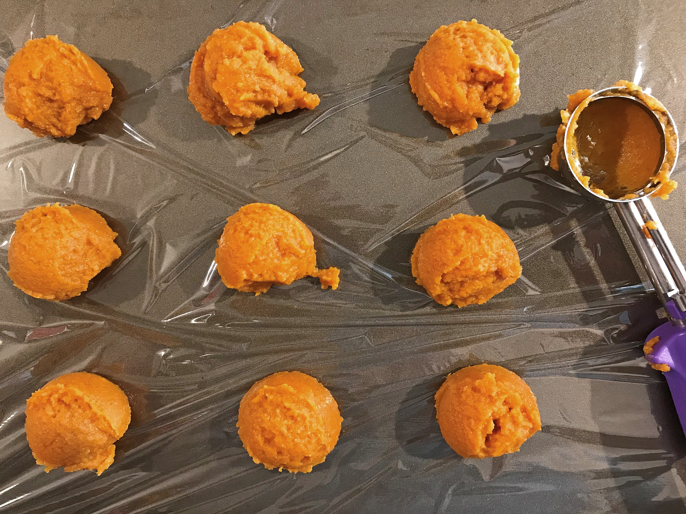

Pickled Butternut Squash
Yield: about 4 pint jars
BW/STEAM CANNING

2 medium butternut squash (about 4 lbs)
1 ½ tbsp pickling salt
1 cup sugar
2 cloves garlic
2 tsp fennel seeds
¼ tsp black peppercorns
2 ½ cups white wine vinegar (at least 5% acidity)
½ cup water
4 springs fresh thyme

- Wash the squash, remove stems and blossom ends, and peel. Cut squash in half lengthwise, remove seeds, and cut into 1-inch cubes.

- Combine squash cubes and salt in a large bowl, tossing to coat evenly. Let stand 2 hours, then rinse under cool running water and drain.

- Combine the sugar, garlic, fennel seeds, peppercorns, vinegar, and water in a large saucepan. Bring mixture to a boil, stirring until sugar dissolves. Reduce heat to a simmer, cover the pan, and simmer 10 minutes. Remove garlic and discard.

- Pack squash cubes into jar, leaving ½-inch headspace. Add 1 sprig of thyme to each pint jar. Ladle hot pickling liquid over the squash, leaving ½-inch headspace. Remove air bubbles and adjust headspace if needed. Wipe jar rims with a dampened clean paper towel or cloth. Apply and adjust two-piece metal canning lids. Place jar in canner. Repeat with remaining jar(s).

- Process pint jars in a boiling water or atmospheric steam canner as follows:
10 minutes at 0-1,000 feet elevation
15 minutes at 1,001-3,000 feet elevation
20 minutes at 3,001-6,000 feet elevation
25 minutes at 6,001-8,000 feet elevation
30 minutes at 8,000-10,000 feet elevation

- For boiling water canning, turn off heat, remove canner lid and wait 5 minutes. For atmospheric steam canning, turn off heat, leave canner lid on and wait 2-3 minutes. Remove jars to a rack or towel and let cool, undisturbed, for 12-24 hours and then check seals. Store unsealed jars in the refrigerator or reprocess. Clean and label sealed jars and store in a cool, dry dark location.

Source: Adapted from Ball Blue Book (2020)

Pumpkin Granola Bars
DEHYDRATING
5 cups rolled oats
1 cup pumpkin seeds
½ cup golden raisins
½ cup pecans
½ cup almonds
¼ cup flax seeds
¼ cup flaked coconut
1 tbsp pumpkin pie spice
2 tsp cinnamon
1 pinch salt
½ cup pumpkin purée
1 ½ cups maple syrup
2 tbsp coconut oil

- Combine the dry ingredients (oats through salt) in a large bowl. In a smaller bowl, whisk together the purée, syrup and oil until well combined. Pour over the dry ingredients and stir until all pieces are well coated.

- Pour mixture onto a silicon-lined dehydrator tray. Pack into a tight square layer no more than ½” thick. Score the layer with desired bar shape with a knife (take care not to cut the silicone mat).

- Dry at 115°F for 8-12 hours, flipping the granola halfway through the drying cycle. (To flip the tray, place a 2nd empty silicon-lined tray face down on top of the tray with the granola. Hold the edges of both trays tightly and flip them over. Remove the top tray and mat.

- Once dry, break the granola apart into bars. They should be dry, but chewy.

Source: www.excaliburdehydrator-recipes.com

DIY Pumpkin Pie Spice
Yield: about 2 tablespoons
DRY STORAGE

1 tbsp cinnamon
1 ½ tsp ground dried ginger
½ tsp nutmeg
¼ tsp allspice
½ tsp ground cloves
optional: ¼ tsp ground cardamom or ½ tsp ground mace

- Combine all ingredients in a small, airtight container.

- Store container in a cool, dry dark place.

Cubed Pumpkin and Winter Squash
Yield: variable
PRESSURE
CANNING

pumpkins or squash*
fresh water

Pumpkin/Squash Math: An average of 16 lbs is needed per canner load of 7 quarts; an average of 10 lbs is needed per canner load of 9 pints (an average of 2 ¼ lbs per quart).

*Quality: Pumpkins and squash should have a hard rind and stringless, mature pulp of ideal quality for cooking fresh. Small size pumpkins (sugar or pie varieties) make better products.

- Wash, remove seeds, cut into 1-inch slices, and peel. Cut flesh into 1-inch cubes.

- Boil 2 minutes in water. Caution! Do not mash or purée.

- Fill jars with cubes and cooking liquid, leaving 1-inch headspace. Remove air bubbles and adjust headspace if needed. Wipe jar rims with a dampened clean paper towel or cloth. Apply and adjust two-piece metal canning lids. Place jar in canner. Repeat with remaining jar(s).

- Process in a pressure canner as follows:

Dial-Gauge Pressure Canner
Jar  Size | Process  Time | 0-  1,000 ft | 1,001-  2,000 ft | 2,001-  4,000 ft | 4,001-  6,000 ft | 6,001-  8,000 ft
Pints | 55 minutes | 11 lb | 11 lb | 12 lb | 13 lb | 14 lb
Quarts | 90 minutes | 11 lb | 11 lb | 12 lb | 13 lb | 14 lb

Weighted-Gauge Pressure Canner
Jar Size | Process Time | 0-1,000 ft | + 1,000 ft
Pints | 55 minutes | 10 lb | 15 lb
Quarts | 90 minutes | 10 lb | 15 lb

Source: USDA Complete Guide to Home Canning

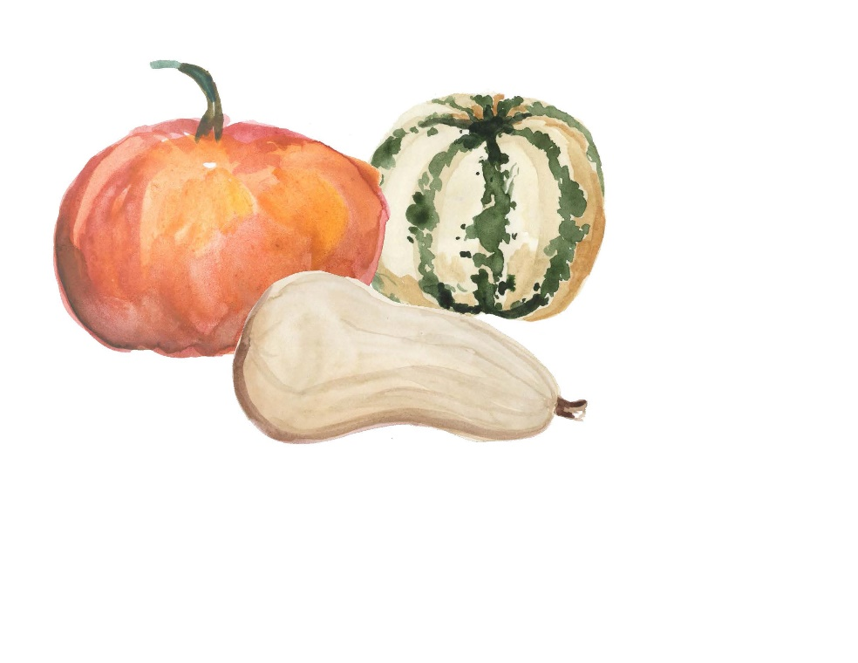

Pumpkin Guts Stock
WASTE NOT WANT NOT! Save the “guts” from your pumpkins and squashes and turn them into a lovely stock that can be used in place of vegetable or chicken stock. Add aromatic vegetables or veggie scraps, or a sprig or two of fresh herbs, if you’d like, for additional flavor. Whenever you cook a pumpkin or squash, save the guts in a bag and freeze, either separately or with other vegetable scraps. When you have a sufficient quantity, make this versatile stock. It can be also be frozen instead of pressure canned.
PRESSURE
CANNING

Yield: variable

pumpkin and/or squash innards, including the stringy pulp, seeds, and if desired the skins
veggies, such as onion, carrot, celery or any veggie scraps you’d like (optional)
peppercorns, bay leaves, etc. to taste (optional)
fresh water

- Place pumpkin guts and veggies, if using, in a pot and cover with fresh water.

- Bring just to a boil, reduce heat, and simmer for 30-60 minutes.

- Strain the stock through a fine mesh strainer lined with several layers of cheesecloth into another pot. Reheat the stock if necessary so that it’s hot.

- Ladle the hot stock into hot jars, leaving 1-inch headspace. Wipe jar rims with a dampened clean paper towel or cloth. Apply and adjust two-piece metal canning lids. Place jar in canner. Repeat with remaining jar(s).

- Process in a pressure canner as follows:

Dial-Gauge Pressure Canner
Jar  Size | Process  Time | 0-  1,000 ft | 1,001-  2,000 ft | 2,001-  4,000 ft | 4,001-  6,000 ft | 6,001-  8,000 ft
Pints | 30 minutes | 11 lb | 11 lb | 12 lb | 13 lb | 14 lb
Quarts | 35 minutes | 11 lb | 11 lb | 12 lb | 13 lb | 14 lb

Weighted-Gauge Pressure Canner
Jar Size | Process Time | 0-1,000 ft | + 1,000 ft
Pints | 30 minutes | 10 lb | 15 lb
Quarts | 35 minutes | 10 lb | 15 lb

Source: Adapted from Ball Blue Book (2020)

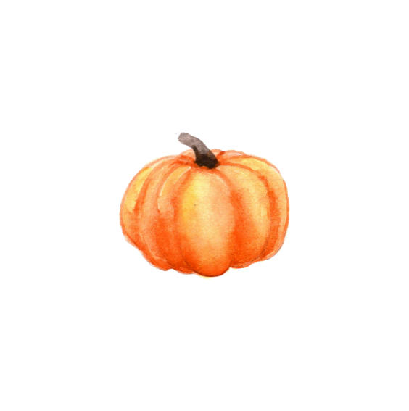

Apple Juice (fresh pressed)
Yield: variable
BW/STEAM
CANNING

fresh apple juice

- Refrigerate juice for 24-48 hours.

- Without mixing, carefully pour off clear liquid and discard sediment. Strain the clear juice through a paper coffee filter or several layers of dampened cheesecloth.

- Heat the juice, stirring occasionally, until the juice begins to boil.

- Pour the juice into a hot jar*, leaving ¼-inch headspace. Wipe jar rims with a dampened clean paper towel or cloth. Apply and adjust two-piece metal canning lids. Place jar in canner. Repeat with remaining jar(s).

- Process pint or quart jars in a boiling water or atmospheric steam canner as follows:
5 minutes at 0-1,000 feet elevation *(jars must be sterilized)
10 minutes at 1,001-6,000 feet elevation
15 minutes above 6,000 feet elevation

- Process half-gallon jars in a boiling water canner as follows (NOTE: half-gallon jars may NOT be processed in atmospheric steam canners):
10 minutes at 0-1,000 feet elevation
15 minutes at 1,001-6,000 feet elevation
20 minutes above 6,000 feet elevation

- For boiling water canning, turn off heat, remove canner lid and wait 5 minutes. For atmospheric steam canning, turn off heat, leave canner lid on and wait 2-3 minutes. Remove jars to a rack or towel and let cool, undisturbed, for 12-24 hours and then check seals. Store unsealed jars in the refrigerator or reprocess. Clean and label sealed jars and store in a cool, dry dark location.

Source: Adapted from National Center for Home Food Preservation

TIP: The best apple juice is made from a blend of apple varieties. If purchasing fresh juice from a local cider maker, it’s best to buy juice within 24 to 48 hours after it’s been pressed.

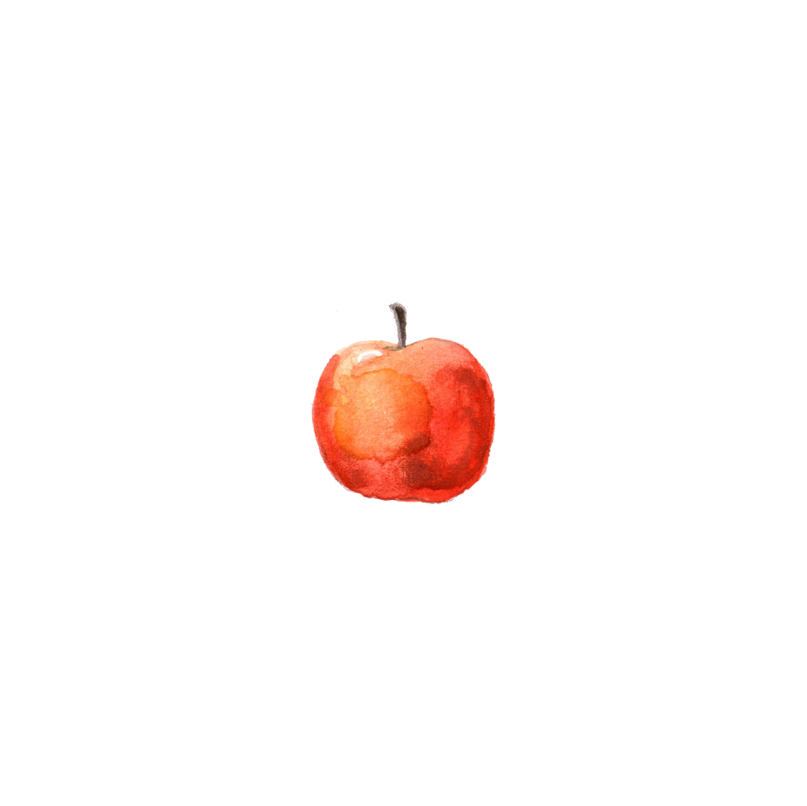

Apple Juice (from bulk apples)
Yield: about 6 quart jars
BW/STEAM
CANNING

24 lbs apples (about 72 medium)
8 cups water

- Remove stems and blossom ends from apples. Chop apples and place in a large non-reactive pot. Add water. Bring to a boil over medium-high heat. Reduce heat and boil gently, stirring occasionally, until apples are tender.

- Working in batches, transfer mixture to a dampened jelly bag or a strainer lined with several layers of dampened cheesecloth set over a deep bowl. (Note: For clearer juice, refrigerate the strained juice for 24-48 hours to allow the sediment to settle. When ready to heat the juice, carefully ladle it into the pot without disturbing the sediment. Discard sediment.)

- In a clean large non-reactive saucepan, heat juice just to a boil.

- Lade the juice into a hot jar, leaving ¼-inch headspace. Wipe jar rims with a dampened clean paper towel or cloth. Apply and adjust two-piece metal canning lids. Place jar in canner. Repeat with remaining jar(s).

- Process half-pint or pint jars* in a boiling water or atmospheric steam canner as follows:
5 minutes at 0-1,000 feet elevation *(jars must be sterilized)
10 minutes at 1,001-6,000 feet elevation
15 minutes above 6,000 feet elevation

Process quart jars in a boiling water canner or atmospheric steam canner as follows:
10 minutes at 0-1,000 feet elevation
15 minutes at 1,001-6,000 feet elevation
25 minutes above 6,000 feet elevation

Process half-gallon jars in a boiling water canner as follows (NOTE: half-gallon jars may NOT be processed in atmospheric steam canners):
10 minutes at 0-1,000 feet elevation
15 minutes at 1,001-6,000 feet elevation
25 minutes above 6,000 feet elevation

- For boiling water canning, turn off heat, remove canner lid and wait 5 minutes. For atmospheric steam canning, turn off heat, leave canner lid on and wait 2-3 minutes. Remove jars to a rack or towel and let cool, undisturbed, for 12-24 hours and then check seals. Store unsealed jars in the refrigerator or reprocess. Clean and label sealed jars and store in a cool, dry dark location.

Source: Adapted from Utah State Extension, “How to Preserve Apples”

Applesauce
Yield: variable
BW/STEAM
CANNING

apples
water
sugar (optional)

Applesauce Math: An average of 21 lbs of apples is needed per canner load of 7 quarts; an average of 13 ½ lbs is needed per canner load of 9 pints. A bushel weighs 48 lbs and yields 14 to 19 quarts of sauce (an average of 3 lbs per quart).

- Wash, peel, and core apples. If desired, slice apples into an ascorbic acid solution to prevent browning (see pg. 2).

- Drain apple slices and put into a large pot. Add ½ cup water.

- Stirring occasionally to prevent burning, heat quickly until the apples are tender (5 to 20 minutes, depending on maturity and variety).

- Press through a sieve or food mill. (Skip this step if you prefer a chunk-style sauce.)

- If desired, add ⅛ cup sugar per quart of sauce. Taste and add more sugar if desired.

- Reheat sauce to a rolling boil.

- Ladle sauce into jar, leaving ½-inch headspace. Remove air bubbles and adjust headspace if needed. Wipe jar rims with a dampened clean paper towel or cloth. Apply and adjust two-piece metal canning lids. Place jar in canner. Repeat with remaining jar(s).

- Process pint jars in a boiling water or atmospheric steam canner as follows:
15 minutes at 0-1,000 feet elevation
20 minutes at 1,001-3,000 feet elevation
20 minutes at 3,001-6,000 feet elevation
25 minutes above 6,000 feet elevation

Process quart jars in a boiling water or atmospheric steam canner as follows:
20 minutes at 0-1,000 feet elevation
25 minutes at 1,001-3,000 feet elevation
30 minutes at 3,001-6,000 feet elevation
35 minutes above 6,000 feet elevation

- For boiling water canning, turn off heat, remove canner lid and wait 5 minutes. For atmospheric steam canning, turn off heat, leave canner lid on and wait 2-3 minutes. Remove jars to a rack or towel and let cool, undisturbed, for 12-24 hours and then check seals. Store unsealed jars in the refrigerator or reprocess. Clean and label sealed jars and store in a cool, dry dark location.

Source: Adapted from USDA Complete Guide to Home Canning (2015)
Apple-Cranberry-Pear Pie Filling
Yield: about 3 quart jars
BW/STEAM
CANNING

4 cups water
¾ cup bottled lemon juice, divided
5 cups thinly sliced peeled apples (from about 2 lbs apples)
5 cups thinly sliced peeled pears (from about 2 ¼ lbs pears)
2 cups cranberries, fresh or thawed frozen
2 ½ cups sugar
1 tsp ground cinnamon
⅛ tsp ground nutmeg

- Combine water and ¼ cup lemon juice in a large bowl. Submerge apple and pear slices in lemon water. Drain.

- Combine fruit slices, cranberries, sugar, spices, and remaining ½ cup lemon juice in a large non-reactive pot. Bring to a simmer over medium heat, cover, and cook 10 minutes or until fruit releases its juices, stirring occasionally.

- Ladle mixture into a hot jar, leaving ½-inch headspace. Remove air bubbles and adjust headspace if needed. Wipe jar rims with a dampened clean paper towel or cloth. Apply and adjust two-piece metal canning lids. Place jar in canner. Repeat with remaining jars.

- Process quart jars in a boiling water or atmospheric steam canner as follows:
30 minutes at 0-1,000 feet elevation
35 minutes at 1,001-3,000 feet elevation
40 minutes at 3,001-6,000 feet elevation
45 minutes above 6,000 feet elevation

Source: Adapted from The All New Ball Book of Canning and Preserving (2016)

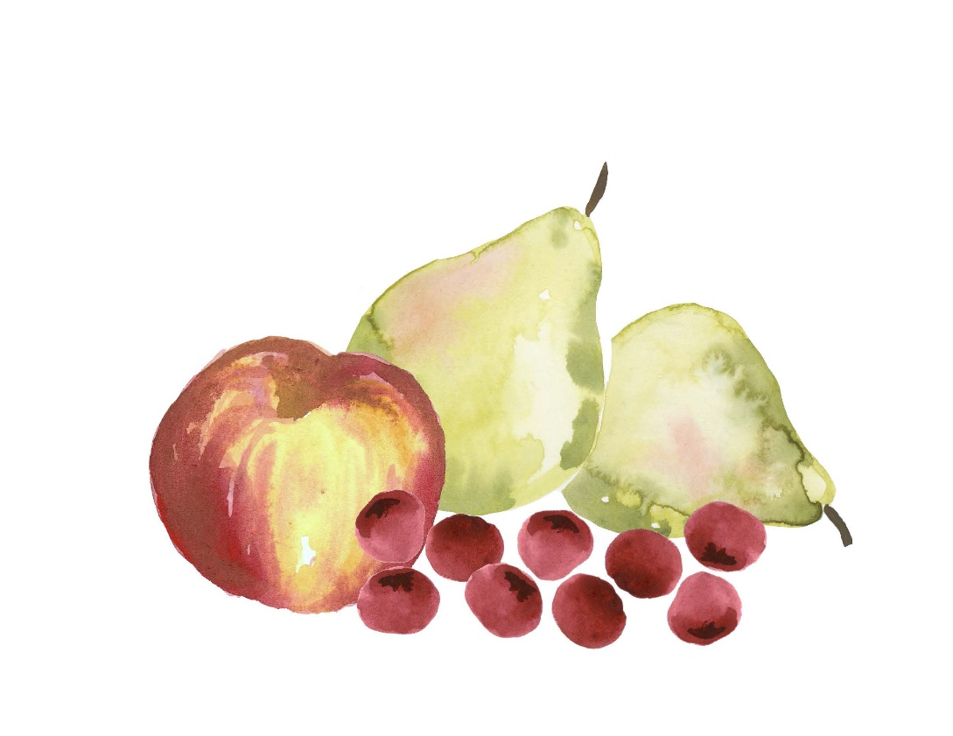

Spiced Apple Pear Freezer Jam
Yield: about 5 half-pint jars
FREEZING

4 cups chopped, cored & peeled apples (approx. 4 apples)
4 cups chopped, cored & peeled pears (approx. 4 pears)
¼ cup water
1 cup granulated sugar
½ cup lightly packed brown sugar
1 package/45 gr (6 tbsp) freezer pectin
¾ tsp ground cinnamon
¼ tsp ground cloves
¼ tsp ground nutmeg
¼ tsp ground allspice

- In a saucepan, combine apples, pears and water. Cover and simmer 5 minutes. (For more of a fruit butter consistency, bring the fruit to boil over medium heat. Reduce the heat, cover the pan, and boil gently until the fruit is softened, about 5 minutes.)

- Using a potato masher, crush the fruit. Measure out 4 cups of the cooked fruit.

- In a large mixing bowl, combine sugars, pectin, and spices, stirring until well blended. Add cooked fruit and stir for 3 minutes.

- Ladle jam into plastic or glass freezer jars, leaving ½-inch headspace. Wipe rims and apply lids tightly.

- Let jam stand at room temperature until thickened, about 30 minutes.

- Serve immediately, if desired. For longer storage, refrigerate for up to 3 weeks or freeze for up to 1 year.

Source: Adapted from Bernardin
SUGAR-FREE VARIATION
For a lower-calorie version of this jam, replace the sugars as follows:
replace the granulated sugar with 1 cup of Splenda® No Calorie Sweetener
replace the brown sugar with ¼ cup Splenda® Brown Sugar Blend

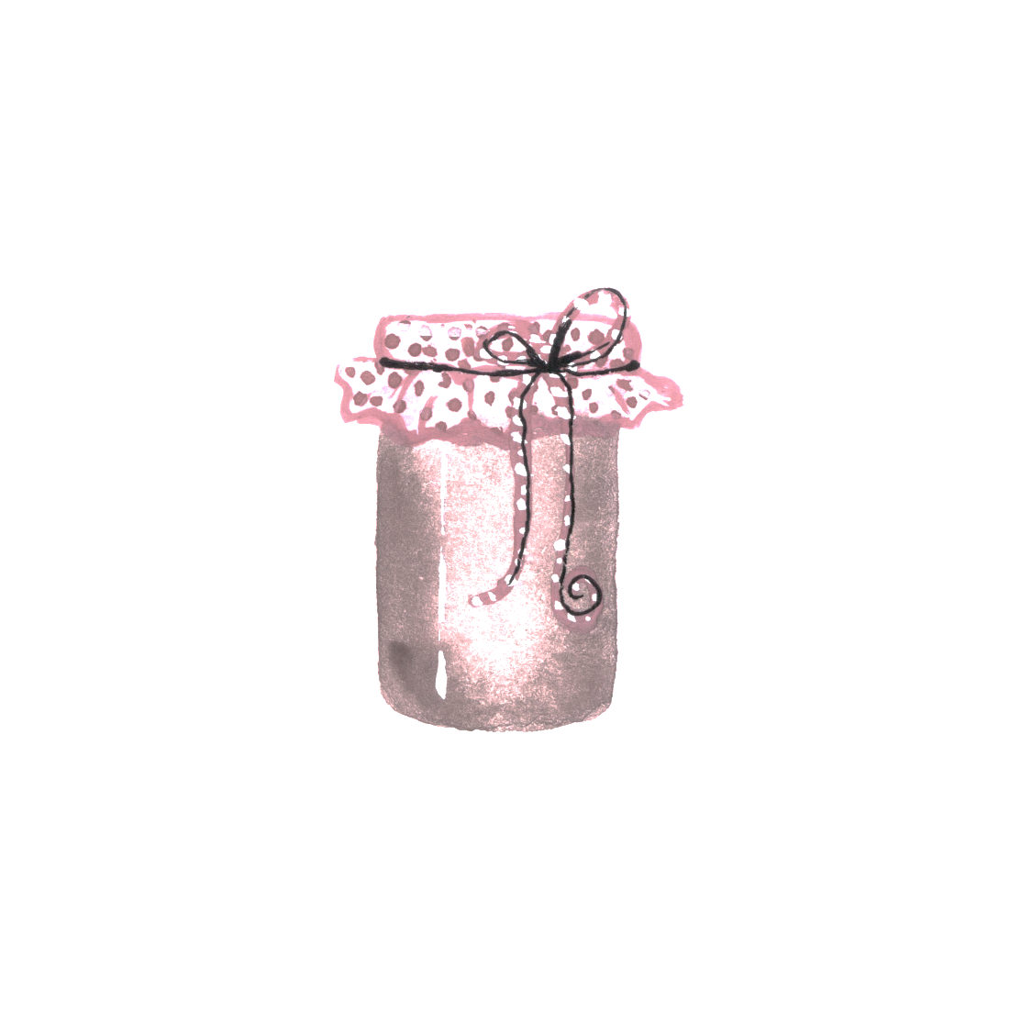

Honey-Dipped Dried Apples (or Pears)
DEHYDRATING
apples
½ cup sugar
1 ½ cups boiling water
½ cup honey

- Make the honey dip: Mix the sugar and boiling water; cool to lukewarm temperature. Add the honey and stir thoroughly.

- Peel the apples if desired, core them, and slice ¼-inch thick. Apples may be sliced into rings, wedges, or chips. (Note that unpeeled apples take longer to dry.)

- Put the sliced apples into the honey dip, and allow to soak for 5 (and no longer than 10) minutes. Remove the fruit from the dip and drain well.

- Set the dehydrator to 140°F. Arrange the well-drained fruit slices on dehydrator trays, making sure they do not touch or overlap. Place trays in the dehydrator, leaving 1-2” between each tray.

- The estimated drying time is 6-12 hours, but this will depend on several factors: the initial moisture content of the fruit; the shape and thickness of the slices; the volume being dried; the efficiency of the dehydrator; and the humidity of the air. Food dries more quickly towards the end of the drying time, so watch closely and remove individual pieces as they dry.

- Test for doneness by removing a few pieces and allow them to cool. Cut the slices in half. There should be no visible moisture, and you should not be able to squeeze any moisture from the pieces. Some apple slices may remain pliable, but they should not be sticky or tacky. If you fold a piece in half, it should not be able to stick to itself.

- After drying, allow the fruit to cool for 30-60 minutes before packing. Warm fruit can sweat and lead to moisture buildup, but waiting too long to pack the fruit could allow it to reabsorb moisture from the air.

- Condition the slices: This important final step, which is done to reduce the risk of mold growth, ensures that all pieces have equal residual moisture (which should be about 20%). Pack the cooled fruit slices loosely into clean glass or plastic jars. Seal the containers and allow them to stand for 7 to 10 days, shaking the jars daily. This allows excess moisture in some pieces to be absorbed by other pieces. If condensation develops in a jar, the fruit is still too moist and needs to be returned to the dehydrator for further drying.

- After conditioning, pack the fruit tightly into containers, removing as much air as possible. Store in a dark, cool place (for best quality, store for up to 1 year). Well-wrapped apples can also be frozen (for best quality, use within 2 years).

Source: Adapted from UC ANR Publ. 8229, Apples: Safe Methods to Store, Preserve and Enjoy
https://anrcatalog.ucanr.edu/pdf/8229.pdf

Pear Mincemeat
Yield: about 9 pint jars
BW/STEAM
CANNING

7 lbs Bartlett pears (about 21 medium)
1 lemon
2 lbs golden or dark raisins
6 ¾ cups sugar
1 tbsp ground cloves
1 tbsp ground cinnamon
1 tbsp nutmeg
1 tbsp allspice
1 tsp ground dried ginger
1 cup vinegar (5% acidity)

- Wash pears and lemon; drain. Cut pears in half lengthwise and core. Coarsely chop pears. Cut lemon into quarters, remove seeds, and finely chop (including the peel), using a food processor or food grinder.

- Combine all ingredients in a large saucepan. Bring mixture to a boil over medium heat, stirring to prevent sticking. Reduce heat and simmer 30 minutes.

- Ladle hot mixture into a hot jar, leaving ½-inch headspace. Remove air bubbles and adjust headspace if necessary. Wipe jar rims with a dampened clean paper towel or cloth. Apply and adjust two-piece metal canning lids. Place jar in canner. Repeat with remaining jar(s).

- Process pint jars in a boiling water or atmospheric steam canner as follows:
25 minutes at 0-1,000 feet elevation
30 minutes at 1,001-3,000 feet elevation
35 minutes at 3,001-6,000 feet elevation
40 minutes at 6,000-8,000 feet elevation

- For boiling water canning, turn off heat, remove canner lid and wait 5 minutes. For atmospheric steam canning, turn off heat, leave canner lid on and wait 2-3 minutes. Remove jars to a rack or towel and let cool, undisturbed, for 12-24 hours and then check seals. Store unsealed jars in the refrigerator or reprocess. Clean and label sealed jars and store in a cool, dry dark location.

Source: Adapted from Ball Blue Book (2020)

IDEAS FOR USING PEAR MINCEMEAT
Serve with roast pork or beef. Stuff into the cavity of acorn squash during the last 15 minutes of baking and then drizzle with honey. Or make the delicious quick bread recipe at the end of this handout.

Asian Pears (Halved or Sliced)
Yield: variable
BW/STEAM
CANNING

fresh Asian pears*
sugar syrup (or juice or water)
bottled lemon juice

Asian Pear Math: An average of 17-19 lbs of Asian pears is needed per canner load of 7 quarts; an average of 11-13 lbs is needed per canner load of 9 pints.

*Quality: Choose ripe, mature fruit of ideal quality for eating fresh or cooking.

- Wash and peel pears. Cut in halves and remove cores. Slice if desired. Place pears in an ascorbic acid solution to prevent discoloration (see pg. 2).

- Prepare a very light, light or medium syrup (see pg. 2). Pears may also be packed in apple juice, white grape juice, or water.

- Boil drained pears 5 minutes in the syrup, juice or water.

- Pack the pears into a hot jar and cover with boiling cooking liquid, leaving ½-inch headspace. IMPORTANT! Add bottled lemon juice to each jar as follows:

Per pint jar: 1 tbsp bottled lemon juice
Per quart jar: 2 tbsp bottled lemon juice

- Remove air bubbles and adjust headspace if necessary. Wipe jar rims with a dampened clean paper towel or cloth. Apply and adjust two-piece metal canning lids. Place jar in canner. Repeat with remaining jar(s).

- Process pint jars in a boiling water or atmospheric steam canner as follows:
20 minutes at 0-1,000 feet elevation
25 minutes at 1,001-3,000 feet elevation
30 minutes at 3,001-6,000 feet elevation
35 minutes above 6,000 feet elevation

- Process quart jars in a boiling water or atmospheric steam canner as follows:
25 minutes at 0-1,000 feet elevation
30 minutes at 1,001-3,000 feet elevation
35 minutes at 3,001-6,000 feet elevation
40 minutes above 6,000 feet elevation

- For boiling water canning, turn off heat, remove canner lid and wait 5 minutes. For atmospheric steam canning, turn off heat, leave canner lid on and wait 2-3 minutes. Remove jars to a rack or towel and let cool, undisturbed, for 12-24 hours and then check seals. Store unsealed jars in the refrigerator or reprocess. Clean and label sealed jars and store in a cool, dry dark location.

Source: Adapted from National Center for Home Food Preservation
Quince Jelly
Yield: about 4 half-pint jars
BW/STEAM
CANNING

3 ¾ cups quince juice (about 3 ½ lbs quince* and 7 cups water)
¼ cup bottled lemon juice

Prepare Juice: *Select about ¼ firm-ripe and ¾ fully ripe quince. Sort, wash, and remove stems and blossom ends; do not pare or core. Slice quince very thin or cut into small pieces into a saucepan. Add water, cover and bring to a boil on high heat. Reduce heat and simmer for 25 minutes. Pour mixture into a dampened jelly bag and suspend the bag over a bowl or pot to drain the juice. The clearest jelly comes from juice that has dripped through a jelly bag without pressing or squeezing. If a fruit press is used to extract the juice, the juice should be restrained through a jelly bag.

- Measure quince juice into a saucepot. Add lemon juice and sugar and stir well. Boil over high heat to 8°F above the boiling point of water (212°F at sea level), or until jelly mixture sheets from a spoon.

- Remove from heat; skim off foam quickly.

- Immediately pour jelly into a hot jar, leaving ¼-inch headspace. Wipe jar rims with a dampened clean paper towel or cloth. Apply and adjust two-piece metal canning lids. Place jar in canner. Repeat with remaining jar(s).

- Process half-pint jars in a boiling water or atmospheric steam canner as follows:
5 minutes at 0-1,000 feet elevation
10 minutes at 1,001-3,000 feet elevation
15 minutes at 3,001-6,000 feet elevation
20 minutes at 6,000-8,000 feet elevation

- For boiling water canning, turn off heat, remove canner lid and wait 5 minutes. For atmospheric steam canning, turn off heat, leave canner lid on and wait 2-3 minutes. Remove jars to a rack or towel and let cool, undisturbed, for 12-24 hours and then check seals. Store unsealed jars in the refrigerator or reprocess. Clean and label sealed jars and store in a cool, dry dark location.

Source: Adapted from So Easy to Preserve (2014)

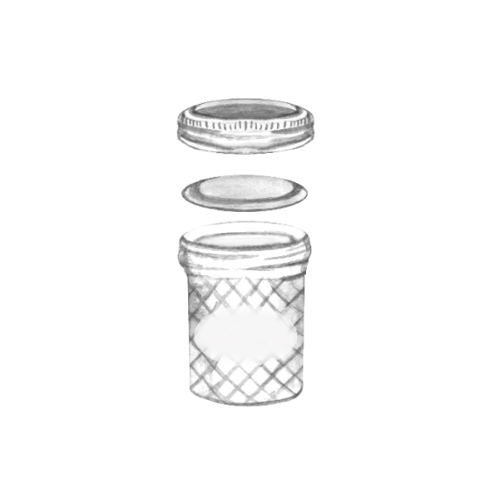

Pumpkin-Apple Pie
1 pie crust (homemade or store bought)
USE YOUR PRESERVES!
2 large eggs
½ cup sugar
1 ½ cups applesauce
1 cup pumpkin purée
1 cup sour cream
1 ½ tsp pumpkin pie spice

- Preheat oven to 400°F. Line a deep-dish pie plate with the crust and chill it while making the filling.

- Beat the eggs until they are combined, then gradually add the sugar and beat until the mixture is pale and thick.

- Mix in the applesauce, pumpkin puree, sour cream, and spice.

- Pour the filling into the pie crust and bake for 1 hour, or until the filling is just set in the center. Cool the pie on a rack for at least 30 minutes before serving.

Recipe from the kitchen of Laura Crowley

Pear Mincemeat Bread
3 cups sifted flour
USE YOUR PRESERVES!
1 cup sugar
¾ tsp allspice
¾ tsp cinnamon
¾ tsp nutmeg
¾ tsp salt
2 cups (1 pint) pear mincemeat
2/3 cup canola or vegetable oil
½ cup apple juice
3 eggs, beaten
½ cup chopped walnuts

- Preheat oven to 350°F. Grease and flour two 9x5” or 8x4” loaf pans.

- In a large bowl, mix dry ingredients.

- Stir in the remaining ingredients except nuts. Do not overmix. Fold in the nuts.

- Divide the batter between the pans and bake for 45-55 minutes, or until a toothpick inserted into the center comes out clean.

Recipe from the kitchen of Mary Grove

Always follow research-based recipes from reliable resources that follow the recommendations of the National Center for Home Food Processing.

For more information on food safety and preserving, see our series of Educational Posters at:

https://ucanr.edu/sites/mfp_of_cs/Food_Safety/

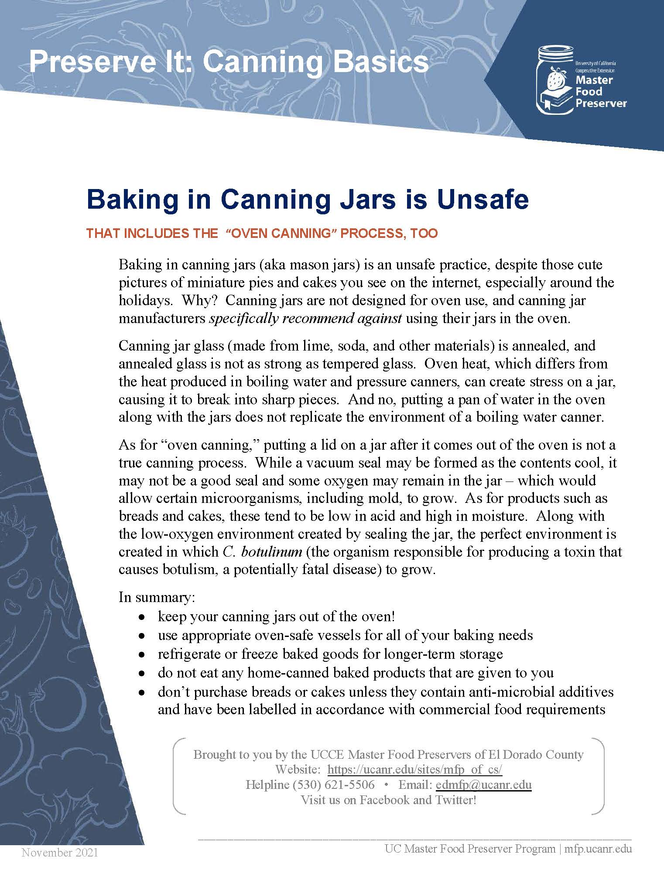

Other Resources:
UC Master Food Preservers of Central Sierra https://ucanr.edu/sites/mfp_of_cs/
National Center for Home Food Processing https://nchfp.uga.edu/
USDA Complete Guide to Home Canning https://nchfp.uga.edu/publications/publications_usda.html#gsc.tab=0

The information in this handout is provided as a courtesy to the reader. No endorsements of commercial products or services are made or implied, nor is criticism implied of similar products or information from organizations not listed.

It is the policy of the University of California (UC) and the UC Division of Agriculture & Natural Resources not to engage in discrimination against or harassment of any person in any of its programs or activities (Complete nondiscrimination policy statement can be found at http://ucanr.edu/sites/anrstaff/files/215244.pdf

