**Dehydrating Your Harvest**

***Food Safety:***

To maintain safety and quality, several factors must be considered when drying fruits, vegetables, and herbs. Keep in mind that specific food products often have recommendations unique to them. Drying removes the moisture from food so microorganisms such as bacteria, yeasts, and molds are less likely to grow; however, drying does not effectively destroy them. Because there is not a heat treatment that effectively destroys disease-causing microorganisms, it is critical to use safe food-handling practices when growing and handling fruits, vegetables, and herbs for drying.

The optimum drying temperature is 140°F. If higher temperatures are used, the food will develop “case hardening” and moisture will not be able to escape from the food; this, in turn, will lead to a moldy food product. Therefore, do not rush the drying process.

Low humidity is also needed when drying foods. If the surrounding air is humid, the foods will not dry effectively. Increasing the air movement away from the food will assist in the drying process.

Foods can be dried in the oven, under the sun, on the vine, or indoors using a dehydrator. There are several resources that provide tested methods for dehydrating vegetables, fruits, and herbs - ask your county UC Cooperative Extension office for information on specific drying methods.

When dehydrating foods, using good sanitary practices is critical in reducing the risk of contaminating foods with pathogens and spoilage microorganisms:

* After harvesting produce or herbs, place them in containers and locations free from additional contamination. (For example, some place pets and wild animals will not have access.)
* Begin the dehydration process soon after harvesting.
* Clean and sanitize all utensils, containers, the food-contact surfaces of dehydrating equipment, and work surfaces. To effectively clean, wash with warm, soapy water; rinse thoroughly with warm water; and sanitize using one of the following methods:
  + Immerse utensils and drying trays in a chlorine bleach solution (1 ½ tsp of bleach per gallon of water) for 10 seconds, then air dry (do not use a towel). Or, prepare a sanitizing spray solution of ½ tsp of household bleach per quart of water, and spray on food-contact surfaces. Let air dry.
* Always wash hands before handling foods—that includes harvesting.
* Consider wearing disposable gloves when preparing foods for dehydrating. Wash hands before putting gloves on, and always remove gloves whenever you change a task (such as answering the phone or preparing another food item). If your gloves become soiled or torn during food preparation, replace them before resuming food preparation. Do not wash gloves to reuse—dispose of gloves after use. Gloves can give a false sense of security. Change gloves as recommended—do not contaminate food with gloves used incorrectly.

*\*Household chlorine bleach is a common sanitizer. Use an unscented and unconcentrated bleach for food-contact surfaces and utensils.*

***Dehydrating***

The overall objective is to remove moisture before the food spoils.

***Equipment:***

An electric Dehydrator needs the following:

* Heating element
* Fan
* Thermostat

If your dehydrator has a top or bottom fan you need to rotate the trays to evenly dry product.

***Fruit*:**

Some foods dry better than others. The following fruits dry well: apples, apricots, blueberries, cherries, cranberries, figs, grapes, huckleberries, peaches, pears and plums.

The following fruits dry less well: blackberries, cantaloupe, lemons, and oranges.

Pretreatment of fruits applies to both dehydration and freezing. Pretreatment of fruits is a personal preference; food safety is not affected. Pretreatment of some fruits before drying will reduce vitamin loss, flavor loss, browning, and deterioration during storage.

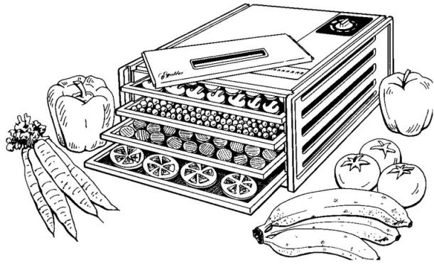***Pretreatment Methods***

***Sodium bisulfite*** is used by dissolving 2 teaspoons of the powder in 1quartof water and adding the cut fruit. Dip the fruit in the solution; drain and dehydrate.

***Ascorbic Acid*** is used by dissolving 1 tablespoon of the powder in 1 quart of cold water. Dip the fruit in the solution then drain and dehydrate.

***Citric Acid*** is only one-eighth as effective as ascorbic acid. Dissolve 1 tablespoon in 1 quart of water. Dip the fruit in the solution then drain and dehydrate.

***Citrus Juices:*** Pineapple, lemon and lime juice may be used, but are only one-sixth as effective as ascorbic acid. Use 1 cup of lemon or lime juice to 1 quart of water. Dip the fruit in the solution then drain and dehydrate.

***Crazing:*** Some fruits have a protective wax coating, such as plums, figs, cranberries, blueberries, and grapes. It is necessary to pre-treat these fruits by dipping them in boiling water for 3- -60 seconds, according to the size and toughness of the skin.

***Sulfuring:*** The process of sulfuring produce is beyond the scope of this presentation. If you want to learn more here is a link: <https://extension.usu.edu/files/publications/publication/FN-330.pdf>

***Vegetables:***

Almost all vegetables should be blanched by hot water or steam before drying. Exceptions include: peppers, onions and mushrooms.

The following vegetables dry well: beets, cabbage, carrots, celery, corn, green peas, green peppers, mushrooms, onions, garlic, potatoes, tomatoes and turnips.

The following vegetables dry less well: lettuce, radishes, spinach, and other greens.

***Blanching:*** Blanching is the process of heating vegetables sufficiently to deactivate enzymes that would cause flavor and color deterioration during either the dehydration or freezing process. Blanch with hot water or steam for the time stated in Table "Freezing Vegetables" on page 8. Green peppers, onions, garlic, mushrooms and okra require no pre-treatment.

***Citric Acid Blanch*:**  A small amount of citric acid (¼ teaspoon) added to water, makes blanching more effective in destroying potentially harmful bacteria, including *Esherihiacoli*, *Salmonella species, and Listeria monocytogenes.* However, while citric acid acts as an anti-darkening agent for light-colored vegetables, it will cause bright green vegetables to turn olive green.

***Meat****:*

The processing of meat and meat jerky is beyond the scope of this presentation.

***Herbs*:**

Temperature range for drying herbs is lower; 95-115º degrees. The following herbs dry well: chervil, rosemary, chives, sage, dill, tarragon, mint, thyme and oregano.

***Test for dryness***

***Fruit:*** Fruit should be pliable and leather-like, without any pockets of moisture.

***Vegetables:*** Most vegetables will be hard and brittle when dried.

Produce may dry unevenly and some pieces may need to be removed before others.

***Finishing:*** All dried foods should be conditioned before packing. Too much moisture left in a few pieces may cause the whole batch to mold. Place dried foods in a tightly closed large container. Stir or shake each day for a week. This will equalize the moisture. If moisture forms on the inside of the container the food has not been dried sufficiently. Return the food to the dehydrator for a few more hours.

Pasteurizing is necessary for any food products that could have been exposed to insect infestation or larva prior to handling or during the drying process. The food should be frozen after it has been conditioned. Pack the food in airtight containers, removing as much air as possible; place in a freezer at 0°F for at least two days.

***Storage:***

Moisture must be kept from dried foods when they are in storage. Containers suitable for the freezer work well for storing dried food.

***Rehydrate****:*

There are three basic methods used to rehydrate dried foods: 1. Soak in liquid, 2. Boil in water, and 3. Cook in liquid. Do not add salt or sugar during the first 5 minutes of rehydration as salt hinders the water absorption process. Various fruit juices, yogurt, cordials, and fruit liqueurs may be used instead of water to reconstitute fruits. Place fruit pieces in a shallow pan and cover with the liquid. The general rule is to use 2 cups of fruit to 1 cup of liquid. Add more liquid as needed. Fruit will usually reconstitute in a couple of hours. Refrigerate if it takes longer.

Vegetables may be reconstituted in consommé, bouillon, vegetable juice, water, or milk. Refrigerate during rehydration. Allow plenty of time - from 1 to 2 hours up to 8 hours, depending upon the vegetable.

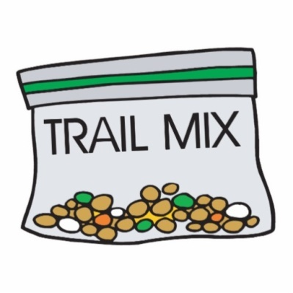 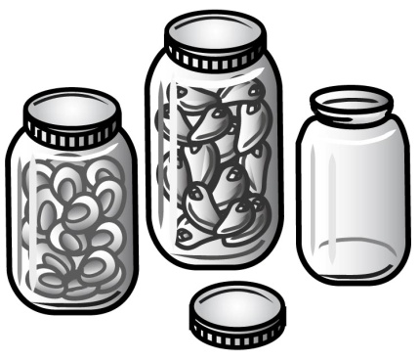 

***Fruit and Vegetable Leathers***

Fruit leather is an ideal way to use fruits that are bruised, overripe, or those not ideal for regular drying or freezing. Cut away bruised spots and puree. Select ripe or slightly overripe fruit. Wash fresh fruit or berries in cool water. Remove peel, seeds and stem. Cut fruit into chunks. Use 2 cups of fruit for each 13" x 15”-inch fruit leather. Puree fruit until smooth. Add 2 teaspoons of lemon juice or 1/8 teaspoon ascorbic acid (375 mg) for each 2 cups of light-colored fruit to prevent darkening.

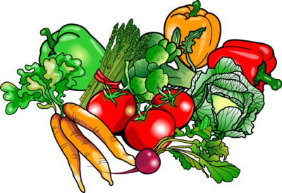

*Optional:* To sweeten, add corn syrup, honey or sugar. Corn syrup or honey is best for longer storage because it prevents crystals. Sugar is fine for immediate use or short storage. Use ¼ to ½ cup sugar, corn syrup or honey for each 2 cups of fruit. Saccharin-based sweeteners could also be used to reduce tartness without adding calories. Aspartame sweeteners may lose sweetness during drying. The best fruit for leathers are apples, apricots, bananas, berries, peaches, and pears.

Vegetable leathers are made similar to fruit leathers. Common vegetable leathers are pumpkin, mixed vegetable and tomato. Purée cooked vegetables and strain. Salt, pepper and spices can be added for flavoring.

***Dehydrated Tomatoes***

Dried tomatoes must be properly packaged because tomatoes readily reabsorb moisture. This will shorten their storage life and cause undesirable flavor changes. Some dried tomatoes turn black during storage due to low acid. This does not harm the tomatoes; just makes them unappetizing. The best varieties of tomatoes to dry are any of the firm, full-flavored varieties. The newer sweet, low acid tomatoes do not dry successfully.

Choose firm, ripe, bright red tomatoes. They should be thick-walled with a high acid content.

There is no pretreatment required for tomatoes.

Wash, core, and peel (if desired) the tomatoes. To peel a tomato, immerse in boiling water for 30 to 45 seconds. Immediately place in cold water and peel. Slice tomatoes crosswise ⅜” to ½" thick with a very sharp stainless-steel knife. Avoid crushing the tissue. Dry at 140oF for 2 to 3 hours, then finish at 130oF until dry. Tomatoes should be dried to brittle stage.

To use the dried tomatoes, crush, crumble, chop and sprinkle over salads, pasta, or use in soup and stews.

High acid tomatoes will sun dry satisfactorily.

***Tomato Powder***

Fresh tomatoes*

* Slice tomatoes into 1/4-inch thick slices. Place on dehydrator tray and dry until crisp.
* Place dried tomato in a blender, herb, or coffee grinder and blend until a fine powder.
* Store in an airtight container in a cool, dry, dark location.
* Use powder in a variety of dishes from soups to meat loaf. The flavor of dried tomatoes is more concentrated so use sparingly in your cooking.

* May use canned pureed tomatoes and dry as a leather.

***Dehydrated Tomato Soup with Basil and Garlic***

* 2 cups dried plum tomatoes
* 1 cup dried onion pieces
* 1/2 cup dried celery slices
* 1 tsp chopped dried garlic
* 7 cups water or vegetable stock
* 2 tbsp finely chopped fresh basil
* 1 tsp salt (or to taste)
* 1/4 tsp freshly ground pepper

In a large pot, combine tomatoes, onions, celery, garlic and water.; bring to boil over high heat. Reduce heat and simmer, stirring occasionally, for about 25 minutes or until vegetables are soft and flavor is well balanced. Using an immersion blender in the pot, or transferring in batches to a blender or food processor, puree soup until silky smooth. Return to pot, if necessary. Reheat over medium heat until steaming, stirring often. Stir in basil, salt and pepper.

*Source: The Dehydrator Bible 2009*

***Dehydrated Entrée in a Jar: Italian Barley Soup Mix***

* 1 cup pearled barley
* 2 cup dried tomato
* 1 Tbsp. dried chopped onion
* 1 Tbsp. dried minced garlic (or I tsp garlic powder)
* 2 Tbsp. dried basil
* 1 Tbsp. dried oregano
* I Tbsp. dried parsley flakes
* 1 tsp. (or one cube) chicken bouillon
* Salt and pepper to taste



Procedure:

Layer all ingredients in a clean pint-size jar in the order listed.

To use:

Add contents of jar, 4 cups water, and one 14-oz can of diced tomatoes to saucepan.

Bring to boil over high heat, reduce heat to low, and simmer until barley is t

ender, approximately Season to taste with salt and pepper.

***Dehydrated Grapes: Raisins***

Small fruits such as cherries or grapes have a thin wax like coating which keeps moisture in. This coating needs to be cracked or checked before drying so the moisture can escape. Commercially these fruits are checked by dipping the fruit in a lye solution. This is not recommended for home drying because of the dangers of handling lye and the possible retention of lye in the fruit.

You can speed the drying process in whole small fruits by dipping them in boiling water just long enough to crack the skins. Raisins dried in a dehydrator differ in appearance from sun dried. They are lighter in color and are plumper. The recommended drying temperature is: 160°F for 1 to 2 hours, 130°F until dry.

***Dehydrated Apples and Pears***

***Dried Apples***

Choose any tart, firm-textured apple.

Wash, peel and core apples.

Cut into 1/4 to 1/2 inch slices or rings.

Pre-treat by dipping into citric acid or lemon juice

Dry at 130 to 135 until pliable.

Use as a snack, for applesauce or in baked goods, such as pies, cobblers or crisps.

Water content 84%

***Dried Pears***

Choose any summer or winter variety. Allow pears to ripen at home before drying.

Wash, peel and core fruit. Cut into 1/2-inch slices, quarters or halves.

Pre-treat by dipping, if desired. Dry at 130 to 135 until leathery with no moisture pockets.

Use as a snack or in baked goods. Water content 83%

***Dehydrated Strawberries***

Choose firm, ripe, red berries with a solid color; the sweeter the better.

Pick when fully ripe. They will not develop natural sugar if picked when slightly green and will not continue to ripen off the vine.

Gently wash berries in plenty of cold water. Do not let berries stand in the water.

Remove the berries from the water and drain.

Remove the caps and cut into ½" slices. Smaller berries may be cut in half.

Place skin side down on the dryer rack.

Dry at a temperature of 140o F for 1 to 2 hours; finish at 130o F until dry.

Berries are pliable and leathery with no pockets of moisture when dry.

***Dehydrated Herbs***

**Herb or Spices** **When Harvested** **Part of Plant Dried**

Anise before Blossoming Leaves

Fall Seeds

Basil Summer Leaves

Borage When mature Leaves

First Blossoming Flowers

Caraway Fall of second season Seeds

Celery When mature Leaves

Chives Throughout growing season Leaves

Cilantro Summer Leaves and stems

Fall Seeds

Dill First blossoming Leaves and stems

Throughout growing season

Oregano First blossoming Leaves & flowers

Parsley When mature Leaves & stems

Rosemary When mature Needle-like leaves

Sage Before blossoming Leaves

Tarragon Before blossoming Leaves

Thyme When mature Leaves

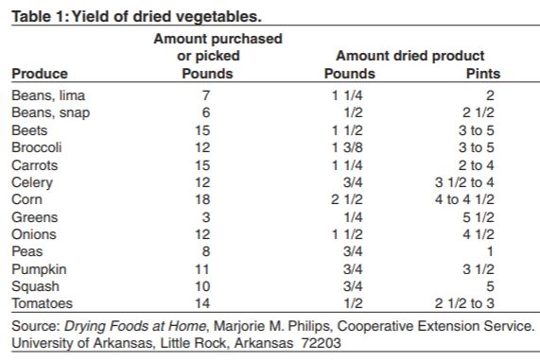

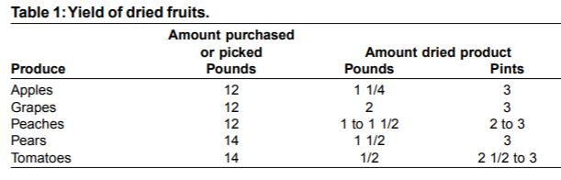

***Resources for tested recipes:***

**National Center for Home Food Preservation**: <http://nchfp.uga.edu/>

**Complete Guide to Home Canning**. 2015. <http://nchfp.uga.edu//publications/publications_usda.html>

Also available in paper copy from Purdue Extension (online store is located at <https://mdc.itap.purdue.edu/item.asp?item_number=AIG-539>)

**Canning Vegetables**, 2012. Publication 8072. University of California Ag & Natural Resources, <http://anrcatalog.ucanr.edu>.

**So Easy to Preserve,** Sixth Edition. 2016. Bulletin 989. Cooperative Extension/University of Georgia, Athens

**Ball Blue Book Guide to Preserving**. 2020. Newell Corporation.

**Ball Complete Book of Home Preserving**, 2020. Bernardin, Newell Corporation.

It is the policy of the University of California (UC) and the UC Division of Agriculture & Natural Resources not to engage in discrimination against or harassment of any person in any of its programs or activities (Complete nondiscrimination policy statement can be found at <http://ucanr.edu/sites/anrstaff/files/215244.pdf> )

7/17/2022