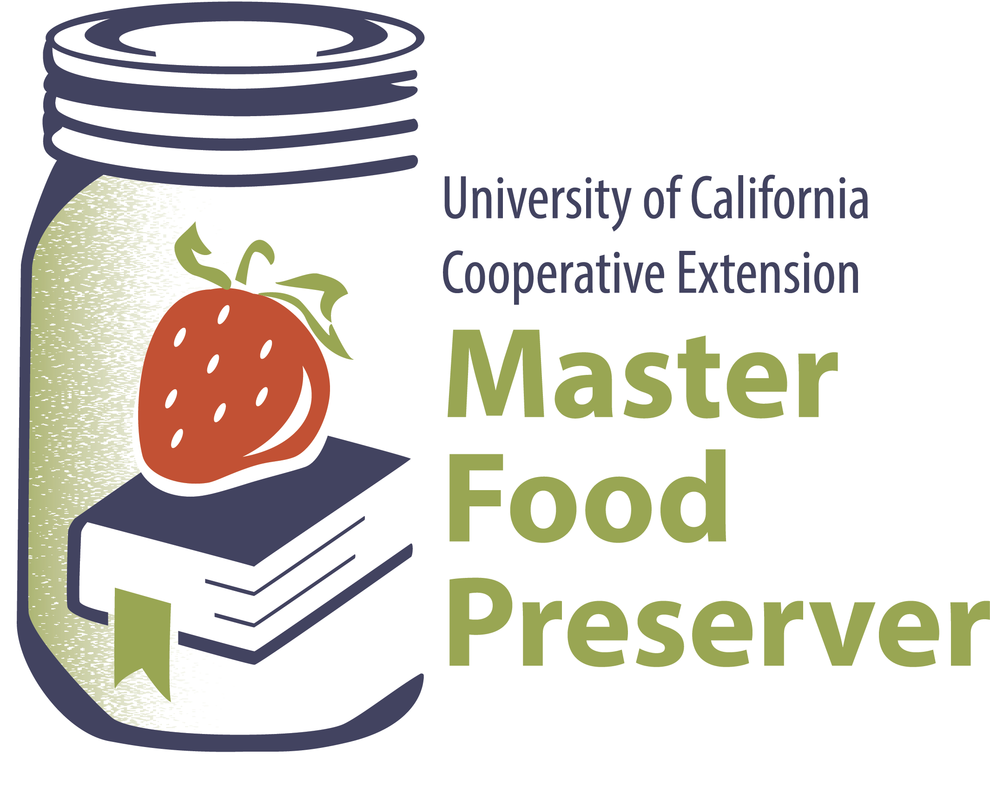

**UCCE Master Food Preservers of El Dorado County**

**311 Fair Lane, Placerville Ca 95667**

**Helpline (530) 621-5506 • Email:** [**edmfp@ucanr.edu**](mailto:edmfp@ucanr.edu)

**Visit us on Facebook and Twitterr!**

**Tomatoes, ToMAHtoes: Basic & Fancy**

***Food Safety***

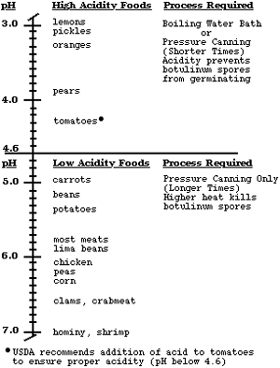

Contrary to popular belief, tomatoes are not a high-acid food. They are borderline high acid with a pH of approximately 4.5. This is too close to the dividing line between high- and low acid foods. As a result, homemade tomato products must be acidified by adding bottled lemon juice, citric acid, or vinegar before they are heat processed in a boiling water, atmospheric steam, or pressure canner. For this reason, it is important to use a recipe from a reliable source and to acidify your tomato products correctly, for both boiling water or atmospheric steam canning as well as for pressure canning.

Today’s tomato hybrids are developed to be less acidic. This is especially true for Roma-type tomatoes, which are popular for sauces. Once other vegetables, such as peppers, onions, celery and herbs are added, the acidity is lowered even further. Therefore, one needs to follow a tested recipe from a reliable source. Boiling water or atmospheric steam canning is only recommended for high acid foods.

If your tomato products are not correctly processed, the food could be unsafe for consumption. Mold, E. coli, or botulism are real food hazards if the food is not processed correctly.

There are some tomato products in the USDA canning procedures that only have a pressure canning process listed (for example, tomatoes with okra or zucchini, spaghetti sauces, Mexican tomato sauce, etc.).  If a pressure canning process is the only listed option, then it is the recommended processing method and the boiling water bath process is not recommended for that recipe. These products made according to the stated recipes and procedures are low-acid food mixtures.

***Selecting Tomatoes***

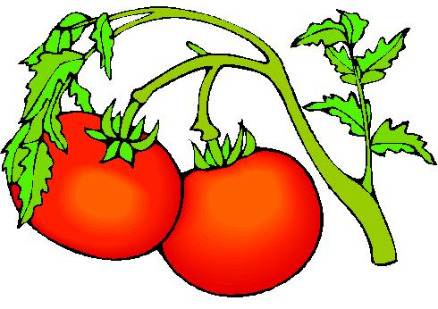

The home canner should use the best quality, vine-ripened tomatoes whenever possible. Most of today’s tomatoes have been bred for sweetness versus acidity. For this reason, additional acid must be added to canned tomatoes, tomato puree, tomato sauce and tomato juice in the form of either bottled lemon juice, citric acid, or vinegar that has an acidity of at least 5%. Green (unripe) tomatoes are more acidic than ripe tomatoes and can be canned safely by the boiling water or atmospheric steam method. Do NOT use tomatoes from dead or frost-killed vines, as the tomatoes may be lower in acid.

Tomatillos may also be canned in a boiling water or atmospheric steam canner but must be acidified the same as tomatoes.

***Dehydrating Tomatoes***

To maintain safety and quality, several factors must be considered when drying fruits, vegetables, and herbs. Keep in mind that specific food products often have recommendations that are unique to them. Drying removes the moisture from food so that microorganisms such as bacteria, yeasts, and molds are less likely to grow; however, drying does not effectively destroy them. Because there is not a heat treatment that effectively destroys disease-causing microorganisms, it is critical to use safe food-handling practices when growing and handling fruits, vegetables, and herbs for drying. The optimum drying temperature is 140°F. If higher temperatures are used, the food will develop case hardening and moisture will not be able to escape from the food; this, in turn, will lead to a moldy food product. Therefore, do not rush the drying process. Low humidity is also needed when drying foods. If the surrounding air is humid, the foods will not dry effectively. Increasing the air movement away from the food will assist in the drying process. Foods can be dried in the oven, under the sun, on the vine, or indoors using a dehydrator. There are several resources that provide tested methods for dehydrating vegetables, fruits, and herbs—ask your county Extension office for information on specific drying methods. When dehydrating foods, using good sanitary practices is critical to reducing the risk of contaminating foods with pathogens and spoilage microorganisms:

Dried tomatoes must be properly packaged because tomatoes readily reabsorb moisture. This will shorten their storage life and cause undesirable flavor changes. Some dried tomatoes turn black during storage due to low acid. This does not harm the tomatoes; just makes them unappetizing. The best varieties of tomatoes to dry are any of the firm, full-flavored varieties. The newer sweet, low acid tomatoes do not dry successfully. Choose firm, ripe, bright red tomatoes. They should be thick-walled with a high acid content. There is no pretreatment required for tomatoes. Wash, core, and peel (if desired) the tomatoes. To peel a tomato, immerse in boiling water for 30 to 45 seconds. Immediately place in cold water and peel. Slice tomatoes crosswise ⅜‖ to ½" thick with a very sharp stainless steel knife. Avoid crushing the tissue. Dry at 140°F for 2 to 3 hours, and then finish at 130°F until dry. Tomatoes should be dried to brittle stage. High acid tomatoes can be sun dried satisfactorily.

**Finishing:** All dried foods should be conditioned before packing. Too much moisture left in a few pieces may cause the whole batch to mold. Place dried foods in a tightly closed large container. Stir or shake each day for a week. This will equalize the moisture. If moisture forms on the inside of the container the food has not been dried sufficiently. Return the food to the dehydrator for a few more hours. Pasteurizing is necessary for any food products that could have been exposed to insect infestation or larva prior to handling or during the drying process. To pasteurize, freeze the food after it has been conditioned. Pack the food in airtight containers, removing as much air as possible; place in a freezer at 0°F for at least two days.

**Storage**: Moisture must be kept from dried foods when they are in storage. Containers suitable for the freezer work well for storing dried food.

Vegetables may be reconstituted in consommé, bouillon, vegetable juice, water, or milk. Refrigerate during rehydration. Allow plenty of time - from 1 to 2 hours up to 8 hours, depending upon the vegetable.

To use the dried tomatoes, crush, crumble, chop and sprinkle over salads, pasta, or use in soup and stews.

***Canned Tomatoes***

|  |  |
| --- | --- |
| **Acidity Chart** | |
| Bottled Lemon Juice | 1 Tablespoon per Pint  2 Tablespoons per Quart |
| Citric Acid | ¼ teaspoon per Pint  ½ teaspoon per Quart |
| Vinegar, 5% acidity | 2 Tablespoons per Pint  4 Tablespoons per Quart |

Sort tomatoes, picking out any that are spoiled or green. If tomatoes are excessively dirty, wash with a solution containing one tablespoon of chlorine bleach in one gallon of water. To peel tomatoes, dip them in boiling water long enough to crack the skins (about 1 minute). (Cutting a shallow X in the blossom end of the tomato speeds this process.) Dip in cold water. Peel the tomatoes and remove the cores. Save any juice to add to the hot liquid in which you boil the tomatoes.

**Hot Pack**: Bring whole or halved, peeled tomatoes to a low boil over medium heat. Add bottled lemon juice to jars using the measurements in the Acidity Chart above. Pack hot tomatoes into hot jars. Pour in the hot water in which the tomatoes were heated, leaving ½" headspace. Add salt, if desired (1 tsp. to each quart jar or ½ tsp. to each pint jar). Carefully run a non-metallic utensil down inside of jars to release trapped air bubbles. Wipe the rims clean. Place lids and rings on jars, tightening rings to “fingertip-tight”. Process pints for 40 minutes and quarts for 45 minutes in a boiling water or atmospheric steam canner.

**Raw Pack**: Remove jars from hot water. Add bottled lemon juice to jars using the measurements in the Acidity Chart above. Pack raw, whole or halved, peeled tomatoes into hot jars. Cover tomatoes in jars with boiling water, leaving ½" headspace. Add salt, if desired (1 tsp. for each quart or ½ tsp. for each pint). Carefully run a non-metallic utensil down inside of jars to release trapped air bubbles. Wipe the rims clean. Place lids and rings on jars, tightening rings to “fingertip-tight”. Process pints for 40 minutes and quarts for 45 minutes in a boiling water or **atmospheric steam canner.

Adjust for altitude if needed: 1000-3000 ft. above sea level, increase processing time 5 minutes, 3001-6000 ft. by 10 minutes, above 6000 ft. by 15 minutes.

**Note: If you use boiling tomato juice instead of boiling water to cover the tomatoes in the jars, processing time is 85 minutes for both pints and quarts.**

** Atmospheric steam canners are not recommended where processing times are greater than 45.

*Source: National Center for Home Food Preservation* [*http://www.uga.edu/nchfp/how/can3_tomato.html*](http://www.uga.edu/nchfp/how/can3_tomato.html)

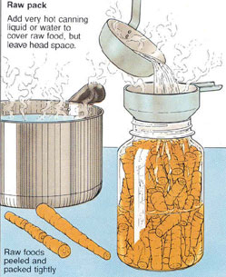 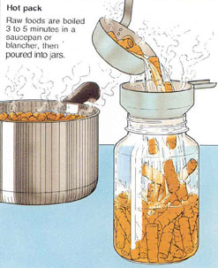

# ***What is “fingertip tight”?***

A practical way to determine if the ring is fingertip tight is to place the band on the jar, turn it just until you feel resistance, then turn the band one-quarter turn more. For beginning canners, it may help to mark the band and lid with a marker at the point of first resistance and at the point that represents an additional quarter turn and to then turn the band to that point.

*Source: Clemson Cooperative Extension, https://www.clemson.edu/extension/food/canning/canning-tips/08tighten-lids.html.*

**RECIPE: *Chunky Basil Pasta Sauce* Yield: About 4 pints**

* 8 cups tomatoes, peeled and coarsely chopped, about 4 lbs.
* 1 cup onion, chopped
* 3 cloves garlic, minced
* ⅔ cup red wine
* ⅓ cup red wine vinegar (5%)
* ½ cup fresh basil, chopped
* 1 Tbsp fresh parsley, chopped
* 1 tsp pickling salt
* ½ tsp granulated sugar
* 1 can tomato paste (6 oz.)
* bottled lemon juice

Combine all ingredients in a large kettle. Bring to a boil over high heat; reduce heat and simmer uncovered, stirring frequently, for 40 minutes or until thickened to desired consistency. Add 1 Tbsp. bottled lemon juice directly into each pint jar. Ladle hot sauce into hot jars, leaving 1/2" headspace. Carefully run a non-metallic utensil down inside of jars to release trapped air bubbles; add more sauce to get the proper headspace if needed. Wipe jar rims clean. Place lids and rings on jars, tightening rings “fingertip- tight”.

Process pint jars in a water bath or **atmospheric steam canner for:

35 minutes at 1000-3000 ft., 40 minutes 3001-6000 ft., 45 minutes above 6001 ft.

Process quarts jars in a boiling water canner for:

40 minutes at 1000-3000 ft., 45 minutes 3001-6000 ft., 50 minutes above 6001 ft.

** Atmospheric steam canners are not recommended where processing times are greater than 45 minutes.

*Source: Adapted from National Center for Home Food Preservation; http://nchfp.uga.edu/how/can3_tomato.html*

**RECIPE: *Spiced Tomato Jam* Yield:** **About 5 half-pint jars**

* 3 cups prepared tomatoes (about 2 ¼ lbs.)
* 1½ tsp. grated lemon rind
* ½ tsp. ground allspice
* ½ tsp. ground cinnamon
* ¼ tsp. ground cloves
* 4½ cups sugar
* 1 box powdered pectin
* ¼ cup lemon juice

Wash firm-ripe tomatoes. Scald, peel, and chop tomatoes. Cover and simmer 10 minutes, stirring constantly. Measure 3 cups tomatoes into a saucepot. Add lemon rind, allspice, cinnamon and cloves.

Place prepared fruit into a saucepot. Add lemon juice. Measure sugar and set aside. Stir powdered pectin into prepared fruit. Bring to a boil over high heat, stirring constantly. At once, stir in sugar. Stir and bring to a full rolling boil that cannot be stirred down. Then boil hard for 1 minute, stirring constantly. Remove from heat. Skim off foam.

Ladle hot jam into hot jars, leaving ¼ inch headspace. Remove air bubbles and adjust headspace, if necessary, by adding more hot jam. Wipe rims; place lids and rings on jars. Tighten rings only finger tight.

Process in either a boiling water or atmospheric steam canner for 10 minutes between 0-1,000 feet,

15 minutes between 1,001-6,000 feet, and 20 minutes above 6,000 feet.

Wait 5 minutes, then remove jars, cool, clean, label and store.

*Source: So Easy To Preserve, Cooperative Extension/The University or Georgia, 2014*

**RECIPE: *Zesty Salsa*** Yield: 6 pints

*Traditional salsa with a zesty kick! Use whatever type of chili peppers your family prefers ­ and add hot pepper sauce if your tastes are even more daring. This recipe may be cut in half.*

* 10 cups chopped cored peeled tomatoes (about 25 medium)
* 5 cups chopped seeded green bell peppers (about 4 large)
* 5 cups chopped onions (about 6 to 8 medium)
* 2 ½ cups chopped seeded chili peppers, such as hot banana, Hungarian wax, Serrano or Jalapeño (about 13 medium)
* 1 ¼ cups cider vinegar
* 3 cloves garlic, finely chopped
* 2 Tbsp finely chopped cilantro
* 1 Tbsp salt
* 1 tsp hot pepper sauce, optional

Combine tomatoes, green peppers, onions, chili peppers, vinegar, garlic, cilantro, salt and hot pepper sauce, if using, in a large stainless steel saucepan. Bring to a boil over using medium high heat, stirring constantly. Reduce heat and boil gently, stirring frequently, until slightly thickened, about 10 minutes.

Ladle hot salsa into hot jars, leaving 1/2-inch headspace. Remove air bubbles and adjust headspace, if necessary, by adding hot salsa. Wipe rim. Center lid on jar. Apply band until fit is fingertip tight.

Process pints and half-pints in a water bath or atmospheric steam canner for:

0-1000 ft. = 15 minutes, 1001-6000 ft. = 20 minutes, above 6000 ft. = 25 minutes. Remove boiling water canner lid.

Wait 5 minutes, then remove jars, cool, clean, label and store.

*Source: Ball Complete Book of Home Preserving, 2006/2012*

***Resources***

**Core canning Techniques** <http://cecentralsierra.ucanr.edu/files/241815.pdf>

**Dehydrating Basics** <http://cecentralsierra.ucanr.edu/files/241816.pdf>

**National Center for Home Food Preservation**: <http://nchfp.uga.edu/>

**Complete Guide to Home Canning**. 2015. <http://nchfp.uga.edu//publications/publications_usda.html>

Also available in paper copy from Purdue Extension (online store is located at <https://mdc.itap.purdue.edu/item.asp?item_number=AIG-539>)

**So Easy to Preserve,** Sixth Edition. 2014. Bulletin 989. Cooperative Extension/The University of Georgia/Athens

**Ball Blue Book Guide to Preserving**. 2014. Jarden Corporation.

**Ball Complete Book of Home Preserving**, 2006/2012. Jarden Corporation.

06/27/2022

It is the policy of the University of California (UC) and the UC Division of Agriculture & Natural Resources not to engage in discrimination against or harassment of any person in any of its programs or activities (Complete nondiscrimination policy statement can be found at <http://ucanr.edu/sites/anrstaff/files/215244.pdf> ) Inquiries regarding ANR’s nondiscrimination policies may be directed to John I. Sims, Affirmative Action Compliance Officer/Title IX Officer, University of California, Agriculture and Natural Resources, 2801 Second Street, Davis, CA 95618, (530) 750- 1397.

Should you need assistance or require special accommodations for any of our educational programs, please contact us at 530-621-5502. MCj02933200000[1]MCj02933200000[1]MCj02933200000[1]