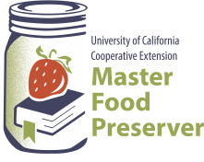

**UCCE Master Food Preservers of El Dorado County**

**311 Fair Lane, Placerville CA 95667**

**Helpline (530) 621-5506 • Email:** [**edmfp@ucanr.edu**](mailto:edmfp@ucanr.edu) **• Visit us on Facebook!**

**Preserve Today, Relish Tomorrow**

**High Acid Canning Basics:**

**Introduction to Canning and Food Safety**

The quality of food is judged by wholesomeness, its nutritional value, and our expectations of its color, flavor, odor, and texture. The quality of preserved food varies greatly and depends mostly on the quality of the fresh food and preservation methods. High quality preserved foods are free from microbial spoilage and toxins, are pleasing to eat, and are reasonably nutritious.

**The Bottom Line:** If you prepare or serve food, you are responsible for making sure safe food is served.

**Factors That Affect Growth of Microorganisms**

1. **Temperature:** Foodborne pathogens grow best under the same conditions that allow people to thrive. Most foodborne bacteria grow fastest at temperatures from 90° to 110°F. However, foodborne bacteria will grow in the temperature range known as the ***Danger Zone***, 40° to 140°F; some grow at temperatures below this range.
2. 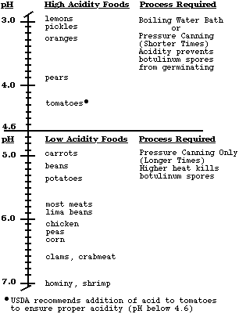**Acidity or alkalinity (pH):** Most organisms grow best under conditions that have a neutral pH, rather than highly acid or alkaline (few foods are highly alkaline).  High acid foods generally do not support bacterial growth.
3. **Moisture:** Microorganisms require moisture for growth. Dehydration preserves foods by removing moisture.
4. **Oxygen:** Most microorganisms require oxygen to grow; a few pathogens do not, or may require limited oxygen. However, controlling oxygen content is not useful for controlling bacterial growth for home food preservers.
5. **Time:** It takes time for microorganisms to grow or multiply in foods. The time required is affected by temperature, acidity, moisture and oxygen levels. Under ideal conditions bacteria can double in number every 10 to 20 minutes.
6. **Food:** Bacteria require nutrients to reproduce. Foods provide proteins and carbohydrates for growth.
7. **Inhibitors:** Some natural compounds/food additives are bacterial inhibitors (sugar, acid).

**Potentially Dangerous Microorganisms**

***Bacteria***

*Staphylococcus aureus*

* Produced when contaminated, high protein food is left too long at room temperature.
* Cooking at 165°F will not kill the toxin.
* Found in 50% of human noses, throats, hair, and skin.
* Will grow in meats, poultry, egg products, milk, salads with protein, macaroni and potato salads, tuna, puddings, custards, cream pies and pastries.

*Clostridium botulinum*

* Toxin known to cause botulism.
* Spores from the bacteria are widespread in the environment.
* Toxin only produced in anaerobic (oxygen free) environment of low acidity.
* May result from inadequate processing of vegetables and meats, which are low-acid foods.

*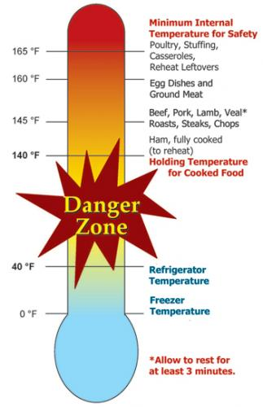Salmonella species*

* Salmonellosis is the disease state.
* Multiplies rapidly at room temperature.
* A leading cause of foodborne illness.
* Found in raw meats, poultry, eggs, fish, milk/milk products, raw fruits/vegetables.

*Campylobacter jejuni*

* More common in poultry than Salmonella.
* Causes 14% of diarrhea worldwide; is a leading cause of foodborne illness.
* Chief food sources: raw poultry, raw meats, unpasteurized milk.

*E. coli 0157:H7*

* Very common, found in all animal and human digestive systems.
* As few as 10 bacterial cells may be enough to cause illness through toxin produced.
* Can grow in the refrigerator if temperatures are above 40°F.
* Sources include undercooked meats, unpasteurized juices and milk, sprouts.

*Listeria monocytogenes*

* Found in soil, vegetation and water.
* Frequently carried by humans and animals.
* Can survive for a long period of time under adverse conditions.
* May be found in raw milk, soft cheese and processed foods (i.e. deli meats).

**Viruses**

* Smaller than bacteria.
* Cannot grow in food, need living host. Some can survive cooking and freezing.
* Can be transmitted to human through food and contaminated water.

*Includes: Hepatitis A, Typhoid, Norwalk Virus (Norovirus). Note: Norovirus is now considered to be the leading cause of foodborne illness. Source is primarily contaminated food handlers.*

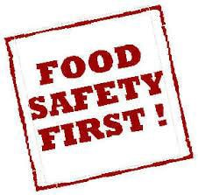**Molds**

* Molds are primarily spoilage organisms.
* The mold you see is only the “tip of the iceberg” of colonies under the surface.
* Some molds produce toxins.
* Toxins are not destroyed in cooking.

Moldy foods should be discarded.

**Parasites**

Live on/in another living host to get food. Examples:

* *Trichinosis*: pork, bear, flesh eating animals.
* *Cysticercosis*: tape worm.
* *Anisakiasis*: fish round worms.
* *Giardia lamblia*: fecal contamination of toys, food, and water.
* *Toxoplasma gondii*: consumption of raw meat, unwashed or uncooked fruits, and vegetables, in feces of infected cats.

**Preventing Foodborne Illnesses**

1. Clean
2. Cook
3. Separate
4. Chill
5. **Clean**

* 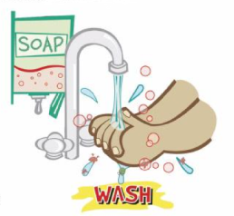Wash hands frequently and after: using toilet, changing baby's soiled diaper, sneezing or coughing, touching animals, handling raw meat, fish and poultry, and before handling food.
* 20-second rule: wash hands for 20-seconds or sing Happy Birthday song twice.
* Bandage any cuts or burns on hands before handling food.
* Use disposable latex gloves to protect food.
* Run sponges and dish scrapers through the dishwasher often.
* Change dish cloths daily.
* Use paper towels to mop up spilled juices from meat, fish or poultry.
* Use a disinfecting solution consisting of 1 tablespoon regular, unscented chlorine bleach to 1 quart of water. Use a spray bottle to disinfect countertops, cutting surfaces, etc.
  + The disinfecting solution has very specific instructions for mixing. Once bleach is mixed with water its disinfecting properties start to diminish after 24 hrs. When you are cleaning up after things that are highly likely to spread bacteria (like raw meat), you would want to use a freshly mixed solution.

1. **Cook**

Internal Temperatures & Rest Times:

* All poultry products including ground poultry and stuffing (cooked alone or in bird) 165°F.
* Ground meat (beef, pork, veal and lamb), sausages, and bacon: 160°F.
* Steaks, chops and roast (beef, pork, lamb and veal): 145°F & allow to rest for at least 3 minutes before carving.
* 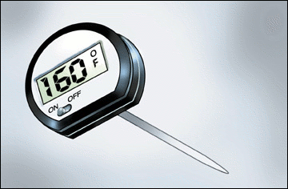Fish and shellfish: 145°F (Cook shellfish until the shells open).
* Eggs: 160°F internal temperature.
* Casseroles: 165°F.
* Reheat leftovers to 165°F.
* Use a thermometer.

1. **Separate**

Avoid cross contamination

* Ice is food! Use clean ice to avoid contaminating food.
* **ALWAYS** wash your hands, knives, cutting boards, and food preparation surfaces well with soapy water before and after any contact with raw meat, fish, or poultry. Using a separate cutting board for meat and poultry is recommended.
* Rinse all fresh fruits and vegetables well under running water before preparing or eating them.
* When grilling or barbecuing, always use a clean plate to put the cooked meat on.
* Store raw meat, fish and poultry on the bottom shelf in the refrigerator or on a plate to prevent juices from dripping onto other food items.
* Use a separate cutting board for fresh produce, raw meat, and cooked meat.

1. **Chill**

* Keep your refrigerator set at 40°F or below and refrigerate all perishable foods.
* Thaw frozen perishable foods in a refrigerator overnight, in a microwave oven, or under cold running water. Do not thaw frozen food on your counter.
* Do not prepare food more than 2 hours before serving without plans for proper storage in a refrigerator. Reheat just before serving.
* Divide leftover hot food into shallow containers to accelerate cooling; refrigerate within 2 hours after preparation.
* Foods can spoil in as little as 1 hour in the hot sun. Discard any perishable foods from a picnic or potluck that have not been kept adequately chilled (40°F or below) or kept hot (140°F or above).

**When In Doubt - Throw It Out**



**DANGER** - Never taste food that looks or smells strange to see if it can still be used.

**Just discard it.**

Generally, foods that contain bacteria will look, smell, and taste normal. Generally speaking, most bacteria that cause foodborne illness are odorless, colorless, and tasteless.

**Seven Major Methods of Food Preservation**

1. 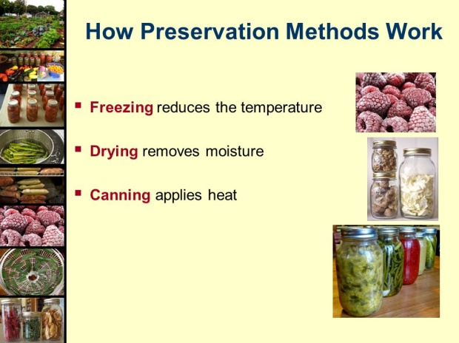**Refrigeration**

* Retards growth of microorganisms.
* Slows action of enzymes.

1. **Freezing**

* Prevents growth of microorganisms, but does not necessarily kill them.
* Slows, but does not stop enzymatic activity. Therefore, enzymes in most fresh vegetables must be inactivated by blanching before freezing.
* For highest quality, lower the food temperature to 0°F as rapidly as possible and maintain 0°F food temperatures.
* Freeze only the amount you can use before its shelf life expires. Use packaging that is moisture proof, sealable and oxygen impermeable to retain quality.

1. **Canning**

* With proper canning practices, air is forced from the jars, leaving a vacuum. Heat destroys most heat-resistant microorganisms capable of growing in food stored at room temperature.
* Molds and some yeasts are unable to grow in a vacuum. However, there is a very healthy growth environment for anaerobic bacteria in sealed, home-canned foods. Such foods must be heat processed until a commercially sterile product is achieved, or they must have salts, sugars, acids or other preservatives added.
* Yeasts and molds are destroyed when food temperatures reach about 190°F, whereas most bacterial vegetative cells are destroyed in foods heated to a boiling temperature. Bacterial spores can survive for a long period at the temperature of boiling water.
* Boiling water and atmospheric steam canning are USDA approved for high acid foods (fruits, pickled products).
* Pressure enables the processing of canned foods at temperatures higher than boiling water, where kill rates are greatly increased. Pressure canning is required to safely process low acid foods that may support the growth of bacterial spores, leading to the production of toxins.
* Open kettle canning: The USDA does **not** recommend this method of canning.

1. **Sweetening and Acidifying Jellies & Jams**

* Adds sugar and acids that tie up free water and lower ph.

1. **Pickling and Fermenting**

* Use either naturally produced or added acids to inhibit or prevent the growth of *Clostridium botulinum* as well as molds and other pathogens.
* Fermenting uses bacteria to produce lactic acid and lower the pH in products such as fermented pickles and sauerkraut.

1. **Drying**

* Removes water and prevents growth of microorganisms.
* Water in fresh food exists in free and chemically bound forms. Removal or reduction of free water from a food prevents microorganism growth and controls enzyme activity.
* Package dried foo

1. **Salting**

* Chemically bonds water, inhibiting growth of some bacteria.

**Packaging**

The success of all preservation methods depends on using appropriate packages. Airtight packages prevent recontamination of foods and are ideally suited for most preserved foods.

* Use standard canning jars, lids and rings.
* A deep, non-reactive kettle (stainless steel, enameled or glass) must be used for cooking the product.
* Use a tested recipe from a reputable source for the best results, as these recipes have been tested for quality, flavor and safety.
* Paraffin**,** as a sealing agent, is **not** recommended.

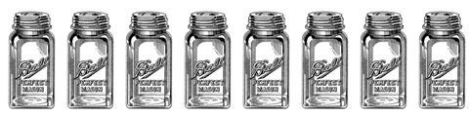

**Use the Best Ingredients**

Select fruit of good flavor and color, but not fully ripe. For jam and jelly it is better to have some under-ripe fruit as it contains more pectin and acid than fully ripe fruit.

Cane or beet sugar can be used with equal success.

**Get Ready, Be Prepared**

* Read the recipe thoroughly before you begin.
* Measure out all ingredients. Do not change the quantities in any recipe that calls for pectin. Follow directions for the pectin or the finished product will not gel correctly.
* Have all necessary utensils at hand.
* Wash jars, lids and rings in hot soapy water and rinse well.
* Place clean jars into the boiling water canner and heat them to 180°F.
* To prepare lids, follow the manufacturer’s directions on the lid package; some say to heat and some say just wash.
* Fill hot jars with hot mixture. Leave headspace as specified in the recipe.
* Wipe the jar rim.
* Place lids and rings on jars. Tighten the rings only finger tight.

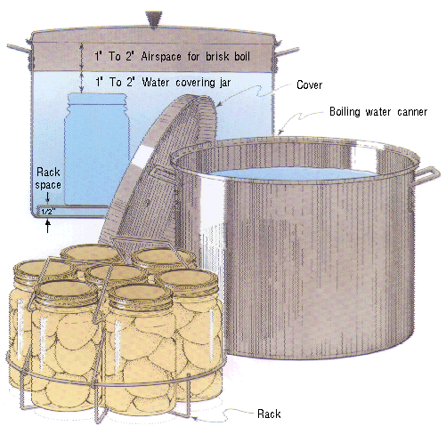 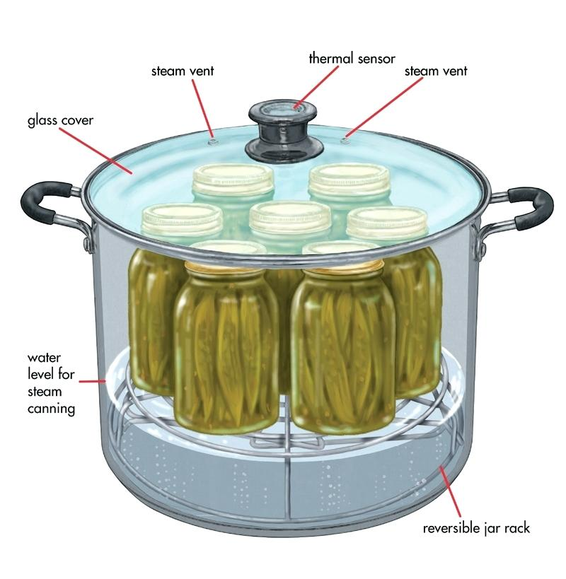

**Boiling Water Bath Canner Steam Canner**

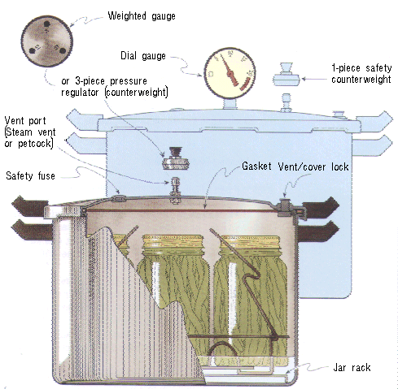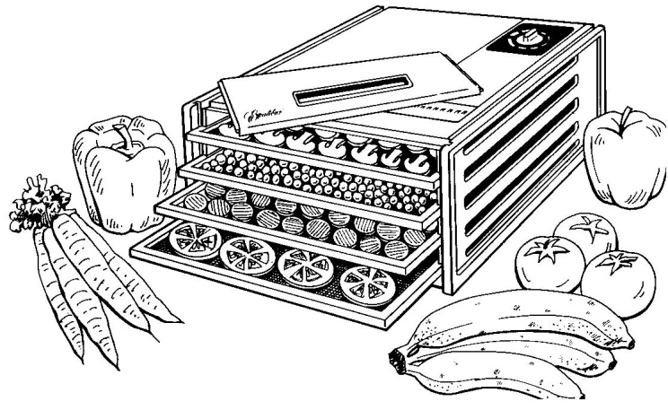

**Pressure Canner Dehydrator**

**Boiling Water Canner Processing**

1. Place jars in a canner with a rack.
2. Water should be 140° for raw pack jars and 180° for hot pack jars. Add enough water to cover the tops of the jar by at least 1" to 2". Cover with 2" of water if processing time is more than 30 minutes.
3. Place lid on canner. Bring the water to a rolling boil, then reduce heat to a gentle boil.
4. Begin to count processing time when the water comes to a boil.
5. Process for the time indicated in the recipe.
6. All recipes are developed using sea level as the criteria for processing time. If you are at a higher altitude, adjust the processing times according to the following chart:

|  |  |
| --- | --- |
| **Altitude Chart** | |
| Altitude in feet | Increase processing time |
| 1000 - 3000 | 5 minutes |
| 3001 - 6000 | 10 minutes |
| 6001 - 8000 | 15 minutes |
| 8001 - 10000 | 20 minutes |

1. Remove lid and let sit for 5 minutes, then remove jars from the canner. When you take the jars from the canner after processing, hold upright; do not disturb the seal. Do not retighten the rings. Place the hot jars on a rack or folded towel away from drafts or cool surfaces. Keep the jars separated so they will cool evenly.
2. Leave the ring bands on the jars until they have cooled (approximately 24 hours). Do not try to dump the water off the lids.
3. **Do NOT invert jars:** Some canning books still recommend inverting the jars after removing them from the boiling water canner. The USDA does not recommend this method.
4. After the jars have cooled, remove the ring bands. Look at the top of each jar. If the lid is slightly concave, it indicates a seal. Test the seal by pressing on the lid with your finger; the lid should not give. If you are not sure a jar is sealed, carefully lift the jar by the lid after removing the ring band. If not properly sealed, the lid will come off.
5. Wash and dry bands. Store rings for future use. Storing jars with rings attached is not recommended. Clean the jars with a damp cloth. Label and date the jars, and store in a cool, dark, dry area.

**Reprocessing -** If a jar did not seal, refrigerate and use within a few days, or reprocess it within 24 hours using a new lid. Check the jar for flaws. Process by the method originally advised and for the full length of time.

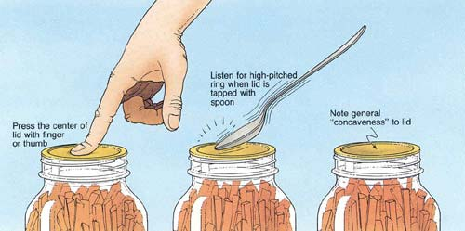

**Atmospheric Steam Canner Processing**

1. Use a research tested recipe and processing time developed for a **boiling water** canner when using an atmospheric steam canner. An atmospheric steam canner may be used with recipes approved for half-pint, pint, or quart jars.
2. Add enough water to the base of the canner to cover the rack. (Follow manufacturer recommendations.)
3. Preheat water to 140°F for raw packed foods and to 180°F for hot packed foods. Food preparation can begin while this water is preheating. Do not have the water boiling when you add the jars.
4. Heat jars prior to filling with hot liquid (raw or hot pack). Do not allow the jars to cool before filling.
5. Load filled jars, fitted with lids, onto the canner rack and place the lid on the canner base.
6. Turn heat to its highest position to boil the water until a steady column of steam (4-6 inches) appears from the vent hole(s) in the canner lid. Jars must be processed in pure steam environment.
7. If using a canner without a temperature sensor, begin processing time when a steady stream of steam is visible from the vent hole(s). I
8. If using a canner with a temperature sensor, use the temperature gauge only as a guide.
   * The processing time should begin only after a full column of steam (approximately 6 -8 inches) appears through the canner vent holes at the bottom of the cover. Some canners come with built-in temperature sensors, which can be used to monitor the temperature. A full column of steam should be present throughout the process time. If there is an interruption in the steam, the product should be reprocessed for the full processing time.
   * The temperature gauges on steam canners cannot be tested, therefore it is not recommended that they be relied upon to know when to start the processing time.
9. Set the timer for the total minutes required for processing the food, adjusting for altitude. Processing time must be limited to **45 minutes or less, including any modification for elevation**. The processing time is limited by the amount of water in the canner base. When processing food, **do not** open the canner to add water.
10. Monitor the temperature sensor and/or steady stream of steam throughout the entire timed process. Regulate heat so that the canner maintains a temperature of 212°F. A canner that is boiling too vigorously can boil dry within 20 minutes. If a canner boils dry, the food is considered under-processed and therefore potentially unsafe.
11. At the end of the processing time, turn off the heat, wait 5 minutes then remove the lid, lifting the lid away from you.
12. Using a jar lifter, remove the jars without tipping and place them on a towel, leaving at least 1 inch spaces between the jars during cooling. Let jars sit undisturbed to cool at room temperature for 12 to 24 hours.

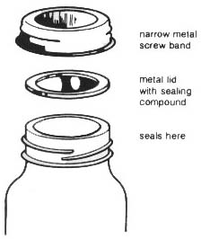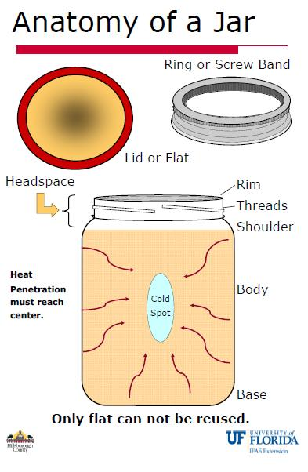

**Pickled Corn Relish** Makes about 9 pint jars

Makes about 9 pint jars

* 10 cups corn kernels (about 16-20 medium-size ears of corn) or
* 6 ten-ounce packages of frozen corn
* 5 cups diced, seeded, mixed red and green bell peppers
* 2 ½ cups diced celery
* 1 ¼ cup diced onions
* 1 ¾ cups granulated sugar
* 5 cups white vinegar
* 2 ½ Tblsp pickling salt
* 2 ½ Tbsp dry mustard
* 2 ½ tsp celery seeds
* 1 ¼ tsp ground turmeric

Procedure:

Boil ears of corn for 5 minutes. Dip in cold water to stop the cooking process. Cut whole kernels from cob (see **tip below).

Combine peppers, celery, onions, sugar, vinegar, canning salt, and celery seed in a saucepan. Bring to a boil and simmer for 5 minutes, stirring occasionally to dissolve the sugar and salt. Mix mustard and turmeric in ½ cup of the simmered mixture. Add this mixture and the corn to the hot mixture. Simmer another 5 minutes. If desired, thicken the mixture with flour paste (1/4 cup flour blended in ¼ cup water) and stir frequently.

Fill hot jars with hot mixture, leaving ½ inch headspace. Remove air bubbles and adjust headspace, if needed, by adding more of the corn mixture.

Wipe jar rims clean with a dampened clean paper towel. Place lids and rings on jars. Tighten rings only finger tight. Process using the table below:

|  |  |  |  |  |
| --- | --- | --- | --- | --- |
| Table 1. Recommended process time for Pickled Corn Relish in a boiling-water canner. | | | | |
|  | | Process Time at Altitudes of | | |
| Style of Pack | Jar Size | 0 - 1,000 ft | 1,001 - 6,000 ft | Above 6,000 ft |
| Hot | Half-pints or Pints | 15 min | 20 | 25 |

**Variations:**

You can grill you corn to a toasty brown to give your relish a toasty flavor. Be careful not to burn it. That burnt taste can intensify once it sits in the jar for a while and can ruin a perfectly good batch of relish.

You can also change up your spices and make a Tex-Mex version:

Substitute some jalapeno pepper for some sweet pepper.

**Be sure the total amount of fresh pepper remains 5 cups.**

2 ½ Tbsp. chili powder

½ -1 tsp. powered cumin

¼ - ½ tsp. smoked paprika

Source: national Center For Home Food Preservation https://nchfp.uga.edu/how/can_06/pickled_corn_relish.html

**Strawberry-Lemon Marmalade** Makes about 7 half-pint jars

* 1/4 cup thinly sliced lemon peel (about 2 large)
* 4 cups crushed strawberries (about 4 1-lb containers)
* 1 Tbsp. lemon juice
* 6 Tbsp Ball® RealFruit™ Classic Pectin or 1 pkg. powdered pectin
* 6 cups sugar

Directions:

COMBINE lemon peel and water to cover in a 6- or 8-quart saucepan. Bring to a boil over medium high heat and boil for 5 minutes, until peel is softened. Drain and discard liquid. Return peel to pan.

ADD strawberries and lemon juice to peel and mix well. Gradually stir in pectin. Bring mixture to a full rolling that cannot be stirred down, over high heat, stirring constantly.

ADD entire measure of sugar, stirring to dissolve. Return mixture to a full rolling boil. Boil hard for 1 minute, stirring constantly. Remove from heat. Skim off foam if necessary.

LADLE hot preserves into hot jars leaving 1/4 inch headspace. Remove air bubbles.

Wipe rim. Center lid on jar. Apply band until fit is fingertip tight.

PROCESS in a boiling water or atmospheric steam canner for: 0-6000 ft. = 10 minutes, above 6000 ft. = 15 minutes.

For boiling water canning, turn off the heat, remove canner lid and wait 5 minutes. For atmospheric steam canning, turn off the heat, leave canner lid on and wait 2-3 minutes.

Check lids for seal after 24 hours. Lid should not flex up and down when center is pressed. Label and store in a cool, dry place.

Quick Tip:

Use lime peel and lime juice in place of lemon for a Strawberry Lime Marmalade.

*Source: Ball Complete Book of Home Preserving*

***Resources***

**National Center for Home Food Preservation**: <http://nchfp.uga.edu/>

**Complete Guide to Home Canning**. 2015. <http://nchfp.uga.edu//publications/publications_usda.html>

Also available in paper copy from Purdue Extension (online store is located at <https://mdc.itap.purdue.edu/item.asp?item_number=AIG-539>)

**So Easy to Preserve,** Sixth Edition. 2014. Bulletin 989. Cooperative Extension/The University of Georgia/Athens

**Ball Blue Book Guide to Preserving**. 2014. Jarden Corporation.

**Ball Complete Book of Home Preserving**, 2006/2022. Newell Corporation.

UC ANR is an equal opportunity provider and employer

Should you need assistance or require special accommodations for any of our educational programs, please contact us at 530-621-5502.