**Preserve Today, Relish Tomorrow**

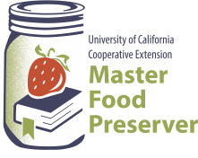

**UCCE Master Food Preservers of El Dorado County**

**311 Fair Lane, Placerville CA 95667**

**Helpline (530) 621-5506 • Email:** [**edmfp@ucanr.edu**](mailto:edmfp@ucanr.edu) **• Visit us on Facebook!**

**Preserving Citrus**

The quality of food is judged by wholesomeness, its nutritional value, and our expectations of its color, flavor, odor, and texture. The quality of preserved food varies greatly and depends mostly on the quality of the fresh food and preservation methods. High quality preserved foods are free from microbial spoilage and toxins, are pleasing to eat, and are reasonably nutritious.

**The Bottom Line:** If you prepare or serve food, you are responsible for making sure safe food is served.

**Factors That Affect Growth of Microorganisms**

1. **Temperature:** Foodborne pathogens grow best under the same conditions that allow people to thrive. Most foodborne bacteria grow fastest at temperatures from 90° to 110°F. However, foodborne bacteria will grow in the temperature range known as the ***Danger Zone***, 40° to 140°F; some grow at temperatures below this range.
2. 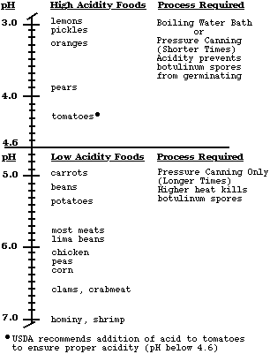**Acidity or alkalinity (pH):** Most organisms grow best under conditions that have a neutral pH, rather than highly acid or alkaline (few foods are highly alkaline).  High acid foods generally do not support bacterial growth.
3. **Moisture:** Microorganisms require moisture for growth. Dehydration preserves foods by removing moisture.
4. **Oxygen:** Most microorganisms require oxygen to grow; a few pathogens do not, or may require limited oxygen. However, controlling oxygen content is not useful for controlling bacterial growth for home food preservers.
5. **Time:** It takes time for microorganisms to grow or multiply in foods. The time required is affected by temperature, acidity, moisture and oxygen levels. Under ideal conditions bacteria can double in number every 10 to 20 minutes.
6. **Food:** Bacteria require nutrients to reproduce. Foods provide proteins and carbohydrates for growth.
7. **Inhibitors:** Some natural compounds/food additives are bacterial inhibitors (sugar, acid).



**Potentially Dangerous Microorganisms**

***Bacteria***

*Staphylococcus aureus*

* Produced when contaminated, high protein food is left too long at room temperature.
* Cooking at 165°F will not kill the toxin.
* Found in 50% of human noses, throats, hair, and skin.
* Will grow in meats, poultry, egg products, milk, salads with protein, macaroni and potato salads, tuna, puddings, custards, cream pies and pastries.

*Clostridium botulinum*

* Toxin known to cause botulism.
* Spores from the bacteria are widespread in the environment.
* Toxin only produced in anaerobic (oxygen free) environment of low acidity.
* May result from inadequate processing of vegetables and meats, which are low-acid foods.

*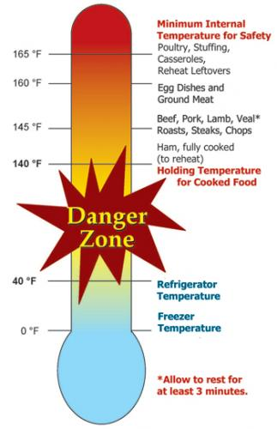Salmonella species*

* Salmonellosis is the disease state.
* Multiplies rapidly at room temperature.
* A leading cause of foodborne illness.
* Found in raw meats, poultry, eggs, fish, milk/milk products, raw fruits/vegetables.

*Campylobacter jejuni*

* More common in poultry than Salmonella.
* Causes 14% of diarrhea worldwide; is a leading cause of foodborne illness.
* Chief food sources: raw poultry, raw meats, unpasteurized milk.

*E. coli 0157:H7*

* Very common, found in all animal and human digestive systems.
* As few as 10 bacterial cells may be enough to cause illness through toxin produced.
* Can grow in the refrigerator if temperatures are above 40°F.
* Sources include undercooked meats, unpasteurized juices and milk, sprouts.

*Listeria monocytogenes*

* Found in soil, vegetation and water.
* Frequently carried by humans and animals.
* Can survive for a long period of time under adverse conditions.
* May be found in raw milk, soft cheese and processed foods (i.e. deli meats).

**Viruses**

* Smaller than bacteria.
* Cannot grow in food, need living host. Some can survive cooking and freezing.
* Can be transmitted to human through food and contaminated water.

*Includes: Hepatitis A, Typhoid, Norwalk Virus (Norovirus). Note: Norovirus is now considered to be the leading cause of foodborne illness. Source is primarily contaminated food handlers.*

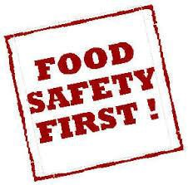**Molds**

* Molds are primarily spoilage organisms.
* The mold you see is only the “tip of the iceberg” of colonies under the surface.
* Some molds produce toxins.
* Toxins are not destroyed in cooking.
* Moldy foods should be discarded.

**Parasites**

Live on/in another living host to get food. Examples:

* *Trichinosis*: pork, bear, flesh eating animals.
* *Cysticercosis*: tape worm.
* *Anisakiasis*: fish round worms.
* *Giardia lamblia*: fecal contamination of toys, food, and water.
* *Toxoplasma gondii*: consumption of raw meat, unwashed or uncooked fruits, and vegetables, in feces of infected cats.

**Preventing Foodborne Illnesses**

1. Clean
2. Cook
3. Separate
4. Chill
5. **Clean**

* 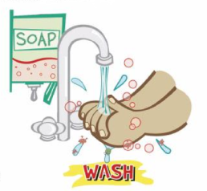Wash hands frequently and after: using toilet, changing baby's soiled diaper, sneezing or coughing, touching animals, handling raw meat, fish and poultry, and before handling food.
* 20-second rule: wash hands for 20-seconds or sing Happy Birthday song twice.
* Bandage any cuts or burns on hands before handling food.
* Use disposable latex gloves to protect food.
* Run sponges and dish scrapers through the dishwasher often.
* Change dish cloths daily.
* Use paper towels to mop up spilled juices from meat, fish or poultry.
* Use a disinfecting solution consisting of 1 tablespoon regular, unscented chlorine bleach to 1 quart of water. Use a spray bottle to disinfect countertops, cutting surfaces, etc.
  + The disinfecting solution has very specific instructions for mixing. Once bleach is mixed with water its disinfecting properties start to diminish after 24 hrs. When you are cleaning up after things that are highly likely to spread bacteria (like raw meat), you would want to use a freshly mixed solution.

1. **Cook**

Internal Temperatures & Rest Times:

* All poultry products including ground poultry and stuffing (cooked alone or in bird) 165°F.
* Ground meat (beef, pork, veal and lamb), sausages, and bacon: 160°F.
* Steaks, chops and roast (beef, pork, lamb and veal): 145°F & allow to rest for at least 3 minutes before carving.
* 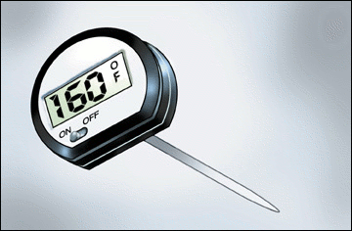Fish and shellfish: 145°F (Cook shellfish until the shells open).
* Eggs: 160°F internal temperature.
* Casseroles: 165°F.
* Reheat leftovers to 165°F.
* Use a thermometer.

1. **Separate**

Avoid cross contamination

* Ice is food! Use clean ice to avoid contaminating food.
* **ALWAYS** wash your hands, knives, cutting boards, and food preparation surfaces well with soapy water before and after any contact with raw meat, fish, or poultry. Using a separate cutting board for meat and poultry is recommended.
* Rinse all fresh fruits and vegetables well under running water before preparing or eating them.
* When grilling or barbecuing, always use a clean plate to put the cooked meat on.
* Store raw meat, fish and poultry on the bottom shelf in the refrigerator or on a plate to prevent juices from dripping onto other food items.
* Use a separate cutting board for fresh produce, raw meat, and cooked meat.

1. **Chill**

* Keep your refrigerator set at 40°F or below and refrigerate all perishable foods.
* Thaw frozen perishable foods in a refrigerator overnight, in a microwave oven, or under cold running water. Do not thaw frozen food on your counter.
* Do not prepare food more than 2 hours before serving without plans for proper storage in a refrigerator. Reheat just before serving.
* Divide leftover hot food into shallow containers to accelerate cooling; refrigerate within 2 hours after preparation.
* Foods can spoil in as little as 1 hour in the hot sun. Discard any perishable foods from a picnic or potluck that have not been kept adequately chilled (40°F or below) or kept hot (140°F or above).

**When In Doubt - Throw It Out**



**DANGER** - Never taste food that looks or smells strange to see if it can still be used.

**Just discard it.**

Generally, foods that contain bacteria will look, smell, and taste normal. Generally speaking, most bacteria that cause foodborne illness are odorless, colorless, and tasteless.

**Seven Major Methods of Food Preservation**

1. **Refrigeration**

* Retards growth of microorganisms.
* 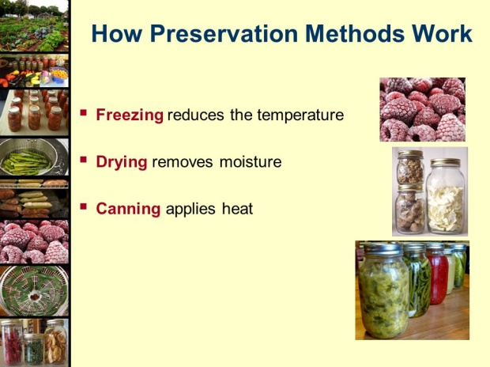Slows action of enzymes.

1. **Freezing**

* Prevents growth of microorganisms, but does not necessarily kill them.
* Slows, but does not stop enzymatic activity. Therefore, enzymes in most fresh vegetables must be inactivated by blanching before freezing.
* For highest quality, lower the food temperature to 0°F as rapidly as possible and maintain 0°F food temperatures.
* Freeze only the amount you can use before its shelf life expires. Use packaging that is moisture proof, sealable and oxygen impermeable to retain quality.

1. **Canning**

* With proper canning practices, air is forced from the jars, leaving a vacuum. Heat destroys most heat-resistant microorganisms capable of growing in food stored at room temperature.
* Molds and some yeasts are unable to grow in a vacuum. However, there is a very healthy growth environment for anaerobic bacteria in sealed, home-canned foods. Such foods must be heat processed until a commercially sterile product is achieved, or they must have salts, sugars, acids or other preservatives added.
* Yeasts and molds are destroyed when food temperatures reach about 190°F, whereas most bacterial vegetative cells are destroyed in foods heated to a boiling temperature. Bacterial spores can survive for a long period at the temperature of boiling water.
* Boiling water and atmospheric steam canning are USDA approved for high acid foods (fruits, pickled products).
* Pressure enables the processing of canned foods at temperatures higher than boiling water, where kill rates are greatly increased. Pressure canning is required to safely process low acid foods that may support the growth of bacterial spores, leading to the production of toxins.
* Open kettle canning: The USDA does **not** recommend this method of canning.

1. **Sweetening and Acidifying Jellies & Jams**

* Adds sugar and acids that tie up free water and lower ph.

1. **Pickling and Fermenting**

* Use either naturally produced or added acids to inhibit or prevent the growth of *Clostridium botulinum* as well as molds and other pathogens.
* Fermenting uses bacteria to produce lactic acid and lower the pH in products such as fermented pickles and sauerkraut.

1. **Drying**

* Removes water and prevents growth of microorganisms.
* Water in fresh food exists in free and chemically bound forms. Removal or reduction of free water from a food prevents microorganism growth and controls enzyme activity.
* Package dried food

1. **Salting**

* Chemically bonds water, inhibiting growth of some bacteria.

**Packaging**

The success of all preservation methods depends on using appropriate packages. Airtight packages prevent recontamination of foods and are ideally suited for most preserved foods.

* Use standard canning jars, lids and rings.
* A deep, non-reactive kettle (stainless steel, enameled or glass) must be used for cooking the product.
* Use a tested recipe from a reputable source for the best results, as these recipes have been tested for quality, flavor and safety.
* Paraffin**,** as a sealing agent, is **not** recommended.

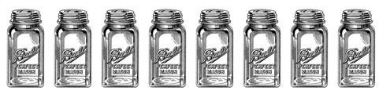

**Use the Best Ingredients**

Select fruit of good flavor and color, but not fully ripe. For jam and jelly it is better to have some under-ripe fruit as it contains more pectin and acid than fully ripe fruit.

Cane or beet sugar can be used with equal success.

**Get Ready, Be Prepared**

* Read the recipe thoroughly before you begin.
* Measure out all ingredients. Do not change the quantities in any recipe that calls for pectin. Follow directions for the pectin or the finished product will not gel correctly.
* Have all necessary utensils at hand.
* Wash jars, lids and rings in hot soapy water and rinse well.
* Place clean jars into the boiling water canner and heat them to 180°F.
* To prepare lids, follow the manufacturer’s directions on the lid package; some say to heat and some say just wash.
* Fill hot jars with hot mixture. Leave headspace as specified in the recipe.
* Wipe the jar rim.
* Place lids and rings on jars. Tighten the rings only finger tight.

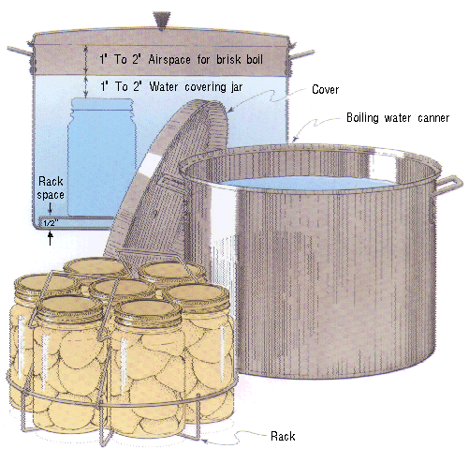 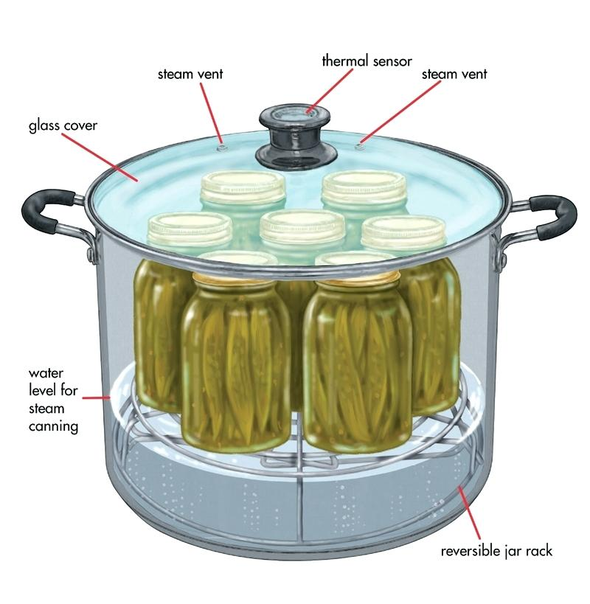

**Boiling Water Bath Canner Steam Canner**

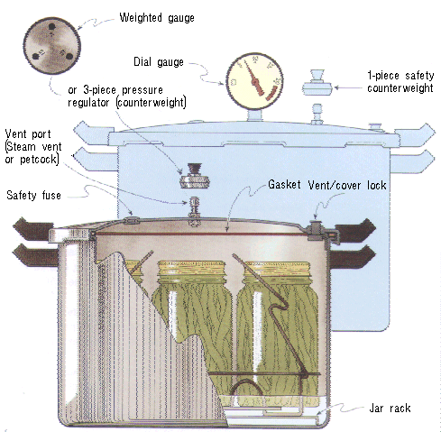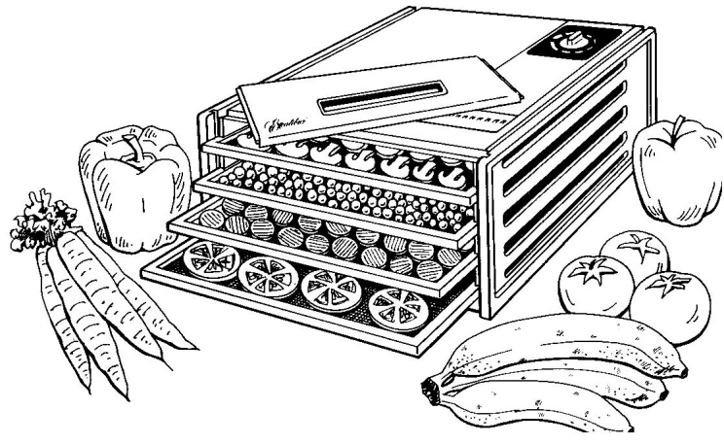

**Pressure Canner Dehydrator**

**Boiling Water Canner Processing**

1. Place jars in a canner with a rack.
2. Water should be 140° for raw pack jars and 180° for hot pack jars. Add enough water to cover the tops of the jar by at least 1" to 2". Cover with 2" of water if processing time is more than 30 minutes.
3. Place lid on canner. Bring the water to a rolling boil, then reduce heat to a gentle boil.
4. Begin to count processing time when the water comes to a boil.
5. Process for the time indicated in the recipe.
6. All recipes are developed using sea level as the criteria for processing time. If you are at a higher altitude, adjust the processing times according to the following chart:

|  |  |
| --- | --- |
| **Altitude Chart** | |
| Altitude in feet | Increase processing time |
| 1000 - 3000 | 5 minutes |
| 3001 - 6000 | 10 minutes |
| 6001 - 8000 | 15 minutes |
| 8001 - 10000 | 20 minutes |

1. Remove lid and let sit for 5 minutes, then remove jars from the canner. When you take the jars from the canner after processing, hold upright; do not disturb the seal. Do not retighten the rings. Place the hot jars on a rack or folded towel away from drafts or cool surfaces. Keep the jars separated so they will cool evenly.
2. Leave the ring bands on the jars until they have cooled (approximately 24 hours). Do not try to dump the water off the lids.
3. **Do NOT invert jars:** Some canning books still recommend inverting the jars after removing them from the boiling water canner. The USDA does not recommend this method.
4. After the jars have cooled, remove the ring bands. Look at the top of each jar. If the lid is slightly concave, it indicates a seal. Test the seal by pressing on the lid with your finger; the lid should not give. If you are not sure a jar is sealed, carefully lift the jar by the lid after removing the ring band. If not properly sealed, the lid will come off.
5. Wash and dry bands. Store rings for future use. Storing jars with rings attached is not recommended. Clean the jars with a damp cloth. Label and date the jars, and store in a cool, dark, dry area.

**Reprocessing -** If a jar did not seal, refrigerate and use within a few days, or reprocess it within 24 hours using a new lid. Check the jar for flaws. Process by the method originally advised and for the full length of time.

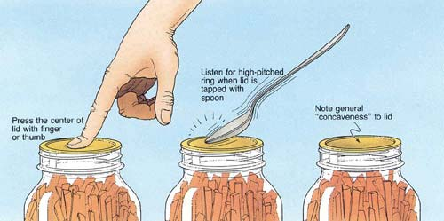

**Atmospheric Steam Canner Processing**

1. Use a research tested recipe and processing time developed for a **boiling water** canner when using an atmospheric steam canner. An atmospheric steam canner may be used with recipes approved for half-pint, pint, or quart jars.
2. Add enough water to the base of the canner to cover the rack. (Follow manufacturer recommendations.)
3. Preheat water to 140°F for raw packed foods and to 180°F for hot packed foods. Food preparation can begin while this water is preheating. Do not have the water boiling when you add the jars.
4. Heat jars prior to filling with hot liquid (raw or hot pack). Do not allow the jars to cool before filling.
5. Load filled jars, fitted with lids, onto the canner rack and place the lid on the canner base.
6. Turn heat to its highest position to boil the water until a steady column of steam (4-6 inches) appears from the vent hole(s) in the canner lid. Jars must be processed in pure steam environment.
7. If using a canner without a temperature sensor, begin processing time when a steady stream of steam is visible from the vent hole(s). I
8. If using a canner with a temperature sensor, use the temperature gauge only as a guide.
   * The processing time should begin only after a full column of steam (approximately 6 -8 inches) appears through the canner vent holes at the bottom of the cover. Some canners come with built-in temperature sensors, which can be used to monitor the temperature. A full column of steam should be present throughout the process time. If there is an interruption in the steam, the product should be reprocessed for the full processing time.
   * The temperature gauges on steam canners cannot be tested, therefore it is not recommended that they be relied upon to know when to start the processing time.
9. Set the timer for the total minutes required for processing the food, adjusting for altitude. Processing time must be limited to **45 minutes or less, including any modification for elevation**. The processing time is limited by the amount of water in the canner base. When processing food, **do not** open the canner to add water.
10. Monitor the temperature sensor and/or steady stream of steam throughout the entire timed process. Regulate heat so that the canner maintains a temperature of 212°F. A canner that is boiling too vigorously can boil dry within 20 minutes. If a canner boils dry, the food is considered under-processed and therefore potentially unsafe.
11. At the end of the processing time, turn off the heat, wait 2-3 minutes then remove the lid, lifting the lid away from you.
12. Using a jar lifter, remove the jars without tipping and place them on a towel, leaving at least 1 inch spaces between the jars during cooling. Let jars sit undisturbed to cool at room temperature for 12 to 24 hours.

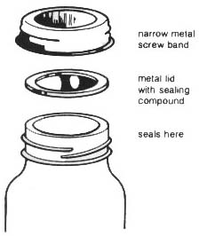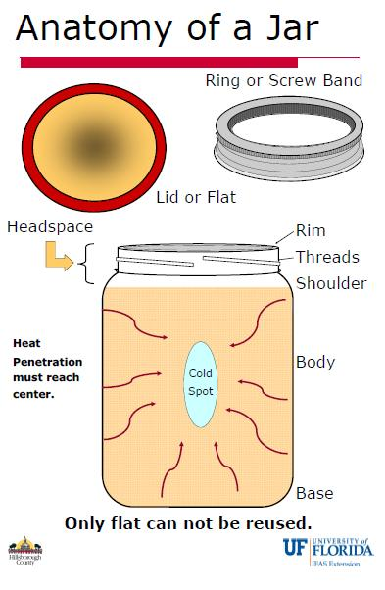

**Dehydrating Basics**

The overall objective is to remove moisture before the food spoils.

***Fruit*:**

Some foods dry better than others. The following fruits dry well: apples, apricots, blueberries, cherries, cranberries, figs, grapes, huckleberries, peaches, pears and plums.

The following fruits dry less well: blackberries, cantaloupe, lemons, and oranges.

Pretreatment of fruits applies to both dehydration and freezing. Pretreatment of fruits is a personal preference; food safety is not affected. Pretreatment of some fruits before drying will reduce vitamin loss, flavor loss, browning, and deterioration during storage.

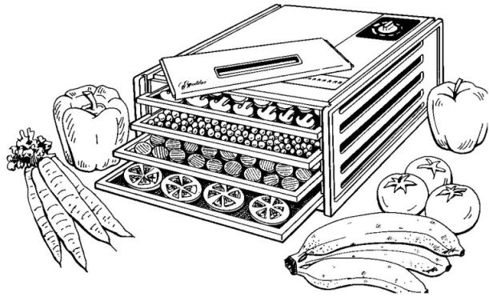***Pretreatment Methods***

***Sodium bisulfite*** is used by dissolving 2 teaspoons of the powder in 1quartof water and adding the cut fruit. Dip the fruit in the solution; drain and dehydrate.

***Ascorbic Acid*** is used by dissolving 1 tablespoon of the powder in 1 quart of cold water. Dip the fruit in the solution then drain and dehydrate.

***Citric Acid*** is only one-eighth as effective as ascorbic acid. Dissolve 1 tablespoon in 1 quart of water. Dip the fruit in the solution then drain and dehydrate.

***Citrus Juices:*** Pineapple, lemon and lime juice may be used, but are only one-sixth as effective as ascorbic acid. Use 1 cup of lemon or lime juice to 1 quart of water. Dip the fruit in the solution then drain and dehydrate.

***Crazing:*** Some fruits have a protective wax coating, such as plums, figs, cranberries, blueberries, and grapes. It is necessary to pre-treat these fruits by dipping them in boiling water for 3- -60 seconds, according to the size and toughness of the skin.

***Sulfuring:*** The process of sulfuring produce is beyond the scope of this presentation. If you want to learn more here is a link: <https://extension.usu.edu/files/publications/publication/FN-330.pdf>

***Vegetables:***

Almost all vegetables should be blanched by hot water or steam before drying. Exceptions include: peppers, onions and mushrooms.

The following vegetables dry well: beets, cabbage, carrots, celery, corn, green peas, green peppers, mushrooms, onions, garlic, potatoes, tomatoes and turnips.

The following vegetables dry less well: lettuce, radishes, spinach and other greens.

***Blanching:*** Blanching is the process of heating vegetables sufficiently to deactivate enzymes that would cause flavor and color deterioration during either the dehydration or freezing process. Blanch with hot water or steam for the time stated in Table "Freezing Vegetables" on page 8. Green peppers, onions, garlic, mushrooms and okra require no pre-treatment.

***Citric Acid Blanch*:**  A small amount of citric acid (¼ teaspoon) added to water, makes blanching more effective in destroying potentially harmful bacteria, including *Esherihiacoli*, *Salmonella species, and Listeria monocytogenes.* However, while citric acid acts as an anti-darkening agent for light-colored vegetables, it will cause bright green vegetables to turn olive green.

***Meat****:*

The processing of meat and meat jerky is beyond the scope of this presentation and will be covered in the classes on meat preservation. See our schedule of classes here: <http://ucanr.edu/edmfp_classes>.

***Herbs*:**

Temperature range for drying herbs is lower; 95-115º degrees. The following herbs dry well: chervil, rosemary, chives, sage, dill, tarragon, mint, thyme and oregano.

***Test for dryness***

***Fruit:*** Fruit should be pliable and leather-like, without any pockets of moisture.

***Vegetables:*** Most vegetables will be hard and brittle when dried.

Produce may dry unevenly and some pieces may need to be removed before others.

***Finishing:*** All dried foods should be conditioned before packing. Too much moisture left in a few pieces may cause the whole batch to mold. Place dried foods in a tightly closed large container. Stir or shake each day for a week. This will equalize the moisture. If moisture forms on the inside of the container the food has not been dried sufficiently. Return the food to the dehydrator for a few more hours.

Pasteurizing is necessary for any food products that could have been exposed to insect infestation or larva prior to handling or during the drying process. The food should be frozen after it has been conditioned. Pack the food in airtight containers, removing as much air as possible; place in a freezer at 0°F for at least two days.

***Storage:***

Moisture must be kept from dried foods when they are in storage. Containers suitable for the freezer work well for storing dried food.

***Rehydrate****:*

There are three basic methods used to rehydrate dried foods: 1. Soak in liquid, 2. Boil in water, and 3. Cook in liquid. Do not add salt or sugar during the first 5 minutes of rehydration as salt hinders the water absorption process. Various fruit juices, yogurt, cordials, and fruit liqueurs may be used instead of water to reconstitute fruits. Place fruit pieces in a shallow pan and cover with the liquid. The general rule is to use 2 cups of fruit to 1 cup of liquid. Add more liquid as needed. Fruit will usually reconstitute in a couple of hours. Refrigerate if it takes longer.

Vegetables may be reconstituted in consommé, bouillon, vegetable juice, water, or milk. Refrigerate during rehydration. Allow plenty of time - from 1 to 2 hours up to 8 hours, depending upon the vegetable.

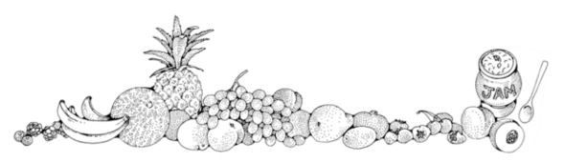

***Orange Marmalade***  **Yield:** about 7 half-pints

*Marmalade is a suspension of fruit peel and pulp in a tart, yet sweet, jelly. Toast with marmalade is a traditional breakfast favorite, but marmalade also makes a fantastic glaze for sweet and savory foods and is a marvelous addition to many marinades.*

* 6 medium oranges
* 2 medium lemons
* 2 ½ cups water
* 1/8 tsp. baking soda
* 6 ½ cups granulated sugar
* 1 pkg. 1.75 oz. pectin (regular powdered fruit pectin)
* ¼ tsp. butter

Under running water, rinse/wash oranges and lemons. Thinly pare using a sharp paring knife or vegetable peeler, rind from fruits, and cut into thin slivers. In a non-reactive pot, such as stainless steel or enamel, add water, baking soda, and slivers of orange and lemon rind. Bring to a boil; cover. Simmer on medium-low heat for 20 minutes, stirring occasionally. Remove and discard white membrane and seeds from fruits; chop fruit, reserving the juice. Add fruits and juices to pot with rinds. Simmer for 10 minutes longer, stirring occasionally.

Into a non-reactive pot, measure exactly 4 cups of cooked fruit and rind mixture, the package of pectin, and ½ tsp. butter if desired (to prevent foaming). Bring to a full rolling boil a boil, stirring constantly.

Add sugar to fruit mixture all at once; stir; bring back to a full rolling boil for exactly 1 minute or the time specified in the pectin package instructions, stirring constantly. Remove from heat and let stand for 5 to 10 minutes, stirring often. Skim off foam with metal spoon.

Ladle into hot jars leaving ¼-inch headspace. Remove air bubbles add adjust headspace, if necessary, by adding more hot marmalade. Wipe jar rims. Center lid on jar. Screw band down until resistance is met, then increase to finger-tip tight. Process in a boiling water or atmospheric steam canner for 10 minutes at 0-1000 ft., 15 minutes at 1001-6000 ft., and 20 min at 6001 ft. and above. Turn off the heat, lid and wait 5 minutes. remove canner lid and jars. Cool jars for 12-24 hours, wash, label, and store in a cool dark place.

Note: Marmalade may take up to 2 weeks to set.

*Source: Ball Pectin box*

***Citrus Flavored Salts***  **Yield:** 1 cup

* 1 cup flake salt, such as Maldon sea salt, or coarse sea salt
* 3 tablespoons citrus zest

Mix salt and zest in a bowl. Work the zest into the salt with your fingers to release oils and flavor. Spread on a baking tray, air-dry until dried completely; 8 hours to overnight.

*Note:* Zests color will fade over time, but this won’t affect taste.

Make ahead 2 months, keep airtight at room temperature.

***Homemade Lemon Pepper Seasoning***  **Yield:** 1 cup

* 5 lemons (zested)
* ⅓ cup crushed peppercorns
* ¼ cup kosher salt (optional)

Mix pepper and zest in a bowl. Work the zest into the pepper with your fingers to release oils and flavor. Add salt, if wanted. Spread on a baking tray, air-dry until dried completely; 8 hours to overnight.

When dry, place mixture in a spice grinder and grind to desired texture.

Store in an airtight container for 2-3 months.

*Note:* Zests color will fade over time, but this won’t affect taste.

**Source:**  <https://www.simplyscratch.com/2010/11/homemade-lemon-pepper-seasoning.html>

***Candied Citrus Peel***  **Yield:** about 2 cups

*Refreshing, addictive, and absolutely satisfying at the end of a meal. Candied citrus peel keeps so well that it's a good idea to double the recipe.*

* 2 grapefruit or 3 oranges or 6 lemons
* 2 cups sugar
* 3 tablespoons light corn syrup
* water

Peel the fruit in ~3/8" thick strips, using only the zest and white peel. If the white is very thick, trim it down a little.

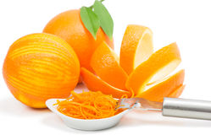Put the peel in a pan, cover with cold water and simmer for 30 minutes. Drain, cover with cold water again, and simmer until tender. Drain.

Mix one cup of the sugar with the corn syrup and ¾ cup water in a heavy saucepan**;** add fruit peel and stir over low heat until most of the syrup has been absorbed. Cover and let stand overnight. Reheat until syrup melts and citrus peel can be separated, then cool a little and drain. Pour remaining sugar (or more, if needed) into a baking dish and roll the peel in it, turning so that all the pieces are coated. Let them stand until they are dry; overnight or longer. Stored airtight, they will stay fresh for several months. If they become too dry put a lemon in the container for a day or two and the peel will soften.

The citrus peel may also be dried in an electric dehydrator. To dry on dehydrator trays, set temperature to 135°F, and dehydrate for 8-24 hrs. Check your candy every few hours. Rotate trays for even drying. Candy is done when dry but pliable, not brittle.

To test for dryness, condition your candy by filling a jar 2/3 full and close with a lid. If after 24 hours there is some condensation on the sides of the jar, return the candy to the dehydrator.

*Source: Sunset Magazine*

***Lime/Lemon Curd Yield: about 3 cups***

* 4 tsp. grated lime or lemon peel
* ⅔ cup fresh lime or lemon juice
* 5 eggs
* 1 cup sugar (add 1 additional Tbsp. if using Meyer Lemons)
* ½ cup melted butter

In a blender, blend the first four ingredients until smooth. With blender motor running at lowest setting, gradually add the melted butter, pouring in a steady stream until just blended. Transfer the mixture to a small, heavy saucepan and cook over medium heat, stirring continuously until mixture bubbles and thickens. Remove from heat. Ladle into hot jars leaving ½ inch headspace. Cover with lid and ring, cool in refrigerator, then freeze.

Want a canned version? Go to <http://nchfp.uga.edu/how/can_02/lemon_curd.html>

*Source: Sunset “Gifts From Your Kitchen”, 1988*

***Spiced Orange Jelly Yield: about 4 half pint jars***

* 2 cups orange juice (about 5 medium oranges)
* ⅓ cup lemon juice (about 2 medium lemons)
* ⅔ cup water
* 1 package powdered pectin
* 2 Tbls. orange peel, finely chopped
* 1 tsp. whole allspice
* ½ teaspoon whole cloves
* 4 sticks cinnamon, 2 inches long
* 3 ½ cups sugar

Mix orange juice, lemon juice, and water in a large saucepan. Stir in pectin. Place orange peel, allspice, loves, and cinnamon sticks loosely in a clean white cloth; tie with a string and add to fruit mixture. Place on high heat and, stirring constantly, bring quickly to a full rolling boil that cannot be stirred down. Add sugar, continue stirring, and heat again to a full rolling boil. Boil hard for 1 minute. Remove from heat. Remove spice bag and skim off foam quickly.

Ladle into hot jars leaving ¼-inch headspace. Remove air bubbles add adjust headspace, if necessary, by adding more hot jelly. Wipe jar rims. Center lid on jar. Screw band down until resistance is met, then increase to finger-tip tight. Process in a boiling water or atmospheric steam canner for 10 minutes at 0-1000 ft., 15 minutes at 1001-6000 ft., and 20 min at 6001 ft. and above. Turn off the heat, wait 5 minutes. remove canner lid. Cool jars for 12-24 hours, wash, label, and store in a cool dark place.

*Source:* [*https://nchfp.uga.edu/how/can_07/orange_jelly_spiced.html*](https://nchfp.uga.edu/how/can_07/orange_jelly_spiced.html)

***Resources***

**National Center for Home Food Preservation**: <http://nchfp.uga.edu/>

**Complete Guide to Home Canning**. 2015. <http://nchfp.uga.edu//publications/publications_usda.html>

Also available in paper copy from Purdue Extension (online store is located at <https://mdc.itap.purdue.edu/item.asp?item_number=AIG-539>)

**So Easy to Preserve,** Sixth Edition. 2014. Bulletin 989. Cooperative Extension/The University of Georgia/Athens

**Ball Blue Book Guide to Preserving**. 2014. Jarden Corporation.

**Ball Complete Book of Home Preserving**, 2006/2012. Jarden Corporation.

UC ANR is an equal opportunity provider and employer

Should you need assistance or require special accommodations for any of our educational programs, please contact us at 530-621-5502.

Revised 1/28/2020