**Winter Pickling**

**Quick-Process Pickling Fundamentals**

**Use the Right Equipment**

* Standard canning jars, lids, and rings must be used.
* A deep, non-reactive kettle, stainless steel, enameled, or glass, must be used for cooking the product.
* Use a reputable recipe for the best results, as these recipes have been tested for quality, flavor, and ***safety***.

**Open Kettle Canning**

* Open kettle canning involves heating the food to boiling, pouring it into the jars, applying lids, and allowing the heat of the jar to cause the lid to seal, without further processing.
* **The USDA does not recommend this method of canning.**

**Use the Best Ingredients**

* Select produce of good flavor and color, but not fully ripe.
* Cane or beet sugar can be used with equal success.

**Getting Ready: Be Prepared!**

* Read the recipe thoroughly before you begin. Measure out all ingredients and have all needed utensils at hand. Make sure your vinegar is 5% acidity (read label).
* Do not change the quantities of produce nor vinegar in any recipe, unless specified in a tested recipe.
* Check the jar for flaws. Wash jars, lids, and rings in hot soapy water and rinse well. Place clean jars into the boiling water canner and heat the jars.
* To prepare lids, follow the manufacturer’s directions on the lid package; some say to heat and some say just wash.

**Fill and Seal Jars Properly**

* 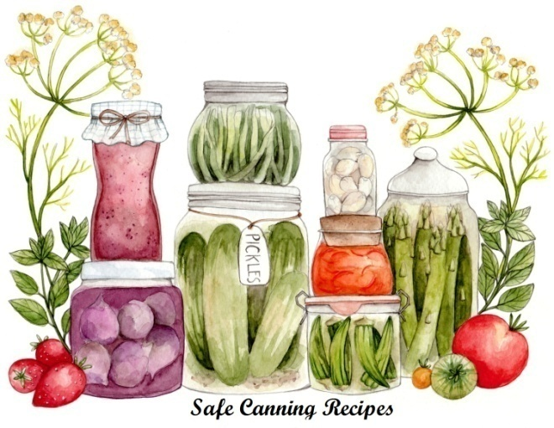Fill hot jars with hot mixture. Leave headspace specified in the recipe.
* Wipe the rim with a clean, damp, paper towel.
* Place lids and rings on jars. Tighten the rings only fingertip tight.
* Paraffin, as a sealing agent, is not recommended.

**Boiling Water Canner Processing**

* Place jars in a canner with a spacer or rack in the bottom of the canner. The jars should not sit directly on the bottom of the canner. Water should be very hot but not boiling. Add enough water to cover the tops of the jars by at least 1".
* Place lid on canner. Bring the water to a rolling boil then reduce the heat to a gentle boil. Begin to count processing time when the water comes to a boil. Process for the time indicated in the recipe.

**Atmospheric Steam Canners**

* Use a research tested recipe and processing time developed for a **boiling water** canner when using an atmospheric steam canner. An atmospheric steam canner may be used with recipes approved for half-pint, pint, or quart jars.
* If using a canner with a temperature sensor, begin processing time when the temperature marker is in the green zone for your altitude. If using a canner without a temperature sensor, begin processing time when a steady stream of steam is visible from the vent hole(s).
* Set the timer for the total minutes required for processing the food, adjusting for altitude. Processing time must be limited to **45 minutes or less, including any modification for elevation**. The processing time is limited by the amount of water in the canner base. When processing food, **do not** open the canner to add water.
* Monitor the temperature sensor and/or steady stream of steam throughout the entire timed process. Regulate heat so that the canner maintains a temperature of 212°F.
  + A canner that is boiling too vigorously can boil dry within 20 minutes. If a canner boils dry, the food is considered under-processed and therefore potentially unsafe.
  + Maintain a ***gentle boil***. Aside from keeping the jars from rattling around and bumping into each other and possibly breaking, there’s another reason – canner belching. If it’s boiling hard the lid may rise up just a little and belch out some steam. It will also suck cold air in!
* At the end of the processing time, turn off the heat, wait 2-3 minutes and remove the lid, lifting the lid away from you.

|  |  |
| --- | --- |
| Altitude Chart | |
| Altitude in feet | Increase processing time |
| 1000 - 3000 | 5 minutes |
| 3001 - 6000 | 10 minutes |
| Above 6001 | 15 minutes |

**Adjusting for Altitude**

* Not everybody lives at the same altitude. At sea level, water boils at 212oF. All recipes are developed using sea level as the criteria for processing times. At higher altitudes water will boil at a lower degree.
* Adjustments have to be made to ensure safe canning. If you are at a higher altitude you must adjust the processing times according to the included chart.

**Food safety tips**

* Wash hands and forearms frequently: after using toilet, after changing baby's soiled diaper, after touching animals, before handling food, and after touching raw meat, fish and poultry.
* 20-second rule: wash hands for 20-seconds.
* Use disposable gloves if you have a cut or sore on your hands.

***When in doubt - throw it out***

* DANGER - Never taste food that looks or smells strange to see if it can still be used. Just discard it.
* Generally foods that contain bacteria will look, smell, and taste normal.
* Generally speaking most bacteria that cause food borne illness are odorless, colorless, and tasteless.

**General cleaning tips**

* Run sponges and pot scrubbers through the dishwasher frequently.
* Change dish cloths daily.
* Mop up spilled juices from meat, fish or poultry immediately using a disposable paper towel.
* Use a disinfecting solution consisting of 1 ½ teaspoon of chlorine bleach to 1 pint of water. Dispense with a spray bottle to disinfect countertops, cutting surfaces, etc. Make a new solution every week.
* AVOID CROSS CONTAMINATION. ALWAYS wash your hands, knives, cutting boards, and food preparation surfaces well with soapy water before and after any contact with raw meat, fish, or poultry.
* Rinse all fresh fruits and vegetables well under running water before preparing or eating them. Do not soak.

**Basic canning tips**

* Remove the jars from the canner as stated in the recipe. When you remove the jars from the canner after processing, hold upright; do not disturb the seal. Do not retighten the rings.
* Place the hot jars on a rack or folded towel away from drafts. Keep the jars separated so they will cool evenly.
* Leave the ring bands on the jars until they have cooled thoroughly. Do not try to dump the water off the lids.
* Some canning books still recommend inverting jars after removing them from the boiling water canner. ***The USDA does not recommend this method.***
* After the jars have cooled (allow 24 hours), remove the ring bands. Look at the top of each jar. If the lid is slightly concave, it indicates a seal. Test the seal by pressing on the lid with your finger; the lid should not give. If you are not sure a jar is sealed, carefully lift the jar by the lid after removing the ring band. If not properly sealed, the lid will come off.
* Remove ring bands. Wash and dry ring bands and store for later use. Store jars without rings.
* Clean the jars to remove sticky residue.
* Label and date the jars, and store in a cool, dark, dry area.

**Reprocessing**

* If a jar does not seal, refrigerate and use within a few days, or reprocess it within 24 hours using a new metal lid. Check the jar for flaws. Process by the method originally advised and for the full length of time.

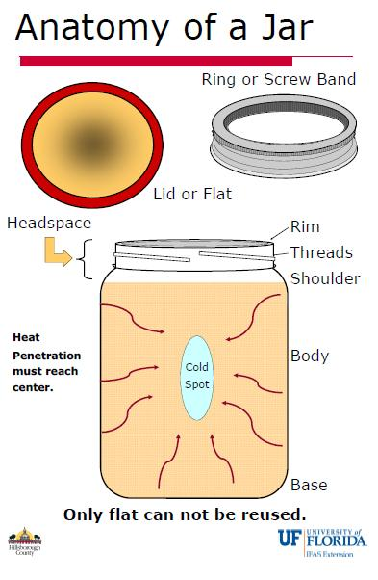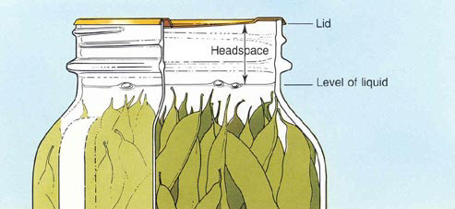

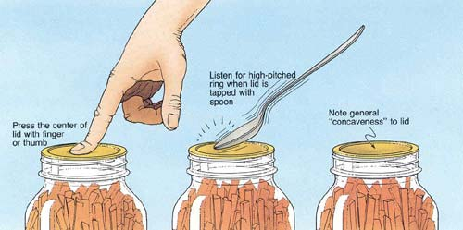

**Pickles**

A pickle is any fruit or vegetable preserved in vinegar or brine.

* **Brine pickles** are products fermented in salt brine. Regular dill pickles and sauerkraut are fermented and cured for about 3 weeks. They may be canned or stored in the refrigerator for 4-6 months.
* **Refrigerator dills** are not heat processed and must be stored in the refrigerator for 4-6 months.
* **Fresh-pack or quick-process pickles** are not fermented; some are brined several hours or overnight, then drained and covered with vinegar and seasonings.
* **Fruit pickles** are fruits that are pickled in spicy, sweet-sour syrup.
* **Relishes** are prepared using chopped products and cooked in a spicy vinegar solution.

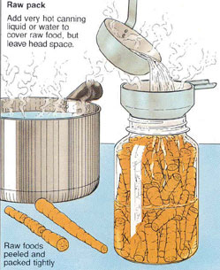Be sure to remove and discard a 1/16-inch slice from the blossom end of fresh cucumbers. Blossoms may contain an enzyme which causes excessive softening of pickles.

***Raw (Cold) Pack Or Hot-Pack***

The raw, or cold-pack, method means packing the cold or raw food into a hot jar, then adding boiling liquid brine. The jars are then processed in a boiling-water canner. Fruits such as apricots, berries, cherries, grapes, plums, rhubarb and tomatoes are best if packed raw. Most vegetables can be packed raw (cold-packed) if processed in the pressure canner.

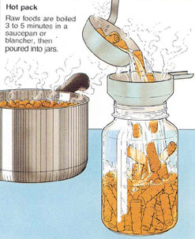The hot-pack method requires a short pre-cooking period (boiling or heating in some manner). Then the boiling-hot product is packed into clean, hot jars and processed immediately. The hot-pack method is more satisfactory for some vegetables and fruits and it is recommended for peaches, pears and pineapple. Benefits include a tighter pack and, because food expels air when heated, less float.

Use the method suggested in your tested recipe for best flavor and texture.

***Salt***

* Use canning or pickling salt. Table salt contains anti-caking ingredients which can cloud the brine.
* Since flake salt varies in density (grain size), it is not recommended for making pickled and fermented foods. (If you must substitute

Kosher salt, it is lighter than canning salt so you need to use the same amount of salt by weight, not volume.

In our class experiment, **1/2 cup pickling salt = 1 cup plus 2 Tablespoons Kosher salt**.)

***Vinegar***

The level of acidity in a pickled product is as important to its safety as it is to taste and texture. When pickling, always use high-quality commercial vinegars with 5% acidity or higher (also listed as 50-grain). The acidity should be listed on the label; if not, assume it is not 5%.

* Do not alter vinegar, food, or water proportions in a recipe or use a vinegar with unknown acidity. Doing so may alter its preservative effect and undermine the safety of the product.
* Use only recipes with tested proportions of ingredients.
* White distilled and cider vinegars of 5% acidity are recommended. White vinegar is usually preferred when light color is desirable.
* Do not use homemade vinegar as the acidity is unknown. It also produces a cloudy brine that may make your products appear spoiled.

***Water***

* Soft water makes the best brine for pickles
* Hard water may cause cloudiness in the brine and discolor pickles. If only hard water is available, boil and let site for 24 hours. Skim off scum and use water from the top of the container without disturbing the sediment.

**Pickles with reduced salt content**

In the making of fresh-pack pickles, cucumbers are acidified quickly with vinegar. Use only tested recipes formulated to produce the proper acidity. While these pickles may be prepared safely with reduced or no salt, their quality may be noticeably lower. Both texture and flavor may be slightly, but noticeably, different than expected. You may wish to make small quantities first to determine if you like them.

However, the salt used in making fermented sauerkraut and brined pickles not only provides characteristic flavor but is also vital to safety and texture. In fermented foods, salt favors the growth of desirable bacteria while inhibiting the growth of others. **Caution: Do not attempt to make sauerkraut or fermented pickles by cutting back on the salt required.**

***Sugars***

White granulated and brown sugars are most often used. Corn syrup and honey, unless called for in reliable recipes, may produce undesirable flavors.

***Spices***

Use fresh whole spices for the best quality and flavor in pickles. Powdered spices may cause the product to darken and become cloudy. Pickles will darken less if you tie whole spices loosely in a clean white cloth or cheesecloth bag and then remove the bag from the product before packing the jars.

***Firming Agents***

If good quality ingredients are used in pickling and up-to-date methods are followed, lime and alum are not needed for crisp pickles. If you choose to use firming agents, alum may be safely used to firm fermented cucumbers. Alum does not have an effect on quick-processes pickles. However, since it is unnecessary, it is not included in these recipes.

* Soaking cucumber in ice water for 4 to 5 hours prior to pickling is a safe method for making crisp pickles.
* The calcium in pickling lime does improve pickle firmness. Food-grade lime may be used as a lime-water solution for soaking fresh cucumbers 12 to 24 hours before pickling them. However, EXCESS LIME ABSORBED BY THE CUCUMBERS MUST BE REMOVED TO MAKE SAFE PICKLES. To remove excess lime, drain the lime-water

solution, rinse and then re-soak the cucumbers in fresh water for 1 hour. Repeat the rinsing and soaking steps two more times.

* Calcium chloride for pickling is often sold where you buy canning supplies. It is usually added directly to the jars of pickles. Follow the instructions on the package.

***Other considerations:***

* ***Yellow crystals on pickled asparagus:*** Sometimes pickled asparagus will form yellow crystals. Do not panic!!! According to San Joaquin County extension, "when asparagus is heated with acid (such as vinegar), rutin is drawn out of the asparagus plant. It then becomes insoluble in the vinegar and crystallizes on the exterior of the asparagus stems. In commercially canned asparagus, a small amount of tin salts are added to the pickling solution, which prevents the rutin from crystallizing."
* ***Blue garlic***: Garlic contains anthocyanins, water- soluble pigments that can turn blue or purple in acidic environments like vinegar or pickling brine - the garlic is still safe to eat. Garlic should be fresh and at the peak of maturity. Immature or sprouting garlic can turn blue in the jar

***For Best Results …***

* Marinate refrigerator pickles in the refrigerator for at least two weeks before serving and use within 3 months.
* Store fresh-pack/quick pickles for 4-6 weeks in a cool, dry, dark place to allow the flavors to mellow and blend.

***Alternative Low-Temperature Pasteurization Process***

* Low-temperature pasteurization can produce a better pickle texture, but must be done very carefully to avoid spoilage and is only acceptable for certain recipes. Fill jars with room temperature pickles. Pour 165° to 180° F liquid over the product, leaving the appropriate headspace. Remove bubbles with a rubber spatula. Wipe the jars clean and adjust lids. Process at 180˚F for 30 minutes. Be sure to use a thermometer.
* **Caution: Use this process only when a recipe indicates and only for cucumbers and zucchini.**

**Preventing Spoilage**

Pickle products are subject to spoilage from microorganisms, particularly yeasts and molds, as well as enzymes that may affect flavor, color, and texture. Processing the pickles in a boiling-water or steam canner will prevent these problems. Standard canning jars and self-sealing lids are recommended. Processing times and procedures will vary according to food acidity and the size of food pieces.

***Whole Pickling Spice Yield: 4 ounces***

* 2 Tbsp bay leaves
* 1 Tbsp cardamom seeds
* 1 Tbsp dried gingerroot
* 1 stick cinnamon
* 1 ½ whole dried chilies (use more for hotter spice)
* 2 Tbsp mustard seeds
* 1 Tbsp allspice
* 1 Tbsp coriander
* 1 Tbsp peppercorns

Crush bay leaves. If you have cardamom in the pod, pound it with a mortar and pestle to extract seeds.

Pound dried gingerroot and break cinnamon sticks into small pieces to distribute flavors

Dried chilies can be broken or crushed into small pieces.

Combine all ingredients. Blend and store in an airtight container.

Keep away from light. Use as directed in recipes.

***Marinated Mushrooms Yield: about 9 half-pint jars***

* 7 lbs small whole mushrooms
* ½ cup bottled lemon juice
* 2 cups olive or salad oil
* 2 ½ cups white vinegar (5 percent)
* 1 Tbsp oregano leaves
* 1 Tbsp dried basil leaves
* 1 Tbsp canning or pickling salt
* ½ cup finely chopped onions
* ¼ cup diced pimento
* 2 cloves garlic, cut in quarters
* 25 black peppercorns



Select very fresh unopened mushrooms with caps less than 1 ¼ inch in diameter. Wash. Cut stems, leaving ¼ inch attached to cap. Add lemon juice and water to cover. Bring to boil. Simmer 5 minutes. Drain mushrooms. Mix olive oil, vinegar, oregano, basil, and salt in a saucepan. Stir in onions and pimento and heat to boiling. Place ¼ garlic clove and 2-3 peppercorns in a half-pint jar.

Fill hot jars, leave ¼ inch headspace. Remove air bubbles. Wipe jar rims clean with white vinegar (remove oil). Place lids and rings onto jars, tightening rings finger-tip tight.

Process jars in a boiling water or atmospheric steam canner for 20 minutes at 0-1000 ft., 25 minutes at 1001-3000 ft., 30 minutes at 3001-6000 ft., and 35 min at 6001 ft. and above.

For boiling water canning, turn off the heat, remove canner lid and wait 5 minutes.

For atmospheric steam canning, turn off the heat, leave canner lid on and wait 2-3 minutes.

Remove jars, cool 12-24 hours, wash, and store in a cool dark place.

*Source: National Center For Home Food Preservation* <https://nchfp.uga.edu/how/can_06/marinated_mushrooms.html>

***Orange-Ginger Carrots Coins Yield: about 7 pint jars***

* 6 cups cider vinegar
* 2 cups water
* ½ cup pickling or canning salt
* 2 cups sugar
* 2 tsp. canning salt
* 3 Tbsp. fresh ginger, finely juilenned
* zest of 2 oranges, finely juilenned
* 3 - 4 Serrano chiles, cut into rings (optional)
* 5 lbs carrots, ends removed, peeled and cut into coins about ⅛ - ¼" thick

Blanch carrots for 1 minute, drain, and immediatly cool with ice water.

In a large stainless steel saucepan, combine vinegar, water, suagr,ginger, chiles, and salt. Stir well and bring to a boil over medium-high heat, stirring to dissolve salt and sugar. Add carrots and julienned ginger and orange zest. Bring to a boil then turn off the heat.

Pack carrot coins into hot jars. Be sure to include some orange zest and ginger into each jar. Ladle hot pickling liquid into jar to cover carrots, leaving ½-inch headspace. Remove air bubbles and adjust headspace, if necessary, by adding hot pickling liquid. Wipe rim and center lid on jar. Screw band down until resistance is met, then increase to fingertip-tight.

Process in a boiling water canner or atmospheric steam canner for 15 minutes 0-1000 ft., 20 minutes 1001-6000 ft., 25 minutes above 6000 ft. For boiling water canning, turn off the heat, remove canner lid and wait 5 minutes.

For atmospheric steam canning, turn off the heat, leave canner lid on and wait 2-3 minutes.

*Source: adapted from Ball Complete Book of Home Preserving, 2006/2012*

***Frog Balls Yield: about 4-5 pint jars***

* 12 cups small Brussels sprouts
* 4 cups white vinegar (5 percent)
* 2 cups sugar
* 2 cups thinly sliced onions
* 1 cup diced sweet red peppers
* 2 Tbsp mustard seed
* 1 Tbsp celery seed
* 1 tsp turmeric
* 1 tsp hot red pepper flakes

Wash Brussels sprouts (remove stems and blemished outer leaves) and boil in salt water (4 tsp canning salt per gallon of water) for 4 minutes. Drain and cool.

Combine vinegar, sugar, onion, diced red pepper, and spices in large saucepan. Bring to a boil and simmer 5 minutes.

Distribute onion and diced pepper among jars. Fill jars with Brussels Sprouts. Ladle hot pickling liquid into jar to cover Brussels Sprouts, leaving ½-inch headspace. Remove air bubbles and adjust headspace, if necessary, by adding more hot pickling liquid. Wipe rim and center lid on jar. Screw band down until resistance is met, then increase to fingertip-tight.

Process in a boiling water canner or atmospheric steam canner for 10 minutes 0-1000 ft., 15 minutes 1001-6000 ft., 05 minutes above 6000 ft. For boiling water canning, turn off the heat, remove canner lid and wait 5 minutes.

For atmospheric steam canning, turn off the heat, leave canner lid on and wait 2-3 minutes.

*Source:* [*https://nchfp.uga.edu/how/can_06/pickled_cauliflower_brussel.html*](https://nchfp.uga.edu/how/can_06/pickled_cauliflower_brussel.html)

***Pickled Cranberries Yield: about 5-6 half-pint jars***

* 3 cups sugar
* 3 cup apple cider vinegar(5% acidity)
* ½ cup water water
* 2 cinnamon sticks (4-inch pieces)
* 1 ½ tsp whole cloves
* 1 ½ tsp. whole allspice
* 2 twelve oz.bags of cranberries

Combine sugar, vinegar, water and cinnamon sticks; add cloves and allspice that are tied in a clean, thin, white cloth. Boil gently, uncovered, about 20 minutes.

Wash cranberries, and remove bad bits and stems.

Add cranberries to the hot syrup, bring to a boil, lower heat and continue simmering for 5-10 minutes or until the cranberries start to pop.

Add a bit of cinnamon stick to each jar. Pack hot cranberries into hot jars. Ladle hot pickling liquid into jar to cover carrots, leaving ½-inch headspace. Remove air bubbles and adjust headspace, if necessary, by adding hot pickling liquid. Wipe rim and center lid on jar. Screw band down until resistance is met, then increase to fingertip-tight.

Process in a boiling water canner or atmospheric steam canner for 10 minutes 0-1000 ft., 15 minutes 1001-6000 ft., 20 minutes above 6000 ft.For boiling water canning, turn off the heat, remove canner lid and wait 5 minutes.

For atmospheric steam canning, turn off the heat, leave canner lid on and wait 2-3 minutes.

.

*Source: adapted from Pear Pickles, So Easy To Preserve, 6th edition*

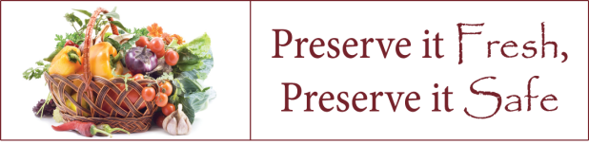

***Jardiniere Yield: about 5 pint jars***

*This tasty pickle contains a colorful array of vegetables and makes a satisfying snack or addition to any meal.*

* 3 bay leaves
* 6 whole black peppercorns
* 3 cloves garlic, thinly sliced
* 4 cups white vinegar
* 2 cups water
* 2 cups granulated sugar
* 1 tbsp pickling or canning salt
* 2 cups small cauliflower florets
* 1 ½ cups peeled pickling or pearl onions
* 3 stalks celery, cut into ¼-inch slices
* 2 carrots, peeled and cut into sticks
* 1 small zucchini, cut into ¼-slices
* 2 large red bell peppers, seeded and cut into ¼-inch strips
* 1 large yellow pepper, seeded and cut into ¼-inch strips
* 1 large green pepper, seeded and cut into ¼-inch strips

Prepare canner, jars and lids.

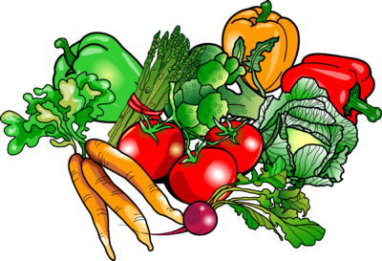

Tie bay leaves, peppercorns and garlic in a square of cheesecloth creating a spice bag.

In a large stainless steel saucepan, combine vinegar, water, sugar, salt and spice bag. Bring to a boil over medium-high heat, stirring to dissolve sugar. Reduce heat, cover and boil gently for 5 minutes, until spices have infused the liquid.

Add cauliflower, onions, celery, carrots, and zucchini. Return to a boil. Remove from heat and stir in the bell peppers. Discard spice bag.

Pack vegetables into hot jars to within a generous ½ inch of top of jar. Ladle hot pickling liquid into the jar to cover vegetables, leaving ½ inch headspace. Remove air bubbles and adjust headspace, if necessary, by adding hot pickling liquid. Wipe rim, center lid on jar. Screw band down until resistance is met, then increase to fingertip-tight.

Process in a boiling water canner or atmospheric steam canner for 10 minutes 0-1000 ft., 15 minutes 1001-6000 ft., 20 minutes above 6000 ft. For boiling water canning, turn off the heat, remove canner lid and wait 5 minutes.

For atmospheric steam canning, turn off the heat, leave canner lid on and wait 2-3 minutes.

*Source: Ball Complete Book of Home Preserving, 2006/2012*

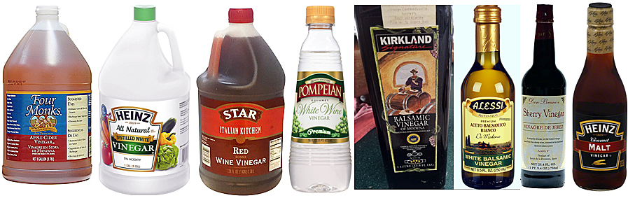

***English Pub Pickled Onions Yield: about 3-4 pint jars***

* 2.5 pounds small unpeeled onions (four 10 oz. bags)
* 8 cups water, divided
* 8 Tbsp. pickling canning salt, divided
* 1 tsp. black peppercorns
* ¼ tsp. whole allspice
* ¼ tsp. chile flakes
* bay leaves
* 5.5 cups malt vinegar (5% acidity)
* ¼ cup light brown sugar

Put 4 cups of water in a large bowl. Add the 4 Tbsp. salt, whisk or stir well to dissolve. Add the onions. Put a plate on the bowl, and weigh it down, to hold the onions down into the water. Let sit for 8 to 12 hours at room temperature.

Drain onions, discarding soaking liquid from bowl.

Make a second batch of brine in the large bowl with the second 4 cups of water and 4 Tbsp. salt.

Peel onions, adding to the fresh batch of brine in the bowl. Put a plate on the bowl, and weigh it down, to hold the onions down into the water. Let stand for 2 days at room temperature. Drain onions, discarding brine. Rinse the onions, drain well.

Make a spice mixture from the peppercorns, allspice berries, and hot pepper flakes; set aside.

Combine vinegar and sugar in a saucepan. Bring to a boil stirring until sugar dissolves.

In each jar put 1 bay leaf. Divide the spice mixture between the jars.

Raw-pack onions into hot jars. Ladle hot pickling liquid into the jars to cover onions, leaving ½ inch headspace. Remove air bubbles and adjust headspace, if necessary, by adding hot pickling liquid. Wipe rim, center lid on jar. Screw band down until resistance is met, then increase to fingertip-tight.

Process in a boiling water canner or atmospheric steam canner for 10 minutes 0-1000 ft., 15 minutes 1001-6000 ft., 20 minutes above 6000 ft. For boiling water canning, turn off the heat, remove canner lid and wait 5 minutes.

For atmospheric steam canning, turn off the heat, leave canner lid on and wait 2-3 minutes.

*Source: adapted from* [*https://nchfp.uga.edu/how/can_06/pickled_pearl_onions.html*](https://nchfp.uga.edu/how/can_06/pickled_pearl_onions.html)

***Pickled Beets Yield: about 8 pint jars***

* 7 lbs of 2- to 2 ½ inch diameter beets
* 4 cups vinegar (5 % acidity)
* 1 ½ tsp. canning or pickling salt
* 2 cups sugar
* 2 cups water
* 2 cinnamon sticks
* 12 whole cloves
* 4 to 6 onions (2- to 2 ½ inch diameter) if desired

Trim off beet tops, leaving 1 inch of stem and roots to prevent bleeding of color. Wash thoroughly. Sort for size. Cover similar sizes together with boiling water and cook until tender (about 25 to 30 minutes).**Caution: Drain and discard liquid.**Cool beets. Trim off roots and stems and slip off skins.

Slice into ¼ inch slices. Peel and thinly slice onions. Combine vinegar, salt, sugar, and fresh water. Put spices in cheesecloth bag and add to vinegar mixture. Bring to a boil. Add beets and onions. Simmer 5 minutes. Remove spice bag.

Pack beets into hot jars to within a generous ½ inch of top of jar. Ladle hot pickling liquid into the jar to cover beets, leaving ½ inch headspace. Remove air bubbles and adjust headspace, if necessary, by adding hot pickling liquid. Wipe rim, center lid on jar. Screw band down until resistance is met, then increase to fingertip-tight. Process in a boiling water canner or atmospheric steam canner for 30 minutes 0-1000 ft., 35 minutes 1001-3000 ft.,

40 minutes 3001-6000 ft , 45 minutes above 6000 ft. For boiling water canning, turn off the heat, remove canner lid and wait 5 minutes. For atmospheric steam canning, turn off the heat, leave canner lid on and wait 2-3 minutes.

*Source: National Center For Home Food preservation* [*https://nchfp.uga.edu/how/can_06/pickled_beets.html*](https://nchfp.uga.edu/how/can_06/pickled_beets.html)

***Apple Chutney Yield: about 6 pint jars***

* 4 quarts (16 cups) pared, cored, chopped tart apples (about 10 medium)
* 1 cup chopped onions
* 1 cup chopped sweet red bell peppers (about 1 medium)
* 2 tsp. seeded and finely chopped red Serrano pepper (about 2 to 4 peppers)
* 12 ounces seedless golden raisins
* 4 cups light brown sugar
* 3 Tbsp. mustard seed
* 2 Tbsp. ground ginger
* 2 tsp. ground allspice
* 2 tsp. canning salt
* 1 clove garlic, crushed
* 4 cups apple cider vinegar (5%)

***Caution: Wear plastic or rubber gloves and do not touch your face while handling or cutting hot peppers. If you do not wear gloves, wash hands thoroughly with soap and water before touching your face or eyes.***



Combine all prepared ingredients in a large stockpot; bring to a boil. Reduce heat and simmer until thickened, about 45 minutes. As mixture thickens, stir frequently to prevent sticking.

Ladle hot chutney in hot jars leaving ½ inch headspace. Remove air bubbles and adjust headspace, if necessary, by adding more hot chutney. Wipe rim, center lid on jar. Screw band down until resistance is met, then increase to fingertip-tight.

Process in a boiling water canner or atmospheric steam canner for 10 minutes 0-1000 ft., 15 minutes 1001-6000 ft., 20 minutes above 6000 ft. For boiling water canning, turn off the heat, remove canner lid and wait 5 minutes.

For atmospheric steam canning, turn off the heat, leave canner lid on and wait 2-3 minutes.

*Source:* [*https://nchfp.uga.edu/how/can_06/apple_chutney.html*](https://nchfp.uga.edu/how/can_06/apple_chutney.html)

***Resources***

**National Center for Home Food Preservation**: <http://nchfp.uga.edu/>

**Complete Guide to Home Canning**. 2009. <http://nchfp.uga.edu//publications/publications_usda.html>

Also available in paper copy from Purdue Extension (online store is located at <https://mdc.itap.purdue.edu/item.asp?item_number=AIG-539>)

**Canning Vegetables**, 2012. Publication 8072. University of California Ag & Natural Resources, <http://anrcatalog.ucanr.edu>.

**So Easy to Preserve,** Sixth Edition. 2016. Bulletin 989. Cooperative Extension/University of Georgia, Athens

**Ball Blue Book Guide to Preserving**. 2014. Jarden Corporation.

**Ball Complete Book of Home Preserving**, 2006. Jarden Corporation.

It is the policy of the University of California (UC) and the UC Division of Agriculture & Natural Resources not to engage in discrimination against or harassment of any person in any of its programs or activities (Complete nondiscrimination policy statement can be found at <http://ucanr.edu/sites/anrstaff/files/215244.pdf> ) Inquiries regarding ANR’s nondiscrimination policies may be directed to John I. Sims, Affirmative Action Compliance Officer/Title IX Officer, University of California, Agriculture and Natural Resources, 2801 Second Street, Davis, CA 95618, (530) 750- 1397

1-4-2020