**Preserve Today, Relish Tomorrow**

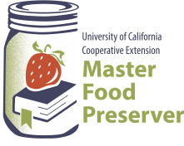

**UCCE Master Food Preservers of El Dorado County**

**311 Fair Lane, Placerville CA 95667**

**Helpline (530) 621-5506 • Email:** [**edmfp@ucanr.edu**](mailto:edmfp@ucanr.edu) **• Visit us on Facebook!**

**Spirited Preserving**

**High Acid Canning Basics:**

The quality of food is judged by wholesomeness, its nutritional value, and our expectations of its color, flavor, odor, and texture. The quality of preserved food varies greatly and depends mostly on the quality of the fresh food and preservation methods. High quality preserved foods are free from microbial spoilage and toxins, are pleasing to eat, and are reasonably nutritious.

**The Bottom Line:** If you prepare or serve food, you are responsible for making sure safe food is served.

**Factors That Affect Growth of Microorganisms**

1. **Temperature:** Foodborne pathogens grow best under the same conditions that allow people to thrive. Most foodborne bacteria grow fastest at temperatures from 90° to 110°F. However, foodborne bacteria will grow in the temperature range known as the ***Danger Zone***, 40° to 140°F; some grow at temperatures below this range.
2. 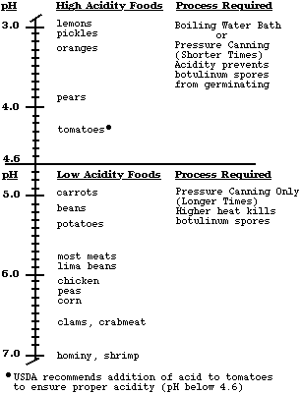**Acidity or alkalinity (pH):** Most organisms grow best under conditions that have a neutral pH, rather than highly acid or alkaline (few foods are highly alkaline).  High acid foods generally do not support bacterial growth.
3. **Moisture:** Microorganisms require moisture for growth. Dehydration preserves foods by removing moisture.
4. **Oxygen:** Most microorganisms require oxygen to grow; a few pathogens do not, or may require limited oxygen. However, controlling oxygen content is not useful for controlling bacterial growth for home food preservers.
5. **Time:** It takes time for microorganisms to grow or multiply in foods. The time required is affected by temperature, acidity, moisture and oxygen levels. Under ideal conditions bacteria can double in number every 10 to 20 minutes.
6. **Food:** Bacteria require nutrients to reproduce. Foods provide proteins and carbohydrates for growth.
7. **Inhibitors:** Some natural compounds/food additives are bacterial inhibitors (sugar, acid).

**Potentially Dangerous Microorganisms**

***Bacteria***

*Staphylococcus aureus*

* Produced when contaminated, high protein food is left too long at room temperature.
* Cooking at 165°F will not kill the toxin.
* Found in 50% of human noses, throats, hair, and skin.
* Will grow in meats, poultry, egg products, milk, salads with protein, macaroni and potato salads, tuna, puddings, custards, cream pies and pastries.

*Clostridium botulinum*

* Toxin known to cause botulism.
* Spores from the bacteria are widespread in the environment.
* Toxin only produced in anaerobic (oxygen free) environment of low acidity.
* May result from inadequate processing of vegetables and meats, which are low-acid foods.

*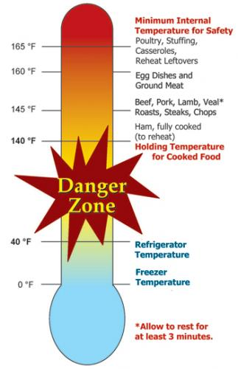Salmonella species*

* Salmonellosis is the disease state.
* Multiplies rapidly at room temperature.
* A leading cause of foodborne illness.
* Found in raw meats, poultry, eggs, fish, milk/milk products, raw fruits/vegetables.

*Campylobacter jejuni*

* More common in poultry than Salmonella.
* Causes 14% of diarrhea worldwide; is a leading cause of foodborne illness.
* Chief food sources: raw poultry, raw meats, unpasteurized milk.

*E. coli 0157:H7*

* Very common, found in all animal and human digestive systems.
* As few as 10 bacterial cells may be enough to cause illness through toxin produced.
* Can grow in the refrigerator if temperatures are above 40°F.
* Sources include undercooked meats, unpasteurized juices and milk, sprouts.

*Listeria monocytogenes*

* Found in soil, vegetation and water.
* Frequently carried by humans and animals.
* Can survive for a long period of time under adverse conditions.
* May be found in raw milk, soft cheese and processed foods (i.e. deli meats).

**Viruses**

* Smaller than bacteria.
* Cannot grow in food, need living host. Some can survive cooking and freezing.
* Can be transmitted to human through food and contaminated water.

*Includes: Hepatitis A, Typhoid, Norwalk Virus (Norovirus). Note: Norovirus is now considered to be the leading cause of foodborne illness. Source is primarily contaminated food handlers.*

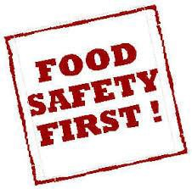**Molds**

* Molds are primarily spoilage organisms.
* The mold you see is only the “tip of the iceberg” of colonies under the surface.
* Some molds produce toxins.
* Toxins are not destroyed in cooking.
* Moldy foods should be discarded.

**Parasites**

Live on/in another living host to get food. Examples:

* *Trichinosis*: pork, bear, flesh eating animals.
* *Cysticercosis*: tape worm.
* *Anisakiasis*: fish round worms.
* *Giardia lamblia*: fecal contamination of toys, food, and water.
* *Toxoplasma gondii*: consumption of raw meat, unwashed or uncooked fruits, and vegetables, in feces of infected cats.

**Preventing Foodborne Illnesses**

1. Clean
2. Cook
3. Separate
4. Chill
5. **Clean**

* 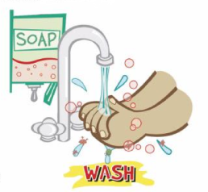Wash hands frequently and after: using toilet, changing baby's soiled diaper, sneezing or coughing, touching animals, handling raw meat, fish and poultry, and before handling food.
* 20-second rule: wash hands for 20-seconds or sing Happy Birthday song twice.
* Bandage any cuts or burns on hands before handling food.
* Use disposable latex gloves to protect food.
* Run sponges and dish scrapers through the dishwasher often.
* Change dish cloths daily.
* Use paper towels to mop up spilled juices from meat, fish or poultry.
* Use a disinfecting solution consisting of 1 tablespoon regular, unscented chlorine bleach to 1 quart of water. Use a spray bottle to disinfect countertops, cutting surfaces, etc.
  + The disinfecting solution has very specific instructions for mixing. Once bleach is mixed with water its disinfecting properties start to diminish after 24 hrs. When you are cleaning up after things that are highly likely to spread bacteria (like raw meat), you would want to use a freshly mixed solution.

1. **Cook**

Internal Temperatures & Rest Times:

* All poultry products including ground poultry and stuffing (cooked alone or in bird) 165°F.
* Ground meat (beef, pork, veal and lamb), sausages, and bacon: 160°F.
* Steaks, chops and roast (beef, pork, lamb and veal): 145°F & allow to rest for at least 3 minutes before carving.
* 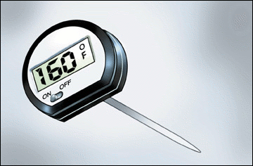Fish and shellfish: 145°F (Cook shellfish until the shells open).
* Eggs: 160°F internal temperature.
* Casseroles: 165°F.
* Reheat leftovers to 165°F.
* Use a thermometer.

1. **Separate**

Avoid cross contamination

* Ice is food! Use clean ice to avoid contaminating food.
* **ALWAYS** wash your hands, knives, cutting boards, and food preparation surfaces well with soapy water before and after any contact with raw meat, fish, or poultry. Using a separate cutting board for meat and poultry is recommended.
* Rinse all fresh fruits and vegetables well under running water before preparing or eating them.
* When grilling or barbecuing, always use a clean plate to put the cooked meat on.
* Store raw meat, fish and poultry on the bottom shelf in the refrigerator or on a plate to prevent juices from dripping onto other food items.
* Use a separate cutting board for fresh produce, raw meat, and cooked meat.

1. **Chill**

* Keep your refrigerator set at 40°F or below and refrigerate all perishable foods.
* Thaw frozen perishable foods in a refrigerator overnight, in a microwave oven, or under cold running water. Do not thaw frozen food on your counter.
* Do not prepare food more than 2 hours before serving without plans for proper storage in a refrigerator. Reheat just before serving.
* Divide leftover hot food into shallow containers to accelerate cooling; refrigerate within 2 hours after preparation.
* Foods can spoil in as little as 1 hour in the hot sun. Discard any perishable foods from a picnic or potluck that have not been kept adequately chilled (40°F or below) or kept hot (140°F or above).

**When In Doubt - Throw It Out**



**DANGER** - Never taste food that looks or smells strange to see if it can still be used.

**Just discard it.**

Generally, foods that contain bacteria will look, smell, and taste normal. Generally speaking, most bacteria that cause foodborne illness are odorless, colorless, and tasteless.

**Seven Major Methods of Food Preservation**

1. **Refrigeration**

* Retards growth of microorganisms.
* 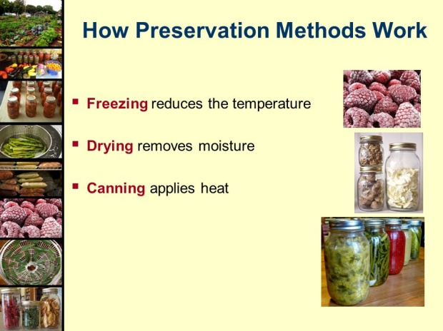Slows action of enzymes.

1. **Freezing**

* Prevents growth of microorganisms, but does not necessarily kill them.
* Slows, but does not stop enzymatic activity. Therefore, enzymes in most fresh vegetables must be inactivated by blanching before freezing.
* For highest quality, lower the food temperature to 0°F as rapidly as possible and maintain 0°F food temperatures.
* Freeze only the amount you can use before its shelf life expires. Use packaging that is moisture proof, sealable and oxygen impermeable to retain quality.

1. **Canning**

* With proper canning practices, air is forced from the jars, leaving a vacuum. Heat destroys most heat-resistant microorganisms capable of growing in food stored at room temperature.
* Molds and some yeasts are unable to grow in a vacuum. However, there is a very healthy growth environment for anaerobic bacteria in sealed, home-canned foods. Such foods must be heat processed until a commercially sterile product is achieved, or they must have salts, sugars, acids or other preservatives added.
* Yeasts and molds are destroyed when food temperatures reach about 190°F, whereas most bacterial vegetative cells are destroyed in foods heated to a boiling temperature. Bacterial spores can survive for a long period at the temperature of boiling water.
* Boiling water and atmospheric steam canning are USDA approved for high acid foods (fruits, pickled products).
* Pressure enables the processing of canned foods at temperatures higher than boiling water, where kill rates are greatly increased. Pressure canning is required to safely process low acid foods that may support the growth of bacterial spores, leading to the production of toxins.
* Open kettle canning: The USDA does **not** recommend this method of canning.

1. **Sweetening and Acidifying Jellies & Jams**

* Adds sugar and acids that tie up free water and lower ph.

1. **Pickling and Fermenting**

* Use either naturally produced or added acids to inhibit or prevent the growth of *Clostridium botulinum* as well as molds and other pathogens.
* Fermenting uses bacteria to produce lactic acid and lower the pH in products such as fermented pickles and sauerkraut.

1. **Drying**

* Removes water and prevents growth of microorganisms.
* Water in fresh food exists in free and chemically bound forms. Removal or reduction of free water from a food prevents microorganism growth and controls enzyme activity.
* Package dried food

1. **Salting**

* Chemically bonds water, inhibiting growth of some bacteria.

**Packaging**

The success of all preservation methods depends on using appropriate packages. Airtight packages prevent recontamination of foods and are ideally suited for most preserved foods.

* Use standard canning jars, lids and rings.
* A deep, non-reactive kettle (stainless steel, enameled or glass) must be used for cooking the product.
* Use a tested recipe from a reputable source for the best results, as these recipes have been tested for quality, flavor and safety.
* Paraffin**,** as a sealing agent, is **not** recommended.

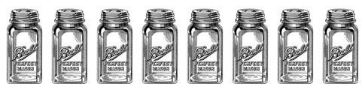

**Use the Best Ingredients**

Select fruit of good flavor and color, but not fully ripe. For jam and jelly it is better to have some under-ripe fruit as it contains more pectin and acid than fully ripe fruit.

Cane or beet sugar can be used with equal success.

**Get Ready, Be Prepared**

* Read the recipe thoroughly before you begin.
* Measure out all ingredients. Do not change the quantities in any recipe that calls for pectin. Follow directions for the pectin or the finished product will not gel correctly.
* Have all necessary utensils at hand.
* Wash jars, lids and rings in hot soapy water and rinse well.
* Place clean jars into the boiling water canner and heat them to 180°F.
* To prepare lids, follow the manufacturer’s directions on the lid package; some say to heat and some say just wash.
* Fill hot jars with hot mixture. Leave headspace as specified in the recipe.
* Wipe the jar rim.
* Place lids and rings on jars. Tighten the rings only finger tight.

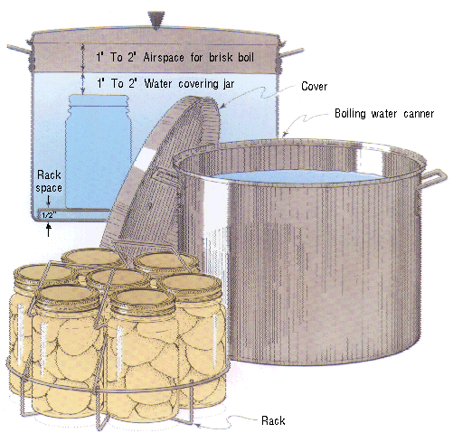 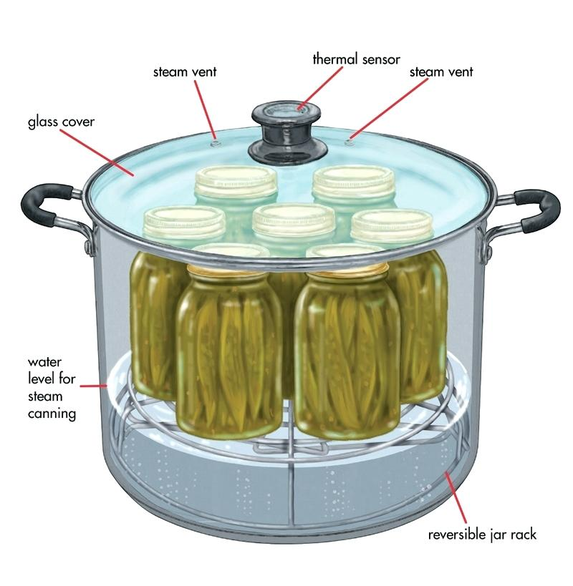

**Boiling Water Bath Canner Steam Canner**

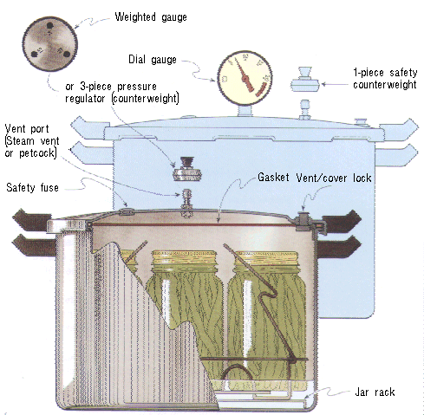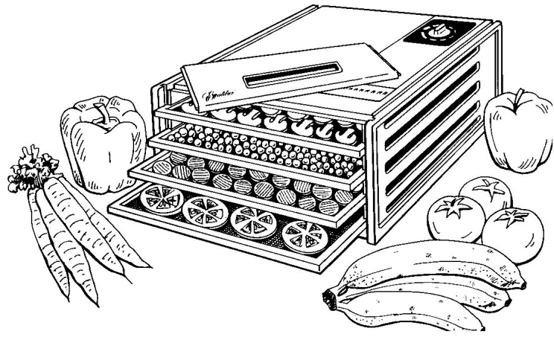

**Pressure Canner Dehydrator**

**Boiling Water Canner Processing**

1. Place jars in a canner with a rack.
2. Water should be 140° for raw pack jars and 180° for hot pack jars. Add enough water to cover the tops of the jar by at least 1" to 2". Cover with 2" of water if processing time is more than 30 minutes.
3. Place lid on canner. Bring the water to a rolling boil, then reduce heat to a gentle boil.
4. Begin to count processing time when the water comes to a boil.
5. Process for the time indicated in the recipe.
6. All recipes are developed using sea level as the criteria for processing time. If you are at a higher altitude, adjust the processing times according to the following chart:

|  |  |
| --- | --- |
| **Altitude Chart** | |
| Altitude in feet | Increase processing time |
| 1000 - 3000 | 5 minutes |
| 3001 - 6000 | 10 minutes |
| 6001 - 8000 | 15 minutes |
| 8001 - 10000 | 20 minutes |

1. Remove lid and let sit for 5 minutes, then remove jars from the canner. When you take the jars from the canner after processing, hold upright; do not disturb the seal. Do not retighten the rings. Place the hot jars on a rack or folded towel away from drafts or cool surfaces. Keep the jars separated so they will cool evenly.
2. Leave the ring bands on the jars until they have cooled (approximately 24 hours). Do not try to dump the water off the lids.
3. **Do NOT invert jars:** Some canning books still recommend inverting the jars after removing them from the boiling water canner. The USDA does not recommend this method.
4. After the jars have cooled, remove the ring bands. Look at the top of each jar. If the lid is slightly concave, it indicates a seal. Test the seal by pressing on the lid with your finger; the lid should not give. If you are not sure a jar is sealed, carefully lift the jar by the lid after removing the ring band. If not properly sealed, the lid will come off.
5. Wash and dry bands. Store rings for future use. Storing jars with rings attached is not recommended. Clean the jars with a damp cloth. Label and date the jars, and store in a cool, dark, dry area.

**Reprocessing -** If a jar did not seal, refrigerate and use within a few days, or reprocess it within 24 hours using a new lid. Check the jar for flaws. Process by the method originally advised and for the full length of time.

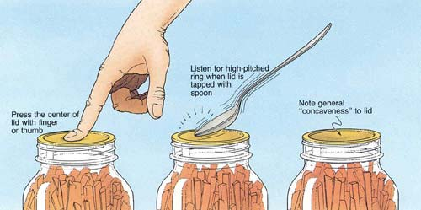

**Atmospheric Steam Canner Processing**

1. Use a research tested recipe and processing time developed for a **boiling water** canner when using an atmospheric steam canner. An atmospheric steam canner may be used with recipes approved for half-pint, pint, or quart jars.
2. Add enough water to the base of the canner to cover the rack. (Follow manufacturer recommendations.)
3. Preheat water to 140°F for raw packed foods and to 180°F for hot packed foods. Food preparation can begin while this water is preheating. Do not have the water boiling when you add the jars.
4. Heat jars prior to filling with hot liquid (raw or hot pack). Do not allow the jars to cool before filling.
5. Load filled jars, fitted with lids, onto the canner rack and place the lid on the canner base.
6. Turn heat to its highest position to boil the water until a steady column of steam (4-6 inches) appears from the vent hole(s) in the canner lid. Jars must be processed in pure steam environment.
7. If using a canner without a temperature sensor, begin processing time when a steady stream of steam is visible from the vent hole(s). I
8. If using a canner with a temperature sensor, use the temperature gauge only as a guide.
   * The processing time should begin only after a full column of steam (approximately 6 -8 inches) appears through the canner vent holes at the bottom of the cover. Some canners come with built-in temperature sensors, which can be used to monitor the temperature. A full column of steam should be present throughout the process time. If there is an interruption in the steam, the product should be reprocessed for the full processing time.
   * The temperature gauges on steam canners cannot be tested, therefore it is not recommended that they be relied upon to know when to start the processing time.
9. Set the timer for the total minutes required for processing the food, adjusting for altitude. Processing time must be limited to **45 minutes or less, including any modification for elevation**. The processing time is limited by the amount of water in the canner base. When processing food, **do not** open the canner to add water.
10. Monitor the temperature sensor and/or steady stream of steam throughout the entire timed process. Regulate heat so that the canner maintains a temperature of 212°F. A canner that is boiling too vigorously can boil dry within 20 minutes. If a canner boils dry, the food is considered under-processed and therefore potentially unsafe.
11. At the end of the processing time, turn off the heat, wait 2-3 minutes then remove the lid, lifting the lid away from you.
12. Using a jar lifter, remove the jars without tipping and place them on a towel, leaving at least 1 inch spaces between the jars during cooling. Let jars sit undisturbed to cool at room temperature for 12 to 24 hours.

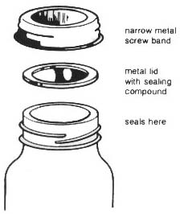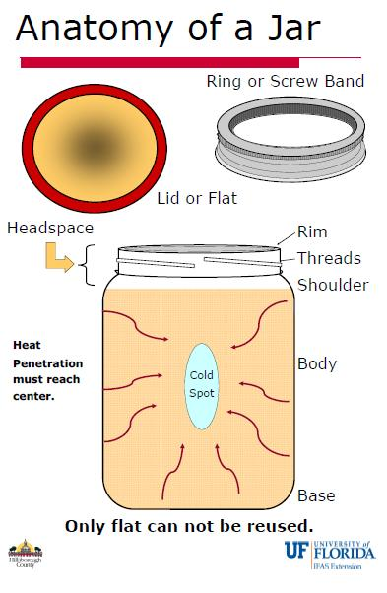

**Berry Wine Jelly** Makes about six 4 ounce jars

*This fabulous rose-hued jelly is a regal accent for cheese trays, an intriguing glaze on poultry or pork and a show-stopper gift for tea and breakfast lovers.*

* 1 cup raspberries or sliced hulled strawberries
* 2 ½ cups dry white wine
* 3 ½ cups granulated sugar
* 1 pouch (3oz) liquid pectin

In a large stainless steel saucepan or bowl, combine berries and wine. Crush berries and transfer to a dampened jelly bag or a strainer lined with several layers of dampened cheesecloth set over a deep bowl. Let drip, undisturbed, for 1 hour. Measure 2 ½ cups berry wine.

Transfer berry wine to a large, deep stainless steel saucepan. Stir in sugar. Over high heat, stirring constantly, bring to a full rolling boil that cannot be stirred down. Stir in pectin. Boil hard, stirring constantly for 2 minutes. Remove from heat and quickly skim off foam.

Quickly pour hot jelly into hot jars, leaving ¼-inch headspace. Wipe rim, center lid on jar. Screw band down until resistance is met, then increase to fingertip-tight. Place jars in canner a boiling water or atmospheric steam canner. Process for: 0-1000 ft. = 10 minutes, 1001-6000 ft. = 10 minutes, above 6000 ft. = 15 minutes.

For boiling water canning, turn off the heat, remove canner lid and wait 5 minutes.

For atmospheric steam canning, turn off the heat, leave canner lid on and wait 2-3 minutes.

Cool jars for 12-24 hours, wash, and store in a cool dark place.

*Source: Ball Complete Book of Preserving, 2006/2012*

**Spirited Blueberries** Makes about 7 half pint jars

* 1 cup granulated sugar
* 2 cups water
* 12 cups blueberries washed and drained

Per Jar:

* 1 tbsp rum, brandy or vodka ***Or***
* 1 ½ tsp Grand Marnier or other orange flavored liqueur
* 1 cup granulated sugar
* 2 cups water
* 12 cups blueberries washed and drained.

Per Jar:

* 1 tbsp rum, brandy or vodka

*Or*

* 1 ½ tsp Grand Marnier or other orange flavored liqueur

In a large stainless steel sauce pan over medium high heat, combine sugar and water. Bring to a boil, stirring to dissolve sugar. Add blueberries, stirring constantly; and return to a boil. Reduce heat, boil gently for 5 minutes.

Using a slotted spoon, pack blueberries into hot jars to within a generous ½-inch of top of jar and add the spirit of your choice. Ladle hot syrup into jar to cover blueberries, leaving ½-inch headspace. Remove air bubbles and adjust headspace, if necessary by adding hot syrup. Wipe rim, center lid on jar and screw band down until resistance is met, then increase to fingertip tight.

Place jars in canner a boiling water bath or atmospheric steam canner. Process for: 0-1000 ft. = 15 minutes, 1001-6000 ft. = 20 minutes, above 6000 ft. = 25 minutes.

For boiling water canning, turn off the heat, remove canner lid and wait 5 minutes.

For atmospheric steam canning, turn off the heat, leave canner lid on and wait 2-3 minutes.

Cool jars for 12-24 hours, wash, and store in a cool dark place.

*Source: Ball Complete Book of Preservation, 2006/2012*

**Blackberries In Framboise** Makes about 4 half pint jars

*Framboise is a raspberry brandy with an irresistible aroma. It infuses the blackberries with a delectable flavor, while the cinnamon and nutmeg add an enticing hint of spice*

* 6 cups blackberries, divided
* Water
* 2 cups granulated sugar
* 1 cinnamon stick (about 4 inches) broken
* 1 Tbsp grated lemon zest
* ½ tsp freshly grated nutmeg
* ½ cup Framboise or other raspberry liqueur

In a stainless steel saucepan, place 2 cups of the blackberries. Using a potato masher, crush slightly. Add 3 tbsp water. Cover and boil gently over medium-low heat until fruit is soft, about 2 minutes. Strain through a dampened jelly bag or a strainer lined with several layers of dampened cheesecloth, set over a glass measure to collect ½ cup blackberry juice.

In a large stainless steel saucepan, combine sugar, cinnamon stick pieces, lemon zest, nutmeg and 2 cups water. Bring to a boil over medium-high heat, stirring occasionally. Reduce heat and boil gently for 5 minutes. Strain and return syrup to saucepan. Add blackberry juice, remaining blackberries and Framboise. Bring to a boil over medium-high heat, stirring constantly but gently so as not to crush the blackberries.

Using a slotted spoon, pack hot blackberries into hot jars to within a generous ½-inch of top of jar. Ladle hot syrup into jar to cover blackberries, leaving ½-inch headspace. Remove air bubbles and adjust headspace, if necessary, by adding more hot syrup. Wipe rim, center lid on jar and screw band down until resistance is met, then increase to fingertip-tight. Place jars in a boiling water or atmospheric steam canner. Process for: 0-1000 ft. = 10 minutes, 1001-6000 ft. = 10 minutes, above 6000 ft. = 15 minutes.

For boiling water canning, turn off the heat, remove canner lid and wait 5 minutes. For atmospheric steam canning, turn off the heat, leave canner lid on and wait 2-3 minutes. Cool jars for 12-24 hours, wash, and store in a cool dark place.

*Source: Ball Complete Book of Preservation, 2006/2012*

**Brandied Apple Rings** Makes about 6 pint jars

* 4 cups granulated sugar
* 3 cups water
* 1 Tbsp red food coloring (optional)
* 4 ½ lbs firm red apples, cored, cut into ¼-inch rings, treated to prevent browning and drained
* 1 cup brandy

In a large stainless steel saucepan, combine sugar and water. Bring to a boil over medium-high heat, stirring occasionally. Reduce heat and boil gently, stirring to dissolve sugar, about 5 minutes. Add food coloring, if using and apple rings and return to a boil. Reduce heat and boil gently stirring occasionally until apples are slightly tender and if using food coloring, the desired shade of red, about 15 minutes. Remove from heat.

Using a slotted spoon, remove apple rings from syrup and place in a large glass or stainless steel bowl. Return syrup to a boil over high heat. Remove from heat and stir in brandy.

Pack apple rings loosely in hot jars to within a generous ½-inch of top of jar. Ladle hot syrup into jar to cover apple rings, leaving ½-inch headspace. Remove air bubbles and adjust headspace if necessary by adding more hot syrup. Wipe rim, place lid on jar and screw band down until resistance is met, then increase to fingertip-tight. Place jars in a boiling water or atmospheric steam canner. Process for: 0-1000 ft. = 15 minutes, 1001-6000 ft. = 20 minutes, above 6000 ft. = 25 minutes. For boiling water canning, turn off the heat, remove canner lid and wait 5 minutes. For atmospheric steam canning, turn off the heat, leave canner lid on and wait 2-3 minutes.

Cool jars for 12-24 hours, wash, and store in a cool dark place.

*Source: Ball Complete Book of Home Preserving, 2006/2012.*

**Lemon-Sage Wine Mustard** Makes about five 4 ounce jars

*Subtle lemon and sage accents enhance the flavor of this mild mustard. Stir it into vegetable salads or serve it with grilled vegetables and meats.*

* 1 bunch of fresh sage
* ¾ cup dry white wine
* ¾ cup yellow mustard seeds
* 1 cup white wine vinegar
* Grated zest and juice of 2 large lemons
* ½ cup liquid honey
* ¼ tsp salt

Finely chop enough sage leaves to measure ⅓ cup and set aside.

Coarsely chop remaining sage leaves and stems to measure ½ cup and place in a small stainless steel saucepan with white wine. Bring to a boil over medium heat, stirring and pressing sage to release flavor. Remove from heat, cover and let steep for 5 minutes.

Transfer sage infusion to a sieve placed over a glass orf stainless steel bowl and press leaves with the back of a spoon to extract all the liquid. Discard all solids and return liquid to saucepan. Add mustard seeds. Cover and let stand at room temperature until seeds have absorbed most of the moisture, about 2 hours.

In a blender or food processor fitted with a metal blade, combine marinated mustard seeds (with liquid) and vinegar. Process until blended and most seeds are well chopped. You want to retain a slightly grainy texture.

Transfer mixture to a stainless steel saucepan and add lemon zest, lemon juice, and honey, salt and reserved finely chopped sage. Bring to a boil over high heat, stirring constantly. Reduce heat to low and boil gently, stirring frequently, until volume is reduced by a third, about 20 minutes.

Ladle hot mustard into hot jars, leaving ¼-inch headspace. Remove air bubbles and adjust headspace if necessary by adding hot mustard. Wipe rim with a damp clean paper towel. Center lid on jar and screw band down until resistance is met, then increase to fingertip-tight.

Place jars in a boiling water or atmospheric steam canner. Process for: 0-1000 ft. = 10 minutes, 1001-6000 ft. = 15 minutes, above 6000 ft. = 20 minutes.

For boiling water canning, turn off the heat, remove canner lid and wait 5 minutes.

For atmospheric steam canning, turn off the heat, leave canner lid on and wait 2-3 minutes.

Cool jars for 12-24 hours, wash, and store in a cool dark place.

*Source: Ball Complete Book of Preservation, 2006*

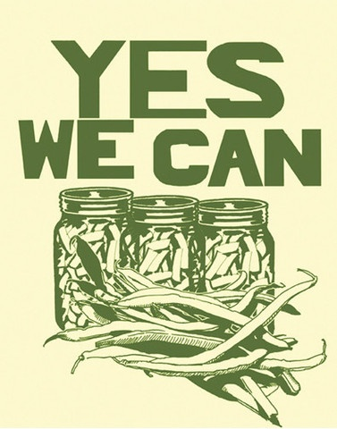

***Resources***

**National Center for Home Food Preservation**: <http://nchfp.uga.edu/>

**Complete Guide to Home Canning**. 2015. <http://nchfp.uga.edu//publications/publications_usda.html>

Also available in paper copy from Purdue Extension (online store is located at <https://mdc.itap.purdue.edu/item.asp?item_number=AIG-539>)

**So Easy to Preserve,** Sixth Edition. 2014. Bulletin 989. Cooperative Extension/The University of Georgia/Athens

**Ball Blue Book Guide to Preserving**. 2014. Jarden Corporation.

**Ball Complete Book of Home Preserving**, 2006/2012. Jarden Corporation.

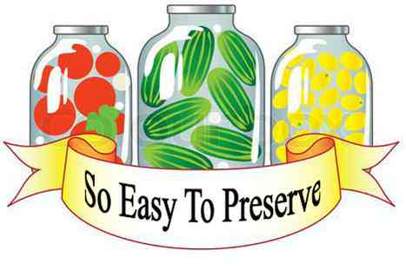

Should you need assistance or require special accommodations for any of our educational programs, please contact us at 530-621-5502.

The University of California, Division of Agriculture and Natural Resources (UC ANR) prohibits discrimination against or harassment of any person in any of its programs or activities on the basis of race, color, national origin, religion, sex, gender, gender expression, gender identity, pregnancy (which includes pregnancy, childbirth, and medical conditions related to pregnancy or childbirth), physical or mental disability, medical condition (cancer-related or genetic characteristics), genetic information (including family medical history), ancestry, marital status, age, sexual orientation, citizenship, status as a protected veteran or service in the uniformed services (as defined by the Uniformed Services Employment and Reemployment Rights Act of 1994 [USERRA]), as well as state military and naval service. UC ANR policy prohibits retaliation against any employee or person in any of its programs or activities for bringing a complaint of discrimination or harassment. UC ANR policy also prohibits retaliation against a person who assists someone with a complaint of discrimination or harassment, or participates in any manner in an investigation or resolution of a complaint of discrimination or harassment. Retaliation includes threats, intimidation, reprisals, and/or adverse actions related to any of its programs or activities. UC ANR is an Equal Opportunity/Affirmative Action Employer. All qualified applicants will receive consideration for employment and/or participation in any of its programs or activities without regard to race, color, religion, sex, national origin, disability, age or protected veteran status. University policy is intended to be consistent with the provisions of applicable State and Federal laws. Inquiries regarding the University’s equal employment opportunity policies may be directed to: John I. Sims, Affirmative Action Compliance Officer and Title IX Officer, University of California, Agriculture and Natural Resources, 2801 Second Street, Davis, CA 95618, (530) 750-1397. Email: [jsims@ucanr.edu](mailto:jsims@ucanr.edu). Website: <http://ucanr.edu/sites/anrstaff/Diversity/Affirmative_Action/>.

Revised 1/14/2019