**Boiling Water and Steam Canning Basics**

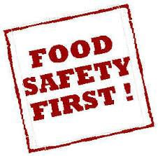The quality of food is judged by wholesomeness, its nutritional value, and our expectations of its color, flavor, odor, and texture. The quality of preserved food varies greatly and depends mostly on the quality of the fresh food and preservation methods. High quality preserved foods are free from microbial spoilage and toxins, are pleasing to eat, and are reasonably nutritious.

**The Bottom Line:** If you prepare or serve food, you are responsible for making sure it’s safe food.

**Factors That Affect Growth of Microorganisms**

1. 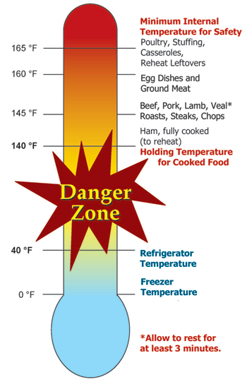**Temperature:** Foodborne pathogens grow best under the same conditions that allow people to thrive. Most foodborne bacteria grow fastest at temperatures from 90° to 110° F. However, foodborne bacteria will grow in the temperature range known as the ***Danger Zone***, 40° to 140°F; some grow at temperatures below this range.
2. **Acidity or alkalinity (pH):** Most organisms grow best under conditions that are not highly acid or alkaline; that is, a neutral pH. (Very few foods are highly alkaline.) High acid foods generally do not support bacterial growth.
3. **Moisture:** Microorganisms require moisture for growth. Dehydration preserves foods by removing moisture.
4. **Oxygen:** Most microorganisms require oxygen to grow; a few pathogens do not, or may require limited oxygen. However, controlling oxygen content is not useful for controlling bacterial growth for home food preservers.
5. **Time:** It takes time for microorganisms to grow or multiply in foods. The time required is affected by temperature, acidity, moisture and oxygen levels. Under ideal conditions bacteria can double in number every 10 to 20 minutes.
6. **Food:** Bacteria require nutrients to reproduce. Foods provide proteins and carbohydrates for growth.
7. **Inhibitors:** Some natural compounds/food additives are bacterial inhibitors (sugar, acid).

**Preventing Foodborne Illnesses**



***Clean***

* Wash hands frequently and after using the toilet, changing a baby's soiled diaper, sneezing or coughing, touching animals, handling raw meat, fish and poultry and before handling food.
* 20-second rule: wash hands for 20-seconds or sing the Happy Birthday song twice.
* Bandage any cuts or burns on hands before handling food; use disposable gloves to protect food.
* Run sponges and dish scrapers through the dishwasher often. Change dish cloths daily.
* Use paper towels to mop up spilled juices from meat, fish or poultry.
* Use a disinfecting solution consisting of 1 tsp unscented chlorine bleach to 1 quart of water. Use a spray bottle to disinfect countertops, cutting surfaces, etc. Make a new solution every week.

***Separate***

* Avoid cross contamination. **ALWAYS** wash your hands, knives, cutting boards, and food preparation surfaces well with soapy water before and after any contact with raw meat or fish.
* Use a separate cutting board for fresh produce, raw meat and cooked meat.
* Rinse all fresh fruits and vegetables well under running water before preparing or eating them.
* When grilling or barbecuing, always use a clean plate for the cooked meat.
* Ice is food! Use clean ice to avoid contaminating food.
* Store raw meat, fish and poultry on the bottom shelf in the refrigerator or on a plate to prevent juices from dripping onto other food items.

***Cook***

* Must reach and maintain an internal temperature high enough to kill pathogens.
* Use a thermometer on meats; follow a reputable recipe when canning.

***Chill***

* Keep your refrigerator set at 40°F or below and refrigerate all perishable foods.
* Thaw frozen perishable foods in a refrigerator overnight, in a microwave oven, or under cold running water. Do not thaw frozen food on your counter.
* Do not prepare food more than 2 hours before serving without plans for proper storage in a refrigerator then reheating just before serving.
* Divide leftover hot food into shallow containers to accelerate cooling and refrigerate within 2 hours after preparation.
* Foods can spoil in as little as 1 hour in the hot sun. Discard any perishable foods from a picnic or potluck that have not been kept adequately chilled (40°F or below) or kept hot (140°F or above).

***When In Doubt - Throw It Out!*** Never taste food that looks or smells strange to see if it can still be used. **Just discard it.** Generally foods that contain bacteria will look, smell, and taste normal. Generally speaking most bacteria that cause foodborne illness are odorless, colorless and tasteless.

**Jars, Lids & Rings**

Jelly Jar 4oz ½ cup

Half pint 8oz 1 cup

Three quarter 12 oz 1¼ cups

Pint 16 oz 2 cups

Quart 32 oz 4 cups

Not any jar will do for canning. Canning jars are special and are made to withstand high heat and / or freezing and are designed for the lids to fit correctly.

The lids are made specifically for canning jars in two different size jar openings, *regular and wide mouth*. Lids are self-sealing round metal disc that are held in place with a metal screw band (ring). The lids have a gasket that seals after processing. The lids are intended for one-time use. The rings are reusable.

There are jars with clear glass lids and a replaceable rubber ring between it and the jar. These are not suitable for canning purposes.

Wash lids and rings with warm soapy water. Do not use rusting or damaged lids or rings. Place lids seal down onto clean jar rim and follow with metal screw band. Tighten enough to hold the lid in place but loose enough to allow the air to vent from the jar, this enables the jar to have a tight vacuum seal when done.

Rule of thumb is to tighten the screw band very gently until you feel a sight resistance. Then finger tight a little more. You do not want the bands too tight or too loose.

***Processing the Jars***

Process foods for which you have a researched-based processing time. The process time is unique to each food, based on the amount of time needed for the contents of the jar to reach a temperature required to destroy all dangerous microorganism. Processing times are specified for jar size. All recipes specify jar size needed. You can move down in size of jar (and be safe). Use the same processing time for the smaller jar as listed in the recipe. Never use a larger jar than the recipe recommends. If a larger jar is used, processing time has to be adjusted for that size jar and content. Don’t estimate on the processing time for larger jars; you need to be precise.

**How Canning Preserves Food Safely**

* With proper canning practices, air is forced from the jars, leaving a vacuum. Heat destroys most heat-resistant microorganisms capable of growing in food stored at room temperature.
* Molds and some yeasts are unable to grow in a vacuum. However, there is a very healthy growth environment for anaerobic bacteria in sealed, home-canned foods. Such foods must be heat processed until a commercially sterile product is achieved, or they must have salts, sugars, acids or other preservatives added.
* Yeasts and molds are destroyed when food temperatures reach about 190°F, whereas most bacterial vegetative cells are destroyed in foods heated to a boiling temperature. Bacterial spores are able to survive for a long period at the temperature of boiling water.
* Pressure enables the processing of canned foods at temperatures higher than boiling water, where kill rates are greatly increased. Pressure canning is required to safely process foods that may support the growth of bacterial spores, leading to the production of toxins.

***Sweetening and Acidifying Jellies & Jams***

* Adds sugar and acids that tie up free water and lower the pH.

***Pickling and Fermenting***

* Use either naturally produced or added acids to inhibit or prevent the growth of *Clostridium botulinum* as well as molds and other pathogens.
* Fermenting uses bacteria to produce lactic acid and lower the pH in products such as fermented pickles and sauerkraut.

***Canning Processes***

* Use an **atmospheric steam canner** or a **boiling water canner** for high acid foods: fruits, pickled and fermented products, jams and jellies.
* Use a **pressure canner** for low acid foods: meats, vegetables, and seafood.

*Why two different processes?* Low acid foods must be pressure canned because *Clostridium botulinum*, the bacteria that causes botulism, is a spore former. When conditions are not favorable for the organism to grow (high heat, dryness, etc.), the bacterial cell forms a protective structure called a spore. It takes a higher temperature than boiling to destroy the spores: 240° - 250°F. If you do not destroy the spores in low acid foods they will germinate and produce fatal toxins in the food when it is stored on the shelf. High acid foods have enough acidity to destroy spores.

The USDA does not recommend the open kettle method of canning because it does not prevent all risks of spoilage. *(Open kettle canning is ladling hot foods into hot jars, applying the lids and letting them seal without processing them in a canner.)*

***5-minute Processing Time for Jams & Jellies***

To prevent growth of molds and loss of good flavor or color, fill hot products into sterile jars, leaving 1/4-inch headspace, and process 5 minutes in a boiling-water or steam canner, adding 1 minute per 1,000 feet above sea level. If using unsterile jars, process the filled jars 10 minutes. Use of sterile jars is preferred, especially when fruits are low in pectin, since the added 5-minute process time may cause weak gels. Sterilize jars in boiling water for 10 minutes, adding 1 minute per 1,000 feet above sea level.

**Basic Jam & Jelly Ingredients**

For an acceptable jam or jelly, the proper proportions of fruit, sugar, acid and pectin are needed.

Fruit

* Gives each spread its unique flavor and color.
* Supplies the liquid to dissolve the rest of the necessary ingredients
* Furnishes some or all of the pectin and acid.
* High-quality, flavorful fruits make the best jellied products.

Sugar

* Serves as a preserving agent, contributes flavor, and aids in gelling.
* Cane and beet sugar are the usual sources of sugar for jelly or jam. Corn syrup and honey may be used to replace part of the sugar in recipes, but too much will mask the fruit flavor and alter the gel structure. Use tested recipes for replacing sugar with honey and corn syrup.
* Do not reduce the amount of sugar in traditional recipes. Too little sugar prevents gelling and may allow yeasts and molds to grow.

Acid

* Adds flavor.
* Proper level of acidity is critical to gel formation. If there is too little acid, the gel will never set; if there is too much acid, the gel will lose liquid (weep).
* For fruits low in acid, add lemon juice or other acid ingredients as directed.
* Commercial pectin products usually contain acids which help to ensure gelling.

Pectin

* Natural occurring carbohydrate located between plant cell walls that give jams and jellies firmness.
* All fruits contain some pectin; some need additional pectin to gel, others do not.
* Forms a gel if it is in the right combination with acid and sugar in traditional recipes.
* Use a low/no sugar pectin to make a reduced sugar fruit spread. These modified pectins use calcium instead of sugar to form the gel.

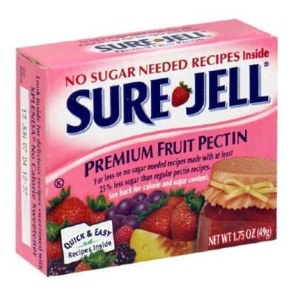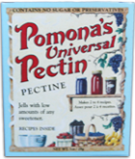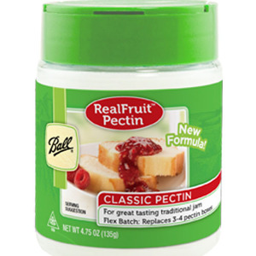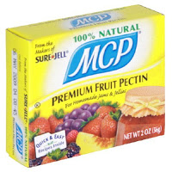

**Canning Basics**

***Get Ready … Be Prepared!***

* Read the recipe thoroughly before you begin.
* Measure out all ingredients.
* Have all of your utensils at hand.
* Wash jars, lids and rings in hot soapy water and rinse well. Check jars for imperfections.
* Place clean jars into the boiling water canner to heat.
* Prepare lids and rings according to the directions on the lid and ring packages. (Newer boxes of lids don’t require pre-heating, older ones do. You may still pre-heat newer lids.)
* Do a “dry run” of the recipe to make sure you have all of your materials and understand the process.

***General Canning Supplies***

* Standard canning jars, rings, self-sealing one-time use lids; no paraffin wax as a sealing agent
* Funnel
* Headspace measurer
* De-bubbler
* Jar lifter
* Tray/towel for hot jars
* Canning pot with bottom rack and a lid
* Reputable recipe that follows the USDA recommended canning procedures

***Raw-Pack vs. Hot-Pack Methods***

Filling jars with raw, unheated food prior to heat processing is called the raw-pack method. The preferred method, filling jars with preheated, hot food prior to heat processing, is called the hot-pack method. Benefits include a tighter pack and, because food expels air when heated, less float.

***Jars***

Check jars, lids and bands for high quality. Wash jars, lids and bands in hot, soapy water. Rinse well.

Heat home canning jars in hot water, not boiling, until ready for use. Fill a large saucepan or stockpot half-way with water. You may also place them in your canner. Place jars in water (filling jars with water from the saucepan will prevent flotation). Bring to a simmer over medium heat. Keep jars hot until ready for use. You may also use a dishwasher to wash and heat jars. Keeping jars hot prevents them from breaking when hot food is added. Leave lids and bands at room temperature for easy handling.

***Headspace***

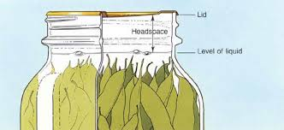Headspace is the completely empty space left in the jar underneath the lid and above the food. Headspace allows for food to expand during canning without being forced out from under the lid during processing. Too much headspace and a vacuum may not form. Too little and the product may boil onto the rim and prevent a good seal.

**Pressure Canning Essentials**

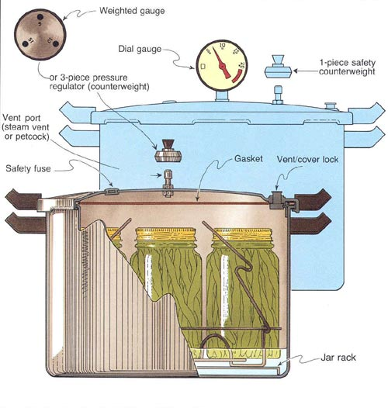***Pressure Canning Equipment***

* Pressure canner with the following features:
  + Flat rack in bottom
  + Pressure regulator or indicator
    - Dial or weighted gauge
    - Vent pipe (port) for pressurizing
  + Safety valves or overpressure plugs
  + Safety locks when pressurized
  + Flexible gasket/sealing ring in lid or metal to metal seal
  + Optional: jar stacking rack
* Please note that a pressure cooker is NOT a pressure canner, but a pressure canner can be used as a pressure cooker. A pressure cooker must be able to hold **4 quart** jars to be considered a pressure canner.

|  |  |
| --- | --- |
| Altitude Chart | |
| **Altitude in feet** | **Required Pressure** |
| Sea Level – 2000ft. | 11lb. |
| 2001 – 4000ft. | 12lb. |
| 4001 – 6000ft. | 13lb. |
| 6001 – 8000ft. | 14lb. |
| 8001 – 10,000ft. | 15lb. |

***Adjusting for Altitude: Pressure Canner***

Processing times for all recipes are at sea level. At sea level to 2,000 feet, 11 pounds of steam pressure will produce 240°F. Above 2,000 feet you must increase the steam pressure to reach this temperature. For altitudes above sea level adjust processing time according to the altitude chart.

***Using a Pressure Canner***

1. Clean lid gaskets and other parts according to the manufacturer’s directions; make sure all vent pipes are clear.
2. Put 2 to 3 inches hot water (140ºF) into the canner.
3. Place filled jars on the jar rack in the canner, using a jar lifter.
4. Fasten the canner lid securely. Leave the weight off the vent pipe or open the petcock.
5. Turn the heat setting to high; heat until the water boils and steams. **Always** vent for 10 minutes.
6. Place the counterweight or weighted gauge on the vent pipe, or close the petcock.
7. Start timing the process when the pressure reading on the dial gauge indicates that the recommended pressure has been reached, or, for canners without dial gauges, when the weighted gauge begins to jiggle or rock as the manufacturer describes.
8. Regulate the heat under the canner to maintain a steady pressure at, or slightly above, the correct gauge pressure. **IMPORTANT:** If at any time pressure goes below the recommended amount, bring the canner back to pressure and begin the timing of the process over, from the beginning using the total original process time. This is important for the safety of the food.
9. When the timed process is completed, turn off the heat, remove the canner from the heat (electric burner) if possible, and let the canner cool down naturally. Do not force cool the canner. Pints take about 30 minutes to cool; 45 minutes for quarts.
10. After the canner is completely depressurized, remove the weight from the vent pipe or open the petcock. **Wait 10** minutes; then unfasten the lid away from you to remove.
11. Remove the jars from the canner by lifting them upright and placing them on a rack or folded towel away from drafts.
12. Do not retighten the rings. Leave the ring bands on the jars until they have cooled thoroughly (approximately 24 hours). Do not try to dump or wipe up any water on the lids.
13. Dry the canner, lid and gasket. Take off removable petcocks and safety valves; wash and dry thoroughly. Follow maintenance and storage instructions that come from your canner manufacturer.

**Boiling Water Canner Processing**

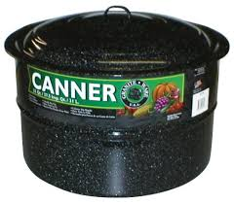

1. Preheat water to 140°F for raw-packed foods and to 180°F for hot-packed foods. Food preparation can begin while this water is preheating. Do not have the water boiling when you add the jars.
2. Place jars on the rack in the canner. Add enough boiling water to cover the tops of the jar by at least 1" to 2".
3. Place lid on canner. Bring the water to a rolling boil, then reduce heat to a gentle boil.
4. Begin to count processing time when the water comes to a boil.
5. Process for the time indicated in the recipe, maintaining a constant boil.
6. All recipes are developed using sea level as the criteria for processing time. If you are at a higher altitude, adjust the processing times according to the following chart:

*Note: these altitude adjustments are for non-jam & jelly recipes. Process jams & jellies for 5+ minutes in sterile jars as recommended on page 4.*

|  |  |
| --- | --- |
| **Altitude in feet** | **Increase processing time** |
| 1000 - 3000 | 5 minutes |
| 3001 - 6000 | 10 minutes |
| 6001 - 8000 | 15 minutes |
| 8001 - 10000 | 20 minutes |

1. When the jars have boiled for the recommended time, turn off the heat and remove the canner lid. Wait no more than 5 minutes before removing jars
2. Keep the jars upright when you remove them from the canner.
3. Place the hot jars on a rack or folded towel away from drafts or cool surfaces. Keep the jars separated so they will cool evenly. Do not disturb the seal. Do not retighten the rings.
4. Leave the ring bands on the jars until they have cooled (approximately 24 hours).
5. Do NOT invert jars: Some canning books still recommend inverting the jars after removing them from the boiling water canner. The USDA does not recommend this method.
6. 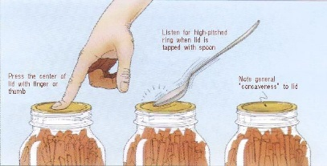After the jars have cooled, remove the ring bands. Look at the top of each jar. If the lid is slightly concave, it indicates a seal. Test the seal by pressing on the lid with your finger; the lid should not give. If you are not sure a jar is sealed, carefully lift the jar by the lid after removing the ring band. If not properly sealed, the lid will come off.
7. Wash and dry bands. Clean the jars with a damp cloth. The ring bands may be replaced on the jars if desired. The ring bands must be thoroughly dry.
8. Label and date the jars, and store in a cool, dark, dry area.

**Reprocessing -** If a jar did not seal, refrigerate and use within a few days, or reprocess it within 24 hours using a new lid. Check the jar for flaws. Process by the method originally advised and for the full length of time.

**Atmospheric Steam Canner Processing**

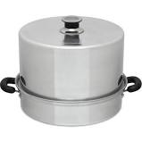

1. Use a research tested recipe and processing time developed for a **boiling water** canner when using an atmospheric steam canner. An atmospheric steam canner may be used with recipes approved for half-pint, pint, or quart jars.
2. Add enough water to the base of the canner to cover the rack. (Follow manufacturer recommendations.)
3. Preheat water to 140°F for raw-packed foods and to 180°F for hot-packed foods. Food preparation can begin while this water is preheating. Do not have the water boiling when you add the jars.
4. Heat jars prior to filling with hot liquid (raw or hot pack). Do not allow the jars to cool before filling.
5. Load filled jars, fitted with lids, onto the canner rack and place the lid on the canner base.
6. Turn heat to its highest position to boil the water until a steady column of steam (6-8 inches) appears from the vent hole(s) in the canner lid. Jars must be processed in pure steam environment.
7. 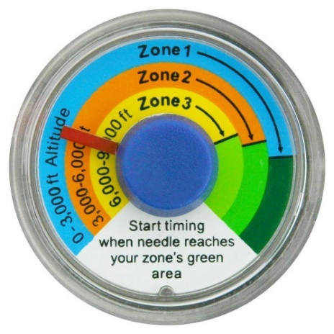If using a canner with a temperature sensor, begin processing time when the temperature marker is in the green zone for your altitude. If using a canner without a temperature sensor, begin processing time when a steady stream of steam is visible from the vent hole(s).
8. Set the timer for the total minutes required for processing the food, adjusting for altitude (see chart on page 5). Processing time must be limited to **45 minutes or less, including any modification for elevation**. The processing time is limited by the amount of water in the canner base. When processing food, **do not** open the canner to add water.
9. Monitor the temperature sensor and/or steady stream of steam throughout the entire timed process. Regulate heat so that the canner maintains a temperature of 212°F. A canner that is boiling too vigorously can boil dry within 20 minutes. If a canner boils dry, the food is considered under-processed and therefore potentially unsafe.
10. At the end of the processing time, turn off the heat, wait 2-3 minutes and remove the lid, lifting the lid away from you.
11. Using a jar lifter, remove the jars without tipping and place them on a towel, leaving at least 1 inch spaces between the jars during cooling. Let jars sit undisturbed to cool at room temperature for 12 to 24 hours.

**Resources: National Center for Home Food Preservation,** [**http://nchfp.uga.edu**](http://nchfp.uga.edu)

No endorsement of any product/company is intended, nor is criticism implied of similar products/companies that are not included.

The University of California, Division of Agriculture and Natural Resources (UC ANR) prohibits discrimination against or harassment of any person in any of its programs or activities on the basis of race, color, national origin, religion, sex, gender, gender expression, gender identity, pregnancy (which includes pregnancy, childbirth, and medical conditions related to pregnancy or childbirth), physical or mental disability, medical condition (cancer-related or genetic characteristics), genetic information (including family medical history), ancestry, marital status, age, sexual orientation, citizenship, status as a protected veteran or service in the uniformed services (as defined by the Uniformed Services Employment and Reemployment Rights Act of 1994 [USERRA]), as well as state military and naval service. UC ANR policy prohibits retaliation against any employee or person in any of its programs or activities for bringing a complaint of discrimination or harassment. UC ANR policy also prohibits retaliation against a person who assists someone with a complaint of discrimination or harassment, or participates in any manner in an investigation or resolution of a complaint of discrimination or harassment. Retaliation includes threats, intimidation, reprisals, and/or adverse actions related to any of its programs or activities. UC ANR is an Equal Opportunity/Affirmative Action Employer. All qualified applicants will receive consideration for employment and/or participation in any of its programs or activities without regard to race, color, religion, sex, national origin, disability, age or protected veteran status. University policy is intended to be consistent with the provisions of applicable State and Federal laws. Inquiries regarding the University’s equal employment opportunity policies may be directed to: John I. Sims, Affirmative Action Compliance Officer and Title IX Officer, University of California, Agriculture and Natural Resources, 2801 Second Street, Davis, CA 95618, (530) 750-1397. Email: [jsims@ucanr.edu](mailto:jsims@ucanr.edu). Website: <http://ucanr.edu/sites/anrstaff/Diversity/Affirmative_Action/>.

**Recipes**

**Red Raspberry Jam with Liquid Pectin**  
*Yields approx.: Six 8-ounce jars (half-pint jars)*

Wash jars, lids and rings. Prepare boiling water or steam canner; heat jars.

4 cups crushed raspberries (approximately 36 ounces)  
6-1/2 cups sugar  
1 pouch liquid pectin

1. Crush berries; if desired, press half the crushed fruit through sieve to remove seeds.
2. Measure 4 cups crushed berries into stock pot, mix in sugar.
3. On high heat, stirring constantly, bring mixture to full rolling boil that does not stir down.
4. Stir in pectin quickly.
5. Return to full rolling boil; boil exactly 1 minute, stirring constantly.
6. Remove from heat; skim off any foam with metal spoon.
7. Fill prepared hot jars to within 1/4 inch of top. Remove air bubbles and adjust head space if necessary by adding hot jam.
8. Wipe jar rims, cover with two-piece lids, screw bands down until resistance is met, then increase to fingertip-tight.
9. Place jars on elevated rack in canner; for boiling water canner, ensure water covers jars by 1 to 2 inches.
10. Process for 10 min, adjusting time if necessary as directed by altitude chart:

1001 – 3000 ft. + 5 min.  
3001 – 6000 ft. + 10 min.  
6001 – 8000 ft. + 15 min.  
8001 – 10000 ft. + 20 min.

1. At the end of processing time, turn off the heat and remove the lid. Let canner cool for 5 minutes. If using steam canner take off heat and leave lid on for 3 - 5 minutes, then remove the lid. Move jars by lifting the jars straight up, out of water without tilting and place on dish towel.
2. Cool in draft-free location for 24 hours without disturbing. Do not dry lids or jars at this time.
3. After 24 hours, check seals, remove rings, rinse and dry jars, label contents.
4. Store in cool, dry location; use within one year for best quality.

*Source: Ball “Complete Book of Home Preserving” 2012 / 2020 editions*

**Strawberry Vinaigrette Dressing**

*Yield: about Six 8-ounce jars (half pints jars)*

5 quarts (25 cups) whole strawberries, washed and stemmed

1 quart (4 cups) white distilled vinegar

Sugar

1. Place strawberries in a large stainless steel sauce-pot or plastic container. Add vinegar. Cover container tightly with plastic wrap and let stand overnight in a dark, cool place (70°F to 75°F).
2. Strain liquid from strawberries. Liquid should be red and clear (no pulp). Measure liquid.
3. Place strawberry vinegar in a clean, large stainless steel saucepan. Add an equal amount of sugar, stirring to combine. Bring mixture just to a boil. Remove from heat and skim foam if necessary.
4. Ladle hot vinaigrette into hot jars leaving 1/4-inch headspace. Wipe rim and apply two-piece metal canning lids.
5. Process in a steam or boiling water canner for 10 minutes at 0-1000’, 15 minutes at 1,001 -3,000’,   
   20 minutes at 3,001 – 6,000’, 25 minutes above 6,000’ elevation.

*Source: Ball “Complete Book of Home Preserving” 2012 / 2020 editions*

**Blueberry Sauce**

*Yield: about Six 8-ounce (half pints jars)*

7 cups blueberries 1-1/4 cups granulated sugar

2-3/4 cups unsweetened apple juice 2/3 cup corn syrup

1 tablespoon grated lemon zest 1/4 cup lemon juice

1. In a large stainless steel saucepan, combine blueberries, apple juice and lemon zest. Bring to a gentle boil over medium heat, crushing berries with a potato masher. While maintaining a constant but gentle boil, gradually add sugar, stirring until completely dissolved. Continue boiling gently while gradually stirring in corn syrup and lemon juice. Bring to a full rolling boil over high heat, stirring constantly. Boil hard for 15 minutes.
2. Ladle hot sauce into hot jars, leaving 1/4-inch headspace. Remove air bubbles and adjust headspace, if necessary, by adding hot sauce. Wipe rim and apply two-piece metal canning lids.
3. Process in a steam or boiling water canner for 10 minutes at 0-1000’, 15 minutes at 1,001 -3,000’,   
   20 minutes at 3,001 – 6,000’, 25 minutes above 6,000’ elevation.

*Source: Ball “Complete Book of Home Preserving” 2012* / *2020 editions*

**Pickled Asparagus***Yield: Six 16-ounce pint jars*

7 lbs. asparagus

Ice water

4 tbsp finely chopped seeded red bell pepper

2 tbsp finely chopped seeded green bell pepper

2 tbsp finely chopped seeded hot chili pepper such as jalapeno or cayenne

3 tbsp finely chopped garlic

5 cups white vinegar

1 2/3 cups water

1 2/3 cups granulated sugar

4 tsp salt for pickling & preserving

2 tbsp dill seeds

2 tbsp mustard seeds

Ball Pickle Crisp or Bernardin Pickle Crisp optional

1. Trim tough ends from asparagus and cut spears into uniform lengths about ¾ inch shorter than the inside height of jars you are using. In a large shallow dish, cover asparagus with ice water and refrigerate for 1 hour. Drain well.
2. Meanwhile, prepare canner, jars and lids.
3. In a small bowl, combine red and green bell peppers, hot pepper and garlic. Mix well and set aside.
4. In a large stainless-steel saucepan, combine vinegar, water, sugar and salt. Stir well and bring to a boil over medium-high heat. Reduce heat and boil gently for 5 minutes. Add asparagus and return to a boil. Boil for 2 minutes or until asparagus is heated through.
5. Place 2 tbsp chopped pepper mixture, 1 tsp dill seeds and 1 tsp mustard seeds into each hot jar. Pack asparagus, tips down, into hot jars to within a generous ½ inch of top of jar. Ladle hot pickling liquid into jar to cover asparagus, leaving ½ inch headspace. Add 1/8 teaspoon Pickle Crisp*, if using, to pint jar. Remove air bubbles and adjust headspace, if necessary, by adding hot pickling liquid. Wipe rim. Center lid on jar. Screw band down until resistance is met, then increase to fingertip-tight.
6. Place jars on a rack in canner, ensuring they are completely covered with water. Bring to a boil and process 10 minutes, adjusting for altitude. See guide below.
7. At the end of processing time, turn off the heat and remove the lid. Let canner cool for 5 minutes. If using steam canner leave lid *on* for 3 - 5 minutes, then remove the lid. Move jars by lifting the jars straight up, out of water without tilting and place on dish towel.
8. Cool in draft-free location for 24 hours without disturbing. Do not dry lids or jars at this time.
9. After 24 hours, check seals, remove rings, rinse and dry jars, label contents.
10. Store in cool, dry location; use within one year for best quality.

**Process Time at Altitudes of:**

|  |  |  |  |  |  |
| --- | --- | --- | --- | --- | --- |
| **Style of Pack** | **Jar size** | **0 – 1000** | **1,001 – 3,000** | **3,001 – 6,000** | **6,001– 8,000 ft** |
| Hot | Pint | 10 minutes | 15 minutes | 20 minutes | 25 minutes |

*Source: Ball “Complete Book of Home Preserving” 2012 / 2020 editions*

**Pickled Carrots**

Yield: About Four 16-ounce pint jars

2¾ pounds peeled carrots (about 3 ½ pounds as purchased) or can use baby carrots

5½ cups white distilled vinegar (5%)

1 cup water

2 cups sugar

2 teaspoons canning salt

8 teaspoons mustard seed

4 teaspoons celery seed

1. Wash carrots well and peel, if necessary. Wash again after peeling and cut into rounds that are approximately ½ inch thick
2. Combine vinegar, water, sugar and canning salt in an 8-quart Dutch oven or stockpot. Bring to a boil and boil gently 3 minutes. Add carrots and bring back to a boil. Then reduce heat to a simmer and heat until the carrots are half-cooked (about 10 minutes).
3. Meanwhile, place 2 teaspoons mustard seed and 1 teaspoon celery seed in the bottom of each clean, hot pint jar.
4. Fill hot jars with the hot carrots, leaving 1-inch headspace. Cover with hot pickling liquid, leaving ½ inch headspace. Remove air bubbles and adjust headspace if needed. Wipe rim; apply lids.
5. Process in a boiling water (with a rack in the bottom) or steam canner for 15 minutes, adjusting time if necessary, as directed by the altitude chart below.
6. At the end of processing time, turn off the heat and remove the lid. Let canner cool for 5 minutes. If using steam canner wait 3 - 5 minutes before removing lid. Move jars by lifting the jars straight up, out of water without tilting and place on dish towel.
7. Allow carrots to sit in processed jars for 3 to 5 days before consuming for best flavor development.

**Process Time at Altitudes of:**

|  |  |  |  |  |
| --- | --- | --- | --- | --- |
| **Style of Pack** | **Jar size** | **0 – 1,000 ft** | **1,001 – 6,000 ft** | **Above 6,000 ft** |
| Hot | Pints | 15 minutes | 20 minutes | 25 minutes |

*Source: USDA Complete Guide to Home Canning, revised 2015*

**Pickled Baby Carrots**

**Procedure:** Follow directions for Pickled Carrots, using 8½ cups peeled baby carrots, leaving them whole, and use the same process time.

*Source: USDA Complete Guide to Home Canning, revised 2015*

**Pickled Corn Relish**

***Yield:*** *About Five 16-ounce pint jars*

2-1/2 cups diced sweet red peppers 1-3/4 cups sugar 2-1/2 tbsp dry mustard

2-1/2 cups diced sweet green peppers 5 cups vinegar (5%) 1-1/4 tsp turmeric

2-1/2 cups chopped celery 2-1/2 tbsp canning or pickling salt Six 10-ounce packages

1-1/4 cups diced onions 2-1/2 tsp celery seed of frozen corn

1. Combine peppers, celery, onions, sugar, vinegar, salt, and celery seed in a saucepan. Bring to boil and simmer 5 minutes, stirring occasionally.
2. Mix mustard and turmeric in 1/2 cup of the simmered mixture. Add this mixture and corn to the hot mixture. Simmer another 5 minutes.
3. Fill jars with hot mixture, leaving 1/2-inch headspace. Wipe rim; apply two-piece metal canning lids.
4. Process in a steam or boiling water canner 15 minutes at 0-1000’, 20 minutes at 1,001 -6,000’,   
   25 minutes above 6,000’.

*Source: USDA Complete Guide to Home Canning, revised 2015*

__________________________________________________________________________

**Grape Jelly**

*Yield: about 8 or 9 half pint jars*

5 cups grape juice (bottled or 3-1/2 pounds Concord grapes & 1 cup water)

1 package powdered pectin

7 cups sugar

1. Sterilize canning jars.
2. Measure juice into a deep pot. Add pectin and stir well. Place on high heat and, stirring constantly, bring quickly to full rolling boil that cannot be stirred down.
3. Add sugar, continue stirring, and heat again to full rolling boil.
4. Boil hard for 1 minute. Remove from heat; skim off foam quickly.
5. Pour hot jelly immediately into hot, sterile jars leaving 1/4-inch headspace. Wipe rim; apply lids.
6. Process in a steam or boiling water canner for 5 minutes at 0-1000’, adding 1 minute for each additional 1000’ in elevation.

*Source: USDA Complete Guide to Home Canning, revised 2015*